SOFTWARE ENGINEERING LAB-5

NAME : SHIVA SANDESH
SRN : PES2UG24CS46
SECTION : H

Githublink
https://github.com/shivasandesh18/L5_32_expense_tracker.git

RESULTS BEFORE THE CHANGES IN THE CODE

Output of Pylint
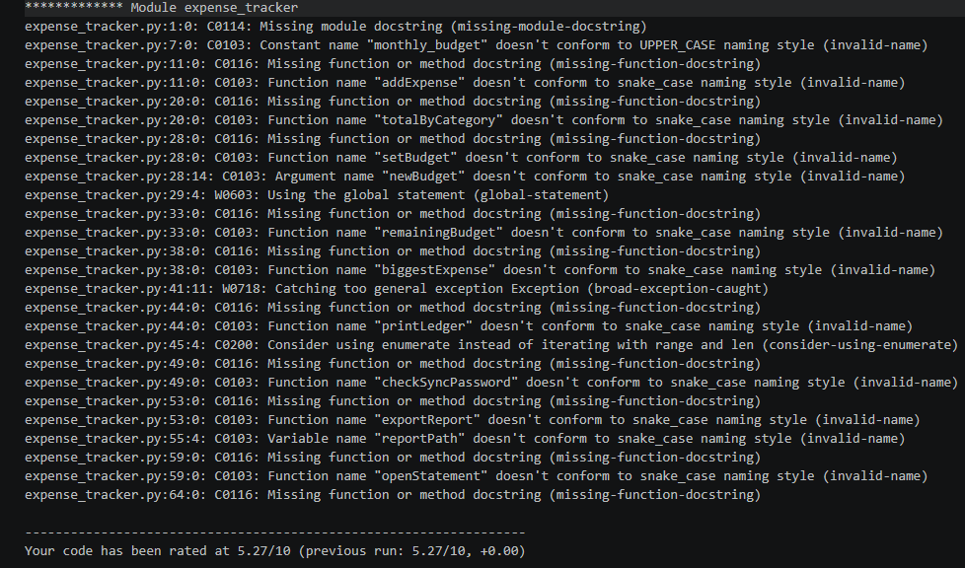
Output of Bandit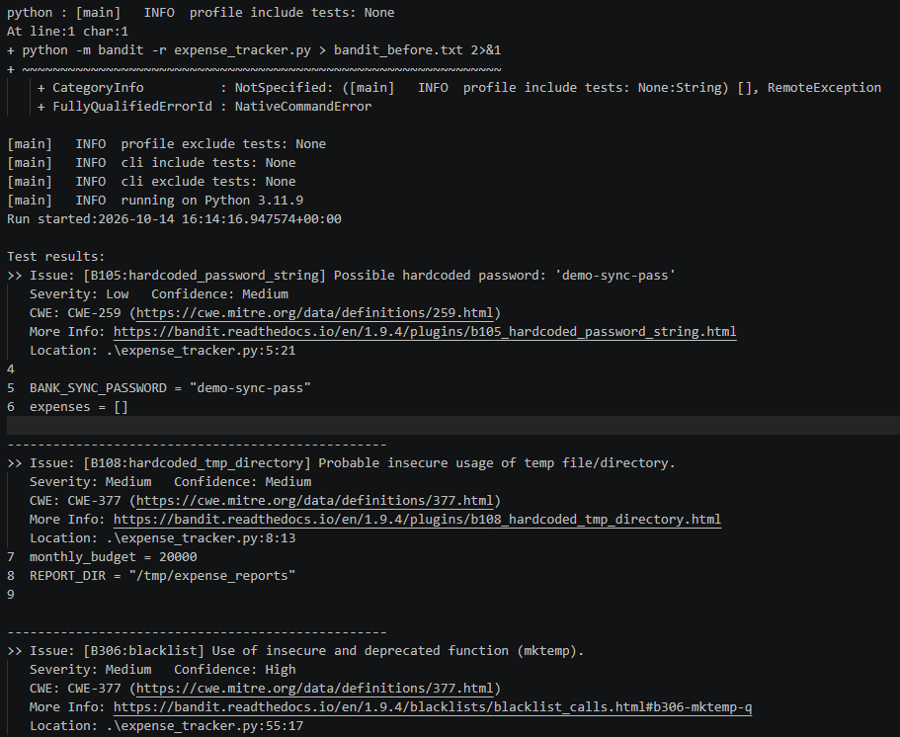

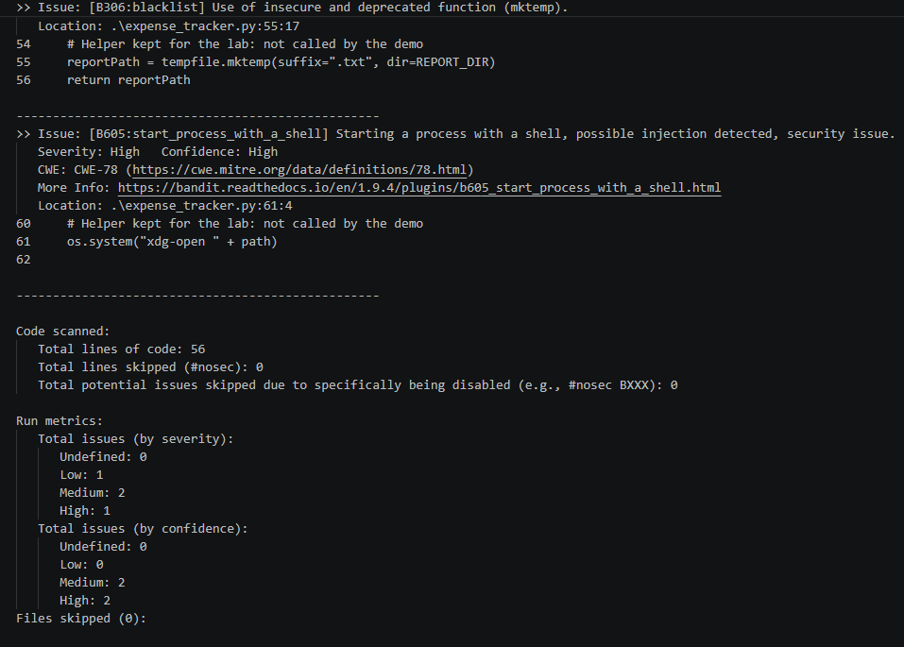

Output for Flake8
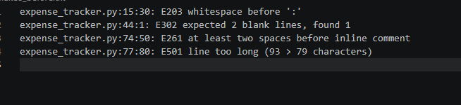

RESULTS AFTER THE CHANGES

Output of pylint
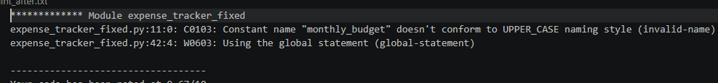

Output of bandit
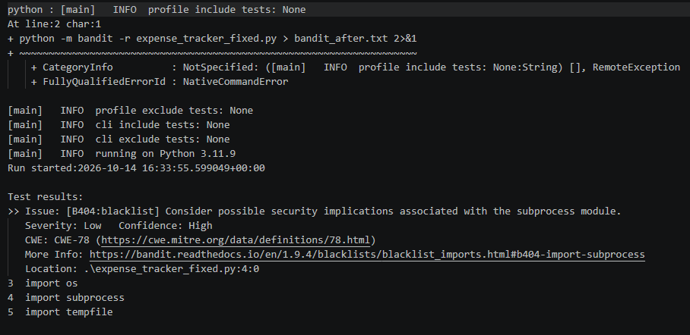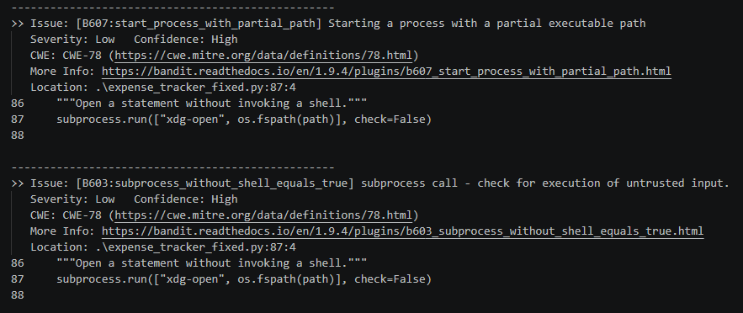
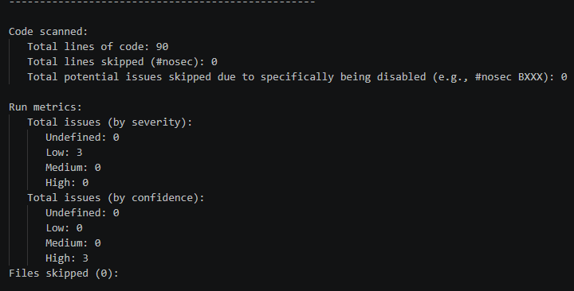

Output of flake8
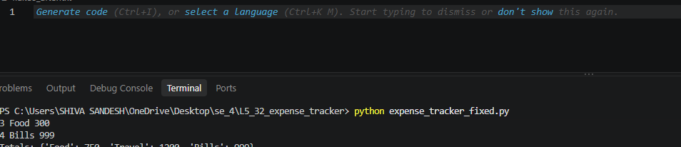

Issue | Type | Line | Description | FixApproach
Command injection risk (os.system) | Security  (high) | 61 |  | Replace os.system() with subprocess.run()
  Using os.system() with a supplied path may allow command injection.
nsecure temporary filename (tempfile.mktemp) | Security  (medium) | 55 | Mktemp() creates filename without creating the file properly | Using tempfile.NamedTemporar  ryFile() , delete=False
Hardcoded temporary directory | medium  security | 8 |  | Use tempfile.gettempdir() and create a dedicated report directory
  The hardcoded /tmp/expense_reports directory is flagged as potentially insecure and platform-specific.
Hardcoded password | Low  Password | 5 |  | Read the password from an environment variable.
  The bank-sync password is stored directly in the source code.
Broad exception handling | Code  quality | 41-42 |  | Catch the specific ValueError raised when max() receives an empty list.
  except Exception catches errors beyond those expected.
incorrect naming conventions | Style  Code  quality | Many |  | Rename functions and variables using snake_case.
  Function and variable names use camelCase instead of Python's recommended snake_case.
Missing docstrings | Code  quality | Many | Functions and the module lack explanatory documentation. | Add module and function docstrings
Unnecessary whitespace before colon | Style | 15 |  | Remove the whitespace before the colon.
  There is an extra space before a dictionary key-value colon.
 | Style | 44 | A top-level function does not have the required blank-line separation. | Add the required blank line before the function.
  Missing blank line
Incorrect inline comment spacing | Style | 74 | The inline comment does not have enough preceding spaces. | The inline comment does not have enough preceding spaces.
Line too long | Style | 77 |  | Split the statement across multiple lines.
  A line exceeds the configured 79-character limit.
Unsafe access to an empty result | Potential  bug | 75 | Accessing ["note"] on None can raise a TypeError if there are no expenses. | Check whether the returned value is None before accessing its note.

