Balaji Furnitures – Website Animations
Name of each animation, what it does and where it is used (with screenshot). Source: public/css/style.css and public/js/main.js. No external animation library is used – everything is plain CSS and a little JavaScript.

Summary
# | Animation | Where it is used
1 | Hero Wipe-Up + Staggered Fade-Up | Home page (index.html) – top hero banner
2 | Pulsing "Open Now" Dot | Green "Open now – until 9 PM" badge on the hero (also on Contact page)
3 | Scroll Reveal (Fade-Up / Scale-In) | Almost every section on every page – category grid, featured pieces, offers, FAQ, owner photo, footer
4 | Gold Line Wipe (Rule Draw-In) | Small gold divider lines under section headings (e.g
5 | Service Card Top-Line Wipe | "Service & warranty" cards on the Home page
6 | Card Lift, Tilt & Image Zoom on Hover | Featured piece cards: lift 6 px, tilt slightly, soft shadow; photo zooms 6 %
7 | Category Card Hover Lift | "Shop by category" tiles: lift, shadow, slow photo zoom and the name slides up
8 | Opening Hours Row Slide + Dot | "Visit us" opening-hours table
9 | Smooth FAQ Accordion | "Frequently asked questions" on Home and Contact pages
10 | Footer Link Slide | Footer link lists – a hovered link slides right 8 px and turns gold
11 | Shrinking Sticky Header + Sliding Nav Underline | Top header on every page
12 | Floating Call Button Ripple + Back-to-Top | Green round call button (bottom-right, every page) rises in after load and sends out a soft ring every few seconds
13 | Button Hover Lift | All gold / ghost / WhatsApp buttons (hero buttons shown) lift slightly with a shadow on hover and press down on click
14 | Form Shake Error | Enquiry form (Contact page, Home page bottom)
15 | Mobile Bottom Bar Slide-Up + Ripple | Phone view: CALL / WHATSAPP / DIRECTIONS bar slides up from the bottom; the WhatsApp tab pulses with a green ring
16 | Hamburger → Cross Morph + Mobile Menu Drop | Phone view menu button

1. Hero Wipe-Up + Staggered Fade-Up
Technique: CSS @keyframes: wipe-up, fade-up
Where used / what you see: Home page (index.html) – top hero banner. On page load the sofa photo is revealed bottom-to-top (clip-path), then the badge, heading, text, buttons and address fade up one after another.
Code location: style.css lines 481, 483, 497-503

Red dashed box marks the animated element.

2. Pulsing "Open Now" Dot
Technique: CSS @keyframes: ping
Where used / what you see: Green "Open now – until 9 PM" badge on the hero (also on Contact page). A ring keeps spreading out and fading around the dot; it stops when the shop is closed. The badge itself is updated by main.js every minute.
Code location: style.css lines 485, 506-508; main.js line 88

Red dashed box marks the animated element.

3. Scroll Reveal (Fade-Up / Scale-In)
Technique: IntersectionObserver in main.js + @keyframes fade-up, scale-in
Where used / what you see: Almost every section on every page – category grid, featured pieces, offers, FAQ, owner photo, footer. Items glide up and fade in as you scroll to them, with a small stagger between neighbours (0.08 s each).
Code location: main.js lines 129-181; style.css lines 481-482, 511-514
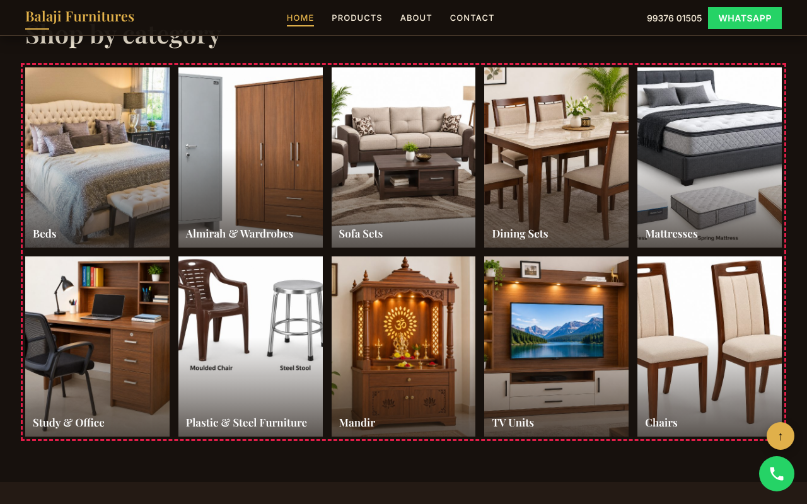
Red dashed box marks the animated element.

4. Gold Line Wipe (Rule Draw-In)
Technique: CSS @keyframes: line-wipe
Where used / what you see: Small gold divider lines under section headings (e.g. "Custom orders") and the gold top border of each "Service & warranty" card draw in from left to right.
Code location: style.css lines 484, 516-522
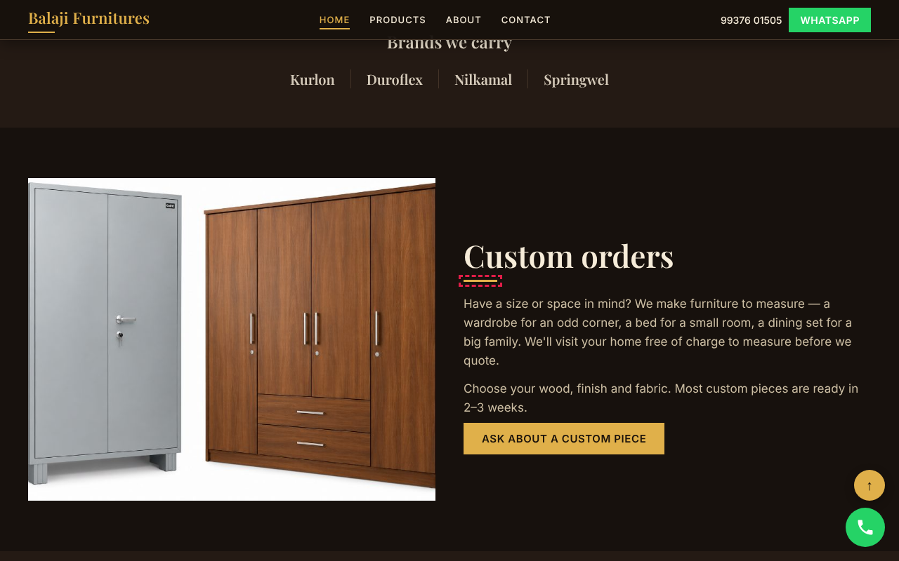
Red dashed box marks the animated element.

5. Service Card Top-Line Wipe
Technique: CSS @keyframes: line-wipe (::before)
Where used / what you see: "Service & warranty" cards on the Home page.
Code location: style.css lines 520-523
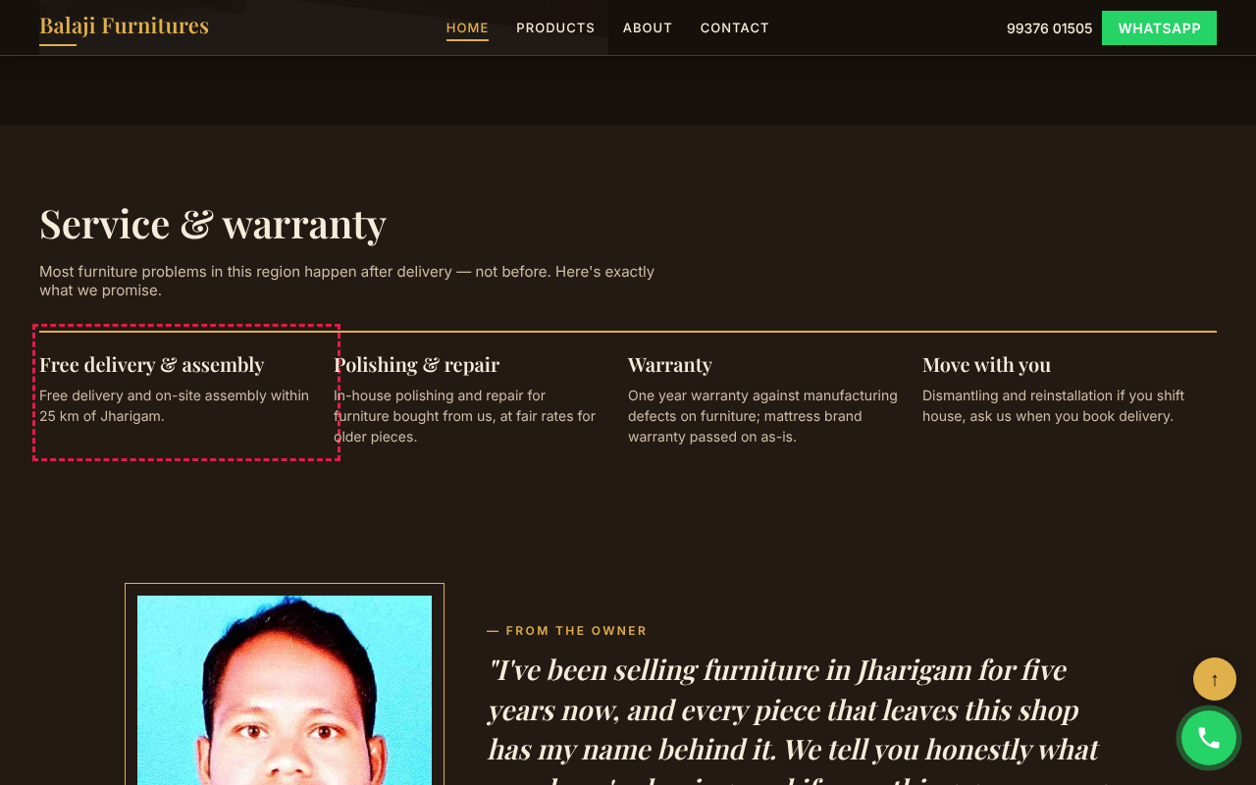
Red dashed box marks the animated element.

6. Card Lift, Tilt & Image Zoom on Hover
Technique: CSS transition + transform
Where used / what you see: Featured piece cards: lift 6 px, tilt slightly, soft shadow; photo zooms 6 %. Only on devices with a mouse.
Code location: style.css lines 555-564
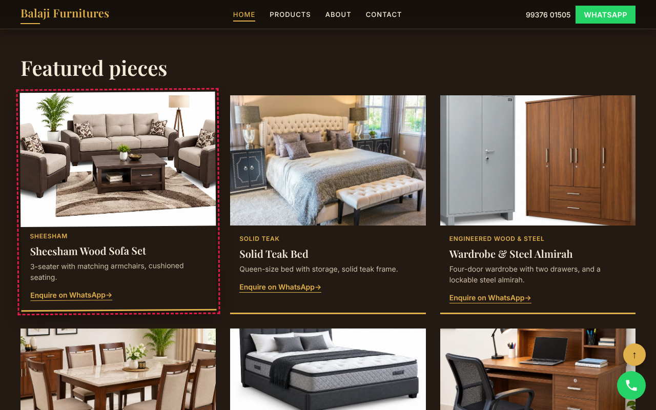
Red dashed box marks the animated element.

7. Category Card Hover Lift
Technique: CSS transition + transform
Where used / what you see: "Shop by category" tiles: lift, shadow, slow photo zoom and the name slides up.
Code location: style.css lines 556-564
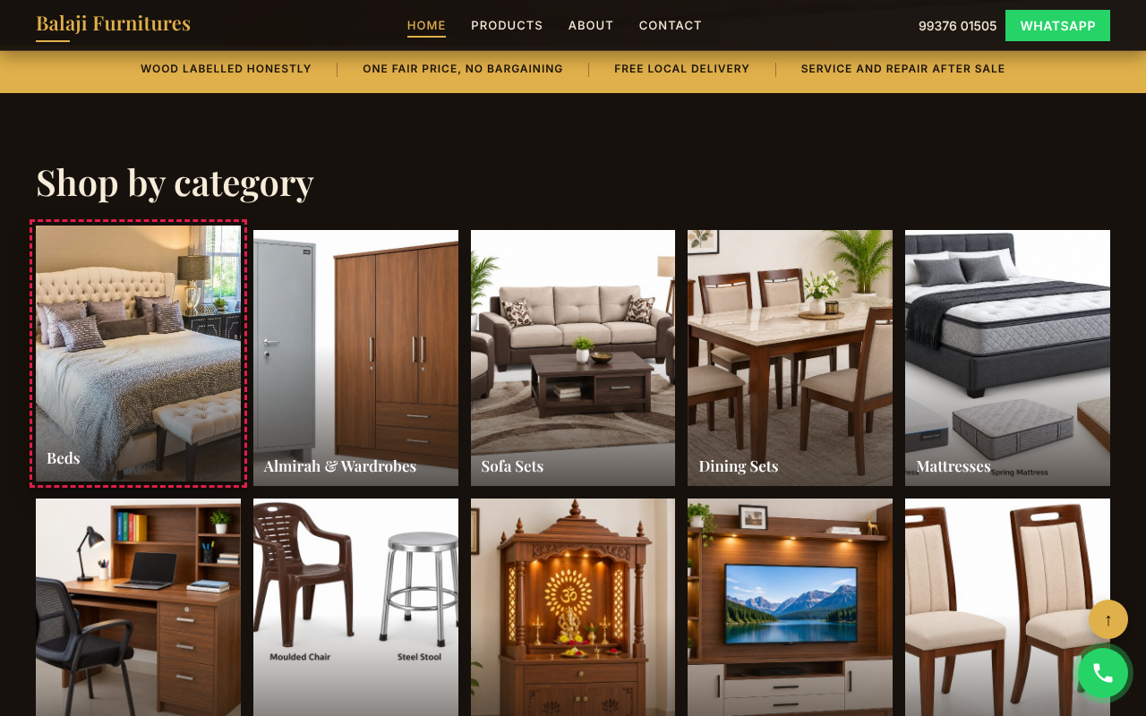
Red dashed box marks the animated element.

8. Opening Hours Row Slide + Dot
Technique: CSS transition
Where used / what you see: "Visit us" opening-hours table. Hovered row (and today's row) slides right and a gold dot pops in.
Code location: style.css lines 568-574
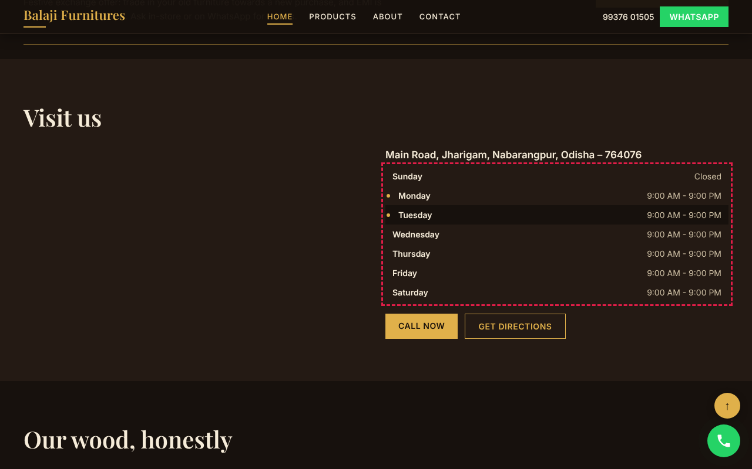
Red dashed box marks the animated element.

9. Smooth FAQ Accordion
Technique: CSS grid-template-rows transition
Where used / what you see: "Frequently asked questions" on Home and Contact pages. Answer opens/closes smoothly by height and the + / arrow sign rotates.
Code location: style.css lines 605-612; main.js line 282 onward
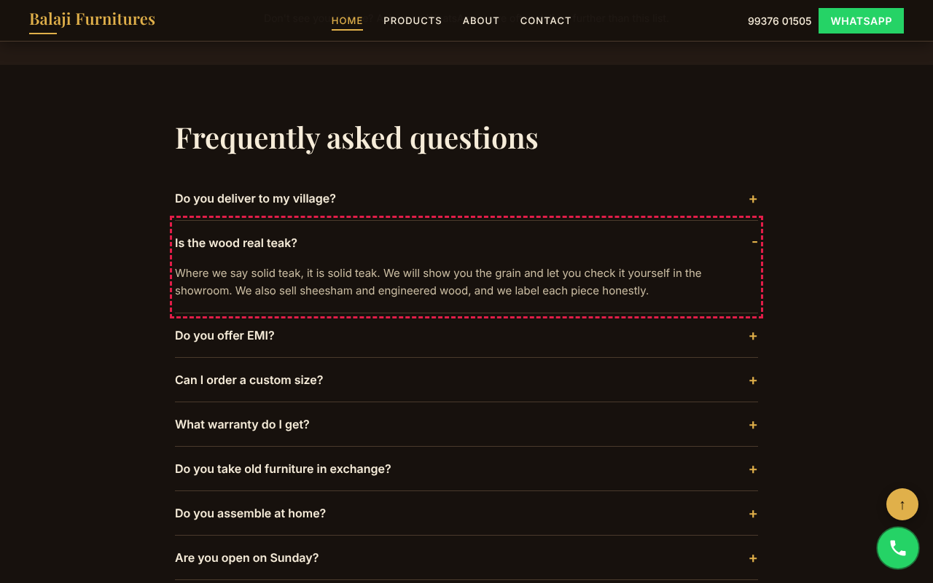
Red dashed box marks the animated element.

10. Footer Link Slide
Technique: CSS transition
Where used / what you see: Footer link lists – a hovered link slides right 8 px and turns gold.
Code location: style.css lines 575-576
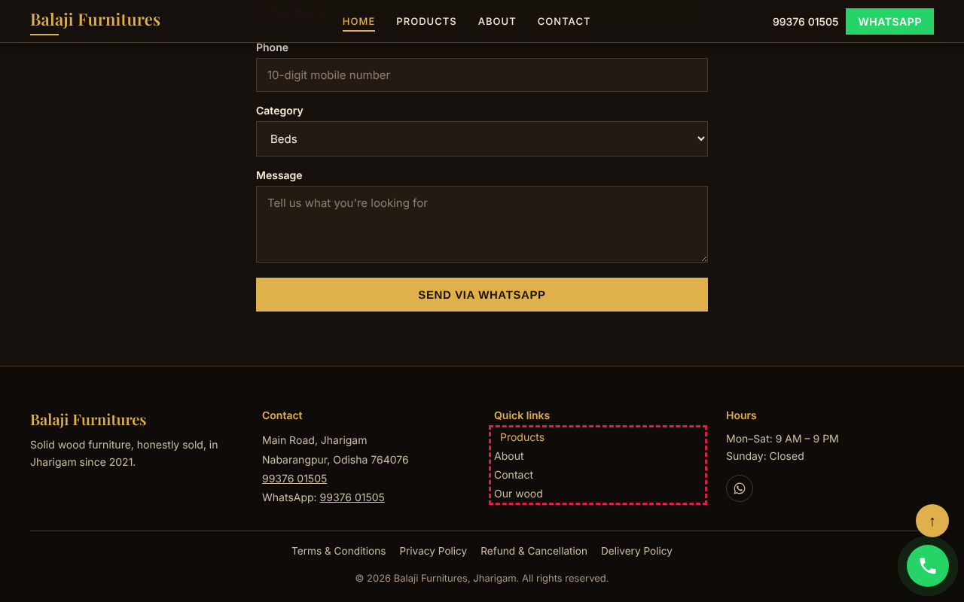
Red dashed box marks the animated element.

11. Shrinking Sticky Header + Sliding Nav Underline
Technique: CSS transition + scroll listener (main.js)
Where used / what you see: Top header on every page. After 40 px of scroll it shrinks to 56 px and gains a shadow; nav links show a gold underline that slides in on hover.
Code location: main.js lines 123-130; style.css lines 526-535

Red dashed box marks the animated element.

12. Floating Call Button Ripple + Back-to-Top
Technique: CSS @keyframes: rise-in, ripple
Where used / what you see: Green round call button (bottom-right, every page) rises in after load and sends out a soft ring every few seconds. The gold ↑ button rises in after scrolling 400 px; click scrolls smoothly to top.
Code location: style.css lines 486-487, 635-640; main.js lines 335-342
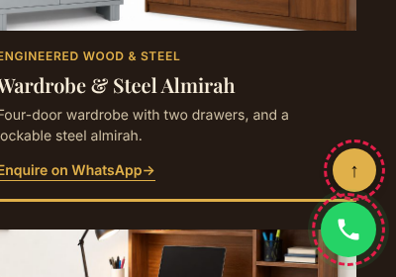
Red dashed box marks the animated element.

13. Button Hover Lift
Technique: CSS transition
Where used / what you see: All gold / ghost / WhatsApp buttons (hero buttons shown) lift slightly with a shadow on hover and press down on click.
Code location: style.css lines 538-552
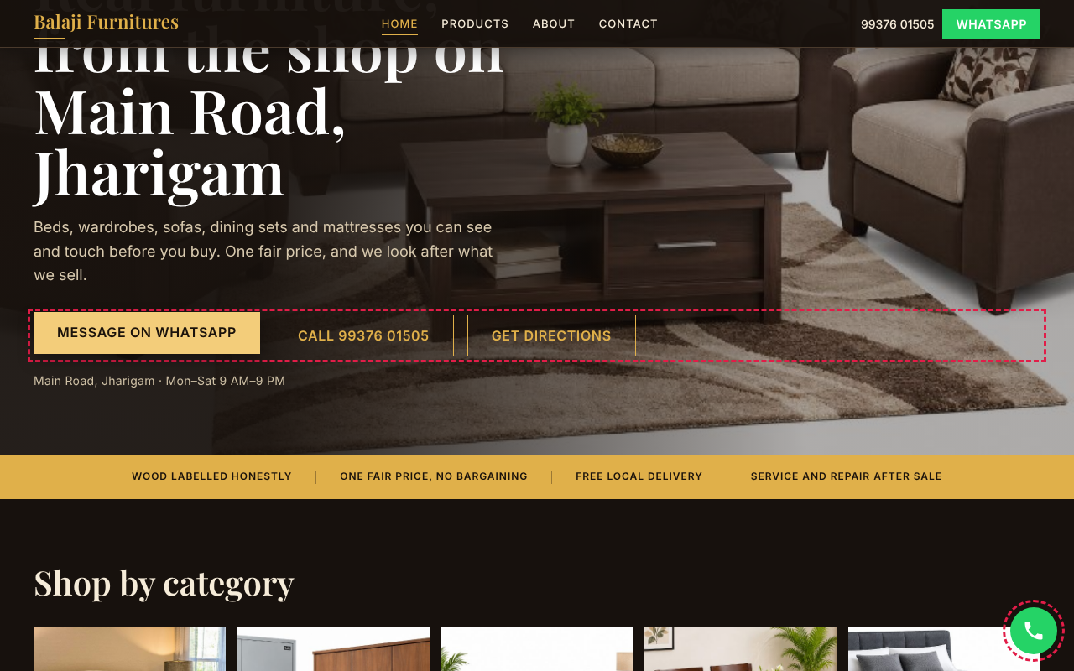
Red dashed box marks the animated element.

14. Form Shake Error
Technique: CSS @keyframes: shake, slide-in
Where used / what you see: Enquiry form (Contact page, Home page bottom). Entering a wrong phone number shakes the field with a red border and slides the error message in. The Send button shows a spinner while sending and a drawn tick when sent (@keyframes spin, draw).
Code location: style.css lines 491-494, 616-631; main.js lines 395-402
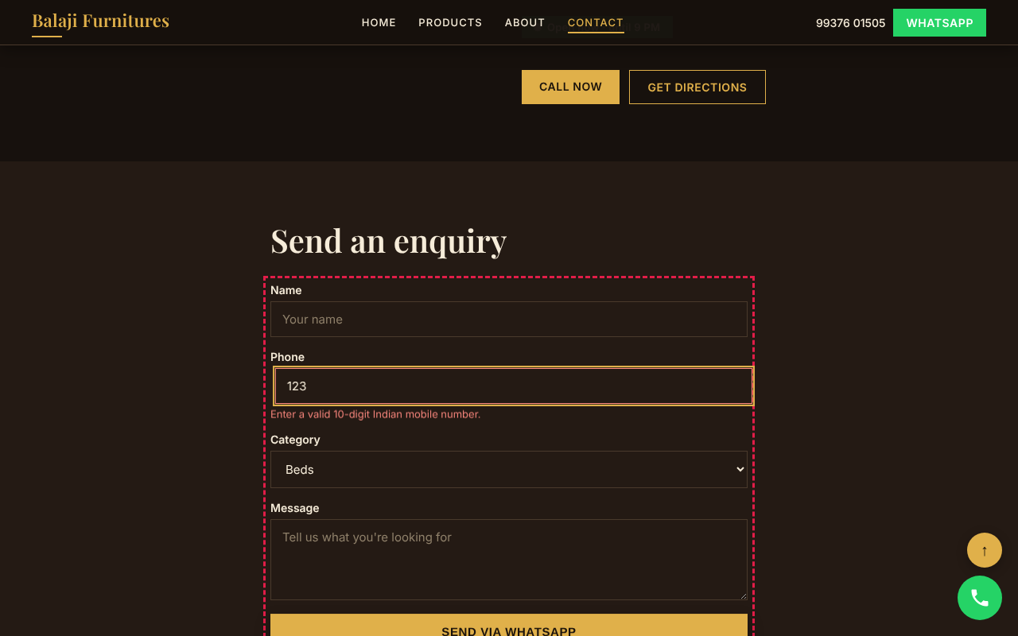
Red dashed box marks the animated element.

15. Mobile Bottom Bar Slide-Up + Ripple
Technique: CSS @keyframes: bar-rise, ripple
Where used / what you see: Phone view: CALL / WHATSAPP / DIRECTIONS bar slides up from the bottom; the WhatsApp tab pulses with a green ring.
Code location: style.css lines 486, 488, 641-642
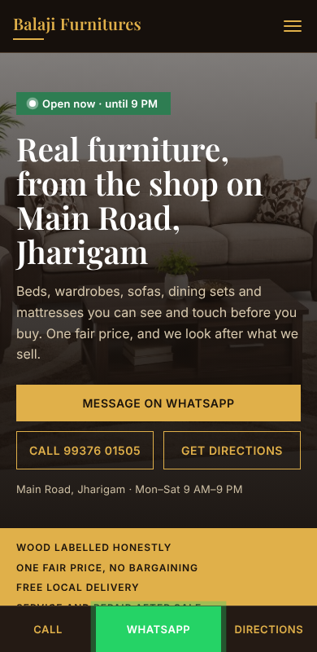
Red dashed box marks the animated element.

16. Hamburger → Cross Morph + Mobile Menu Drop
Technique: CSS transition + @keyframes: menu-drop, menu-link
Where used / what you see: Phone view menu button. Three bars morph into an X; the panel drops down and links slide in one by one.
Code location: style.css lines 489-490, 582-602; main.js lines 95-120
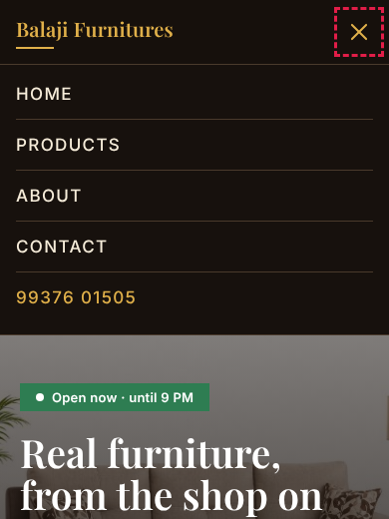
Red dashed box marks the animated element.
Note: all motion is switched off automatically for visitors who set "reduce motion" in their device (style.css line 645).

