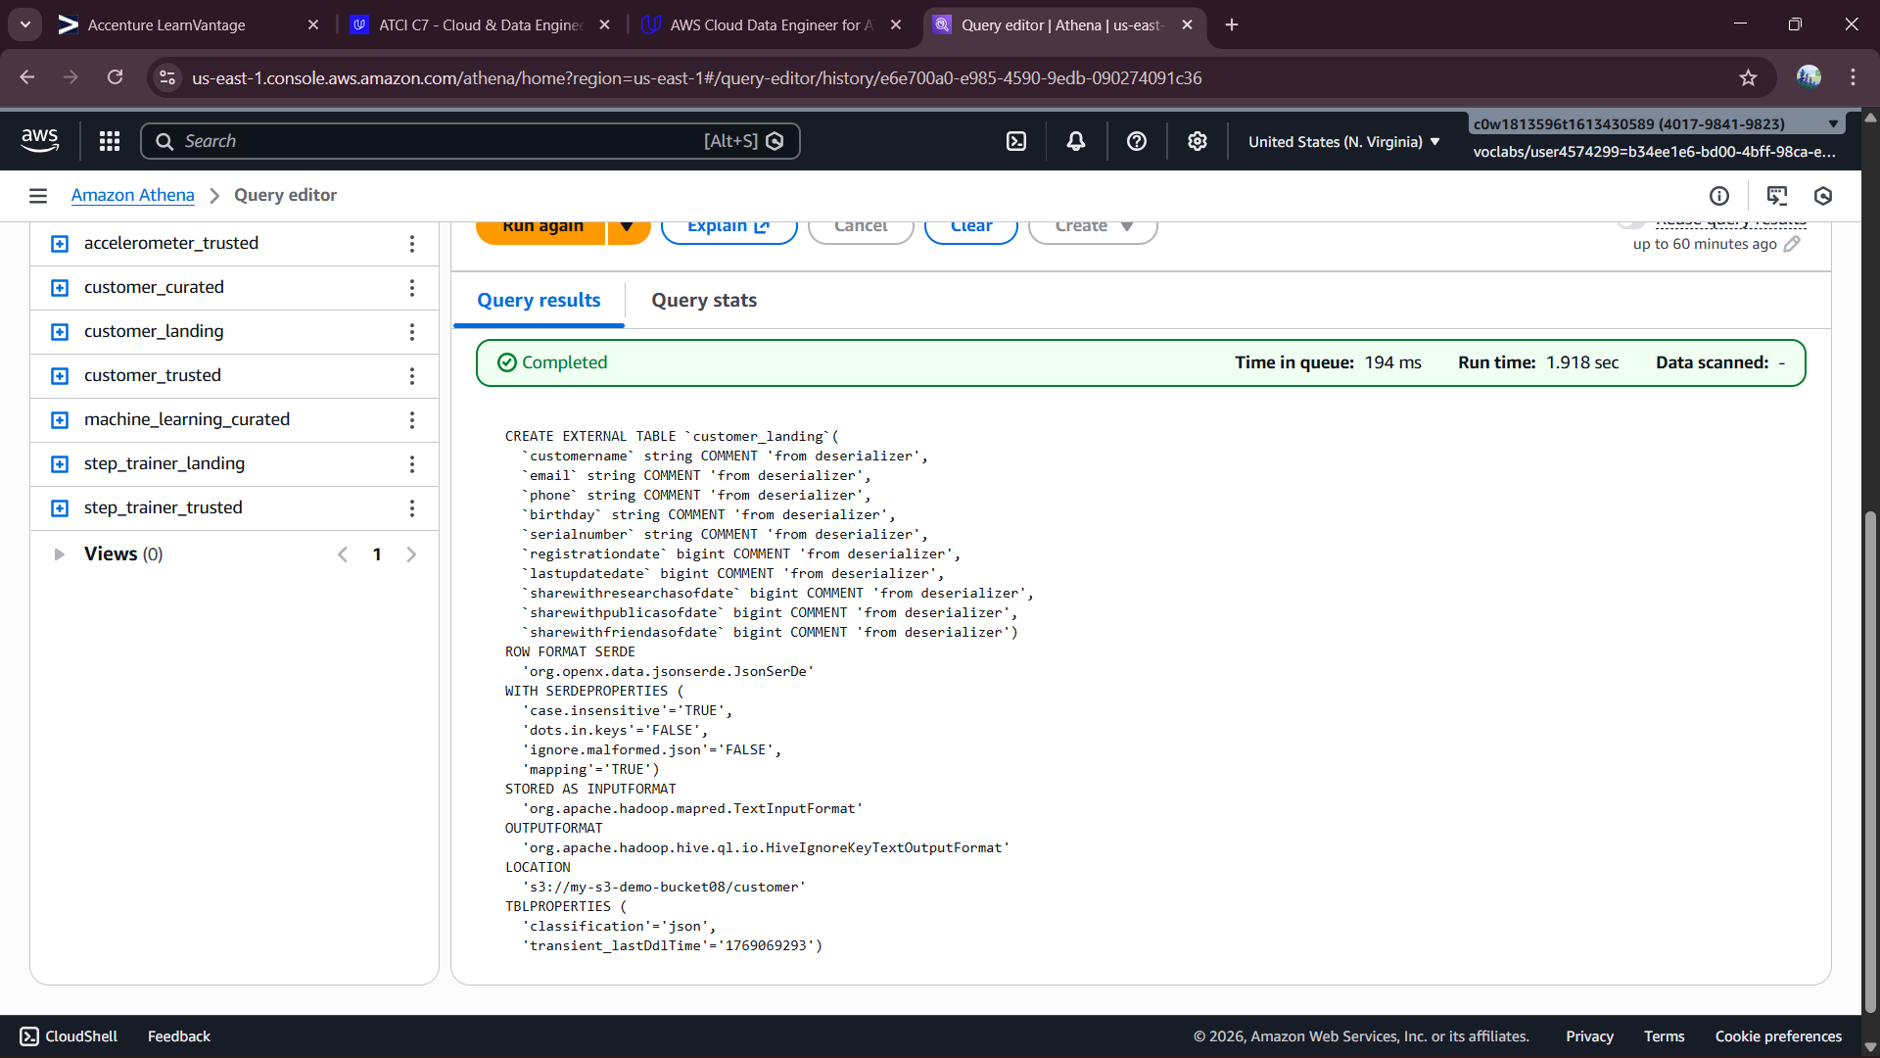
customer_landing DDL
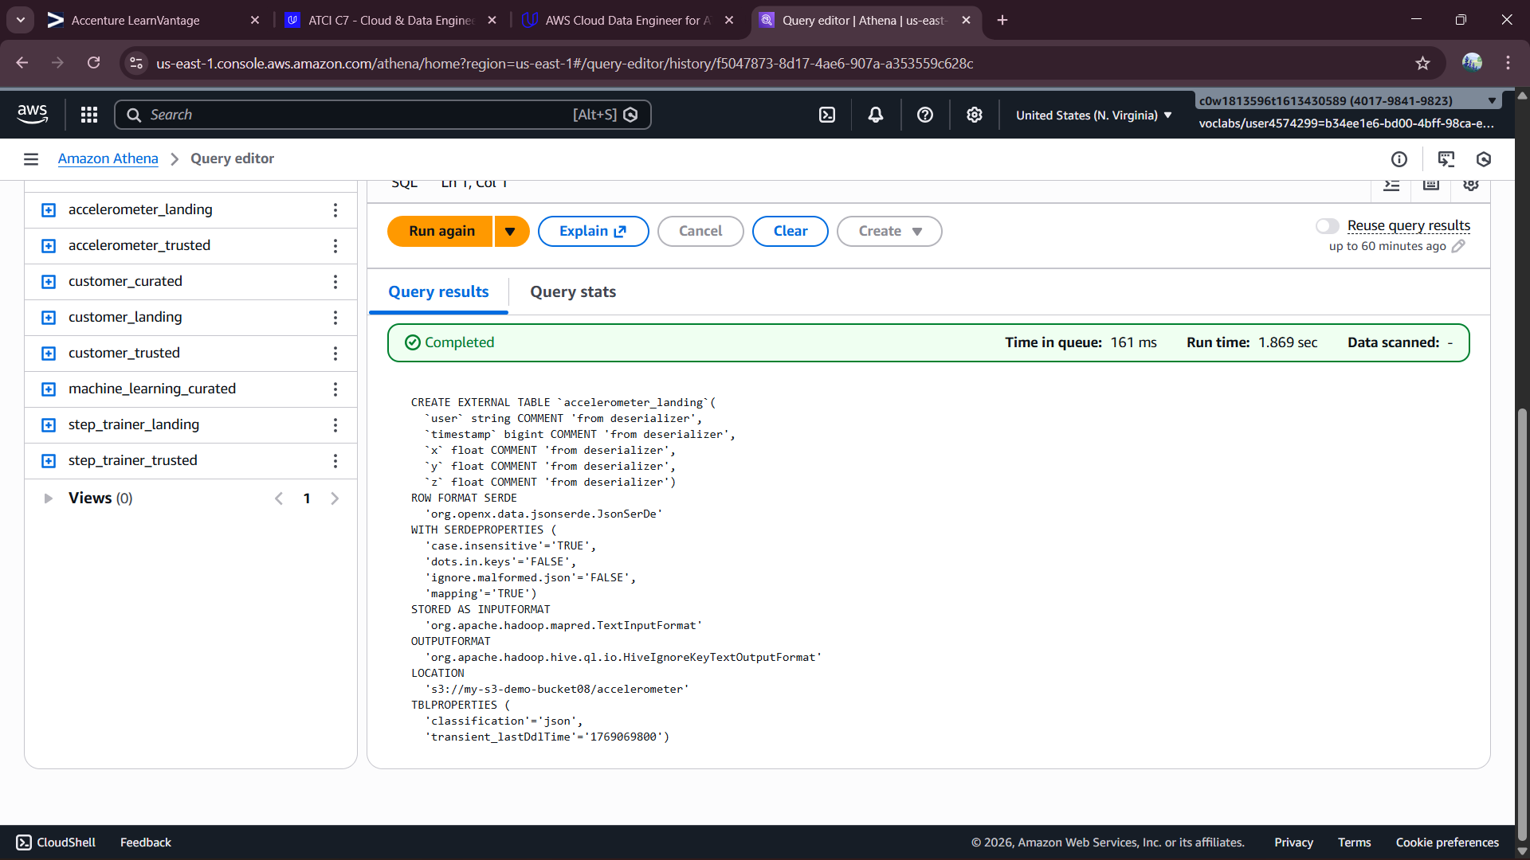
accelerometer_landing DDL
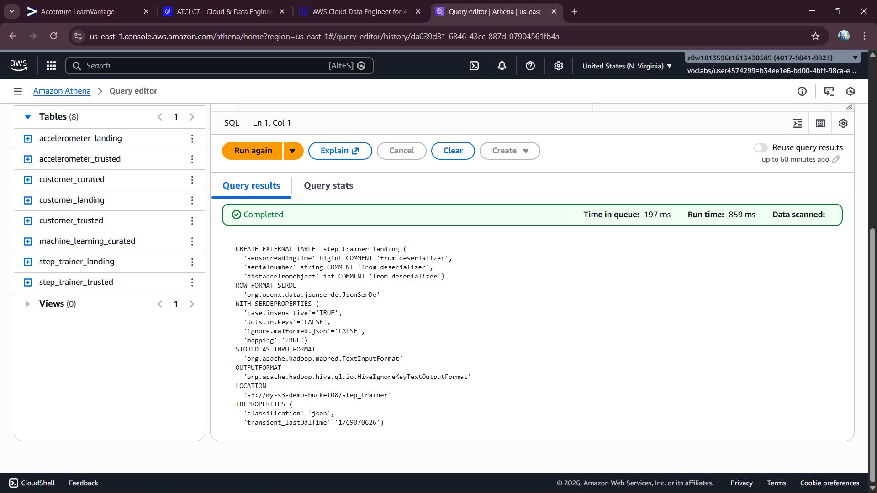
step_trainer_landing DDL

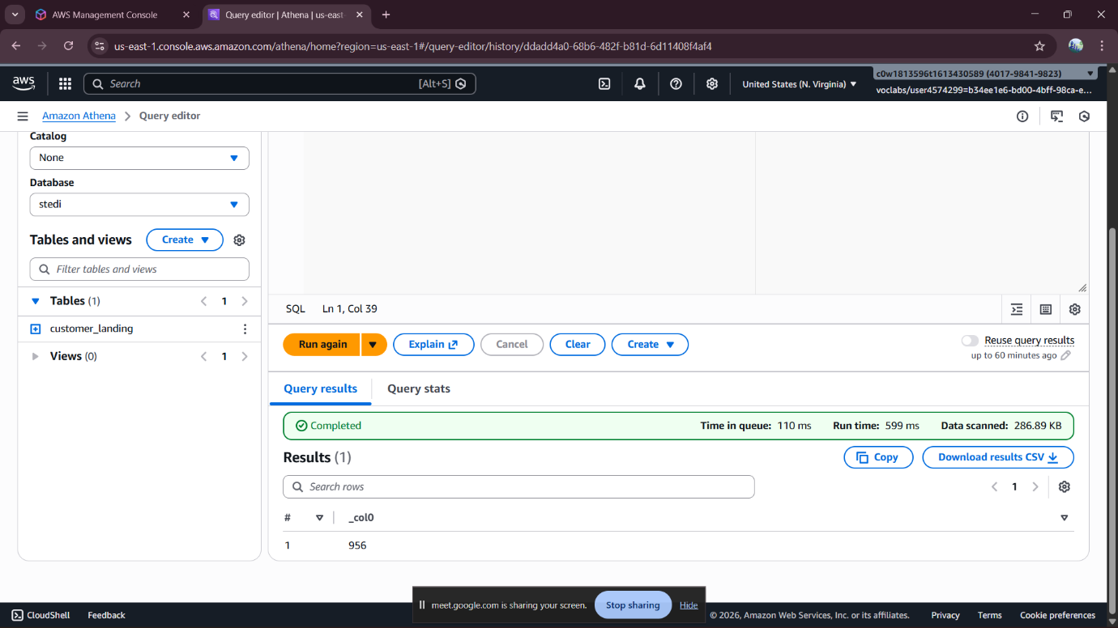
Count of customer_landing:956 rows
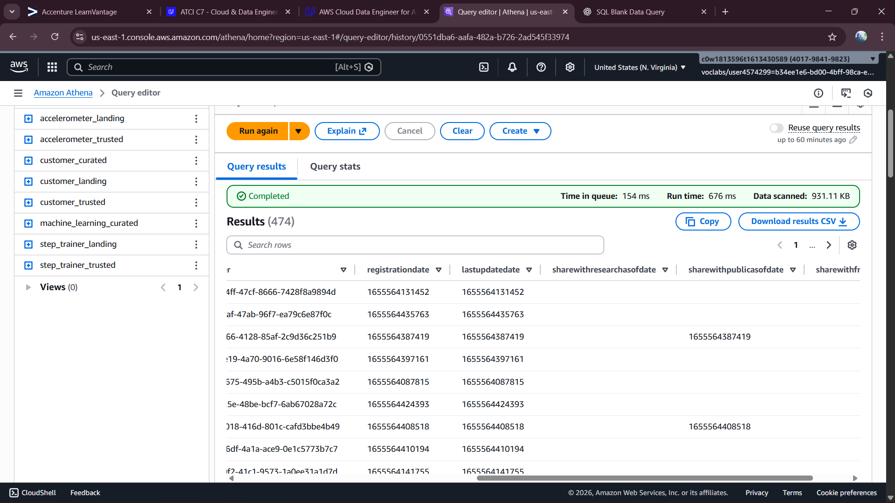
the customer_landing data contains multiple rows with a blank shareWithResearchAsOfDate.

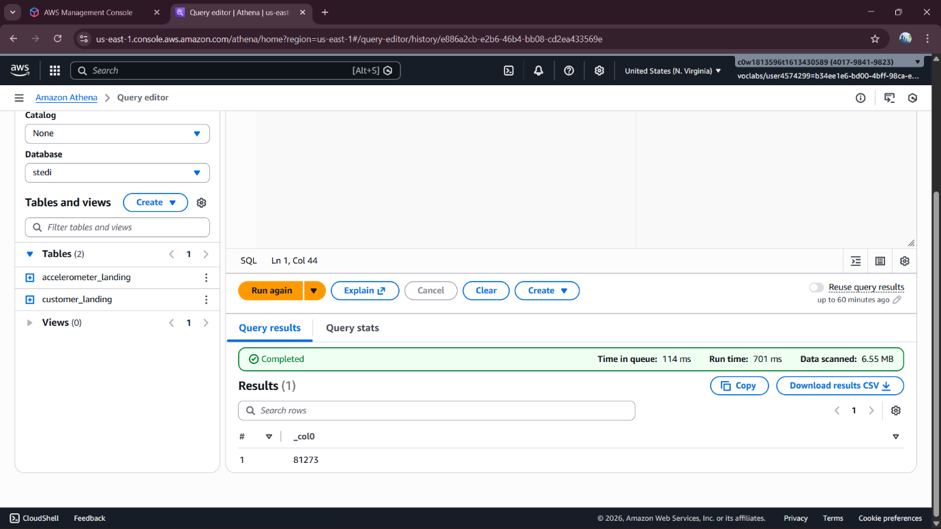Count of accelerometer_landing:81273 rows
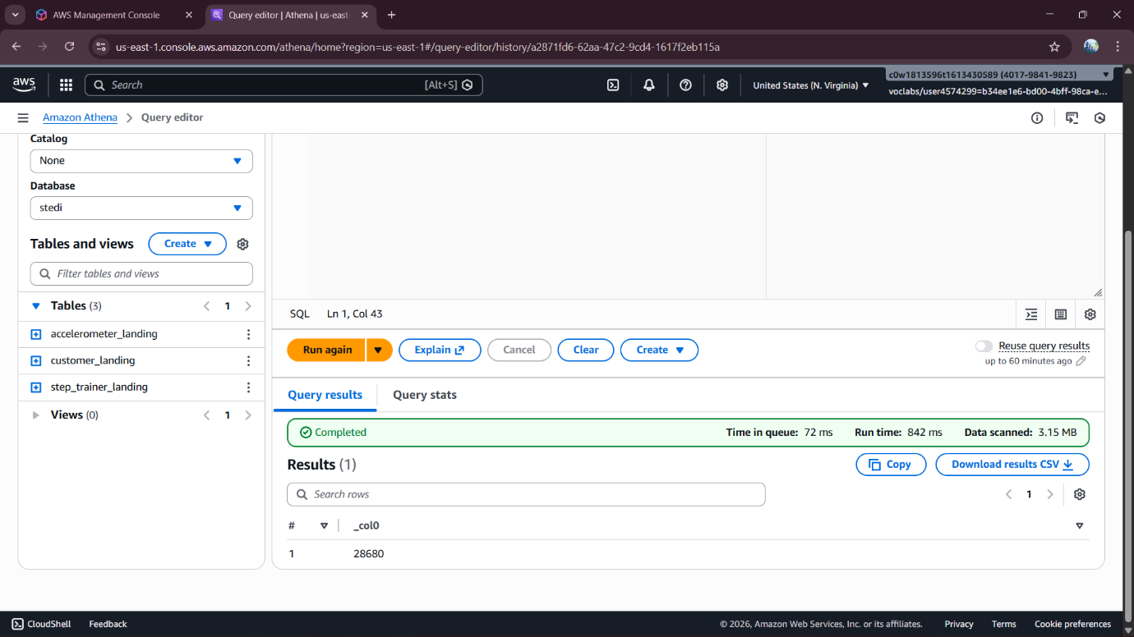
Count of step_training_landing:28680 rows

