**BAT-KL**

**Experimentation Capabilities – Documentation**

Table of Contents

CICD – Pipeline Architectural Overview 3

Flask Application Models 4

User Acceptance Testing Document 4

1. Downloading the docker image 4

2. Testing the models 5

a. Car Sales price prediction regression 5

b. Bank Note Fraud Classification 6

c. Text Sentiment Classification 7

d. Image Colorizer Model 8

# CICD – Pipeline Architectural Overview

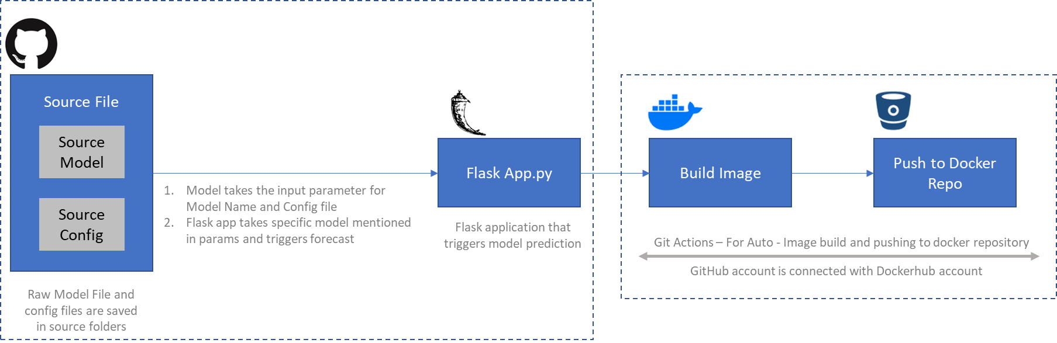

Components of Pipeline

1. GitHub Repository – Source Folders: These are the Source Model and Source Config folder which contains the model dependencies i.e. model pkl file and model configurations. Whenever user wants to push new model – they can push pkl file and config file in the Source Model and Source Config folders respectively.
2. Flask Application – Flask application that consumes the pkl file from Source Model and configurations from Source Config folder and triggers the predict function.
3. Build Image - Git Action: This is the auto build docker imager trigger for Git code. The Git Action functionality is present in the github/workflows. This workflow detects the change in the branch, and whenever any change is detected in the folder the docker image is built with a new tag.

*Detailed document on Git Workflow* - <https://docs.github.com/en/actions/managing-workflow-runs/manually-running-a-workflow>

1. Dockerhub Repository – The Dockerhub and github accounts are connected through Github secrets and Dockerhub token. Post creation of docker image it is pushed to Dockerhub account.

*Detailed document on Github and Dockerhub connection* - <https://davelms.medium.com/build-your-docker-images-automatically-when-pushing-new-code-to-github-394f4c1679cc>

*Whenever the models are added/updated in source folders there are two docker images that are pushed in Dockerhub repository – with a ‘run number’ tag and with a ‘latest’ tag

# Flask Application Models

|  |  |  |  |
| --- | --- | --- | --- |
| Input Format | Model Name | Config File | Vars / Input |
| value | model_car_sale_price_prediction_regression.pkl | config_car_sale_price_prediction_regression.csv | *Vars as mentioned in config file* |
| model_iris_classification.pkl | config_iris_classification.csv | *Vars as mentioned in config file* |
| file | model_banknote_auth.pkl | NA | *file : csv file input* |
| text | model_sentiment_nlp_model.pkl | NA | *text : string input* |
| image | colorization_release_v2.caffemodel  colorization_deploy_v2.prototxt  pts_in_hull.npy | NA | *image : jpg file input* |

# Flask Application Models – Scope

|  |  |  |
| --- | --- | --- |
| Input Format | Scope | Params Required |
| value | **Input Scope:** Single data instance – input as a single value  **Model Scope** – Scikit-learn models – linear_models, svc, naïve_bayes, knn, decision tree, random_forest, xgboost, gbm, ensemble models etc. | * Input format * Model file * Config file * Variables in config file |
| file | **Input Scope**: Multi data instance – input as a csv file with headers  **Model Scope** – Scikit-learn models – linear_models, svc, naïve_bayes, knn, decision tree, random_forest, xgboost, gbm, ensemble models etc. | * Input format * Model file * Data in CSV format |
| text | **Input Scope:** Single data instance – input as a single text string  **Model Scope** – Sentiment Models (NLTK – library base) | * Input format * Model File * Text string |
| image | **Input Scope**: Single data instance – input as a single image  **Model Scope** – Image (Open CV2 – library base) | * Input format * Model File (prototxt, caffemodel,npy) * Image |

# 

# User Acceptance Testing Document

## Downloading the docker image

Download the docker image of the required version from Dockerhub website. The docker images can be found in ***seah101/model_v1*** (private Repository) <https://hub.docker.com/repository/docker/seah101/model_v1/tags?page=1&ordering=last_updated>

Docker image download command:

docker pull seah101/model_v1:<tag name>

Docker image run command:

docker run -it -p 5000:5000 seah101/model_v1:<tag name>

*Github Repository -* [*https://github.com/PrezSeah/modelapi/tree/Docker_Experiment_v4*](https://github.com/PrezSeah/modelapi/tree/Docker_Experiment_v4)

## Testing the models

### Car Sales price prediction regression

**Testing through postman:**

Input through form-data:

|  |  |
| --- | --- |
| **Key** | **Value** |
| input_format | value |
| model | model_car_sale_price_prediction_regression |
| config | config_regression |
| mileage | 1234 |
| age | 19 |

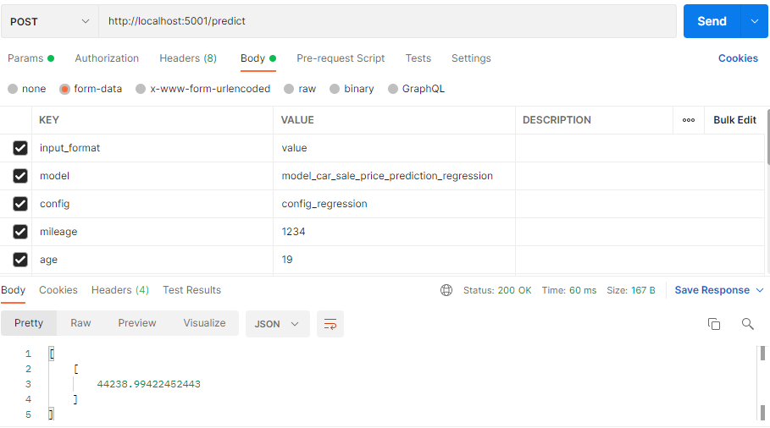Output:

**Testing through curl command:**

curl <http://127.0.0.1:5001/predict> -d "model=model_car_sale_price_prediction_regression&config=config_regression&input_format=value&mileage=1234&age=11"



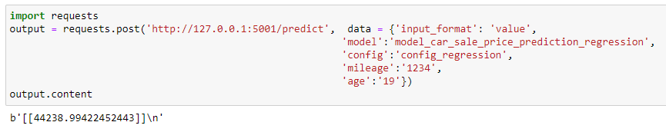**Testing through python:**

### Bank Note Fraud Classification

**Testing through postman:**

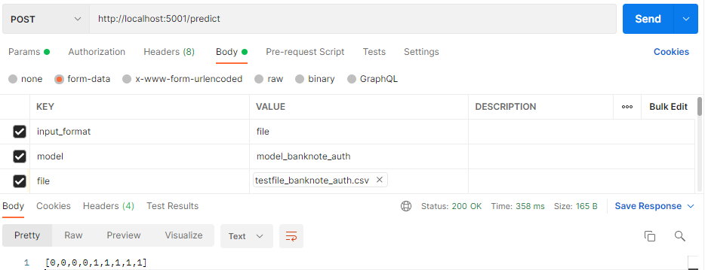Input through form-data:

|  |  |
| --- | --- |
| **Key** | **Value** |
| input_format | file |
| model | model_banknote_auth |
| file | <*testfile_banknote_auth*> |

**Testing through curl command:**

curl <http://127.0.0.1:5001/predict> -F input_format=file -F model=model_banknote_auth -F [file=@testfile_banknote_auth.csv](mailto:file=@testfile_banknote_auth.csv)

* In case of space in filename or location – input the file location within double quotations – (“ “)



**Testing through python:**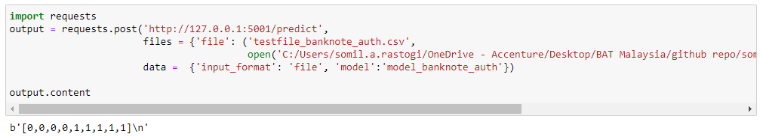

### Text Sentiment Classification

**Testing through postman:**

Input through form-data:

|  |  |
| --- | --- |
| **Key** | **Value** |
| input_format | text |
| model | model_sentiment_nlp_model |
| text | <*text*> |

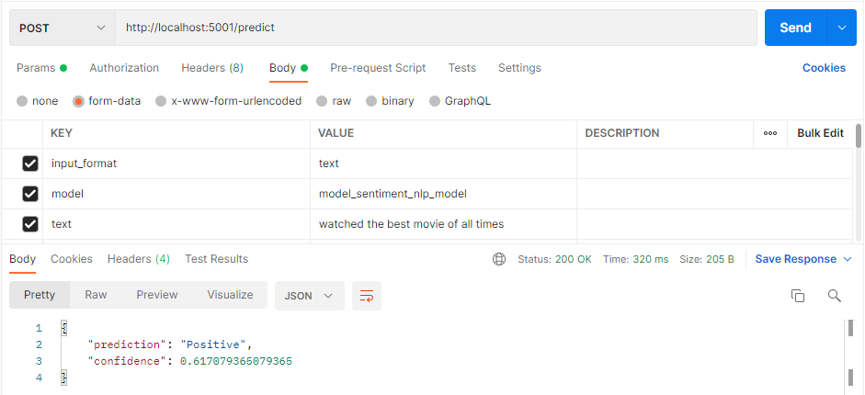

**Testing through curl command:**

curl <http://127.0.0.1:5001/predict> -d "model=model_sentiment_nlp_model&input_format=text&text=watched the best movie of all times"



**Testing through python:**

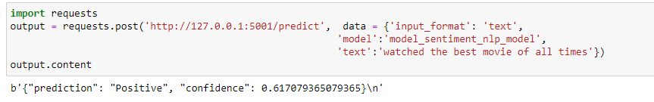

### Image Colorizer Model

**Testing through postman:**

Input through form-data:

|  |  |
| --- | --- |
| **Key** | **Value** |
| input_format | image |
| prototxt | colorization_deploy_v2.prototxt |
| caffemodel | colorization_release_v2.caffemodel |
| npy | pts_in_hull.npy |
| Image | <*image*> |

*The model files are uploaded in shared folder (due to file size limitation in github) - <https://bat.sharepoint.com/:f:/r/sites/DatascienceEngineering/Shared%20Documents/General/Pre_Trained_Models/Docker%20Experiment/source_model?csf=1&web=1&e=ZPHRbO>

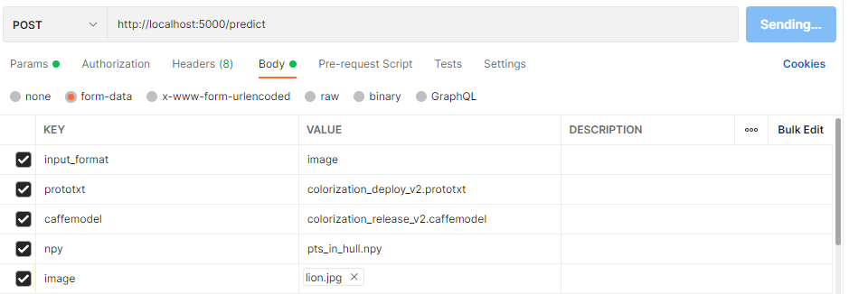

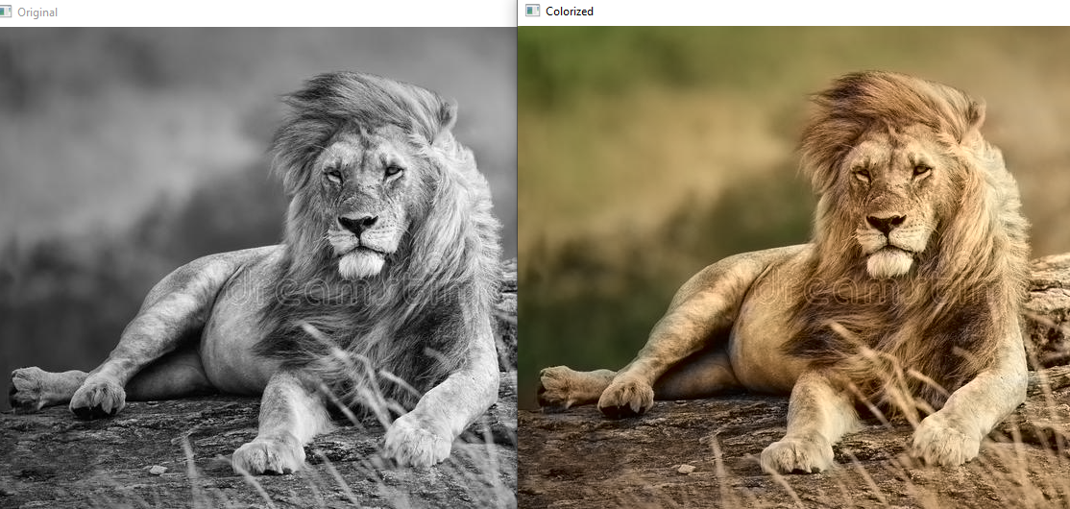

**Testing through curl command:**

curl <http://127.0.0.1:5001/predict> -F input_format=image -F prototxt=colorization_deploy_v2.prototxt -F caffemodel=colorization_release_v2.caffemodel -F npy=pts_in_hull.npy -F [image=@lion.jpg](mailto:image=@lion.jpg)



**Testing through python:**

