Professional High Level Design (HLD) - E‑Commerce Application

1. System Overview
This document describes the High Level Design for a scalable E‑Commerce platform built using Next.js as the frontend framework and Node.js as the backend service.

2. Architecture Diagram
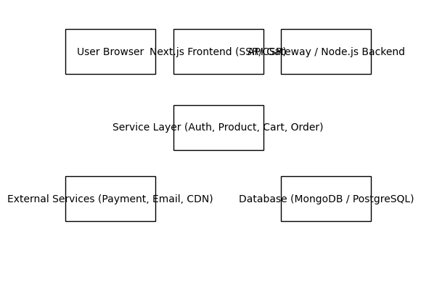

3. Request Flow
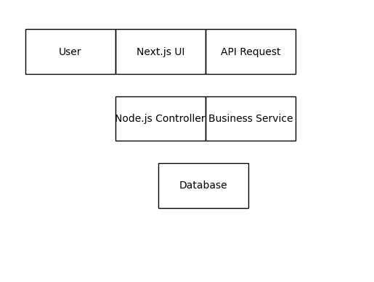

4. Deployment Architecture
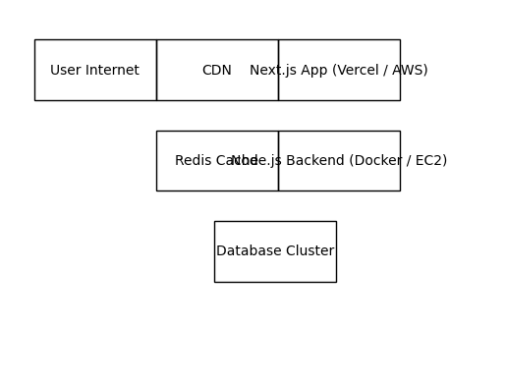

5. Core Modules
Authentication (Login, Register, JWT)
Product Catalog and Search
Cart Management
Order Management
Payment Processing
Admin Management Dashboard

6. Technology Stack
Frontend: Next.js, React, TypeScript, Redux Toolkit
Backend: Node.js, Express.js
Database: MongoDB / PostgreSQL
Caching: Redis
Infrastructure: Docker, AWS, CDN

7. Security Considerations
JWT authentication, HTTPS, rate limiting, input validation, secure payment gateway integration.

8. Scalability Strategy
Horizontal scaling of backend services, CDN caching for static assets, Redis for session and cache management.

