**Name: Shiva Shankar Ganesan UB ID: 1056083 Email ID: sganesan@my.bridgeport.edu**

**Mini Program Assignment: IPC using message queue**

sender.c is the program which sends "Hi!" "Hello" "How are you" through message queue.

receiver.c program receives that message queue and prints the message

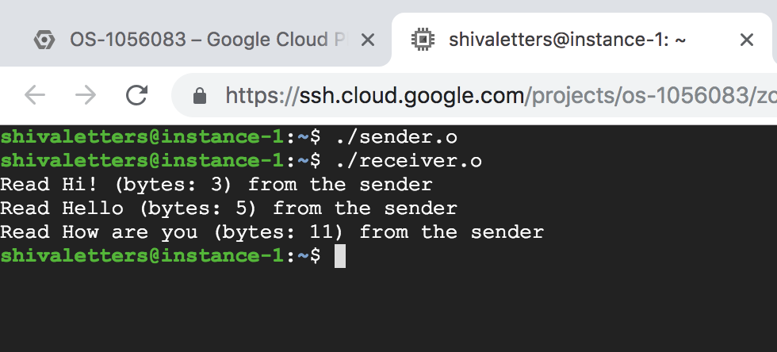

/dev/mqueue lists the all the message queues. After the exeuction of sender.o, our message queue 'msgq' is created. This can be verified by using /dev/mqueue command

Details of the queue can be viewed using cat /dev/mqueue/msg . QSIZE is the total number of bytes in the queue.

