Project Proposal

On

**GAME MANAGEMENT SYSTEM**



**SHIVA SUBEDI**

**NCC ID: 00163032**

**Computing Project**

**Level 5 Diploma in Computing**

**Softwarica College of IT and E-Commerce**

**Kathmandu, Nepal**

**<<4, Jan, 2019>>**

Submitted to: Kiran Rana

Table of Contents

1. Introduction 3

1.1 Introduction 3

1.2 Justification for project 3

1.3 Description of the project 3

2. Project Scope 4

2.1 Scope and Limitation of project 4

2.2 Aims and Objective 4

Objectives 4

3. Development Methodology 5

3.1 Waterfall model 5

3.2 Design Pattern 6

3.3 System Architecture 7

Three Tier Architecture 7

4. Work Breakdown Structure (WBS) / Scheduling 8

4.1 Work Breakdown Structure 8

4.2 Milestones 9

4.3 Scheduling 11

4.4 Gantt Chart 11

5. Risk Management 12

6. Configuration Management 14

7. Conclusion 15

8. References 15

**List of figures**

Figure 1 <<waterfall model>>…………………………………………………….....5

Figure 2 <<MVC design pattern>>……………………………………………..…...6

Figure 3 << three tier architecture >>………………………………………………..7

Figure 4 << WBS>>…………………………………………………………………..8

Figure 5 <<Milestones>>…………………………………………………………..9

Figure 6 << Time Estimation >>……………………………………………………...10

Figure 7 << Schedule>>……………………………………………………………..11

Figure 8 << Gantt chart >>…………………………………………………………..11

Figure 9 <<Risk table >>…………………………………………………………...12

Figure 10 << Git push location >>…………………………………………………...14

Figure 10 << Directory structure >>…………………………………………………14

# 1. Introduction

## 1.1 Introduction

Gaming Event Management System is a tool that handles all the work of the gaming tournament. It helps to organize the gaming tournament easily and properly and stores the details about all the participating team members & their groups. It handles and maintains the scheduling system for games. It also generates the game winner results as report print.

## 1.2 Justification for project

Game management has done a lot of work to automate the tasks, this system can be very user-friendly tool. This android application makes game planning and scheduling more easily that helps to organize game sequels.

Game Management System is a three tier base application which will be developed using **Android** **as MVC design pattern,** this system will be developed using **ANDROID STUDIO** because it will be easier to manage **FIREBASE DATABASE** and it is easily accessible by the help of internet. Open source android development tools manage interface & data servers to control the accessible credits. Android SDK provides the tools and APIs necessary to begin developing applications on the Android platform using the Java programming language.

#### 1.2.1 Background of the project

Users can self register themselves in the system and can participate in the game tournament. There will be limits on number of participants in a single tournament. After that, the system collects data to make game planning and schedule game timetable. This system will also store the gaming details in the cloud database to collect information; the cloud backup provides more protective database system and also generates the output prints of each game tournament.

#### 1.2.2 Problem Statement

This system helps to manage the gaming tournament in an efficient way by doing a proper scheduling of the tournament. This helps to organize the tournament successfully without any disturbance or problem. It also helps to declare upcoming tournament as sustainable chart, each user is easily connected to the server through their devices and individual user gets easy access to their credentials. This project will access database as well as development of the entire application with help of android development tools and research the necessary information as well as build a proper application for a tournament purpose.

### 

### 1.3 Description of the project

#### 1.3.1 Feature of the project is as follows:

* Admin can add new tournament.
  + User could get new access on each game
* Admin can update the tournament details.
  + If game schedule change admin change details also user get easily notification
* Admin can schedule the tournament.
  + Admin know about all tournament on each individual game date time
* Admin manages payment details.
  + No privacy access to every user about financial statement
* Admin edit, update, and delete game information
  + If any game has been cancel admin easily update throw the system
* Users can create their profile by signing up member
  + Enter their name user id its give uniqueness on each user
* Users can login to the website
  + Using their email or username they easily get access on game tournament
* Users can participate in the tournament
  + Each user get access on one tournament on one time
* Users can see the tournaments details
  + User know about their coming game details
* Users can update their account details
  + User update their profile password user details
* User view their score and leader board
  + User get their total score total game on their profile
* User pays their game payment throw online
  + Secure payment system available for each user

## 2. Project Scope

## 2.1 Scope and Limitation of project

The users won’t be able to pay online while participating in the tournament. This system won’t be able manage all the gaming tournaments. This system will be designed to manage few gaming tournaments. To manage more gaming tournaments, it requires

Lots of work and, it requires a lot of time and commitment. But, it can be managed in the coming future.

### 2.2 Aims and Objective

**Aims**

* To help organizers to organize a gaming tournament successfully.
* View the game result by the help of cloud servers.
* Payments done on the tournament are more securely regulated.
* Gives manageable platforms to operate game tournament events.
* Easily accessible on any android devices.
* To create a more user-friendly digital environment.

Objectives

* To perform better analysis of the system.
* To perform better design.
* To perform better coding.
* To perform different tests to find and solve the flaws in the system.
* To deploy the working system.

## 3. Development Methodology

### 3.1 Waterfall model

It is a development methodology which develops the software in a step by step procedure. It is a simple method and easy-to-use. Each stage is completed one at a time and it is also suitable for small projects. There are different phases in this model which are shown below:

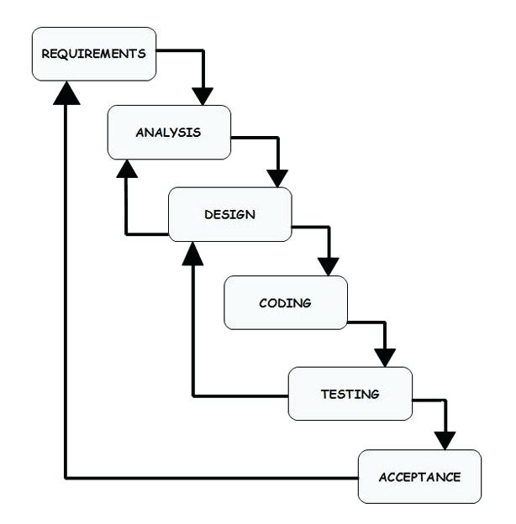

Fig: waterfall model

This methodology is chosen because of the following reasons:

* It is easy to understand and use.
* It is suitable for small projects.

**Advantages of Waterfall model:**

* It is simple to understand and easy to use.
* Costs can be estimated clearly.
* It is suitable for small projects.
* Testing process is easier and more transparent.

**Disadvantages of Waterfall model:**

* Requirements are not clearly defined.
* There will be lack of flexibility in the system.
* Delivery time could take longer that estimated time.
* No open discussion of problem

### 3.2 Design Pattern

Model View Controller (MVC) design pattern.

**Model** - The model handles the business logic.

**View** – It handles the re-representation of the elements in the user interface.

**Controller** - It allows user to interact with the model. It acts as interface between the model and the view components to process all the business logic and incoming requests. It provides the ability to manipulate the system.

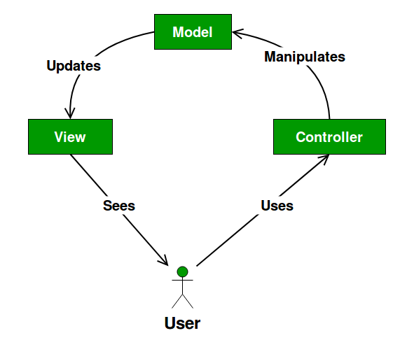

Fig: MVC design pattern

**Advantages of MVC design pattern:**

* MVC helps to develop an application in rapid way. It supports parallel development. A programmer can work on view and controller simultaneously.
* This makes development faster.
* There is less chance of code duplication because it separates data and business logic from the display.
* It also supports asynchronous technique, which helps developers to develop an application that loads very fast.
* Modification does not affect the entire model as model part does not depend on the view parts.

**Disadvantages of MVC design pattern:**

* Because there are three layers in this MVC pattern, it can increase the complexity.
* Developers must have knowledge on multiple technologies.
* There is lack of efficiency of data access in view layer.
* This may need multiple programmers.

### 3.3 System Architecture

## Three Tier Architecture

Three tier Architecture is a pattern used for a completely different reason. It separates the entire application into meaningful design groups UI, Business Logic, & Data storage servers. So, three tier applications refer to all the related code in the application, MVC pattern is a pattern used in the UI tier as view controller.

* Scalability: each tier can scale horizontally. For example, you can load-balance the Presentation tier among three servers to satisfy more Web requests without adding servers to the Application and Data tiers.
* Performance: because the Presentation tier can cache requests, network utilization is minimized, and the load is reduced on the Application and Data tier model controllers. If needed, you can load-balance any tier.
* Availability: If the Application tier server is down and caching is sufficient, the Presentation tier can process Web requests using the cache to collect data resources.

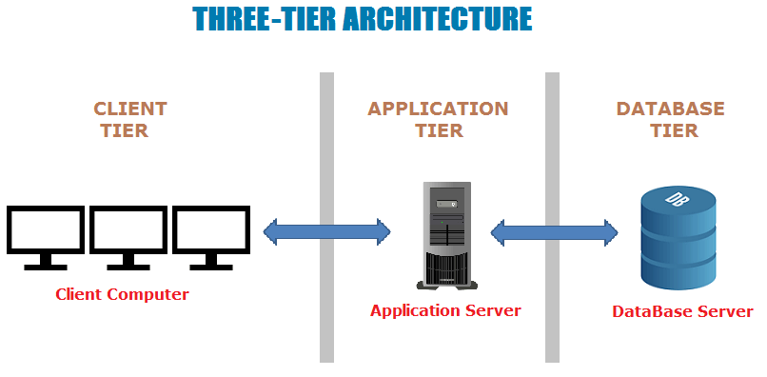

Fig: three tier architecture

## 4. Work Breakdown Structure (WBS) / Scheduling

### 4.1 Work Breakdown Structure

It means the process of dividing the whole project into small pieces of task. It is done to remove the complexity in the project and to manage the project easily. It is represented as a hierarchical subdivision of a project into work areas with the lowest generally being a work package or sometimes even an activity. The WBS provides a foundation for all the project management work including planning, cost and effort estimation, resource allocation, and scheduling. The broke down of the project is shown below:

* **Project Management**: Scoping, planning, monitoring & controlling will be done in this part.
* **Analysis:** Requirements use cases and architecture that are done in analysis part.
* **Design:** Structural model, behavior model and UI design will be done in design part.
* **Implementation:** Building database and coding will be done in implementation part.
* **Testing:** Unit testing and integration testing will be done in testing part
* **Deployment:** User manual and final report will be done in this part.

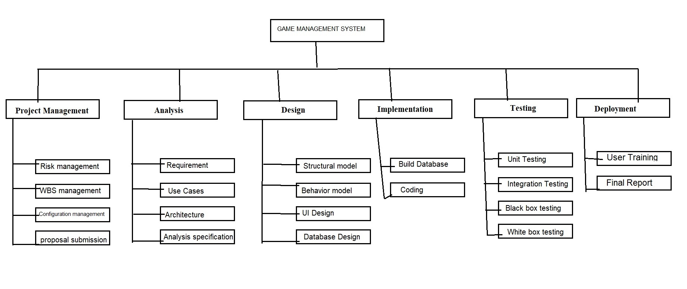

Fig: WBS of Game management system

### 4.2 Milestones

|  |  |  |  |
| --- | --- | --- | --- |
| **Milestones** | **Start Date** | **End Date** | **Total days(124)** |
| **Project Management**  Risk Management  WBS  Configuration Management  Proposal Submission | 12/21/2018  12/21/2018  01/26/2018  01/01/2019  01/05/2019 | 01/08/2019  12/25/2018  12/31/2018  01/04/2019  01/08/2019 | 19  5  6  4  4 |
| **Analysis**  Requirement analysis  Use Case  Architecture  Analysis specification | 01/09/2019  01/09/2019  01/16/2019  01/22/2019  01/30/2019 | 02/02/2019  01/15/2019  01/21/2019  01/29/2019  02/02/2019 | 25  7  6  8  4 |
| **Design**  Structural Diagram  Behavioral Diagram  UI Design  Database Design | 02/03/2019  02/03/2019  02/08/2019  02/15/2019  02/22/2019 | 02/27/2019  02/07/2019  02/14/2019  02/21/2019  02/27/2019 | 25  5  7  7  6 |
| **Implementation**  Building Database  Coding | 02/28/2019  02/28/2019  03/05/2019 | 03/24/2019  03/04/2019  03/24/2019 | 25  5  20 |
| **Testing**  Unit Testing  Integration Testing  Black box Testing  White box Testing | 03/25/2019  03/25/2019  03/30/2019  04/04/2019  04/09/2019 | 04/13/2019  03/29/2019  04/03/2019  04/08/2019  04/13/2019 | 20  5  5  5  5 |
| **Deployment**  User Training  Final Report | 04/14/2019  04/14/2019  04/19/2019 | 04/23/2019  04/18/2019  04/23/2019 | 10  5  5 |

**Fig: Milestones table**

#### Description of Milestones:

For Game management system, I have estimated 124 days in total. For project management 19 days, for analysis 25 days, for design 25 days, for implementation 25 days, for testing 20 days, and for Reporting 10 days. Each activities of the project are estimated which are shown below:

|  |  |  |
| --- | --- | --- |
| **No.** | **Task Name** | **Days** |
| **1** | **Project Management** | **19** |
| 1.1 | Risk management | 5 |
| 1.2 | WBS management | 6 |
| 1.3 | Configuration management | 4 |
| 1.4 | proposal submission | 4 |
| **2** | **Analysis** | **25** |
| 2.1 | Requirement | 7 |
| 2.2 | Use Cases | 6 |
| 2.3 | Architecture | 8 |
| 2.4 | Analysis specification | 4 |
| **3** | **Design** | **25** |
| 3.1 | Structural model | 5 |
| 3.2 | Behavior model | 7 |
| 3.3 | UI Design | 7 |
| 3.4 | Database Design | 6 |
| **4** | **Implementation** | **25** |
| 4.1 | Build Database | 5 |
| 4.2 | Coding | 20 |
| **5** | **Testing** | **20** |
| 5.1 | Unit Testing | 5 |
| 5.2 | Integration Testing | 5 |
| 5.3 | Black box testing | 5 |
| 5.4 | White box testing | 5 |
| 6 | **Deployment** | **10** |
| 6.1 | User Training | 5 |
| 6.2 | Final Report | 5 |

Fig: Time Estimation Table

### 4.3 Scheduling

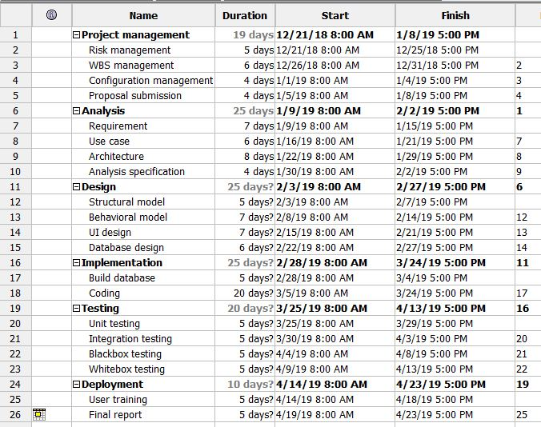

Fig: Schedule

### 4.4 Gantt Chart

The Gantt chart is shown below: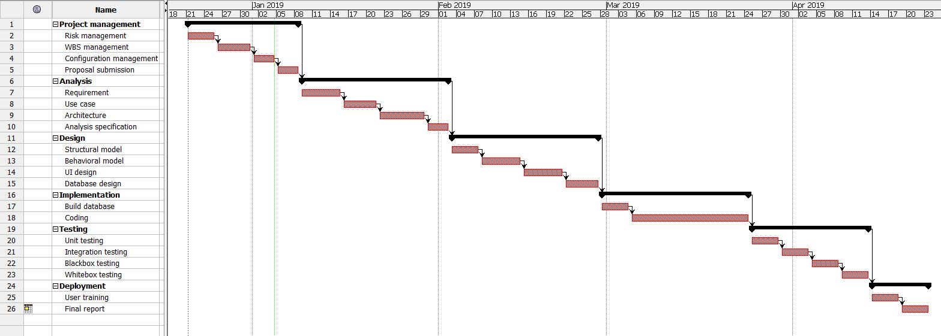

Fig: Gantt chart

## 5. Risk Management

Risk management means the process of identifying the potential risk in advance, analyzing them and taking precautionary steps to minimize the risk.

We need to do risk management plan, it helps to minimize the unexpected risks and extra costs before they happen. By doing the risk management task, we can save extra money and protect the organization’s future.

The steps of risk management are shown below:

* Risk identification – What can go wrong?
* Risk analysis – How will it affect us?
* Risk control – What should we do?

Risk treatment – If something does happen, how will you manage it?

**Likelihood**

|  |  |
| --- | --- |
| **Likelihood** | **Value** |
| Low | 1 |
| Medium | 2 |
| High | 3 |

Fig: Likelihood table

**Consequences**

|  |  |
| --- | --- |
| **Consequences** | **Value** |
| Very Low | 1 |
| Low | 2 |
| Medium | 3 |
| High | 4 |
| Very High | 5 |

Fig: Consequences table

**Impact = Likelihood * Consequence**

|  |  |  |  |  |
| --- | --- | --- | --- | --- |
| **Risk** | **Likelihood** | **Consequences** | **Impact** | **Action** |
| Lack of resources | **1** | **5** | **5** | **All the resources needed for the project should be available** |
| **Os failure** | **2** | **4** | **8** | **File backup should be done** |
| **Electricity cut** | **1** | **5** | **5** | **Ups should be set up and backup should be done** |
| **Human illness** | **3** | **2** | **6** | **Time should be manage properly extra work time should be done after healing** |
| **Human mistake** | **3** | **3** | **9** | **Testing should be done properly** |
| **Infected by virus** | **2** | **4** | **8** | **Antivirus should be installed** |
| **Hard disk crash** | **1** | **4** | **4** | **Cloud backup should be done** |
| **Natural disaster** | **1** | **5** | **5** | **File must be backup on secondary devices** |
| **Serious injury** | **1** | **5** | **5** | **Next another developer should be hired** |

**Fig: Risk Table**

## 6. Configuration Management

Configuration Management means identifying, tracking and protecting a project’s products from unauthorized change. It is used to increase the efficiency, performance and reliability of the system. Files are kept in an organized form so that it is easily accessible from everywhere. Its protect entire source code from unwanted threads.

My directory structure is shown below:

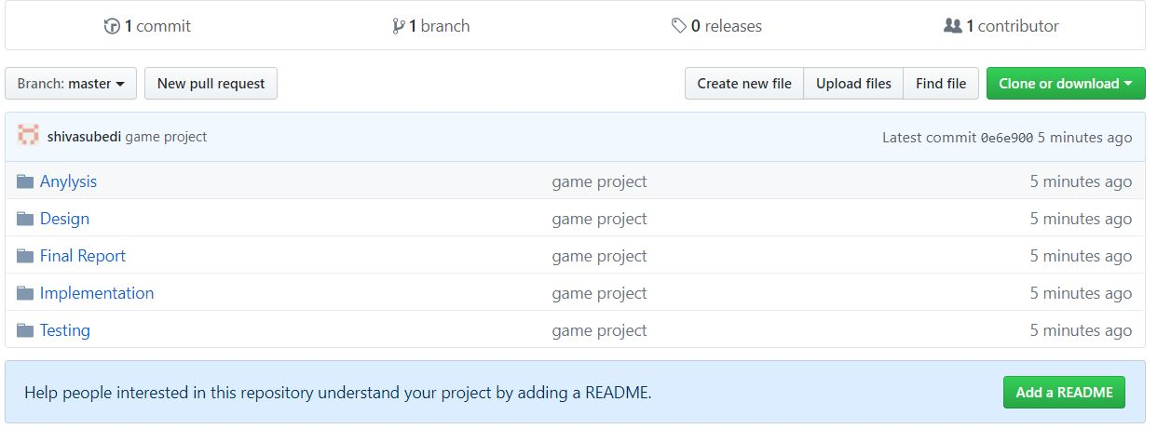

Fig: Git push location

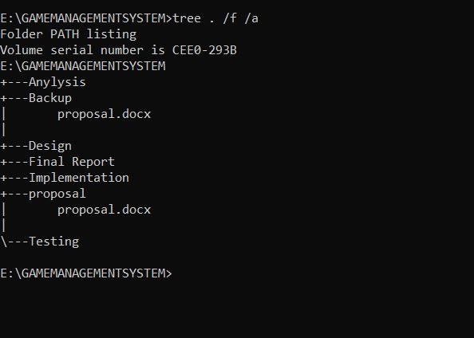

Fig: Directory structure for game management system

## 7. Conclusion

Hence, this project is mainly focused on managing the gaming tournament easily and properly, this helps to automate the work of the organizer. Provide secure system, bug free code. Clean lines of code with comment. Almost every work that needs to be done by the organizers can be done by using this system. This system handles all the work from registering teams, proper scheduling, and game win reporting the results of the tournament. So, this project helps to take burden from the team of organizers and get access throw online cloud database that helps to lead the organization.

## 8. References

[Online] Available at: https://www.brokerlink.ca/blog/risk-management/ [Accessed

25 December. 2018].

Configuration management [ Online] available at : <https://www.github.org/> <https://github.com>

project configuration management | Department of Finance. [Online] Available at: [https://www.finance-ni.gov.uk/articles/programme-and-project-](https://www.finance-ni.gov.uk/articles/programme-and-project-configuration-management) [configuration-management.](https://www.finance-ni.gov.uk/articles/programme-and-project-configuration-management)

The Work Breakdown Structure Project Management. [online] Available at:

[http://2020projectmanagement.com/2013/10/the-work-breakdown-structure-wbs/.](http://2020projectmanagement.com/2013/10/the-work-breakdown-structure-wbs/)

software-development/ [Accessed 25 December. 2018].

Three tier architecture [Online] https://www.izenda.com/blog/5-benefits-3-tier-architecture/[Accessed

3 January. 2019