Madari Software Design Document

Shiva Teja Reddy
Prakhar Agarwal
Akshay Sharma
Surendra Anuragi

October 2012

Madari, The Traffic Shaping Software
Design Document
Revision History

Version | Date | Author(s) | Description
v1.0 | 28/10/2012 | Akshay Sharma,  Surendra Anuragi,  Shiva Teja Reddy, Prakhar Agarwal. | Initial version

Table of Contents
1Introduction 1
1.1Design Overview 2
1.2Intended Audience 2
1.3References 2
2Detailed Design 2
2.1Architecture 2
Components 2
Interfaces 3
2.2Algorithms and Data Structures 3
2.3External Data 3
Files 3
2.4Performance 3
2.5Test Scripts 4

Introduction
Good management control systems are essential to a well-run organisation. Internet, an important and limited resource that needs to be properly used. Bandwidth wastage on websites of not much importance needs to be reduced. Madari solves this purpose. With Madari, you can throttle the bandwidth usage of websites and even allocate bandwidth to different users accessing internet. In this document we provide the design overview of the software.

Design Overview

Madari is a bunch of python and shell scripts. It uses tc and iptables to shape and control the network traffic. tc works by delaying metered traffic. Metering may be implemented with for example the token bucket algorithms. Tc and iptables allow us to control bandwidth allocated to different websites.

Intended Audience
This document is intended for network administrators, software managers, coders and testers.

References
[1] “Traffic Shaping”, Wikipedia, the free encyclopedia, I accessed on 22/10/2012,
http://en.wikipedia.org/wiki/Traffic_shaping
[2] Thomas Graf, Greg Maxwell, Remko Van Mook
Linux Advanced Routing & Traffic Control HOWTO, version 1.0.1
[3] “YAML”, Wikipedia, the free encyclopedia, I accessed on 29/10/2012
http://en.wikipedia.org/wiki/YAML

Detailed Design

Architecture

The main component of Madari is the manager. Madari uses tc and iptables to configure Traffic control in the linux kernel.

Components
Madari Manager written in python, will perform actions like generating required shell scripts and uses cron to run the generated shell scripts. The shell scripts are generated based on a configuration file. The manager configures cron to run specific scripts at given intervals. This will allow controlling the bandwidth allocation to different websites based on time.
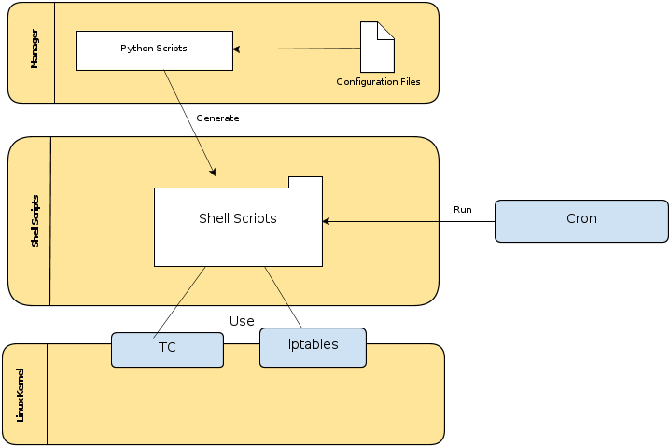
The Autonomous Part is a shell script that checks bandwidth usage every second and if the traffic is high for more than a minute overrides all the previous configurations with the rules defined for high traffic situations such as prioritzing set of websites. If possible decreasing the priority of packets of large size(Proposed).

Interfaces
The only interface to access the manager is terminal based. With this interface you perform actions like starting or stopping Madari.

Algorithms and Data Structures

There are no significant algorithms developed for this product.

External Data

Files
Madari uses a configuration file written in YAML to generate the required shell scripts.

Performance
The product will be benchmarked on different bandwidths on different websites.

Test Scripts

The following shell scripts will be used for testing and benchmarking the performance of Madari. General programs like wget and curl will be used.
CheckDownloadSpeeds.sh: starts two simultaneous downloads from two websites using wget. Average download speeds can be analyzed.

