AI Study Topic Explainer Assignment Documentation

Title
AI Study Topic Explainer

Description
AI Study Topic Explainer is a web application that allows students to enter a study topic and receive a simplified explanation generated using an AI model.
The system is built using Next.js and integrates an external AI API to generate explanations for educational topics.
The goal of this project is to help students quickly understand complex concepts through simple AI‑generated summaries.

Features
- Enter any study topic
- Generate AI-based explanation
- Simple and user-friendly interface
- Loading indicator while AI generates response
- Error handling for empty inputs
- API route implemented using Next.js
- Deployed online using Vercel

Installation (Project Setup)
Clone the repository from GitHub:
git clone https://github.com/shivateja12345/AI-generator.git

Navigate to the project directory:
cd AI-generator

Install dependencies:
npm install

Create environment variable file:
.env.local

Add API key:
GROQ_API_KEY=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

requirements.txt
next
react
react-dom
tailwindcss
typescript
react-markdown

Usage / How to Run the Program
Run the development server:
npm run dev

Open in browser:
http://localhost:3000

Enter a topic and click 'Explain Topic' to generate an AI explanation.

DEMO(OUTPUTS):

OUTPUT-1:
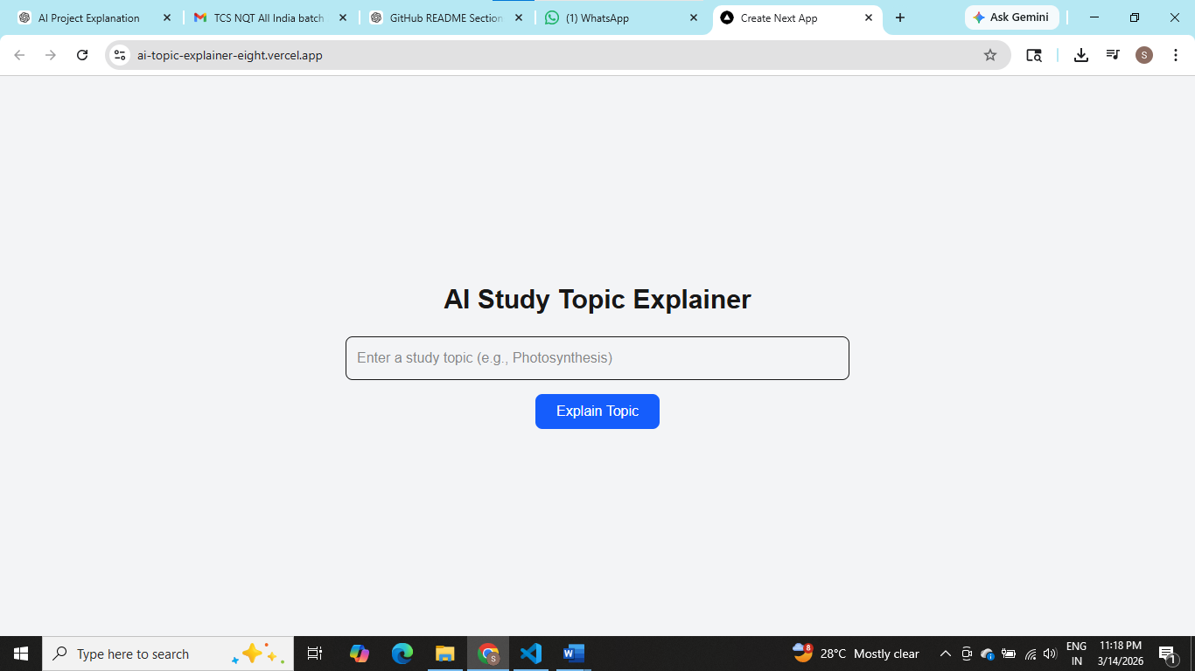OUTPUT-2:
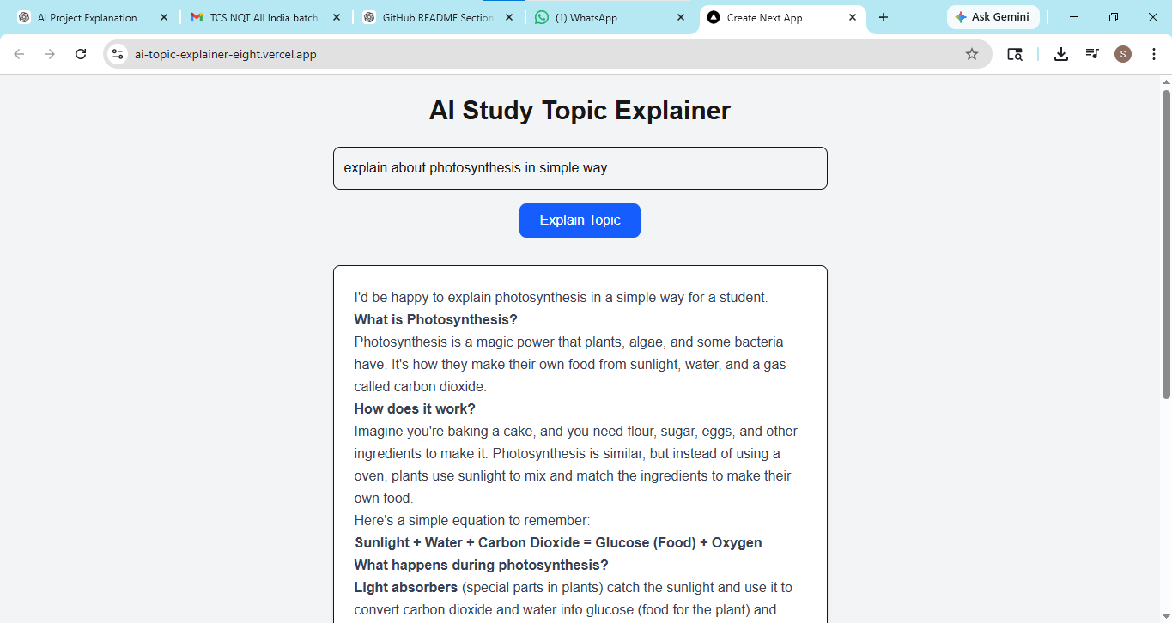

OUTPUT-3 (ERROR HANDLING):
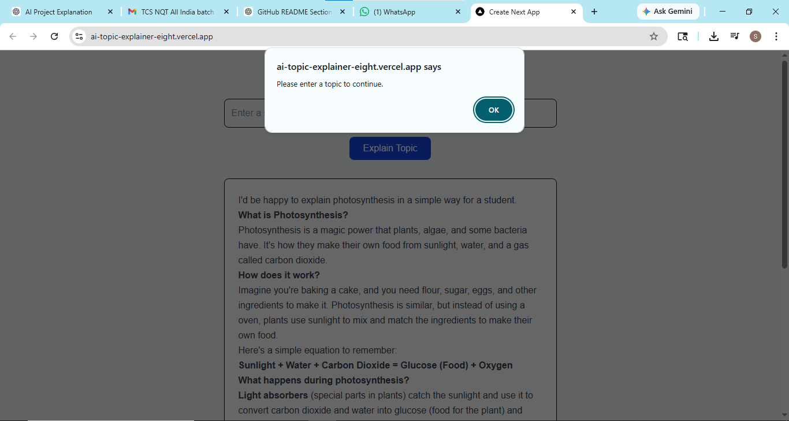

OUTPUT-4:
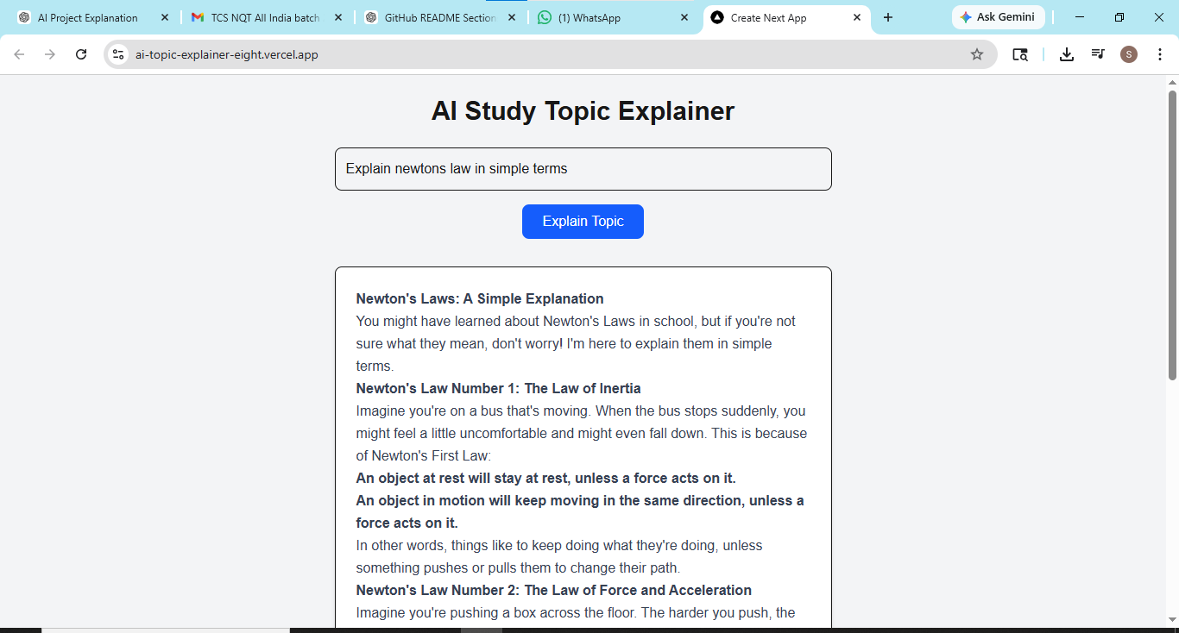

OUTPUT-5:
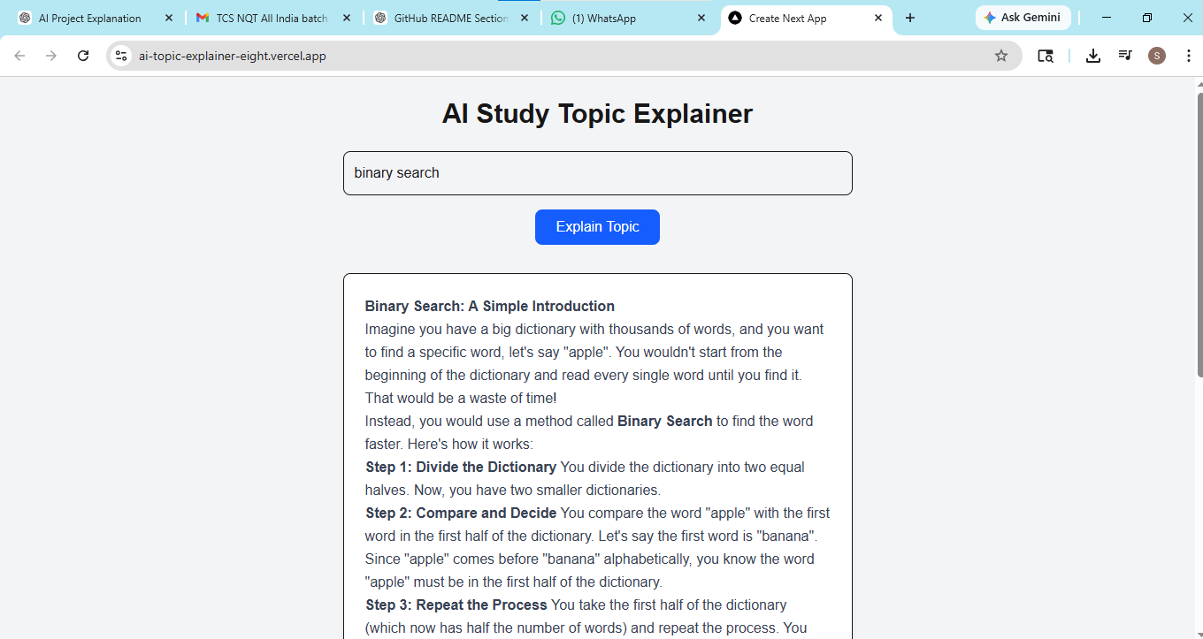

OUTPUT-6

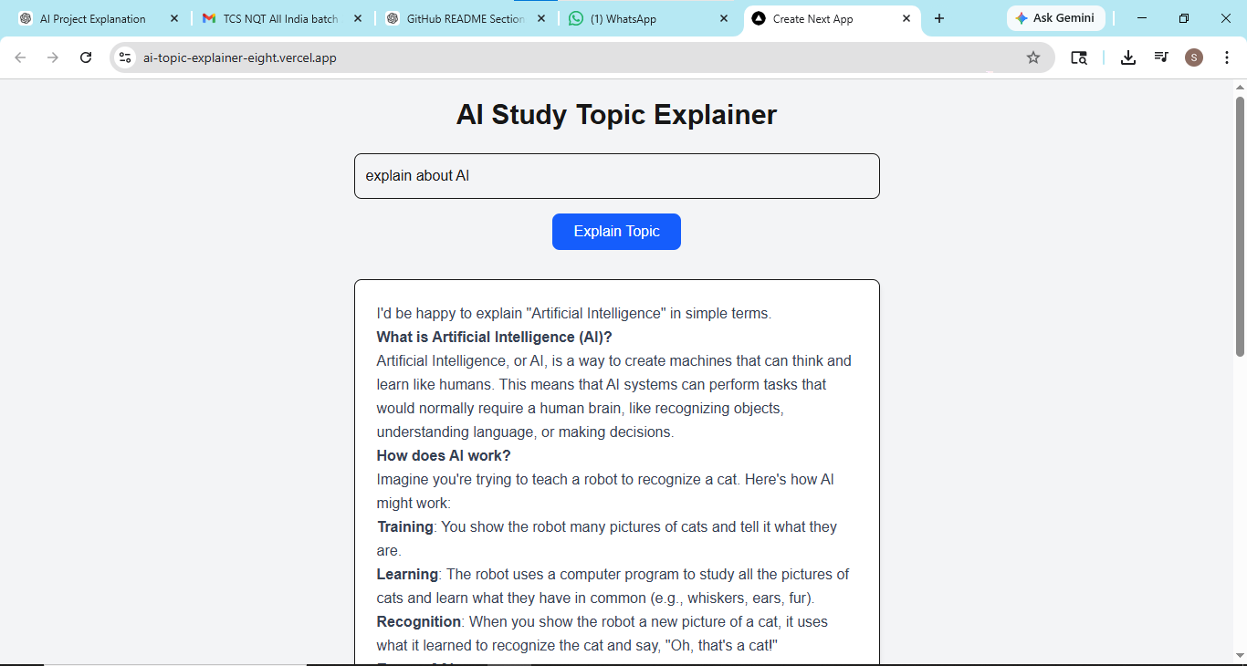

Project Structure
AI-generator
│
├── app
│ ├── api
│ │ └── explain
│ │ └── route.ts
│ ├── layout.tsx
│ └── page.tsx
│
├── components
│ ├── TopicInput.tsx
│ └── ExplanationCard.tsx
│
├── lib
│ └── aiClient.ts
│
├── public
│
├── README.md
├── package.json
├── tailwind.config.ts
└── next.config.ts

Technologies Used
Frontend: Next.js, React, TypeScript, Tailwind CSS
Backend: Next.js API Routes
AI Integration: Groq API
Deployment: Vercel
Version Control: GitHub

How AI API Was Used
When the user enters a topic and clicks the Explain button, the frontend sends a POST request to /api/explain.
The API route processes the request and sends the topic to the Groq AI API.
The AI generates a simplified explanation and returns it to the frontend where it is displayed to the user.

Setup Instructions
1. Install Node.js
2. Clone the repository
3. Run npm install
4. Create .env.local file
5. Add GROQ_API_KEY
6. Run npm run dev
7. Open localhost:3000 in browser

GITHUB REPOSITORY URL:

https://github.com/shivateja12345/AI-generator.git

PROJECT LINK:

https://ai-topic-explainer-eight.vercel.app/

