**INT 301(CA2)**

Name of the project: movie rating

Name: A SHIVA TEJA

Section: KE022

Roll no.: 63

Reg. no.: 11613008

Link of the Github:

**Description:**

Create a Form that accepts shows various movies and user has to rate the movies between 1-5. Whatever value the user chooses should be calculated in average and saved in database. And when user wants to see the rating, it must show average rating of the movie.

**What is movie Rating?:**

The movie rating system that film buffs know today has been around for more than 50 years, but Hollywood studios have been regulating movies to one degree or another since the industry's early days. As cultural standards have changed over time, so have movie ratings, even as the process of rating a film remains a closely guarded industry secret.

**Types of Movie Ratings:**

* **G (general audiences):** G ratings are most notable for what the films

don’t include: sex and nudity, substance abuse, or realistic/noncartoon violence.

* **PG (parental guidance):** Some material may not be suitable forchildren. The movie may have mildly strong language and some violence, but no substance use or physical abuse.
* **PG-13 (parental guidance-13):** Some material may not be suitablefor children under 13. Any nudity has to be nonsexual, and any swear

words have to be used sparingly. Violence in PG-13 films may be intense, but must be bloodless.

* **R (restricted):** No one under 17 admitted without an accompanyingparent or guardian. This rating is given for frequent strong language and violence, nudity for sexual purposes, and drug abuse.
* **NC-17 (no one under 17):** This rare rating is given to films thatfeature mature elements in such profusion or intensity that they surpass even the R rating.
* **Unrated:** Typically reserved for previews of films not yet officiallyrated by the MPAA. A green title card indicates the preview is safe for all viewers, while red is for mature audiences.

**Test Cases:**

Case 1: Movie Rating

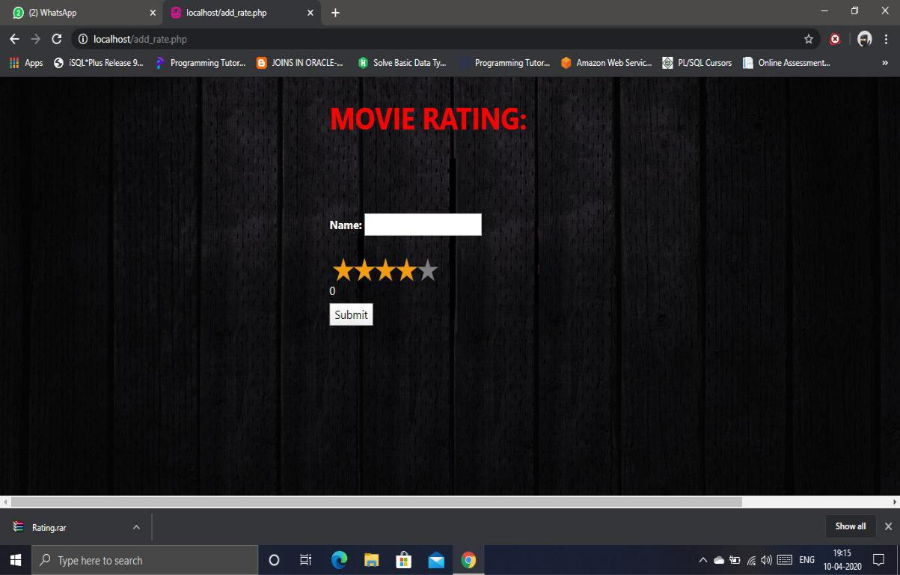

Case 2: Enter Movie name and Giving Rating

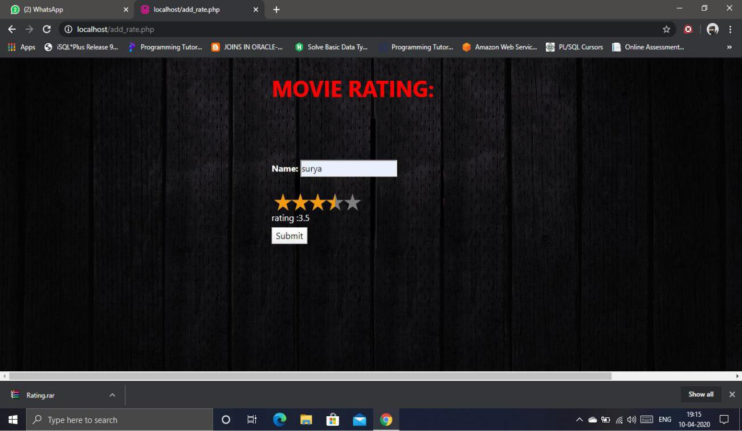

And saved successfully

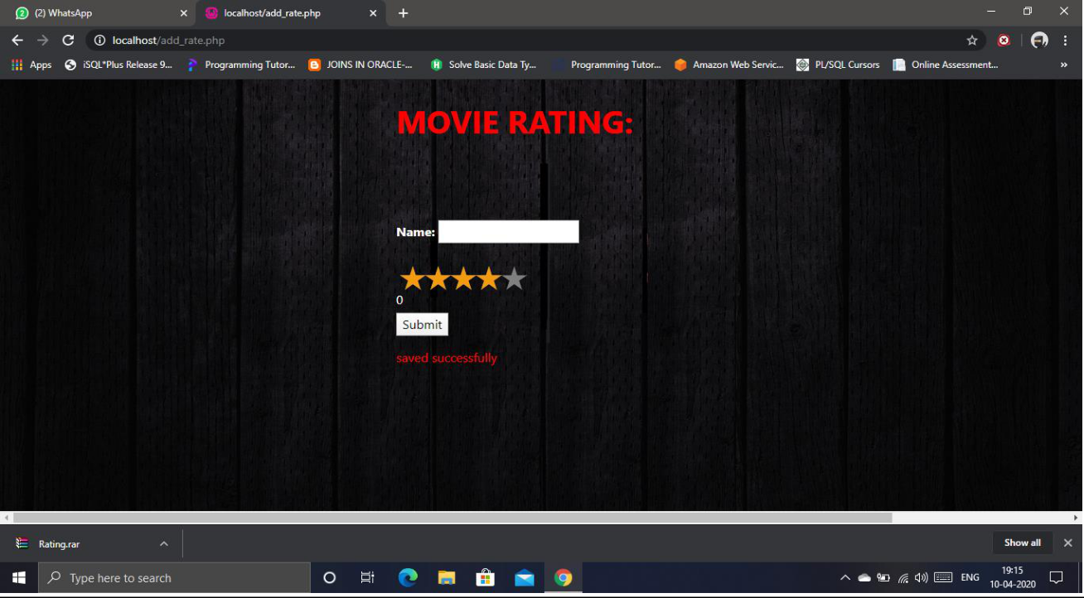

Case 3:

Average of the Ratings



Case 4:

Saved movie Names And Ratings

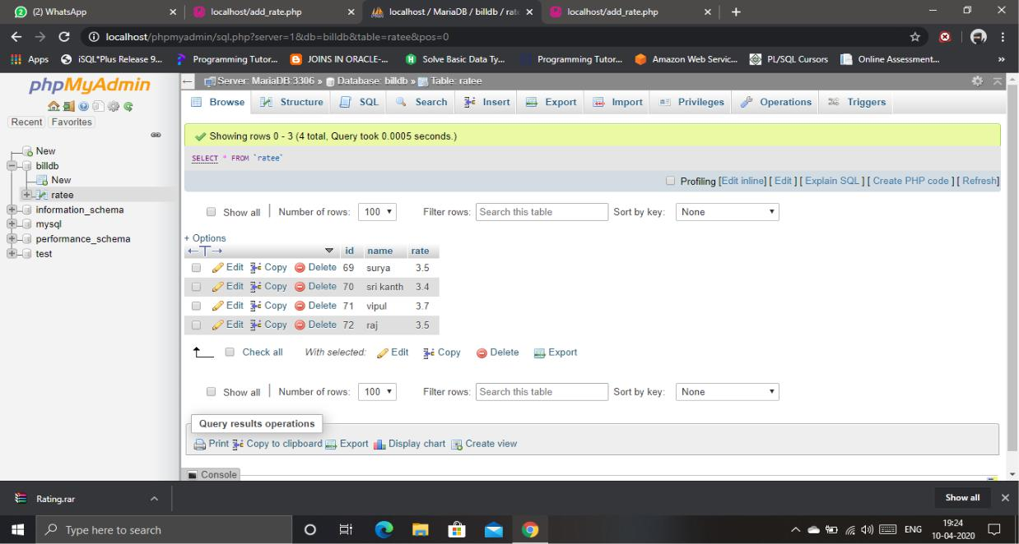

**Code which was used for the project:**

**<html>**

**<style>**

**body {**

**background-image: url('bg2.jpg');**

**background-repeat: no-repeat;**

**background-attachment: fixed;**

**background-size: 100% 100%;**

**}**

**</style>**

**<head>**

**<link rel="stylesheet"**

**href="https://stackpath.bootstrapcdn.com/bootstrap/4.4.1/css/bo**

**otstrap.min.css" integrity="sha384-**

**Vkoo8x4CGsO3+Hhxv8T/Q5PaXtkKtu6ug5TOeNV6gBiFeWPGFN9M**

**uhOf23Q9Ifjh" crossorigin="anonymous">**

**<link rel="stylesheet"**

**href="https://cdnjs.cloudflare.com/ajax/libs/rateYo/2.3.2/jquery.r**

**ateyo.min.css">**

**</head>**

**<body>**

**<h1 style="margin-left:500px;margin-top: 30px;color:red;"> <b>MOVIE RATING:</b></h1><br>**

**<div class="container" style="margin-left:500px;"> <div class="row">**

**<form action="add_rate.php" method="post"> <div>**

**<br>**

**</div>**

**<br>**

**<br>**

**<div>**

**<label><b style="color:white;">Name: </b> </label> <input type="text" name="name"> </div>**

**<br>**

**<div class="rateyo" id="rating"**

**data-rateyo-rating="4"**

**data-rateyo-num-stars="5"**

**data-rateyo-score="3">**

**</div>**

**<span style="color:white;"class='result'>0</span> <input type="hidden" name="rating">**

**<div style="margin-top:5px;"><input type="submit"**

**name="add"></div>**

**</form>**

**</div>**

**<script**

**src="https://cdnjs.cloudflare.com/ajax/libs/jquery/3.3.1/jquery.mi**

**n.js"></script>**

**<script**

**src="https://cdnjs.cloudflare.com/ajax/libs/rateYo/2.3.2/jquery.ra**

**teyo.min.js"></script>**

**<script>**

**$(function() {**

**$(".rateyo").rateYo().on("rateyo.change", function(e,data) {**

**var rating=data.rating;**

**$(this).parent().find('.score').text('score :'+$(this).attr('data-rateyo-score'));**

**$(this).parent().find('.result').text('rating :'+rating);**

**$(this).parent().find('input[name=rating]').val(rating);**

**});**

**});**

**</script>**

**<p style="color:red;margin-left:-15px;">**

**<?php**

**require 'db_connection.php';**

**if($_SERVER["REQUEST_METHOD"]=="POST")**

**{**

**$name=$_POST["name"];**

**$rating=$_POST["rating"];**

**$sql="INSERT INTO ratee (name,rate) VALUES ('$name','$rating')";**

**if(mysqli_query($conn,$sql))**

**{**

**echo "saved successfully";**

**}**

**else**

**{**

**echo "Error: ".$sql. "<br>".mysqli_error($conn);**

**}**

**mysqli_close($conn);**

**}**

**?>**

**<p style="color:red;margin-left:558.7px;"><b> Avgrage Ratting is :3<br>**

**</b>**

**</p>**

**</div>**

**</body>**

**</html>**

**-------------- The End----------**