**A**

**MINOR PROJECT REPORT**

**on**

**Image Compression Using Neural Networks**

**BE(IT)-VI Sem**

**By**

**Sarath Chandra (160120737167)**

**Shiva Theja (160120737172)**

**Under the guidance of**

[**Dr. D. Lakshmi Srinivasa Reddy**](https://www.cbit.ac.in/wp-content/uploads/2019/04/ITD_Dr-DLSREDDY-Profile_Jan-2023.pdf)

**Associate Professor**

**AI & DS Department**



**CHAITANYA BHARATHI INSTITUTE OF TECHNOLOGY (A)**

**(Affiliated to Osmania University; Accredited by NBA(AICTE) and NAAC(UGC), ISO Certified 9001:2015)**

**KOKAPET(V), GANDIPET(M), RR District, HYDERABAD - 75**

**Website:** [**www.cbit.ac.in**](http://www.cbit.ac.in/)

**2022-2023**



**CERTIFICATE**

This is to certify that the project work entitled “**Image Compression Using Neural Networks**” submitted to CHAITANYA BHARATHI INSTITUTE OF TECHNOLOGY, in partial fulfillment of the requirements for the completion of a Minor Project-II of VI Semester B.E. in Information Technology, during the Academic Year 2022-2023, is a record of original work done by **Sarath Chandra (160120737167) and Shiva Theja (160120737172)** during the period of study in the Department of IT, CBIT, HYDERABAD, under our guidance.

|  |  |
| --- | --- |
| **Project Guide** | **Head of the Department** |
| [**Dr. D. Lakshmi Srinivasa Reddy**](https://www.cbit.ac.in/wp-content/uploads/2019/04/ITD_Dr-DLSREDDY-Profile_Jan-2023.pdf) | [**Dr. Rajanikanth Aluvalu**](https://www.cbit.ac.in/wp-content/uploads/2019/04/ITD_Dr.Rajanikanth-Aluvala_Dec-2022.pdf) |
| Assistant Professor, Dept. of AI&DS, | Professor, Dept. of IT, |
| CBIT, Hyderabad. | CBIT, Hyderabad. |

## 

## **ACKNOWLEDGEMENTS**

We would like to express our heartfelt gratitude to [**Dr. D. Lakshmi Srinivasa Reddy**](https://www.cbit.ac.in/wp-content/uploads/2019/04/ITD_Dr-DLSREDDY-Profile_Jan-2023.pdf), our project guide, for his valuable guidance, constant support, and his capable instruction, and persistent encouragement.

We are grateful to our Head of Department, [**Dr. Rajanikanth Aluvalu**](https://www.cbit.ac.in/wp-content/uploads/2019/04/ITD_Dr.Rajanikanth-Aluvala_Dec-2022.pdf), for his steady support and the provision of every resource required for the completion of this project.

We would like to take this opportunity to thank our Principal, **Dr. P. Ravinder Reddy**, as well as the Management of the Institute, for having designed an excellent learning atmosphere.

Our thanks are due to all members of the staff and our lab assistants for providing us with the help required to carry out the groundwork of this project.

**ABSTRACT**

Image compression is a process of reducing the size of an image while maintaining its quality. Traditional image compression algorithms such as JPEG use methods such as transform coding and quantization to achieve compression.

However, these methods can result in a loss of quality and detail in the compressed image. In recent years, CNNs have emerged as a powerful tool for image compression. The project on image compression using CNN aims to develop an image compression algorithm that can compress images while preserving their quality. This project involves building a CNN and GAN model that can learn to encode and decode images, compress and reconstruct images using the trained model, and evaluate the compression performance using metrics such as PSNR and SSIM. The project can have various uses, including improved storage efficiency, and faster image transmission.

**CONTENTS**

|  |  |  |
| --- | --- | --- |
| **S. No** | **Topics** | **Page. No** |
| 1 | **Introduction** | 1 |
| 2 | **Literature** | 2 |
| 3 | **Problem Statement** | 3 |
| 4 | **Methodology** |  |
| a. Existing | 4 |
| b. Proposed | 5 |
| 5 | **Design of Project** | 6 |
| 6 | **Experimental Results** |  |
|  | a. About Data Set | 7 |
|  | b. Data Processing | 7 |
|  | c. Implementation and Execution of existing Models | 7 |
|  | d. Implementation and Execution of Proposed Models | 9 |
|  | e. Comparison of Results in Graphical Representation | 12 |
| 7 | **Conclusion and Future Work** | 13 |
|  | **References/ Bibliography** | 14 |
|  | **List of Figures** | 15 |
|  | **List of Abbreviations** | 16 |
|  |  |  |

**1. INTRODUCTION**

Image compression is an essential technique used to reduce the size of digital images without compromising their quality. Conventional image compression algorithms, like JPEG, use methods such as transform coding and quantization, which can lead to the loss of image details and quality.

In recent years, Convolutional Neural Networks (CNNs) have revolutionized the field of image compression. These neural networks have shown exceptional performance in compressing images while retaining their quality. The objective of image compression using the CNN project is to design an efficient image compression algorithm that can learn to encode and decode images. The proposed algorithm will be based on CNN and Generative models, which will enable it to compress and reconstruct images with high accuracy.

The application of this project is vast and includes various fields such as improved storage efficiency, faster image transmission, and reduced bandwidth consumption. The project will contribute to the development of new and advanced image compression techniques that can handle large-scale image data with improved performance and better quality.

**2. LITERATURE**

i) Published by Kunal Rajan Deshmukh as part of Research in 2019.

Datasets: ImageNet, CIFAR10

The author combined four modules to perform the compression task.

a) Compression using CNNs

b) Arithmetic encoder

c) Arithmetic decoder

d) Reconstruction

Compression ratios for png images: 0.4

Compression ratios for jpg images: 0.5

ii) Published by XIANG LI, AND SHIHAO JI published in 2021.

Datasets: MNIST, CIFAR10

Architecture: Neural Image Compression and Explanation(NICE)

Accuracy: Down sampled by 0.74

**3. PROBLEM STATEMENT**

Image compression is a kind of data compression. Research in data compression is at least four decades old. The Lempel-Ziv data compression algorithm as well as Differential Pulse-Code Modulation were developed in the 1970s. A modification of this algorithm: Lempel-Ziv-Welch (LZW) was published by Welch in the year 1984. This algorithm is still used in GIF image formats. Many techniques such as Run-Length Encoding (RLE), Discrete Cosine Transform (DCT), etc. are used traditionally for image compression. These deterministic image compression algorithms rely mainly on image filters, discrete transformations, and quantization. Because of Moore’s law, handheld devices and personal computers now have much higher processing power than they had at any time in the past. This has allowed the development of modern image compression algorithms. Many image compression frameworks have now been proposed, based on deep neural networks. Several recently published articles on image processing frameworks used deep learning networks. We used parts and ideas from several of those frameworks to develop a new architecture. The goal of this project is to develop a new deep neural network architecture which is an improvement upon existing architectures in terms of efficiency and image quality metrics such as SSIM, and PSNR.

**4. METHODOLOGY**

**a. Existing**

1.JPEG (Joint Photographic Experts Group): It is a widely used lossy compression method that achieves high compression ratios by exploiting the limitations of human visual perception.

2.PNG (Portable Network Graphics): It is a lossless compression method that uses a combination of different compression techniques, including the DEFLATE algorithm.

The CNN-based method described above for image compression offers several advantages over traditional compression methods:

1.End-to-end learning: The CNN model learns the compression and reconstruction process directly from the data, allowing it to adapt and optimize the compression process based on the characteristics of the input images.

2.Non-linear transformations: CNNs can capture complex patterns and non-linear transformations in the image data, enabling better representation of the image features and potentially improving the compression performance.

3. Contextual information: CNN models can exploit the contextual information present in the image data, allowing them to capture dependencies and correlations between different regions of the image. This can lead to more efficient compression by reducing redundancy.

4. Adaptability to different data: CNN models can be trained on various datasets and can handle different types of images, including natural images, medical images, and satellite imagery. This flexibility makes them suitable for a wide range of image compression applications.

However, it is important to note that the effectiveness of the CNN-based method may vary depending on the specific dataset, architecture, training process, and evaluation metrics used

**b. Proposed**

In the proposed model, we try to use two phases in compression and reconstruction of images.

Compression is done by CNNs so as to get the feature maps. These feature maps have the important features of the particular feature by convolutions and max pooling. These convolved images can also be called as encoded images. These encoded images are decoded using generative models like up-sampling layers and max pooling layers so as to reconstruct original images from the compressed images.

The hyperparameters for the proposed methodology are batch size, epochs, the learning rate of Adam optimizer, the decay rate for learning rate, loss function, and layers in two phases.

The performance metrics are chosen as PNSR and SSIM. Datasets are CIFAR-10, CIFAR-100, DIV2K.

**5. DESIGN OF PROJECT**

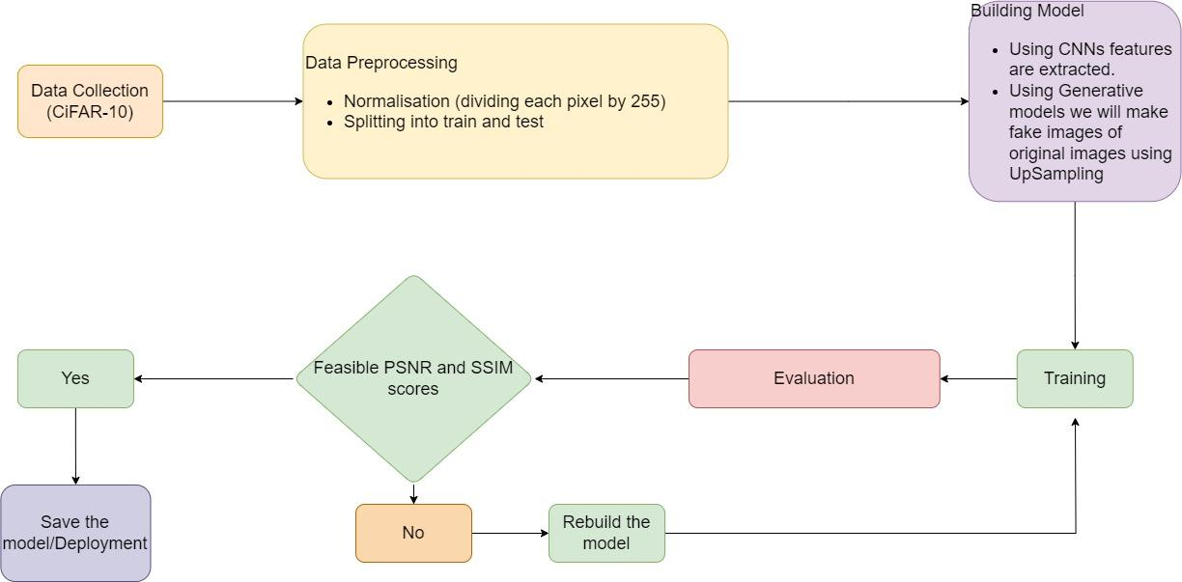

Fig. 5.1 Flow chart of project execution

**6. EXPERIMENTATION RESULTS**

**6a. About Dataset**

The CIFAR-10 dataset consists of 60000 32x32 RGB images in 10 classes, with 6000 images per class. There are 50000 training images and 10000 test images. The dataset is divided into five training batches and one test batch, each with 10000 images. The test batch contains exactly 1000 randomly-selected images from each class. The training batches contain the remaining images in random order, but some training batches may contain more images from one class than another. Between them, the training batches contain exactly 5000 images from each class.

The CIFAR-100 dataset is a widely used image classification dataset that contains 100 classes of images with 600 examples per class. It is a subset of the larger CIFAR-10 dataset, but with a more fine-grained classification problem. Each image in the CIFAR-100 dataset is a 32x32 pixel color image, which makes the dataset particularly challenging due to the low resolution of the images.

The DIV2K dataset is a popular high-resolution image dataset that is commonly used for image super-resolution tasks. It contains 800 high-quality images with a resolution of 2K (i.e., 2048 x 1080 pixels) in PNG format. The images were obtained from various sources, including the internet, digital cameras, and scanners, and were carefully curated to ensure high quality and diversity.

**6b. Data Pre-processing**

The two preprocessing tasks to be done are:

1. Normalizing the images in every channel of images i.e., by dividing with 255
2. Splitting the data into training and testing

**6c. Implementation and Execution of existing models**

Implementation of JPEG in 6 steps:

* Color Space Transform
* Apply DCT
* Quantization
* Serialization
* Vectoring
* Encoding

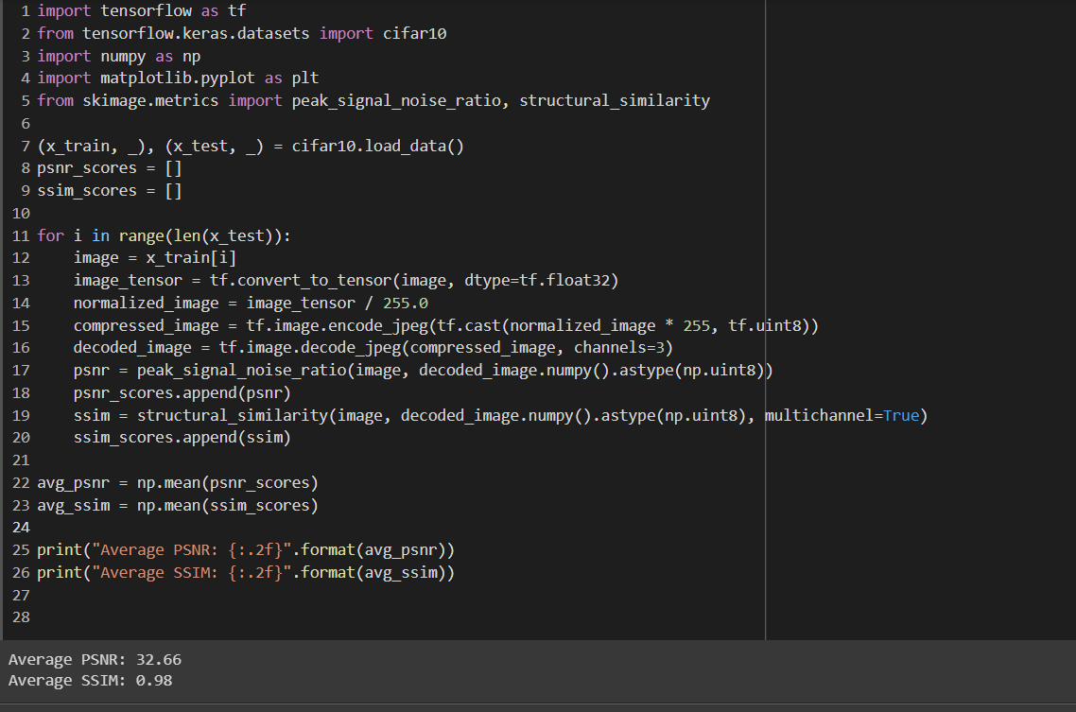

Fig. 6.1 JPEG Implementation

**6d. Implementation and Execution of Proposed Models**

Our proposed model consists of two phases after preprocessing they are compression and reconstruction phases. Then we will compile and fit the model. All the images which are compressed are used to calculate using PSNR and SSIM values as performance metrics.

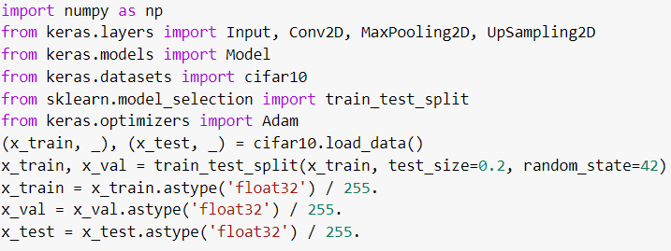

Fig. 6.3 Importing the required modules and preprocessing

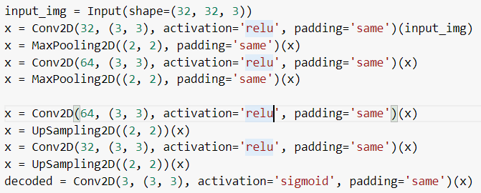

Fig. 6.4 Compression and reconstruction phase

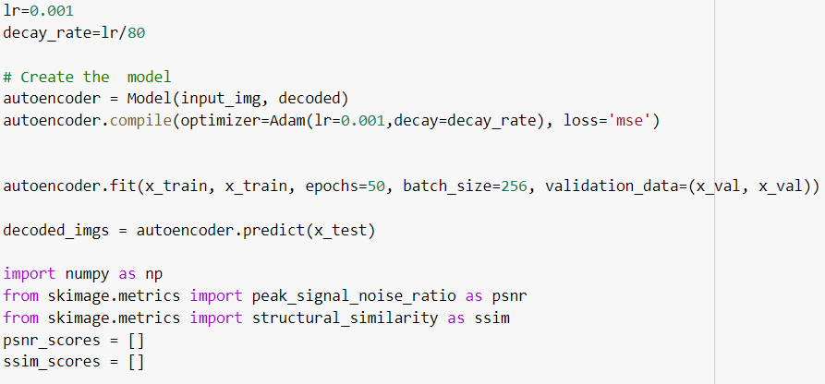

Fig. 6.5 Compiling and Fitting the Model

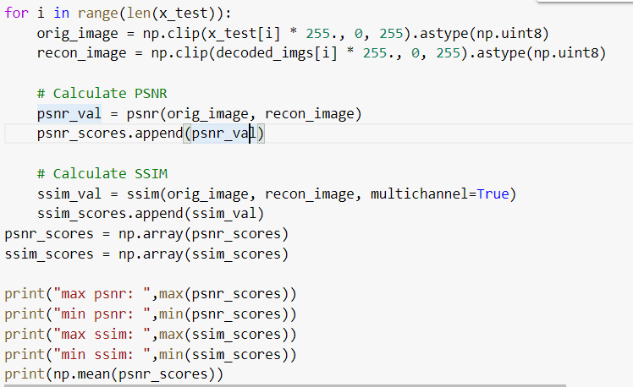

Fig. 6.6 Performance metrics analysis

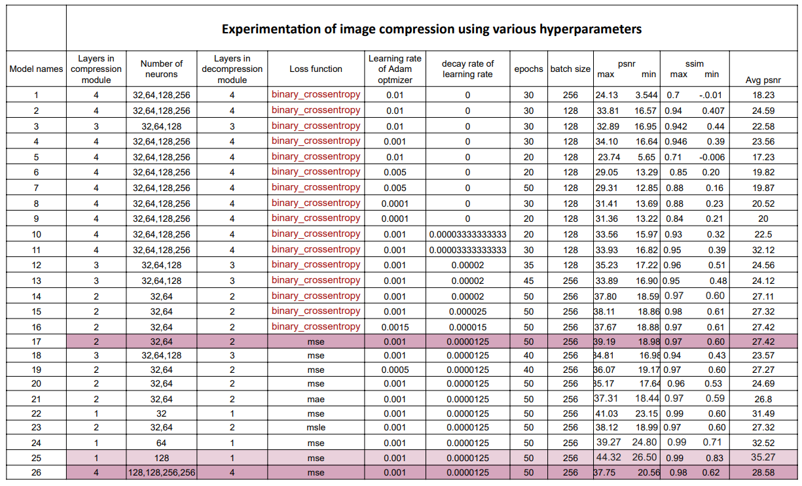

Fig. 6.7 Experimentation Results on CIFAR-10 dataset

**6e. Comparison of Results in Graphical Representation**

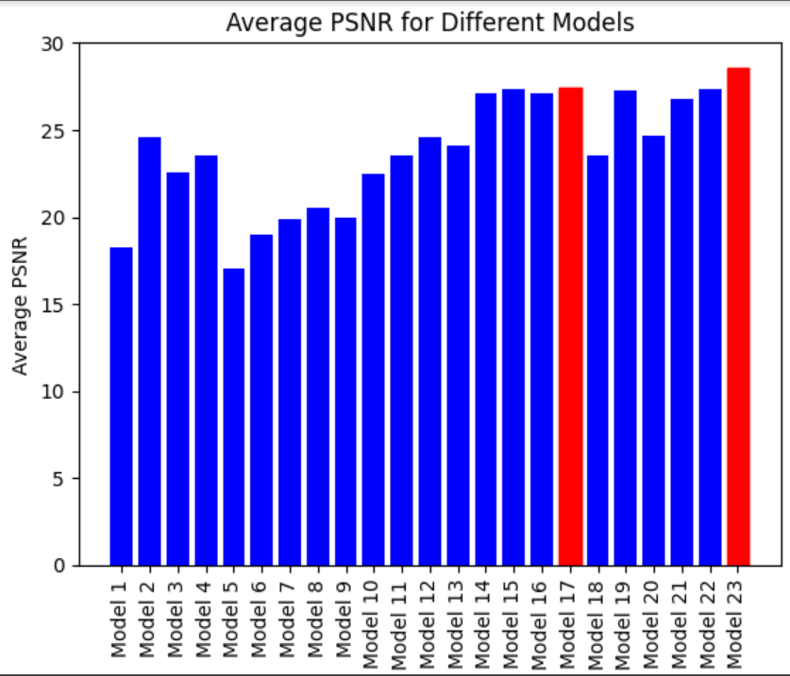

Fig. 6.8 Comparison of various models

**7. CONCLUSION AND FUTURE WORK**

**7.1** **CONCLUSION**

This CNN and GAN model has achieved a maximum PSNR value of 39.19 for the cifar-10 dataset and 36.46 for the cifar-100 dataset. This work can be useful for faster transmission of images and also reduces high computation for any datasets for classification or any other ml and dl projects.

**7.2 FUTURE SCOPE**

The general best values of PSNR values are from 30 to 50. We try to tune the model more to get from 40 to 50. Also, we would to like implement RNNs in image compression because as per other research papers RNNs also improve image compression quality metrics but the disadvantage is that these take a lot of time for computation and fit the models.

**BIBLIOGRAPHY**

[i] <https://arxiv.org/pdf/1908.08988.pdf>

[ii] <https://medium.com/data-science-365/learning-rate-schedules-and-decay-in-keras-optimizers-f68bf91de57d>

[iii] <https://www.sciencedirect.com/science/article/pii/S2405959519303455#:~:text=In%20practical%20terms%2C%20to%20determine,advantage%20of%20the%20GPUs%20processing>.

**List of Figures**

|  |  |  |
| --- | --- | --- |
| **Figure No** | **Name of the Figure** | **Page No** |
| 5.1 | Design of project | 10 |
| 6.1 | Importing the required modules and preprocessing | 10 |
| 6.2 | Compression and reconstruction phase | 11 |
| 6.3 | Compiling and Fitting the Model | 12 |
| 6.4 | Performance metrics analysis | 13 |
| 6.5 | Experimentation Results on CIFAR-10 Dataset | 14 |

**List of Abbreviations**

|  |  |
| --- | --- |
| **Acronym** | **Abbreviation** |
| **CNN** | Convolutional Neural Networks |
| **RNN** | Recurrent Neural Networks |
| **GAN** | Generative Adversarial Networks |
| **PSNR** | Peak Signal Noise Ratio |
| **SSIM** | Structural Similarity Index |
|  |  |