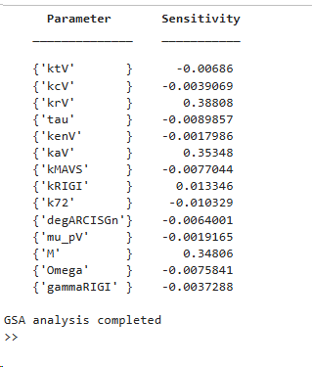

GSA, 25K, one order of magnitude

File name: LSA_JEV

clear; close all; clc;

%% Load parameters
loadedData = load('param_JEV.mat');

param = loadedData.param;

%% Add estimated parameters
param.M = 500;
param.Omega = 50;
param.gamma_RIGI = 1;
param.threshold = 500;
param.n = 2;

%% Parameters for LSA
paramNames = {
'k_t';
'k_c';
'k_r';
'tau';
'k_en';
'k_a';
'k_MAVS';
'k_RIGI';
'k72';
'degARCBySOCS';
'mu_p';
'M';
'Omega';
'gamma_RIGI'
};

%% Initial conditions
load('SteadyState_120h.mat','Yss');
y0 = Yss(end,:);
y0(2) = 1; % Virus Input

%% Simulation settings
I_n = 1;
I_a = 1;
VC = 1;

tend = 96*60;
tspan = linspace(0,tend,1000);

%% Baseline simulation
[Tbase,Ybase] = ode23s(@(t,y) ODEs(t,y,param,I_n,I_a,VC), tspan, y0);
baseline_output = Ybase(end,1);

%% Storage
Sensitivity = zeros(length(paramNames),1);

%% LSA loop
for i = 1:length(paramNames)
pname = paramNames{i};

% Ensure the parameter exists in the structure before modifying
if isfield(param, pname)
param_new = param;
oldval = param.(pname);

% +10% perturbation
param_new.(pname) = 1.1 * oldval;

% Simulate
[T,Y] = ode23s(@(t,y) ODEs(t,y,param_new,I_n,I_a,VC), tspan, y0);
new_output = Y(end,1);

% Normalized sensitivity
if oldval ~= 0
Sensitivity(i) = ((new_output - baseline_output)/baseline_output) ...
/ ((1.1*oldval - oldval)/oldval);
else
Sensitivity(i) = 0; % Avoid division by zero
end
else
warning('Field %s not found in parameter structure.', pname);
end
end

%% Plot
figure
bar(Sensitivity)
set(gca,'XTick',1:length(paramNames))
set(gca,'XTickLabel',paramNames)
xtickangle(45)

ylabel('Sensitivity Index')
title('Local Sensitivity Analysis')
grid on

%% Display table
Results = table(paramNames, Sensitivity, 'VariableNames', {'Parameter', 'Sensitivity'});
disp(Results)

GSA_JEV

clear; close all; clc;

%% Load LHS samples
LHS_table = readtable('LHS_JEV_parameters.csv');

%% Number of parameter sets
N = height(LHS_table);

%% Load baseline parameter structure
load('param_JEV.mat')

%% Add fixed estimated parameters
param.M = 500;
param.Omega = 50;
param.gamma_RIGI = 1;
param.threshold = 500;
param.n = 2;

%% Load steady state initial conditions
load('SteadyState_120h.mat','Yss')

y0 = Yss(end,:);
y0(2) = 1;

%% Simulation settings
I_n = 1;
I_a = 1;
VC = 1;

tend = 96*60;
tspan = linspace(0,tend,1000);

%% Storage
VT_48h = zeros(N,1);
nAOC = zeros(N,1);
Feasible = zeros(N,1);

%% Thresholds
VT_threshold = 100;
nAOC_threshold = 50;

%% GSA loop
for i = 1:N

disp(i)

%% Create parameter copy
param_i = param;

%% Update parameters from LHS table
param_i.k_t = LHS_table.ktV(i);
param_i.k_c = LHS_table.kcV(i);
param_i.k_r = LHS_table.krV(i);
param_i.tau = LHS_table.tau(i);
param_i.k_en = LHS_table.kenV(i);
param_i.k_a = LHS_table.kaV(i);

param_i.k_MAVS = LHS_table.kMAVS(i);
param_i.k_RIGI = LHS_table.kRIGI(i);

param_i.k72 = LHS_table.k72(i);

param_i.degARCBySOCS = LHS_table.degARCISGn(i);

param_i.mu_p = LHS_table.mu_pV(i);

param_i.M = LHS_table.M(i);
param_i.Omega = LHS_table.Omega(i);
param_i.gamma_RIGI = LHS_table.gammaRIGI(i);

param_i.threshold = LHS_table.threshold(i);
param_i.n = LHS_table.nHill(i);

%% Solve ODE
try

[T,Y] = ode23s(@(t,y) ODEs(t,y,param_i,I_n,I_a,VC), tspan, y0);

%% Viral titer at 96 h
VT_96h(i) = Y(end,1);

%% nAOC
nAOC(i) = trapz(T,Y(:,1)) / (T(end)-T(1));

%% Feasibility check
if VT_96h(i) >= VT_threshold && nAOC(i) >= nAOC_threshold

Feasible(i) = 1;

end

catch

VT_96h(i) = NaN;
nAOC(i) = NaN;
Feasible(i) = 0;

end

end

%% Save results table
Results = LHS_table;

Results.VT_96h = VT_96h;
Results.nAOC = nAOC;
Results.Feasible = Feasible;

writetable(Results,'GSA_JEV_Results.csv')

disp('GSA completed')

Analysis_GSA_JEV

clear; close all; clc;

%% Load GSA results
Results = readtable('GSA_JEV_Results.csv');

%% Parameters to analyze
paramNames = {
'ktV'
'kcV'
'krV'
'tau'
'kenV'
'kaV'
'kMAVS'
'kRIGI'
'k72'
'degARCISGn'
'mu_pV'
'M'
'Omega'
'gammaRIGI'
};

%% Storage
Sensitivity = zeros(length(paramNames),1);

%% Correlation-based GSA
for i = 1:length(paramNames)

x = Results.(paramNames{i});
y = Results.VT_96h;

R = corrcoef(x,y,'Rows','complete');

Sensitivity(i) = R(1,2);

end

%% Plot
figure

bar(Sensitivity)

set(gca,'XTick',1:length(paramNames))
set(gca,'XTickLabel',paramNames)

xtickangle(45)

ylabel('Correlation with VT\_96h')

title('Global Sensitivity Analysis')

grid on

%% Display table
GSATable = table(paramNames, Sensitivity, ...
'VariableNames', {'Parameter','Sensitivity'});

disp(GSATable)

%% Save
writetable(GSATable,'GSA_Sensitivity_Table.csv')

disp('GSA analysis completed')

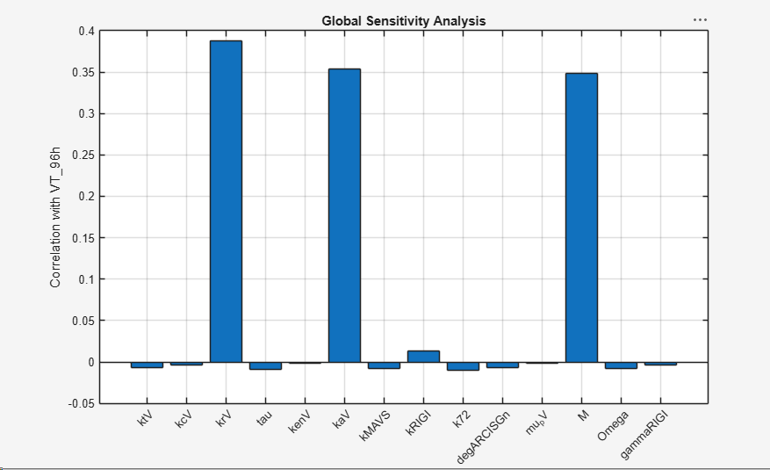

CHANGED IN LHS_datasets_JEV , range 0.5 to 1.5

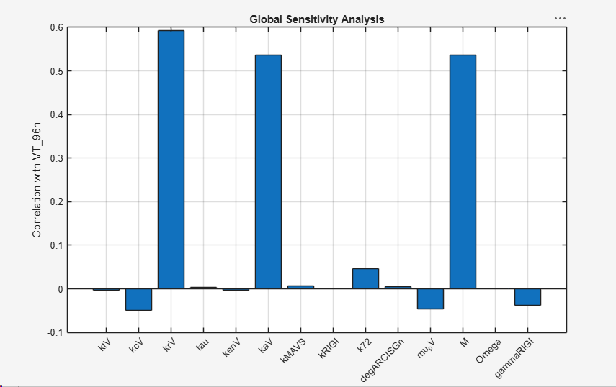

range lb= *0.5 to ub= *1.5

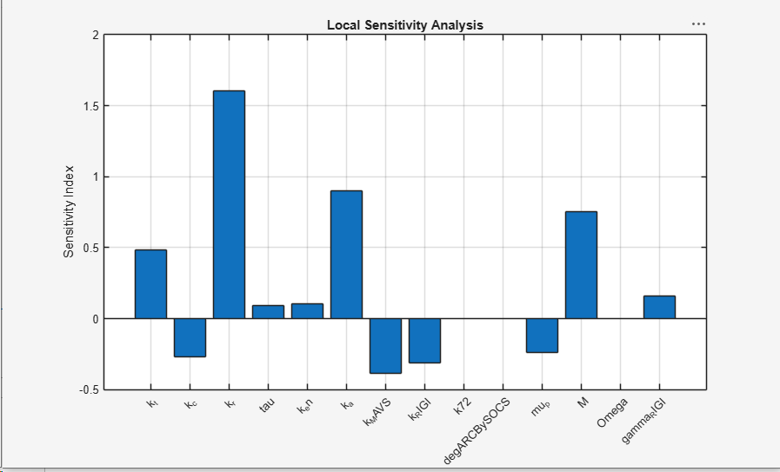

range lb= *0.5 to ub= *1.5 ,1000 simulations

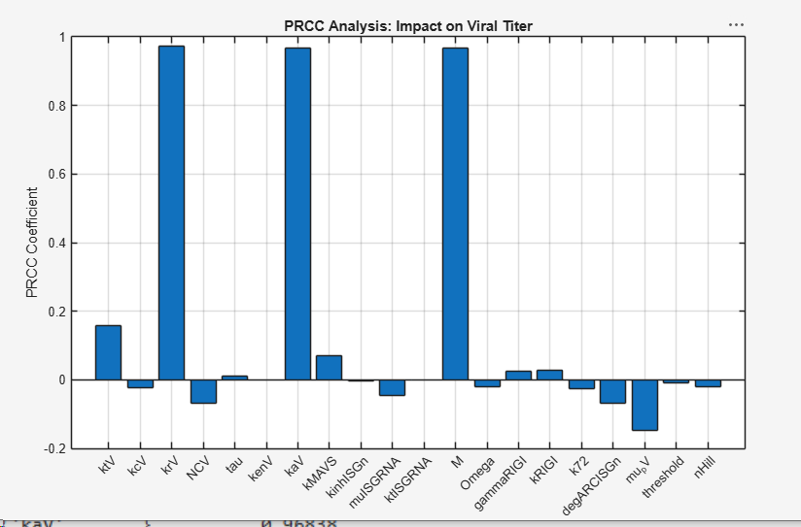

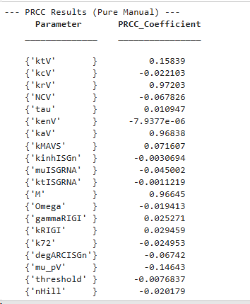

One order of magnnitude, 25k simulations
