280394, SHIVA PRASAD YADAV

PACAKGE : ZSHIVASAPPACK_280394

FORM : ZEXAM_ADOBE_FORM_1

INTERFACE : ZEXAM_INTERFACE_1

"&---------------------------------------------------------------------*

*& Report ZEXAM_280394_REPORT

*&---------------------------------------------------------------------*

*&

*&---------------------------------------------------------------------*

REPORT ZEXAM_280394_REPORT.

data : lv_vbeln type VBELN_VF, " slect option for vbeln

lv_fkdat type fkdat, "select option for fkdat

lv_kunnr type kunnr, "select option for kunnr

LV_FM_NAME TYPE FUNCNAME, " Fm_name for rsl38

lt_final type ZEXAM_VBAK_1_TT. "it_final with final deep structure zexam_vbak_1_tt

types :

TY_OUTPUTPARAMS TYPE SFPOUTPUTPARAMS,

TY_DOCPARAMS TYPE SFPDOCPARAMS.

DATA :WA_OUTPUTPARAMS TYPE SFPOUTPUTPARAMS,

WA_DOCPARAMS TYPE SFPDOCPARAMS.

SELECT-OPTIONS : s_vbeln for lv_vbeln, "SELCT OPTION FROM VBELM,

s_fkdat for lv_fkdat, "SELECT OPTION FROM FKDAT,

s_kunnr for lv_kunnr. "SELECT OPTION FROM KUNNR

wa_outputparams-device = 'PRINTER'.

wa_outputparams-dest = 'LP01'.

wa_outputparams-nodialog = 'X'.

wa_outputparams-preview = 'X'.

select vbeln, fkdat, kunrg " FIRST QUERY FOR THE VBRK - INTERNAL TABLE LT_TAB1

from vbrk

into table @data(lt_tab1)

where vbeln in @s_vbeln

and fkdat in @s_fkdat

and fkart = 'F2'

and gbstk = 'C'

and kunrg in @s_kunnr.

select vbeln,posnr, aubel ,aupos , vgbel ,vgpos , matnr,fkimg, vrkme,netwr,waerk "SECOND QUERY VBRP - INTERNAL TABLE LT_TAB1

from vbrp

into table @data(lt_tab2)

FOR ALL ENTRIES IN @lt_tab1

where vbeln = @lt_tab1-vbeln.

select kunnr, name1, name2, ort01,pstlz ,land1 from kna1 "THIRD QUERY -INTERNAL TABLE LT_TAB3.

into table @data(lt_tab3)

FOR ALL ENTRIES IN @lt_tab1

where kunnr = @lt_tab1-kunrg.

IF lt_tab2 IS NOT INITIAL.

* -- Parallel Cursor

* -- Pre-requisite to sort with common fields used in Parallel cursor

SORT lt_tab1 BY vbeln.

SORT lt_tab2 BY vbeln.

DATA(gv_index) = VALUE syst_tabix( ).

LOOP AT lt_tab1 ASSIGNING FIELD-SYMBOL(<lfs_vbrk>).

APPEND INITIAL LINE TO lt_final ASSIGNING FIELD-SYMBOL(<gfs_final>).

MOVE-CORRESPONDING <lfs_vbrk> TO <gfs_final>.

READ TABLE lt_tab2 TRANSPORTING NO FIELDS

WITH KEY vbeln = <lfs_vbrk>-vbeln BINARY SEARCH.

IF sy-subrc IS INITIAL.

gv_index = sy-tabix.

LOOP AT lt_tab2 ASSIGNING FIELD-SYMBOL(<lfs_vbrp>) FROM gv_index.

IF <lfs_vbrp>-vbeln NE <lfs_vbrk>-vbeln.

EXIT.

ENDIF.

APPEND INITIAL LINE TO <gfs_final>-ITEM ASSIGNING FIELD-SYMBOL(<lfs_items>).

MOVE-CORRESPONDING <lfs_vbrp> TO <lfs_items>.

ENDLOOP.

ENDIF.

ENDLOOP.

endif.

""""" SORTING THE INTERNAL TABLES...

sort lt_final by kunrg.

sort lt_tab3 by kunnr.

LOOP AT lt_final ASSIGNING FIELD-SYMBOL(<lfs_final2>).

loop at lt_tab3 ASSIGNING FIELD-SYMBOL(<lfs_kna1>).

if <lfs_final2>-kunrg eq <lfs_kna1>-kunnr.

MOVE-CORRESPONDING <lfs_kna1> to <lfs_final2>.

endif.

ENDLOOP.

ENDLOOP.

sort lt_final by vbeln.

call function 'FP_JOB_OPEN' "JOB OPEN - STEP ONE

changing

ie_outputparams = WA_OUTPUTPARAMS

* EXCEPTIONS

* CANCEL = 1

* USAGE_ERROR = 2

* SYSTEM_ERROR = 3

* INTERNAL_ERROR = 4

* OTHERS = 5

.

if sy-subrc <> 0.

* Implement suitable error handling here

endif.

call function 'FP_FUNCTION_MODULE_NAME' " FUNCTION MODULE - STEP TWO

exporting

i_name = 'ZEXAM_ADOBE_FORM_1' "ADOBE FORM NAME

IMPORTING

E_FUNCNAME = LV_FM_NAME

* E_INTERFACE_TYPE =

* EV_FUNCNAME_INBOUND =

.

CALL FUNCTION '/1BCDWB/SM00000995' "CALLING THE ADOBE FORM IN PROGRAM - STEP THREE

EXPORTING

* /1BCDWB/DOCPARAMS =

gt_tab = lt_final "LT_FINAL CONTAIN ALL THE DATA, THAT IS FINAL STRUCTURE [TABLE TYPE].

* IMPORTING

* /1BCDWB/FORMOUTPUT =

* EXCEPTIONS

* USAGE_ERROR = 1

* SYSTEM_ERROR = 2

* INTERNAL_ERROR = 3

* OTHERS = 4

.

IF sy-subrc <> 0.

* Implement suitable error handling here

ENDIF.

call function 'FP_JOB_CLOSE' "JOB CLOSE.

* IMPORTING

* E_RESULT =

* EXCEPTIONS

* USAGE_ERROR = 1

* SYSTEM_ERROR = 2

* INTERNAL_ERROR = 3

* OTHERS = 4

.

if sy-subrc <> 0.

* Implement suitable error handling here

endif.

INTERFACE:

---------------------------IMPORT------------------------

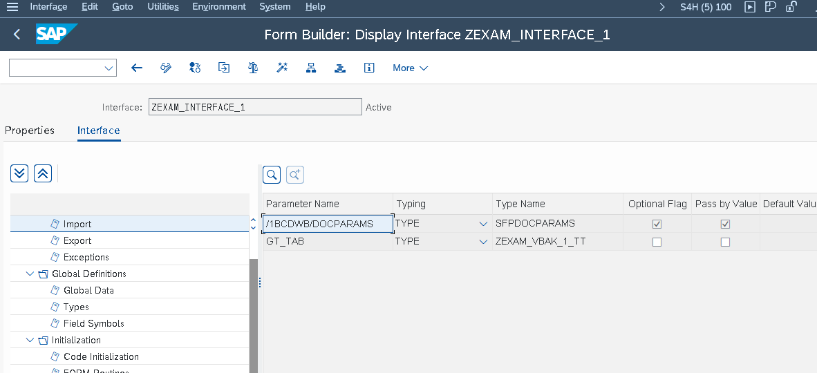

--------------------------------------------GLOBAL DATA:-----------------------------

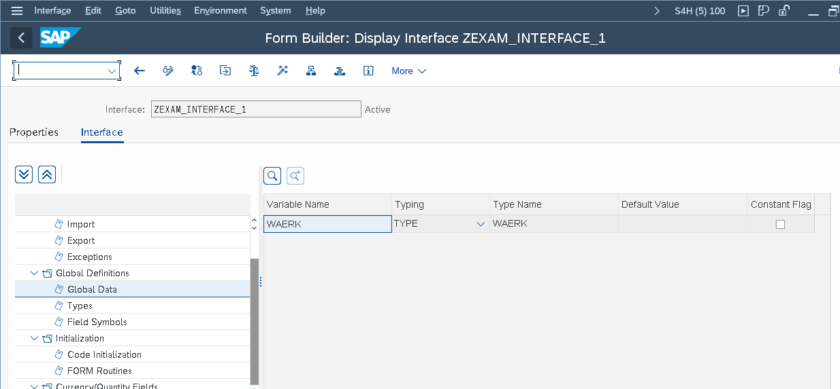

----------------------------QUANTITY AND QURANCY FILEDS-----------------------

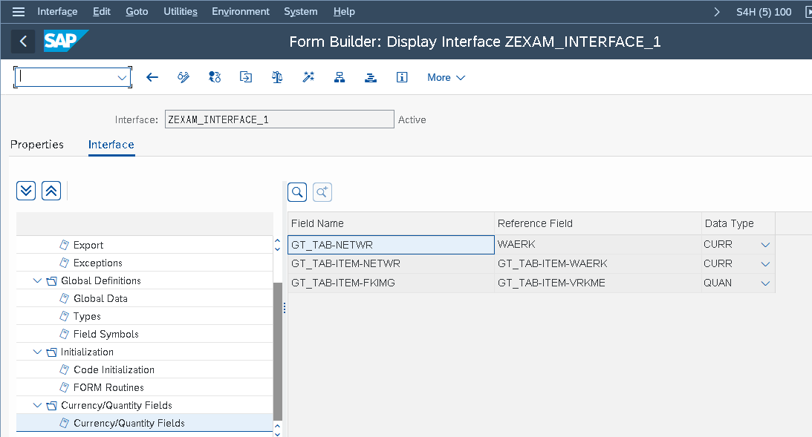

====================================OUTPUT_1=====================================

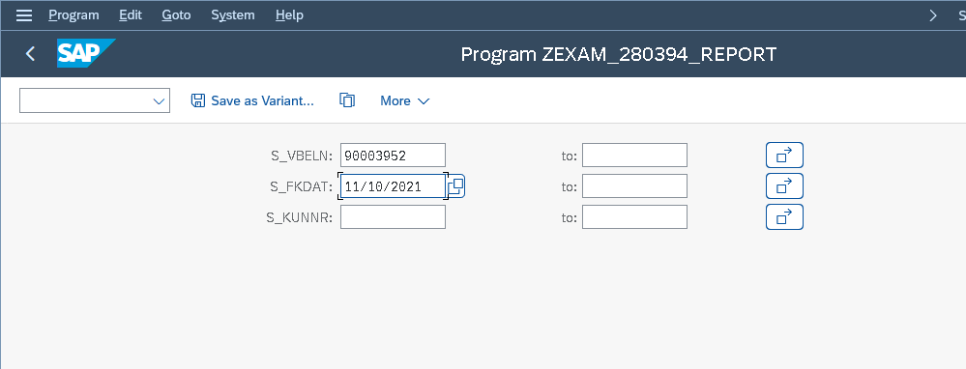

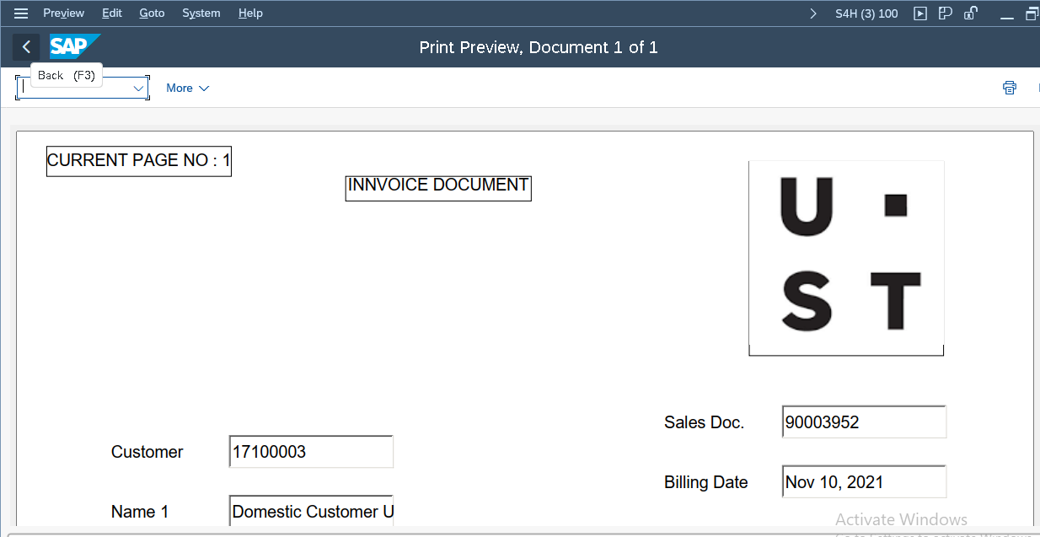

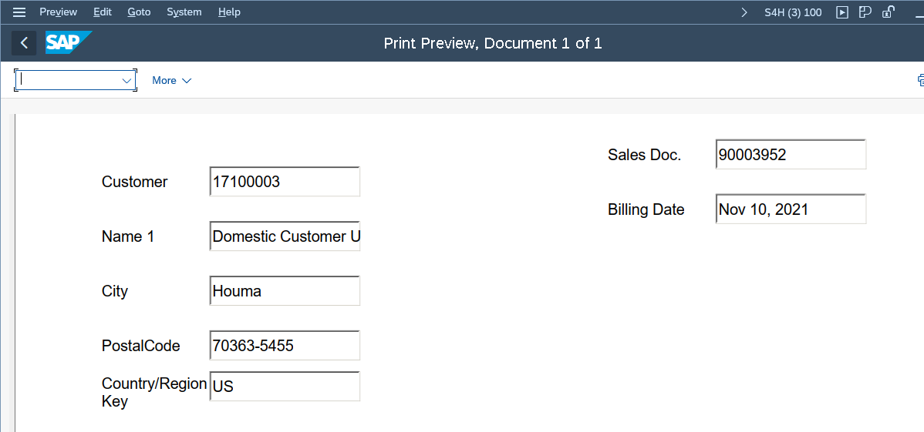

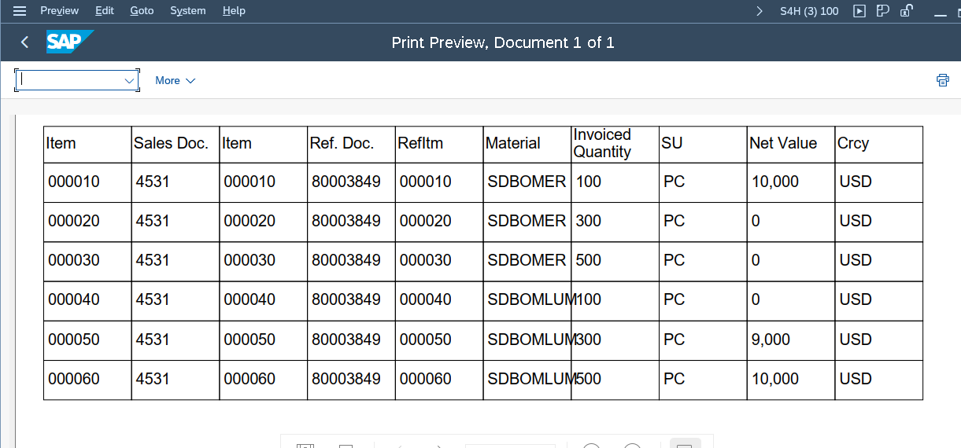

==============================OUTPUT_ 2=========================================

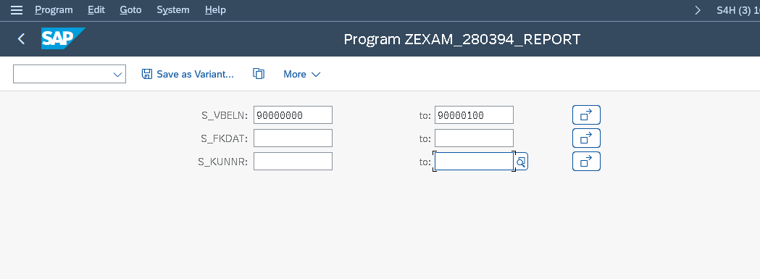

PAGE 1- OUTPUT====================================

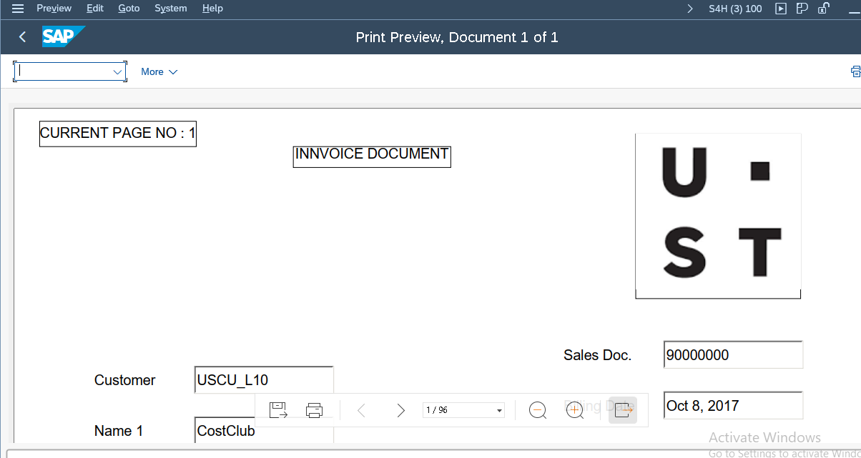

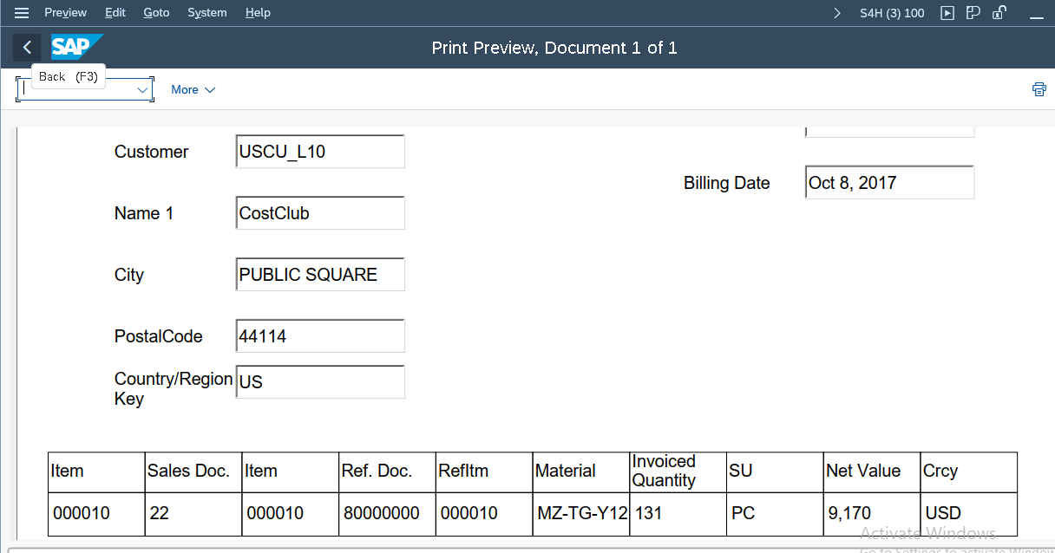

PAGE 2 OUTPUT:===================================

