WEEK2 PROGRAMS:

REPORT zselection_for_studtable NO STANDARD PAGE HEADING LINE-COUNT 20(3) LINE-SIZE 500.  
TYPES : BEGIN OF ls_tab,  " structure1  
          lv_stud_id   TYPE zstud_id,  
          lv_stud_name TYPE zstud_name,  
          lv_stud_ph   TYPE zstud_ph,  
          lv_stud_add  TYPE zstud_add,  
        END OF ls_tab. " end of structure  
DATA : lt_tab TYPE STANDARD TABLE OF ls_tab,  " internal tab 1  
       wa_tab TYPE ls_tab.   " work area 1  
  
DATA lv_STUD_ID TYPE zstud_id.  
  
SELECTION-SCREEN : BEGIN OF BLOCK area1 WITH FRAME TITLE TEXT-001 .  
  SELECT-OPTIONS s_s_id FOR wa_tab-lv_stud_id OBLIGATORY .  
SELECTION-SCREEN END OF BLOCK area1.  
  
  
  
SELECTION-SCREEN : BEGIN OF BLOCK area2 WITH FRAME TITLE TEXT-003.  
  PARAMETERS : r1 RADIOBUTTON GROUP rad1 USER-COMMAND flag DEFAULT 'X',  
               r2 RADIOBUTTON GROUP rad1.  
SELECTION-SCREEN END OF BLOCK area2.  
  
  
  
SELECTION-SCREEN : BEGIN OF BLOCK area3 WITH FRAME TITLE TEXT-002.  
  PARAMETERS : p_s_a  TYPE zstud_add MODIF ID m1,  
               p_s_ph TYPE zstud_ph MODIF ID m2.  
SELECTION-SCREEN END OF BLOCK area3.  
  
AT SELECTION-SCREEN OUTPUT.  
  
  LOOP AT SCREEN.  
    IF r1 = 'X' AND  
    screen-group1 = 'M2'.  
      screen-active = 0.  
*    SCREEN-INVISIBLE = 1.  
    ELSEIF r2 = 'X' AND  
      screen-group1 = 'M1'.  
      screen-active = 0.  
    ENDIF.  
    MODIFY SCREEN.  
  ENDLOOP.  
  START-OF-SELECTION.  
      if r1 = 'X'.  
        PERFORM get_mat_dataforselection.  
        else.  
          PERFORM disp_mat_dataforselection.  
        ENDIF.  
*SELECTION-SCREEN : BEGIN OF BLOCK AREA4 WITH FRAME TITLE TEXT-004.  
*PARAMETERS : c1 AS CHECKBOX,  
*             c2 AS CHECKBOX DEFAULT 'X'.  
*SELECTION-SCREEN END OF BLOCK AREA4.  
INITIALIZATION.  
  s_s_id-low  =  ' 101'.  
  s_s_id-high  = '106'.  
  APPEND s_s_id.  
  
AT SELECTION-SCREEN ON s_s_id.   " 1 to 100  
  SELECT SINGLE stud_id  
    INTO lv_STUD_ID  
     FROM zshiva_student  
  WHERE stud_id IN s_s_id.  
  
START-OF-SELECTION.  
  PERFORM get_mat_dataforselection.  
  PERFORM disp_mat_dataforselection.  
  
END-OF-SELECTION.  
  
  
  DATA lv_count TYPE i.  
  lv_count = sy-linct - sy-linno.  
  SKIP lv_count.  
  
TOP-OF-PAGE.  
  ULINE.  
  WRITE :/ 'Material No',  
         30 'Mat Ind',  
         40 'Mat Type',  
         55 'Mat UOM'.  
  ULINE.  
  
END-OF-PAGE.  
  WRITE :/ 'current list page no:' , sy-pagno,  
          'Date: ', sy-datum,  
          'Time:', sy-uzeit.  
  DATA lv_count1 TYPE i.  
  lv_count1 = sy-linct - sy-linno.  
  SKIP lv_count1.  
FORM disp_mat_dataforselection .  
  LOOP AT lt_tab INTO wa_tab.  
    WRITE : / wa_tab-lv_stud_id,  
             30 wa_tab-lv_stud_name,  
             40 wa_tab-lv_stud_ph,  
             55 wa_tab-lv_stud_add.  
  ENDLOOP.  
ENDFORM.  
  
FORM get_mat_dataforselection .  
  SELECT stud_id stud_name stud_ph stud_add  
  INTO TABLE lt_Tab  
  FROM zshiva_student  
  WHERE stud_id IN  s_s_id AND stud_add EQ p_s_a.  
  SORT lt_Tab BY lv_stud_id DESCENDING.  
  LOOP AT lt_tab INTO wa_tab.  
    WRITE : / wa_tab-lv_stud_id,  
             30 wa_tab-lv_stud_name,  
             40 wa_tab-lv_stud_ph,  
             55 wa_tab-lv_stud_add.  
  ENDLOOP.  
  
  IF sy-subrc EQ 0.  
    WRITE :/ 'Records are found in mara table'.  
  ELSE.  
    WRITE : / 'Records are not found in mara table'.  
  ENDIF.  
  
ENDFORM.

OUTPUT:

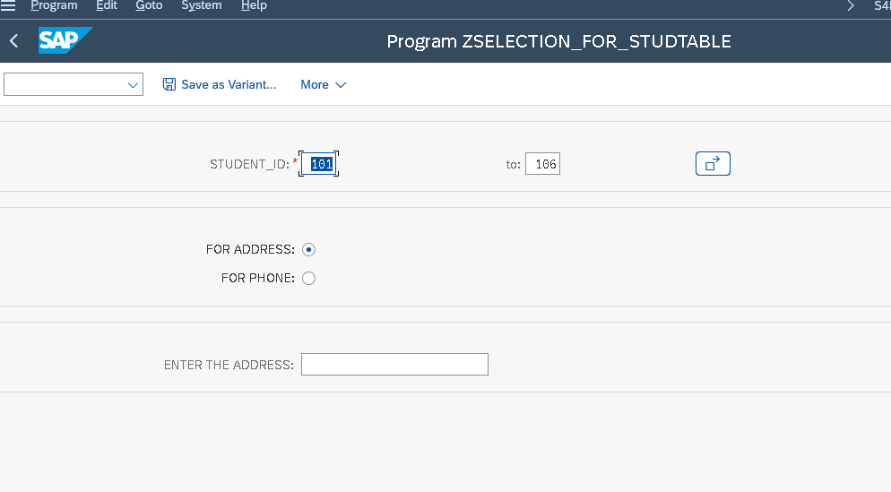

*&---------------------------------------------------------------------*  
*& Report ZSHIVA_CLASSIC_REPORT  
*&---------------------------------------------------------------------*  
*&  
*&---------------------------------------------------------------------*  
REPORT ZSHIVA_CLASSIC_REPORT NO STANDARD PAGE HEADING LINE-COUNT 20(3)  
LINE-SIZE 350 MESSAGE-ID ZSHIVA_MSG.  
  
LOAD-OF-PROGRAM.  
  
INCLUDE ZSHIVA_GETVBAP_TOP.  
  
SELECT-OPTIONS S_VBELN FOR WA_TAB-VBELN OBLIGATORY.  
  
INITIALIZATION.  
CLEAR : WA_TAB,LT_TAB.  
S_VBELN-LOW = '1'.  
S_VBELN-HIGH = '100'.  
APPEND S_VBELN.  
  
AT SELECTION-SCREEN ON S_VBELN.  "1 TO 100  
  
  SELECT SINGLE VBELN  
    INTO LV_VBELN  
    FROM VBAP  
    WHERE VBELN IN S_VBELN.  
  
IF SY-SUBRC EQ 0.  
  MESSAGE S000 .  
ELSE.  
  MESSAGE E001.  
ENDIF.  
  
START-OF-SELECTION.  
PERFORM GET_VBAP_DATA.  
  
END-OF-SELECTION.  
PERFORM DISP_VBAP_DATA.  
  
  
DATA LV_COUNT TYPE I.  
LV_COUNT = SY-LINCT - SY-LINNO.  
SKIP LV_COUNT.  
  
TOP-OF-PAGE.  
ULINE.  
WRITE : /'SALES NO' COLOR 6,  
      30 'MATERIAL NO' COLOR 1,  
      50 'MAT ENTERED' COLOR 4,  
      70 ' ITEM CATEGORY' COLOR 7,  
      85 'SALES ORDER ITEM'.  
ULINE.  
  
  
END-OF-PAGE.  
WRITE :/ 'CURRENT LIST PAGE NO:' , SY-PAGNO,  
         'DATE:', SY-DATUM,  
         'TIME:', SY-UZEIT.  
FORM GET_VBAP_DATA.  
  
  SELECT VBELN MATNR MATWA PSTYV ARKTX  
    INTO TABLE LT_TAB  
    FROM VBAP  
    WHERE VBELN IN S_VBELN.  
  
   IF SY-SUBRC EQ 0.  
     WRITE :/ 'RECORDS ARE FOUND IN VBAP TABLE'.  
     ELSE.  
       WRITE :/ 'RECORDS ARE NOT FOUND IN VBAP TABLE'.  
       ENDIF.  
   ENDFORM.  
  
*&---------------------------------------------------------------------*  
*& Form DISP_VBAP_DATA  
  
*&---------------------------------------------------------------------*  
FORM disp_vbap_data .  
  LOOP AT LT_TAB INTO WA_TAB.  
    WRITE:/ WA_TAB-VBELN COLOR 6 ,  
            30  WA_TAB-MATNR COLOR 1,  
            50 WA_TAB-MATWA COLOR 4,  
            70 WA_TAB-PSTYV COLOR 7,  
            85 WA_TAB-ARKTX COLOR 6.  
ENDLOOP.  
  
ENDFORM.

OUTPUT:

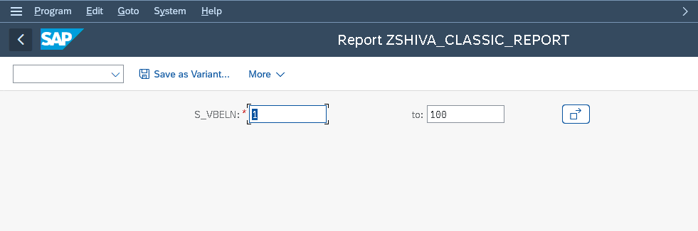

FINAL OUTPUT:

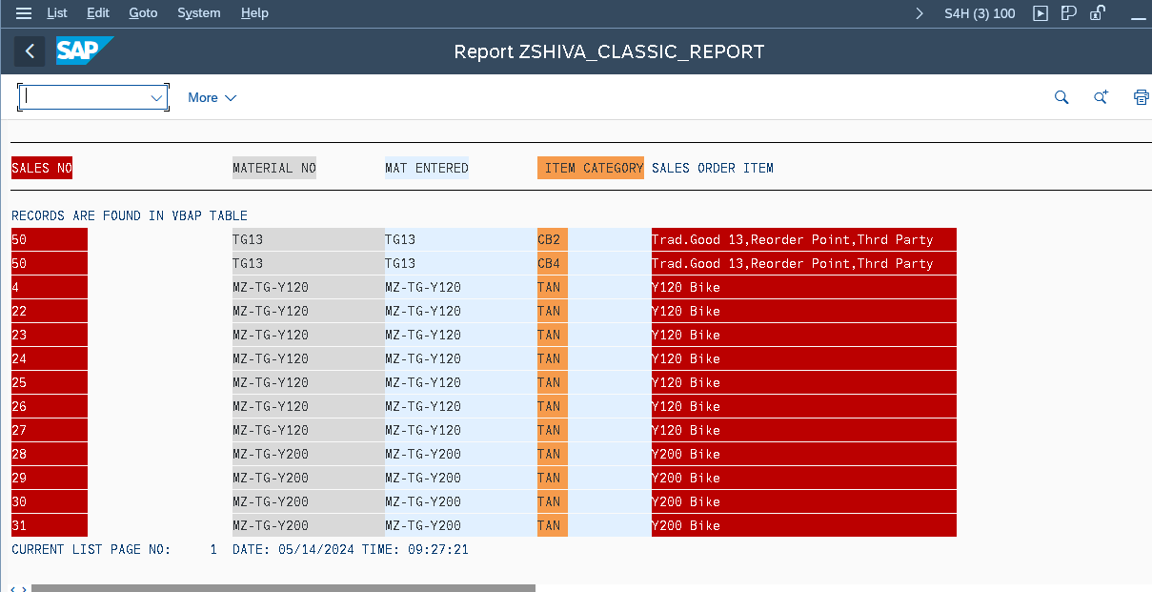

*&---------------------------------------------------------------------*  
*& Report ZSHIVA_CR_STUD_COURSE  
*&---------------------------------------------------------------------*  
*&  
*&---------------------------------------------------------------------*  
REPORT ZSHIVA_CR_STUD_COURSE NO STANDARD PAGE HEADING LINE-COUNT 20(3)  
line-SIZE 350 MESSAGE-ID ZSHIVA_EROR_MSG.  
  
  
LOAD-OF-PROGRAM.  
  
INCLUDE ZSHIVA_CR_SC_INC.  
  
  
  
SELECT-OPTIONS S_S_ID FOR WA_TAB-STUD_ID OBLIGATORY.  
INITIALIZATION.  
S_S_ID-LOW = '101'.  
S_S_ID-HIGH = '106'.  
APPEND S_S_ID.  
AT SELECTION-SCREEN ON S_S_ID.  
  
START-OF-SELECTION.  
  
  PERFORM ZSHIVA_GETJOIN_SC.  
  
  PERFORM ZSHIVA_DISPLOOP.  
  
  IF SY-SUBRC EQ 0.  
    WRITE : 'RECORDS ARE FOUND ',SY-DBCNT.  
    ELSE .  
      WRITE : 'RECORDS ARE NOT FOUND',SY-DBCNT.  
      ENDIF.  
  
END-OF-SELECTION.  
  
TOP-OF-PAGE.  
WRITE : /'STUD_ID',  
20 'STUD_NAME',  
35 'STUD_PH',  
52 'STUD_ADD',  
63 'STUD_ID',  
73  'COURSE_ID',  
95  'COURSE_NAME',  
110   'COURSE_DUR'.  
  
END-OF-PAGE.  
  
*&---------------------------------------------------------------------*  
*& Form ZSHIVA_GETJOIN_SC  
  
FORM zshiva_getjoin_sc .  
  SELECT ZSHIVA_STUDENT~STUD_ID STUD_NAME  STUD_PH STUD_ADD  
       ZSHIVA_COURSE~COURSE_ID COURSE_NAME COURSE_DUR  
  INTO TABLE LT_TAB  
  FROM ZSHIVA_STUDENT INNER JOIN ZSHIVA_COURSE  
  ON ZSHIVA_STUDENT~STUD_ID = ZSHIVA_COURSE~STUD_ID  
  WHERE ZSHIVA_STUDENT~STUD_ID IN S_S_ID.  
  
ENDFORM.  
*&---------------------------------------------------------------------*  
*& Form ZSHIVA_DISPLOOP  
  
FORM zshiva_disploop .  
  LOOP AT LT_TAB INTO WA_TAB.  
        WRITE :/ WA_TAB-STUD_ID,  
                 WA_TAB-STUD_NAME,  
                 WA_TAB-STUD_PH,  
                 WA_TAB-STUD_ADD,  
                 WA_TAB-COURSE_ID,  
                 WA_TAB-COURSE_NAME,  
                 WA_TAB-COURSE_DUR.  
        ENDLOOP.  
  
ENDFORM.

OUTPUT:

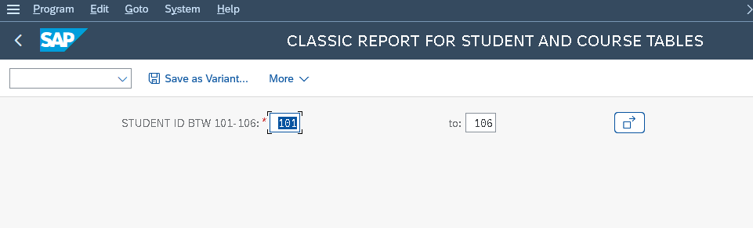

FINAL OUTPUT:

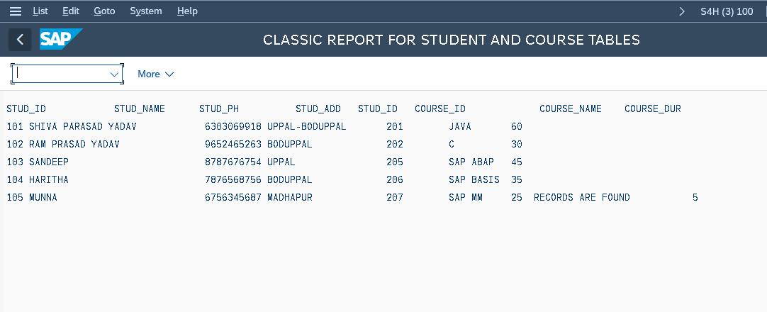

*&---------------------------------------------------------------------*  
*& Report ZSHIVA_ASSI_FNMOD_JOIN  
*&---------------------------------------------------------------------*  
*&  
*&---------------------------------------------------------------------*  
REPORT ZSHIVA_ASSI_FNMOD_JOIN.  
DATA : LV_STUD_ID TYPE ZSTUD_ID,  
  
      TEMP_TAB  TYPE TABLE OF  ZSHIVA_STR_ASSIGN,  
      "TEMP_TAB  TYPE ZSHIVA_STR_ASSIGN_TT,  
  
      WA_TAB TYPE ZSHIVA_STR_ASSIGN.  
  
SELECT-OPTIONS S_S_ID FOR LV_STUD_ID.  
  
CALL FUNCTION 'ZSHIVA_FUN_ASSIGN'  
 EXPORTING  
   INPUT_A       = S_S_ID-LOW  
   INPUT_B       = S_S_ID-HIGH  
  TABLES  
    gt_tab        = TEMP_TAB  
          .  
  
LOOP AT TEMP_TAB INTO WA_TAB.  
  WRITE : / WA_TAB-STUD_ID,  
  WA_TAB-STUD_NAME,  
  WA_TAB-STUD_PH,  
  WA_TAB-STUD_ADD,  
  WA_TAB-COURSE_ID,  
  WA_TAB-COURSE_NAME,  
  WA_TAB-COURSE_DUR.  
 ENDLOOP.

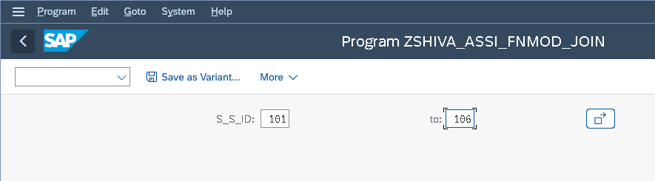

FINAL OUTPUT:

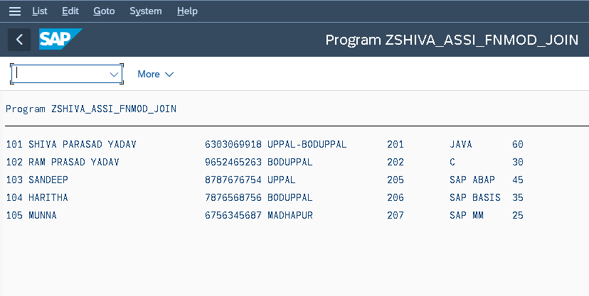

*&---------------------------------------------------------------------*  
*& Report ZSHIVA_IT_STUD  
*&---------------------------------------------------------------------*  
*&  
*&---------------------------------------------------------------------*  
REPORT ZSHIVA_IT_STUD.  
  
TYPES: BEGIN OF LS_TAB,  
  STUD_ID TYPE ZSTUD_ID,  
  STUD_NAME TYPE ZSTUD_NAME,  
  STUD_PH TYPE ZSTUD_PH,  
  STUD_ADD TYPE ZSTUD_ADD,  
  END OF LS_TAB.  
  
  
  DATA : LT_TAB TYPE STANDARD TABLE OF LS_TAB,  
        WA_TAB TYPE LS_TAB,  
        LV_STUD_ID TYPE ZSTUD_ID.  
  
SELECT-OPTIONS S_ID FOR LV_STUD_ID OBLIGATORY.  
  
PARAMETERS P_S_ADD TYPE ZSHIVA_STUDENT-STUD_ADD.  " us  
  
START-OF-SELECTION.  
  
  SELECT  STUD_ID STUD_NAME STUD_PH STUD_ADD  
    INTO TABLE LT_tAB  
         FROM ZSHIVA_STUDENT  
          WHERE STUD_ID IN S_ID. "AND  
              " STUD_ADD EQ p_S_ADD.  
  
  IF sy-subrc EQ 0.  
    WRITE : / 'records are found in kna1 table ', sy-dbcnt.  
  ELSE.  
    WRITE : / 'records are not found in kna1 table ', sy-dbcnt.  
  ENDIF.  
****SKIP .  
SKIP 3.  
  
WRITE : / 'STUDENT ID',  
         10 'STUDENT NAME ',  
         30 'STUDENT PHONE ',  
         50 'STUDENT ADD',  
         65 'Region Key'.  
  
ULINE.  
END-OF-SELECTION.  
  
FORMAT COLOR COL_POSITIVE.  
  
LOOP AT LT_TAB INTO WA_TAB.  
  WRITE : / SY-CTABL,  
  10 WA_TAB-STUD_ID,  
  30 WA_TAB-STUD_NAME,  
  50 WA_TAB-STUD_PH,  
  65 WA_TAB-STUD_ADD.  
  ENDLOOP.

OUTPUT:

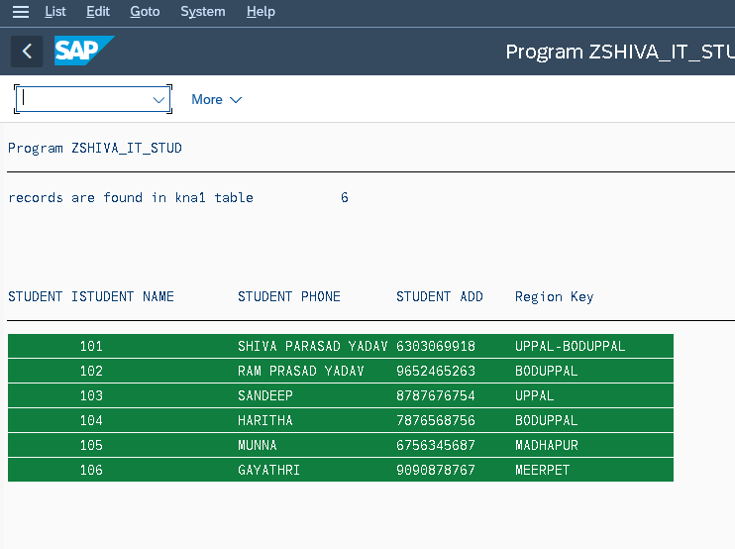

*&---------------------------------------------------------------------*  
*& Report ZSHIVA_LEFTOUTER_JOIN  
*&---------------------------------------------------------------------*  
*&  
*&---------------------------------------------------------------------*  
REPORT ZSHIVA_LEFTOUTER_JOIN.  
TYPES: BEGIN OF LS_TAB,  
  STUD_ID TYPE ZSTUD_ID,  
  STUD_NAME TYPE ZSTUD_NAME,  
  STUD_PH TYPE ZSTUD_PH,  
  STUD_ADD TYPE ZSTUD_ADD,  
  
  COURSE_ID TYPE ZCOURSE_ID,  
  COURSE_NAME TYPE ZCOURSE_NAME,  
  COURSE_DUR TYPE ZCOURSE_DUR,  
  
  END OF LS_TAB.  
  
  DATA : LT_TAB TYPE STANDARD TABLE OF LS_TAB,  
        WA_TAB TYPE LS_TAB.  
  SELECT-OPTIONS S_S_ID FOR WA_TAB-STUD_ID.  
  
  START-OF-SELECTION.  
  SELECT ZSHIVA_STUDENT~STUD_ID STUD_NAME STUD_PH STUD_ADD  
         ZSHIVA_COURSE~COURSE_ID COURSE_NAME COURSE_DUR  
    INTO TABLE LT_TAB  
    FROM ZSHIVA_STUDENT  
    LEFT OUTER JOIN ZSHIVA_COURSE  
    ON ZSHIVA_STUDENT~STUD_ID = ZSHIVA_COURSE~STUD_ID  
    WHERE ZSHIVA_STUDENT~STUD_ID IN S_S_ID.  
  
    IF SY-SUBRC EQ 0.  
      WRITE : 'RECORDS ARE FOUND', SY-DBCNT.  
      ELSE.  
        WRITE : 'RECORDS ARE NOT FOUND ',SY-DBCNT.  
        ENDIF.  
  
        END-OF-SELECTION.  
  
        LOOP AT LT_TAB INTO WA_TAB.  
          WRITE : /   WA_TAB-STUD_ID,  
          WA_TAB-STUD_NAME ,  
          WA_TAB-STUD_PH,  
          WA_TAB-STUD_ADD,  
          WA_TAB-COURSE_ID,  
          WA_TAB-COURSE_NAME,  
          WA_TAB-COURSE_DUR.  
          ENDLOOP.

OUTPUT:

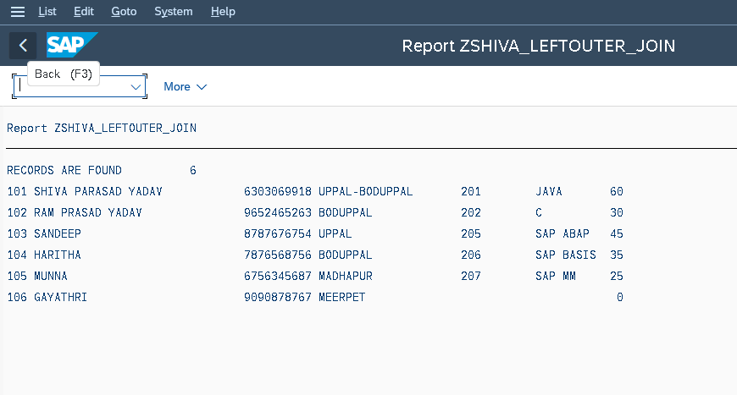

*& Report ZSHIVA_ALV1_HIER  
REPORT ZSHIVA_ALV1_HIER NO STANDARD PAGE HEADING LINE-COUNT 23(3) LINE-SIZE 300.  
INCLUDE ZSHIVA_HIER_INC.  
SELECT-OPTIONS S_VBELN FOR LV_VBELN.  
  
START-OF-SELECTION.  
PERFORM GET_DATA.  
  
PERFORM CREATE_FIELDCAT.  
  
PERFORM HIER_DISPLAY.  
*&---------------------------------------------------------------------*  
*& Form GET_DATA  
*&---------------------------------------------------------------------*  
*& text  
*&---------------------------------------------------------------------*  
*& -->  p1        text  
*& <--  p2        text  
*&---------------------------------------------------------------------*  
FORM get_data .  
  SELECT VBELN FKART FKTYP FROM VBRK  " TABLE 1  
    INTO CORRESPONDING FIELDS OF TABLE IT_TAB1  
    WHERE VBELN IN  
    S_VBELN.  
  
  
  SELECT   VBELN  POSNR  UEPOS  
    FROM VBRP  " TABLE 2  
    INTO  TABLE IT_TAB2  
    WHERE VBELN IN S_VBELN.  
  
ENDFORM.  
*&---------------------------------------------------------------------*  
*& Form CREATE_FIELDCAT  
*&---------------------------------------------------------------------*  
*& text  
*&---------------------------------------------------------------------*  
*& -->  p1        text  
*& <--  p2        text  
*&---------------------------------------------------------------------*  
FORM create_fieldcat .  
  WA_FIELDCAT-col_pos = '1'.  " COLUM POSITION  
  WA_FIELDCAT-fieldname = 'VBELN'. " COLUMN NAME  
  WA_FIELDCAT-tabname = 'IT_TAB1'. " INTERNAL TABLE  
  WA_FIELDCAT-ref_tabname = 'VBRK'. " TABLE NAME  
  WA_FIELDCAT-ref_fieldname = 'VBELN'. "REFERENCE FILED  
  APPEND WA_FIELDCAT TO IT_FIELDCAT.  
  CLEAR WA_FIELDCAT.  
  
  
   WA_FIELDCAT-col_pos = '2'.  " COLUM POSITION  
  WA_FIELDCAT-fieldname = 'FKART'. " COLUMN NAME  
  WA_FIELDCAT-tabname = 'IT_TAB1'. " INTERNAL TABLE  
  WA_FIELDCAT-ref_tabname = 'VBRK'. " TABLE NAME  
  WA_FIELDCAT-ref_fieldname = 'FKART'. "REFERENCE FILED  
  APPEND WA_FIELDCAT TO IT_FIELDCAT.  
  CLEAR WA_FIELDCAT.  
  
  
   WA_FIELDCAT-col_pos = '3'.  " COLUM POSITION  
  WA_FIELDCAT-fieldname = 'FKTYP'. " COLUMN NAME  
  WA_FIELDCAT-tabname = 'IT_TAB1'. " INTERNAL TABLE  
  WA_FIELDCAT-ref_tabname = 'VBRK'. " TABLE NAME  
  WA_FIELDCAT-ref_fieldname = 'FKTYP'. "REFERENCE FILED  
  APPEND WA_FIELDCAT TO IT_FIELDCAT.  
  CLEAR WA_FIELDCAT.  
  
  
  
   WA_FIELDCAT-col_pos = '1'.  " COLUM POSITION  
  WA_FIELDCAT-fieldname = 'VBELN'. " COLUMN NAME  
  WA_FIELDCAT-tabname = 'IT_TAB2'. " INTERNAL TABLE  
  WA_FIELDCAT-ref_tabname = 'VBRP'. " TABLE NAME  
  WA_FIELDCAT-ref_fieldname = 'VEBLN'. "REFERENCE FILED  
  APPEND WA_FIELDCAT TO IT_FIELDCAT.  
  CLEAR WA_FIELDCAT.  
  
   WA_FIELDCAT-col_pos = '2'.  " COLUM POSITION  
  WA_FIELDCAT-fieldname = 'POSNR'. " COLUMN NAME  
  WA_FIELDCAT-tabname = 'IT_TAB2'. " INTERNAL TABLE  
  WA_FIELDCAT-ref_tabname = 'VBRP'. " TABLE NAME  
  WA_FIELDCAT-ref_fieldname = 'POSNR'. "REFERENCE FILED  
  APPEND WA_FIELDCAT TO IT_FIELDCAT.  
  CLEAR WA_FIELDCAT.  
  
  
   WA_FIELDCAT-col_pos = '3'.  " COLUM POSITION  
  WA_FIELDCAT-fieldname = 'UEPOS'. " COLUMN NAME  
  WA_FIELDCAT-tabname = 'IT_TAB2'. " INTERNAL TABLE  
  WA_FIELDCAT-ref_tabname = 'VBRP'. " TABLE NAME  
  WA_FIELDCAT-ref_fieldname = 'UEPOS'. "REFERENCE FILED  
  APPEND WA_FIELDCAT TO IT_FIELDCAT.  
  CLEAR WA_FIELDCAT.  
  
  
  
ENDFORM.  
*&---------------------------------------------------------------------*  
*& Form HIER_DISPLAY  
*&---------------------------------------------------------------------*  
*& text  
*&---------------------------------------------------------------------*  
*& -->  p1        text  
*& <--  p2        text  
*&---------------------------------------------------------------------*  
FORM hier_display .  
  
  
  IT_KEY-HEADER01 = 'VBELN'.  
  LAYOUT-EXPAND_FIELDNAME = 'UST'.  
  
  IF SY-SUBRC EQ 0.  
CALL FUNCTION 'REUSE_ALV_HIERSEQ_LIST_DISPLAY'  
  EXPORTING  
*   I_INTERFACE_CHECK              = ' '  
   I_CALLBACK_PROGRAM             = SY-REPID  
*   I_CALLBACK_PF_STATUS_SET       = ' '  
*   I_CALLBACK_USER_COMMAND        = ' '  
   IS_LAYOUT                      = LAYOUT  
   IT_FIELDCAT                    = IT_FIELDCAT  
*   IT_EXCLUDING                   =  
*   IT_SPECIAL_GROUPS              =  
*   IT_SORT                        =  
*   IT_FILTER                      =  
*   IS_SEL_HIDE                    =  
*   I_SCREEN_START_COLUMN          = 0  
*   I_SCREEN_START_LINE            = 0  
*   I_SCREEN_END_COLUMN            = 0  
*   I_SCREEN_END_LINE              = 0  
*  I_DEFAULT                      = X  
*   I_SAVE                         = ' '  
*   IS_VARIANT                     =  
*   IT_EVENTS                      =  
*   IT_EVENT_EXIT                  =  
    i_tabname_header               = 'IT_TAB1'  
    i_tabname_item                 = 'IT_TAB2'  
*   I_STRUCTURE_NAME_HEADER        =  
*   I_STRUCTURE_NAME_ITEM          =  
    is_keyinfo                     = IT_KEY  
*   IS_PRINT                       =  
*   IS_REPREP_ID                   =  
*   IS_HIERSEQ_SETTINGS            =  
*   I_BYPASSING_BUFFER             =  
*   I_BUFFER_ACTIVE                =  
*   IR_SALV_HIERSEQ_ADAPTER        =  
*   IT_EXCEPT_QINFO                =  
*   I_SUPPRESS_EMPTY_DATA          = ABAP_FALSE  
*   I_LIST_DISPLAY_ONLY            = ABAP_FALSE  
*   O_COMMON_HUB                   =  
* IMPORTING  
*   E_EXIT_CAUSED_BY_CALLER        =  
*   ES_EXIT_CAUSED_BY_USER         =  
  TABLES  
    t_outtab_header                = IT_TAB1  
    t_outtab_item                  = IT_TAB2  
 EXCEPTIONS  
   PROGRAM_ERROR                  = 1  
   OTHERS                         = 2  
          .  
IF sy-subrc <> 0.  
* Implement suitable error handling here  
ENDIF.  
ENDIF.  
  
ENDFORM.

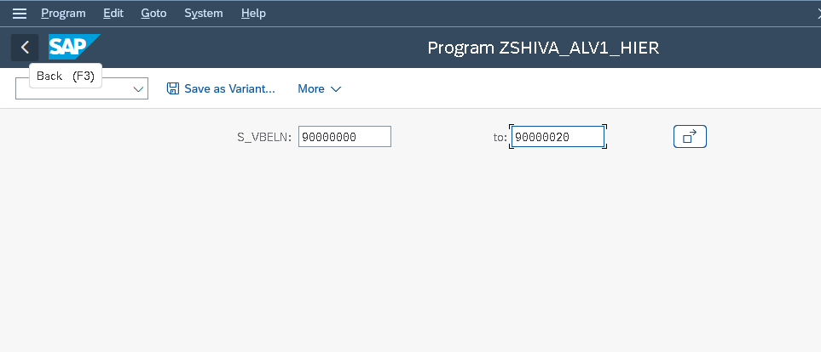

FINAL OUTPUT:

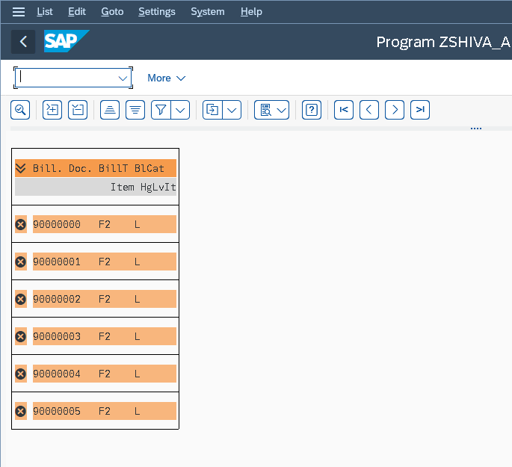

*&---------------------------------------------------------------------*  
*& Report ZSHIVA_ALV_BLOCK  
*&---------------------------------------------------------------------*  
*&  
*&---------------------------------------------------------------------*  
REPORT ZSHIVA_ALV_BLOCK.  
  
  
include zshiva_ust_alv_block_top.  
  
data lv_vbeln type vbeln_va.  
******TABLES VBAK.  
select-options s_vbeln for lv_VBELN. " lv_vbeln.  
  
start-of-selection.  
  perform get_data.  
  
  perform create_fcat_VBAK.  
  perform create_fcat_vbap.  
  
  perform block_list_init.  
  perform block_list_append_vbaK.  
  perform block_list_append_vbap.  
  perform block_list_display.  
  
form get_data.  
  select vbeln  
         erdat  
          erzet  
           from vbak  
  into table it_vbak  where vbeln in s_vbeln.  
  
  if not it_vbak[] is initial .  
  
    select  vbeln pOsnr matnr  
    from vbap  
      into table it_vbap "get vbap data  
  
    "for all entries in it_vbak  
       where vbeln in s_vbeln.  
  
  endif.  
endform.  
  
form create_fcat_vbak.  
  
  w_fcat_vbak-col_pos       = '1'. "coloum position  
  w_fcat_vbak-fieldname     = 'VBELN'. "column name  
  w_fcat_vbak-ref_tabname   = 'VBAK'. "table  VBAK  
  w_fcat_vbak-ref_fieldname = 'VBELN'. "reference field, it will show descriptions automatically  
  append w_fcat_vbak to t_fcat_vbak.  
  clear w_fcat_vbak.  
  
  w_fcat_vbak-col_pos       = '2'. "coloum position  
  w_fcat_vbak-fieldname     = 'ERDAT'. "column name  
  w_fcat_vbak-ref_tabname   = 'VBAK'. "table  VBAK  
  w_fcat_vbak-ref_fieldname = 'ERDAT'. "reference field, it will show descriptions automatically  
  append w_fcat_VBAK to t_fcat_VBAK.  
  clear w_fcat_VBAK.  
  
  w_fcat_vbak-col_pos       = '3'. "coloum position  
  w_fcat_vbak-fieldname     = 'ERZET'. "column name  
  w_fcat_vbak-ref_tabname   = 'VBAK'. "table  VBAK  
  w_fcat_vbak-ref_fieldname = 'ERZET'. "reference field, it will show descriptions automatically  
  append w_fcat_VBAK to t_fcat_VBAK.  
  clear w_fcat_VBAK.  
  
  
endform.  
  
form create_fcat_vbap.  
  
  w_fcat_vbap-col_pos       = '1'. "coloum position  
  w_fcat_vbap-fieldname     = 'VBELN'. "column name  
  w_fcat_vbap-ref_tabname   = 'VBAP'. "table  VBAP  
  w_fcat_vbap-ref_fieldname = 'VBELN'. "reference field, it will show descriptions automatically  
  append w_fcat_vbap to t_fcat_vbap.  
  clear w_fcat_vbap.  
  
  w_fcat_vbap-col_pos       = '2'. "coloum position  
  w_fcat_vbap-fieldname     = 'POSNR'. "column name  
  w_fcat_vbap-ref_tabname   = 'VBAP'. "table  VBAP  
  w_fcat_vbap-ref_fieldname = 'POSNR'. "reference field, it will show descriptions automatically  
  append w_fcat_vbap to t_fcat_vbap.  
  clear w_fcat_vbap.  
  
  w_fcat_vbap-col_pos       = '3'. "coloum position  
  w_fcat_vbap-fieldname     = 'MATNR'. "column name  
  w_fcat_vbap-ref_tabname   = 'VBAP'. "table  VBAP  
  w_fcat_vbap-ref_fieldname = 'MATNR'. "reference field, it will show descriptions automatically  
  append w_fcat_vbap to t_fcat_vbap.  
  clear w_fcat_vbap.  
  
endform.  
  
form block_list_init.  
  
  
  
  
  call function 'REUSE_ALV_BLOCK_LIST_INIT' "initialize Block List ALV  
    exporting  
      i_callback_program = sy-repid.  
endform.  
  
form block_list_append_VBAK.  
**  
*  s_layout-zebra = 'X'.  "  striped pattern  
*  s_layout-No_colhead  = 'X'.        " no headings  
***  s_layout-no_hotspot = 'X'.         " headings not as hotspot  
*  s_layout-no_vline  = 'X'.          " columns separated by space  
*  s_layout-no_hline = 'X'.  
  
  call function 'REUSE_ALV_BLOCK_LIST_APPEND' "append ALV lists  
    exporting  
      is_layout   = s_layout "set layout  
      it_fieldcat = t_fcat_vbak "set field catalog  
      i_tabname   = 'IT_VBAK' "table  
      it_events   = s_events "events  
    tables  
      t_outtab    = it_VBAK. "out put table  
  
  if sy-subrc <> 0.  
* Implement suitable error handling here  
  endif.  
endform.  
  
form block_list_append_VBAP.  
  
  
  call function 'REUSE_ALV_BLOCK_LIST_APPEND' "append ALV lists  
    exporting  
      is_layout   = s_layout "set layout  
      it_fieldcat = t_fcat_VBAP "set field catalog  
      i_tabname   = 'IT_VBAP' "table  
      it_events   = s_events "events  
    tables  
      t_outtab    = it_VBAP. "out put table  
  
  if sy-subrc <> 0.  
* Implement suitable error handling here  
  endif.  
  
endform.  
*&---------------------------------------------------------------------*  
*&      Form  BLOCK_LIST_DISPLAY  
*&---------------------------------------------------------------------*  
  
form block_list_display .  
  
  call function 'REUSE_ALV_BLOCK_LIST_DISPLAY'. "display blocked list  
  
endform.

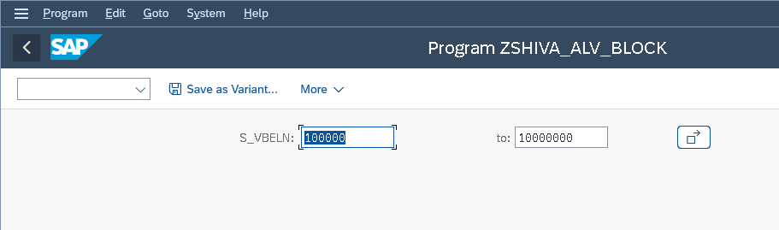

FINAL OUTPUT:

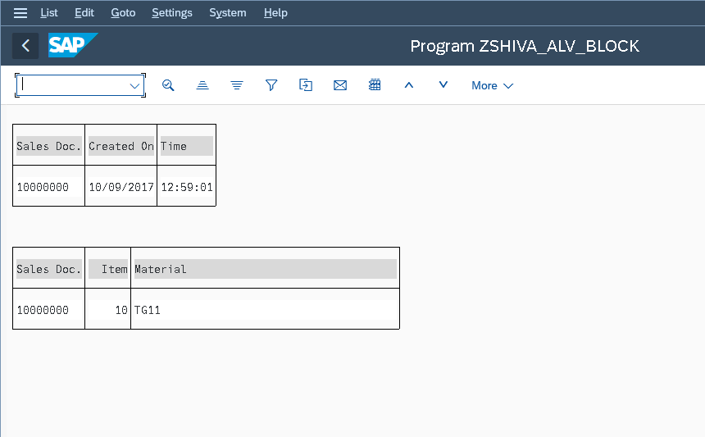

*&---------------------------------------------------------------------*  
*& Report ZSHIVA_ALV_FILEDCAT_MERGE  
*&---------------------------------------------------------------------*  
*&  
*&---------------------------------------------------------------------*  
REPORT ZSHIVA_ALV_FILEDCAT_MERGE  
no standard page heading line-count 20(3)  
line-size 500 message-id zshiva_eror_msg.  
  
INCLUDE ZSHIVA_UST_ALV_MERGE_TOP.  
  
select-options s_matnr for lv_matnr obligatory.  
  
initialization.  
  clear: lt_Tab, wa_fieldcat, lt_fieldcat.  
  s_matnr-low  = '1'.  
  s_matnr-high  = '100'.  
  append s_matnr.  
  
at selection-screen on s_matnr.   " 1 to 100  
  
  select single matnr  
    into lv_matnr  
     from mara  
     where matnr in s_matnr.  
  
  if sy-subrc eq 0.  
    message s000.  " se91 - tcode.  
  else.  
    message e001.  " se91 - tcode.  
  endif.  
  
start-of-selection.  
  
  perform get_alv_fcat.  
  perform get_mat_data.  
  
end-of-selection.  
  perform disp_mat_alvout.  
  
form get_mat_data.  
  select *  
      into table lt_Tab  
      from mara  
      where matnr in  s_matnr.  
  
  if sy-subrc eq 0.  
    message s000.  
  else.  
    message e001.  
  endif.  
  
endform.  
*&---------------------------------------------------------------------*  
*& Form GET_ALV_FCAT  
*&---------------------------------------------------------------------*  
form get_alv_fcat .  
  
**********************COL_POS = '1'.  
  
call function 'REUSE_ALV_FIELDCATALOG_MERGE'  
 EXPORTING  
   I_PROGRAM_NAME               = SY-REPID  
   I_INTERNAL_TABNAME           = 'LT_TAB'  
   I_STRUCTURE_NAME             = 'MARA'  
*   I_CLIENT_NEVER_DISPLAY       = 'X'  
*   I_INCLNAME                   =  
*   I_BYPASSING_BUFFER           =  
*   I_BUFFER_ACTIVE              =  
  changing  
    ct_fieldcat                  = LT_FIELDCAT  
* EXCEPTIONS  
*   INCONSISTENT_INTERFACE       = 1  
*   PROGRAM_ERROR                = 2  
*   OTHERS                       = 3  
          .  
if sy-subrc <> 0.  
* Implement suitable error handling here  
endif.  
  
  
  
endform.  
*&---------------------------------------------------------------------*  
*& Form DISP_MAT_ALVOUT  
*&---------------------------------------------------------------------*  
*& text  
form disp_mat_alvout .  
  
call function 'REUSE_ALV_GRID_DISPLAY'  
 EXPORTING  
*   I_INTERFACE_CHECK                 = ' '  
*   I_BYPASSING_BUFFER                = ' '  
*   I_BUFFER_ACTIVE                   = ' '  
   I_CALLBACK_PROGRAM                = SY-REPID  
*   I_CALLBACK_PF_STATUS_SET          = ' '  
*   I_CALLBACK_USER_COMMAND           = ' '  
*   I_CALLBACK_TOP_OF_PAGE            = ' '  
*   I_CALLBACK_HTML_TOP_OF_PAGE       = ' '  
*   I_CALLBACK_HTML_END_OF_LIST       = ' '  
*   I_STRUCTURE_NAME                  =  
*   I_BACKGROUND_ID                   = ' '  
*   I_GRID_TITLE                      =  
*   I_GRID_SETTINGS                   =  
*   IS_LAYOUT                         =  
   IT_FIELDCAT                       = LT_FIELDCAT  
*   IT_EXCLUDING                      =  
*   IT_SPECIAL_GROUPS                 =  
*   IT_SORT                           =  
*   IT_FILTER                         =  
*   IS_SEL_HIDE                       =  
*   I_DEFAULT                         = 'X'  
*   I_SAVE                            = ' '  
*   IS_VARIANT                        =  
*   IT_EVENTS                         =  
*   IT_EVENT_EXIT                     =  
*   IS_PRINT                          =  
*   IS_REPREP_ID                      =  
*   I_SCREEN_START_COLUMN             = 0  
*   I_SCREEN_START_LINE               = 0  
*   I_SCREEN_END_COLUMN               = 0  
*   I_SCREEN_END_LINE                 = 0  
*   I_HTML_HEIGHT_TOP                 = 0  
*   I_HTML_HEIGHT_END                 = 0  
*   IT_ALV_GRAPHICS                   =  
*   IT_HYPERLINK                      =  
*   IT_ADD_FIELDCAT                   =  
*   IT_EXCEPT_QINFO                   =  
*   IR_SALV_FULLSCREEN_ADAPTER        =  
*   O_PREVIOUS_SRAL_HANDLER           =  
*   O_COMMON_HUB                      =  
* IMPORTING  
*   E_EXIT_CAUSED_BY_CALLER           =  
*   ES_EXIT_CAUSED_BY_USER            =  
  tables  
    t_outtab                          = LT_tAB  
* EXCEPTIONS  
*   PROGRAM_ERROR                     = 1  
*   OTHERS                            = 2  
          .  
if sy-subrc <> 0.  
* Implement suitable error handling here  
endif.  
  
  
  
endform.

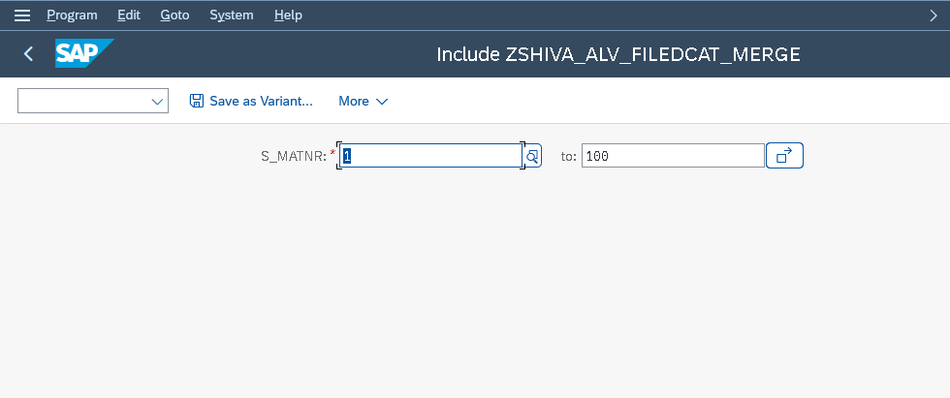

FINAL OUTPUT;

