Product Line Profitability & Margin Performance Analysis
  - Nassau Candy Distributor
Data Analytics Project | EDA, Profitability Diagnostics, Pareto Analysis & Streamlit Dashboard

Abstract
This study analyzes 10,194 Nassau Candy Distributor order records covering 02 Jan 2024 to 31 Dec 2025. Total sales are $141,783.63, cost is $48,340.83, and gross profit is $93,442.80, producing an overall gross margin of 65.9%. The analysis identifies product-level profit leaders, margin risks, division-level performance, profit concentration and cost-to-sales relationships. Results show a highly concentrated portfolio: 5 of 15 products generate at least 80% of gross profit, while 5 products generate at least 80% of revenue. The findings support targeted pricing, sourcing, and portfolio-management decisions rather than relying on sales volume alone.

1. Introduction & Business Problem
Sales volume can obscure profitability. A product may sell frequently but contribute little margin because of high cost or weak pricing. Nassau Candy Distributor therefore needs visibility into product-line economics, division performance and concentration risk so that pricing, promotions, sourcing and rationalization decisions can be evidence-based.

2. Dataset & Variables
The supplied CSV contains 10,194 rows and 24 fields. Core analytical fields are Sales, Units, Gross Profit, Cost, Division, Product ID, Product Name, Order Date, Region and State/Province. The supplied factory correlation was joined to products to support manufacturing-location diagnostics.

3. Data Cleaning & Validation
All 10,194 rows have complete values across the supplied fields. There are 0 exact duplicate rows, 0 non-positive sales rows and 0 non-positive unit rows. Gross Profit reconciles to Sales − Cost with a maximum floating-point difference of 0.00000000. Dates were parsed in day-first format based on the supplied data. A notable data-quality observation is that shipment dates occur far after order dates (median 1274 days); this should be validated with the data owner before using shipping lead time operationally.

4. Analytical Methodology
Gross Margin % = Gross Profit / Sales × 100. Profit per Unit = Gross Profit / Units. Revenue Contribution = Product Sales / Total Sales. Profit Contribution = Product Gross Profit / Total Gross Profit. Margin volatility is measured as the standard deviation of monthly product margin percentages. Pareto analysis ranks products descending by revenue or gross profit and calculates cumulative contribution.

5. Overall KPI Results
Total Sales | Total Cost | Gross Profit | Gross Margin | Units | Products
$141,783.63 | $48,340.83 | $93,442.80 | 65.9% | 38,654 | 15

6. Product-Level Profitability
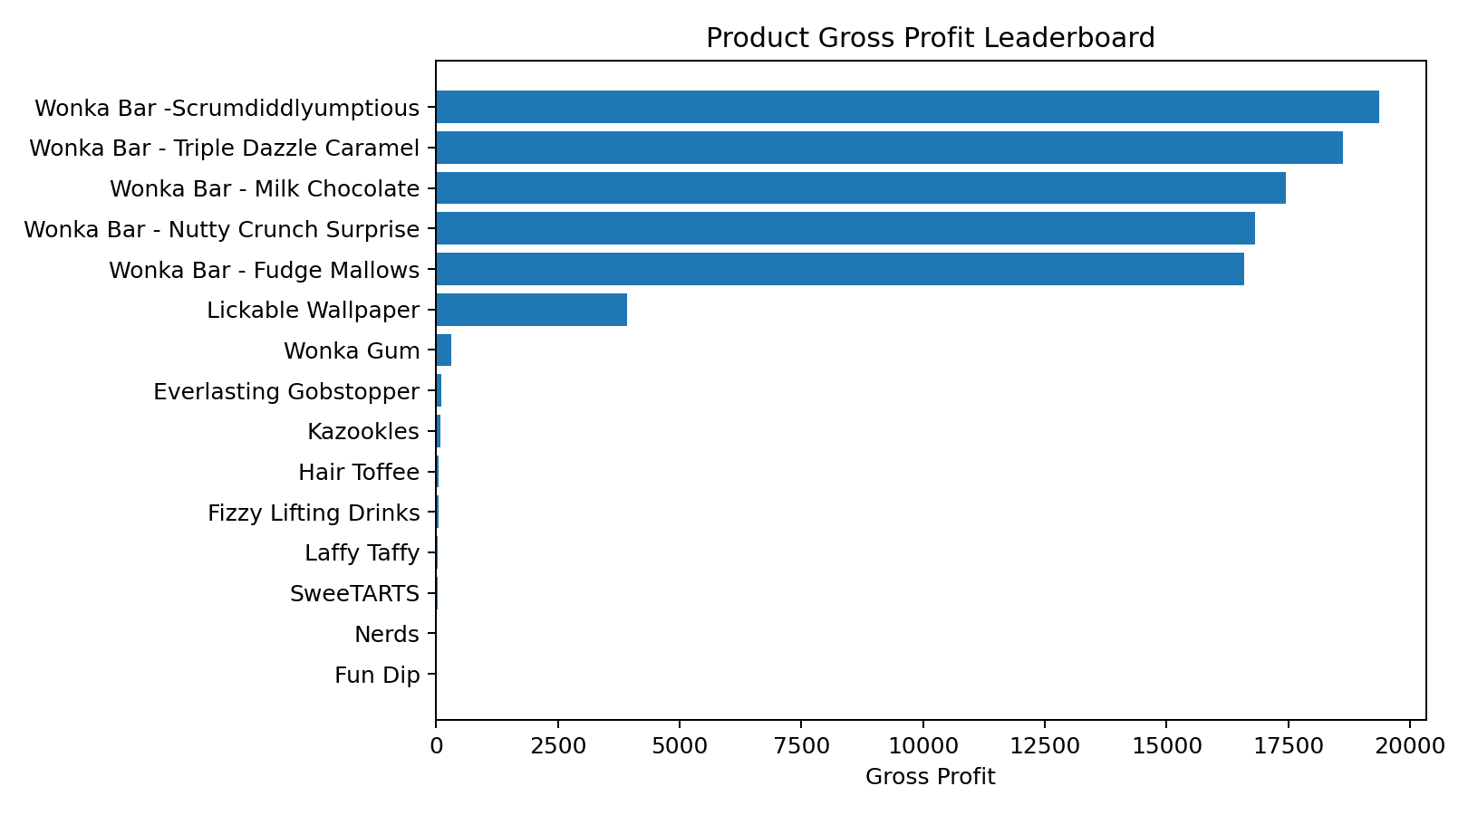
The five leading products by gross profit are: Wonka Bar -Scrumdiddlyumptious, Wonka Bar - Triple Dazzle Caramel, Wonka Bar - Milk Chocolate, Wonka Bar - Nutty Crunch Surprise, Wonka Bar - Fudge Mallows. These products together contribute 95.1% of total gross profit. High-margin products with low absolute sales should not automatically outrank high-profit products; both margin rate and total contribution should be considered.
Product | Sales | Profit | Margin | Profit/Unit
Wonka Bar -Scrumdiddlyumptious | $27,874.80 | $19,357.50 | 69.4% | $2.50
Wonka Bar - Triple Dazzle Caramel | $28,485.00 | $18,610.20 | 65.3% | $2.45
Wonka Bar - Milk Chocolate | $26,867.75 | $17,443.37 | 64.9% | $2.11
Wonka Bar - Nutty Crunch Surprise | $23,574.95 | $16,819.95 | 71.3% | $2.49
Wonka Bar - Fudge Mallows | $24,890.40 | $16,593.60 | 66.7% | $2.40
Lickable Wallpaper | $7,860.00 | $3,930.00 | 50.0% | $10.00
Wonka Gum | $597.50 | $310.70 | 52.0% | $0.65
Everlasting Gobstopper | $130.00 | $104.00 | 80.0% | $8.00
Kazookles | $1,205.75 | $92.75 | 7.7% | $0.25
Hair Toffee | $76.50 | $59.50 | 77.8% | $3.50

7. Division Performance
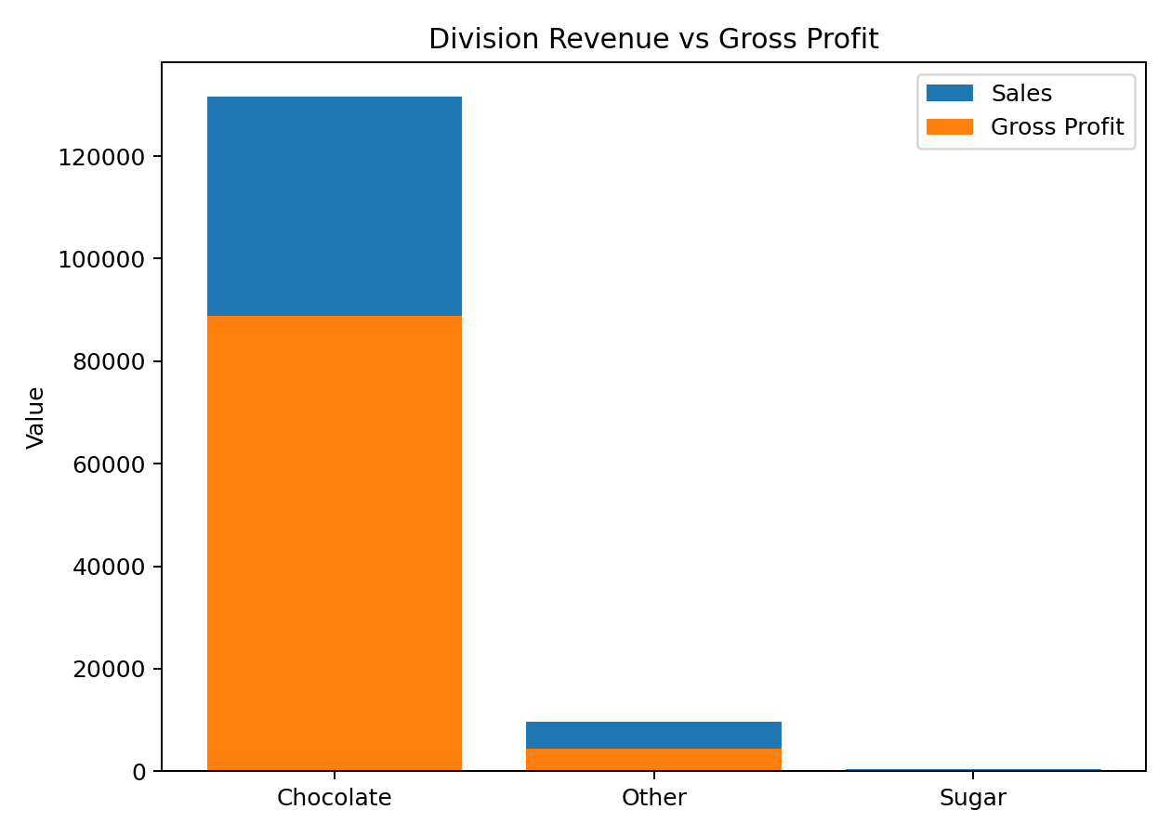
Division | Sales | Profit | Margin | Profit/Unit
Chocolate | $131,692.90 | $88,824.62 | 67.4% | $2.38
Other | $9,663.25 | $4,333.45 | 44.8% | $3.49
Sugar | $427.48 | $284.73 | 66.6% | $2.08
Chocolate dominates the supplied dataset in both revenue and gross profit. This creates an opportunity and a concentration risk: maintaining availability and pricing discipline for the core chocolate portfolio is financially important, while smaller divisions should be evaluated on strategic role and incremental profitability rather than volume alone.

8. Cost & Margin Diagnostics
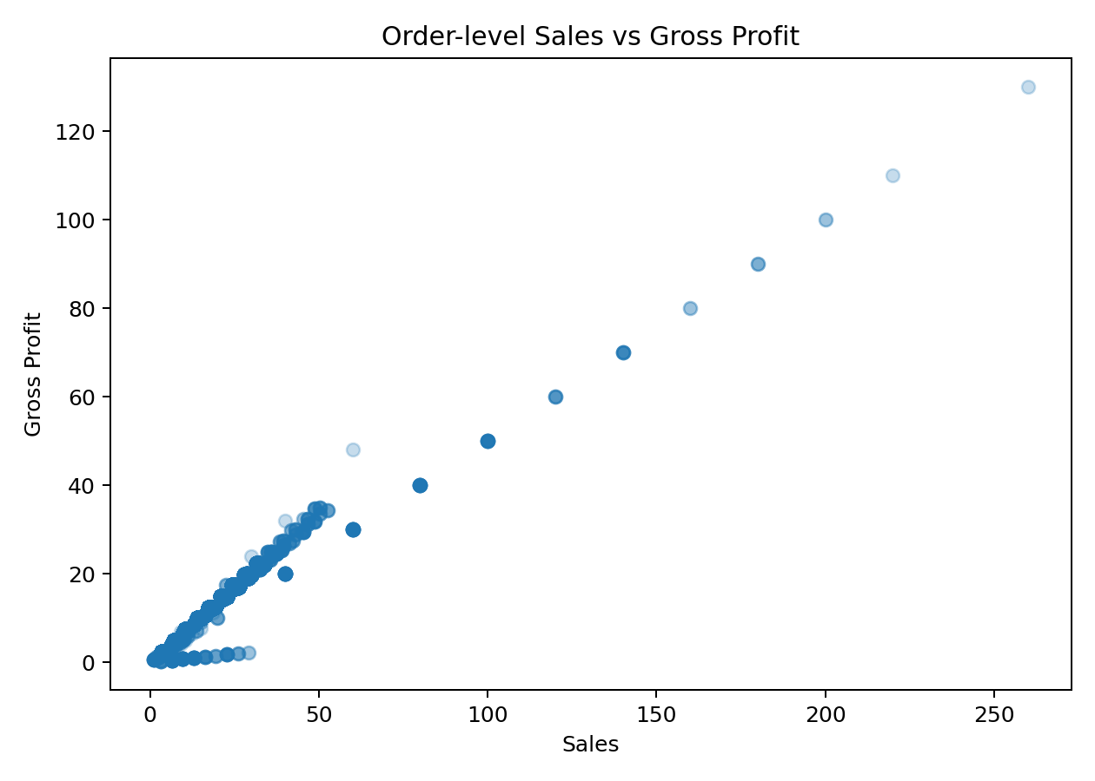
The most important margin-risk product in the supplied portfolio is Kazookles, with a gross margin of about 7.7%. Its sales are meaningful relative to the smaller products, so repricing, sourcing-cost renegotiation or portfolio review should be prioritized. Other low-margin products should be reviewed using the dashboard threshold slider.

9. Profit Concentration / Pareto Analysis
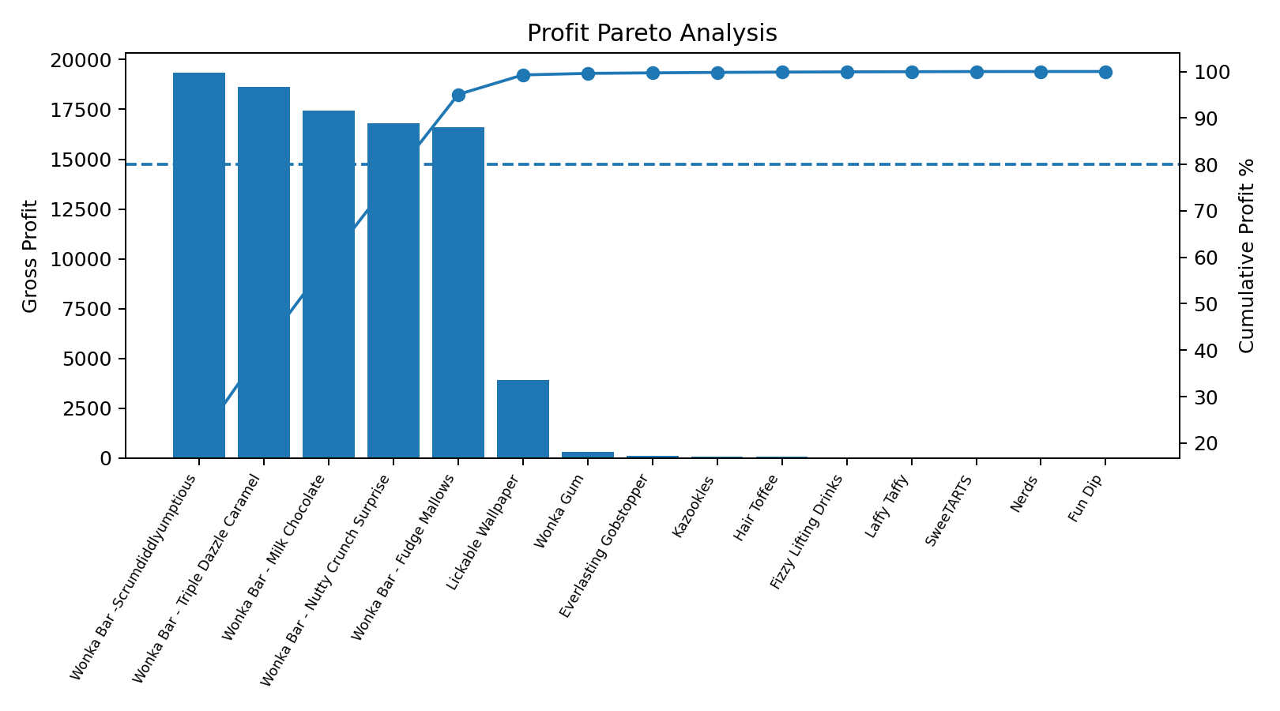
Only 5 of 15 products are required to reach at least 80% of total gross profit; the top five account for 95.1%. Similarly, the top 5 products reach at least 80% of revenue. This concentration means a small set of products drives most financial performance and should receive strong inventory, pricing and sourcing attention.

10. Regional & Geographic Diagnostics
Region | Sales | Profit | Margin
Pacific | $46,301.53 | $30,485.94 | 65.8%
Atlantic | $41,197.24 | $26,973.70 | 65.5%
Interior | $32,037.60 | $21,282.49 | 66.4%
Gulf | $22,247.26 | $14,700.67 | 66.1%
California is the largest state by sales in the supplied records. The dashboard includes state and region views so management can inspect whether concentration is creating operational or commercial dependency.

11. Factory Correlation
Factory | Sales | Profit | Units | Margin
Lot's O' Nuts | $76,340.15 | $52,771.05 | 21,412 | 69.1%
Wicked Choccy's | $55,352.75 | $36,053.57 | 15,863 | 65.1%
Secret Factory | $8,587.50 | $4,344.70 | 884 | 50.6%
The Other Factory | $1,282.25 | $152.25 | 388 | 11.9%
Sugar Shack | $220.98 | $121.23 | 107 | 54.9%
Factory-level results are derived from the supplied Product–Factory correlation rather than a factory field in the transaction data. Therefore, they should be treated as mapped analytical results and validated if manufacturing assignments have changed.

12. Recommendations
- Prioritize the core chocolate products because they account for the overwhelming share of revenue and profit. Protect availability while continuously monitoring price realization and input cost.
- Immediately review Kazookles for repricing and/or supplier/manufacturing-cost reduction because its margin is substantially below the portfolio average.
- Use a dual KPI approach: gross profit contribution for financial impact and gross margin % for efficiency. Avoid decisions based on sales alone.
- Use Pareto concentration as a dependency indicator. Build contingency plans for the small set of products that generate most profit.
- Track monthly margin volatility and investigate products with unstable margins before expanding promotions or volume commitments.
- Use the factory mapping to connect product profitability with sourcing/manufacturing decisions, while validating the mapping with operations.

13. Limitations
Gross profit is treated as Sales − Cost as defined in the supplied data. It therefore does not include separately modeled logistics, labor overhead, marketing, returns, discounts or corporate allocations. The dataset also contains shipment dates far beyond order dates; these dates are not used as a profitability driver in this study. Factory coordinates are provided as a separate mapping and are not independently verified.

14. Conclusion
The analysis converts transaction-level data into product and division profitability intelligence. The portfolio is strongly concentrated in a small group of chocolate products, while at least one product exhibits a clear margin-risk profile. A dashboard-based workflow enables management to move from reactive decisions to continuous monitoring of margin, profit contribution, concentration and cost efficiency.

