**Introduction to Programming**

**Lab Worksheet**

**Week 1**

**Python**

Name: Shivnath Mahato

Level 4 Section: A

British Id: 10012

LBU Id: c7576124

Level 4 BSc. Hons Computing

Subject: Fundamental Of Computer Programming (FOCP)

The British College (TBC)

**Task:**

**#Week 1 Practical**

1. Try inputting and executing the code below:

**Answer:**

print("The first program has executed")

print("____________________________________")

1. Try using a similar command to output at least three alternative messages.

**Answer:**

print("\n Hello friends!")

print("I want to learn python program in deeply.")

print("Can you join me?")

1. Use the up and down arrow keys to recall the commands you have already input, select one of these then re-execute the command by pressing the <enter> key.

**Output of Question No. 1, 2 and 3:**

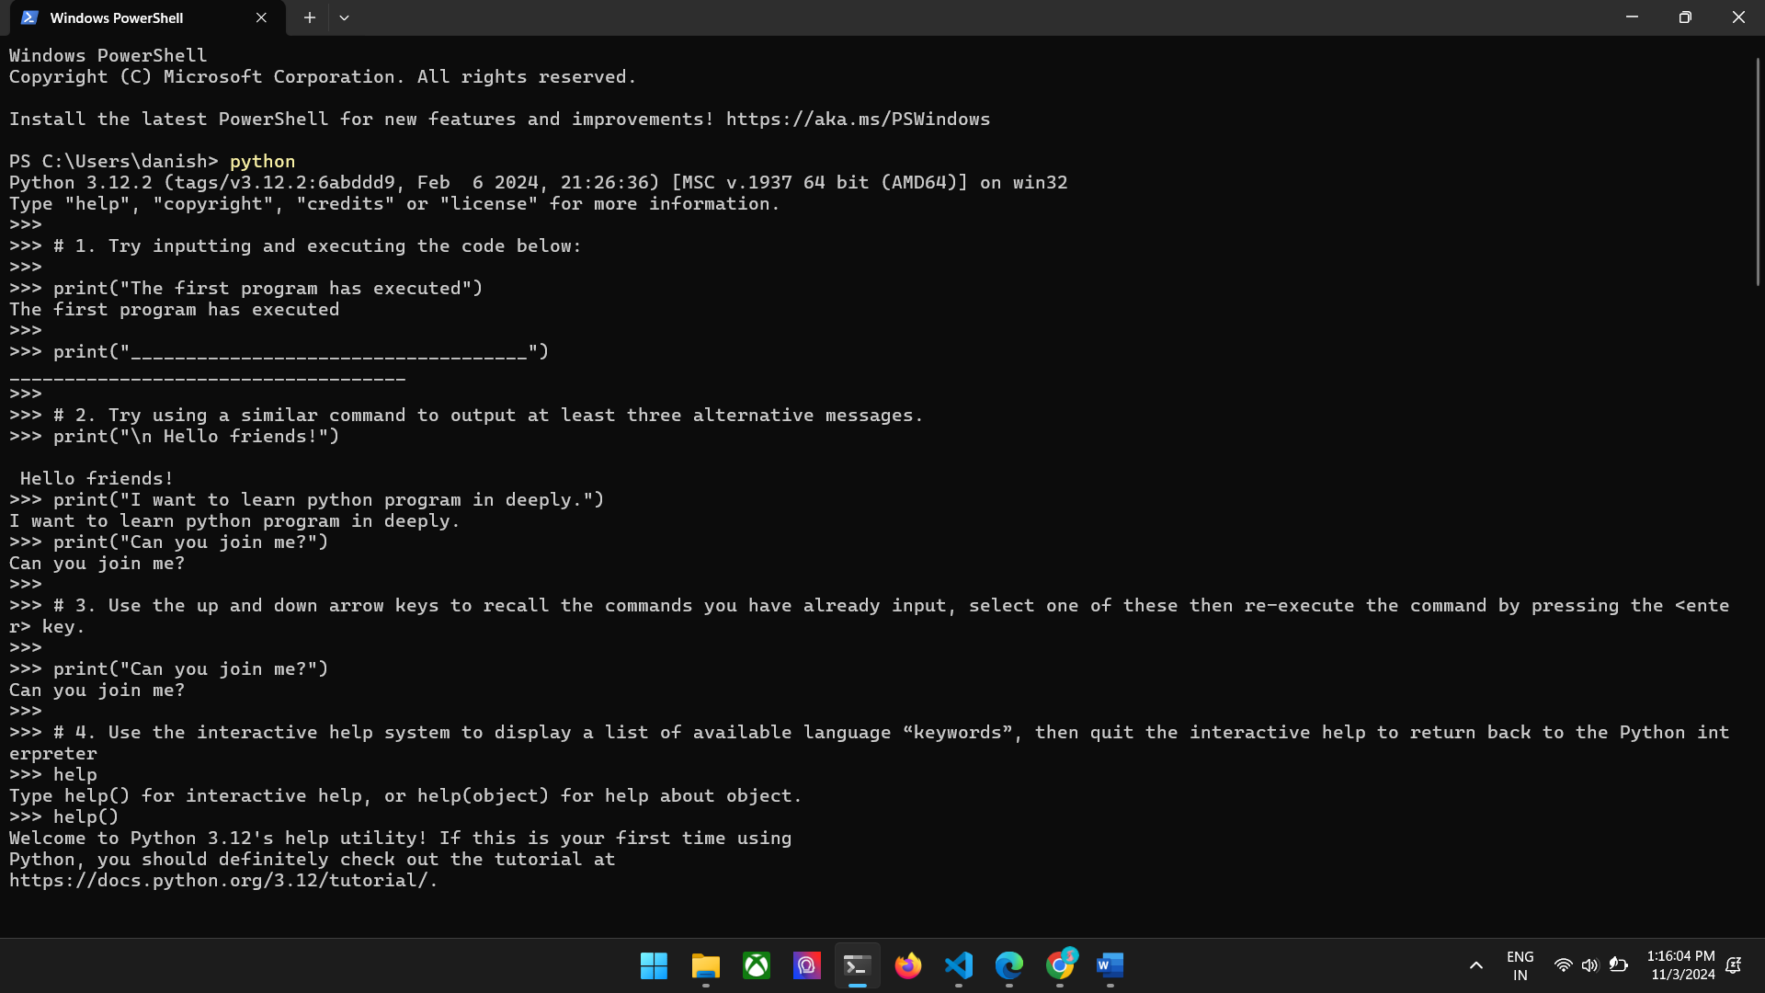

1. Use the interactive help system to display a list of available language “keywords”, then quit the interactive help to return back to the Python interpreter.

**Answer:**

>>>help()

help>q

1. Enter a single ‘help’ command to look up information about the ‘input’ object then return back to the interpreter.

**Answer:**

>>>help()

help>input

**Output of Question No. 4 and 5:**

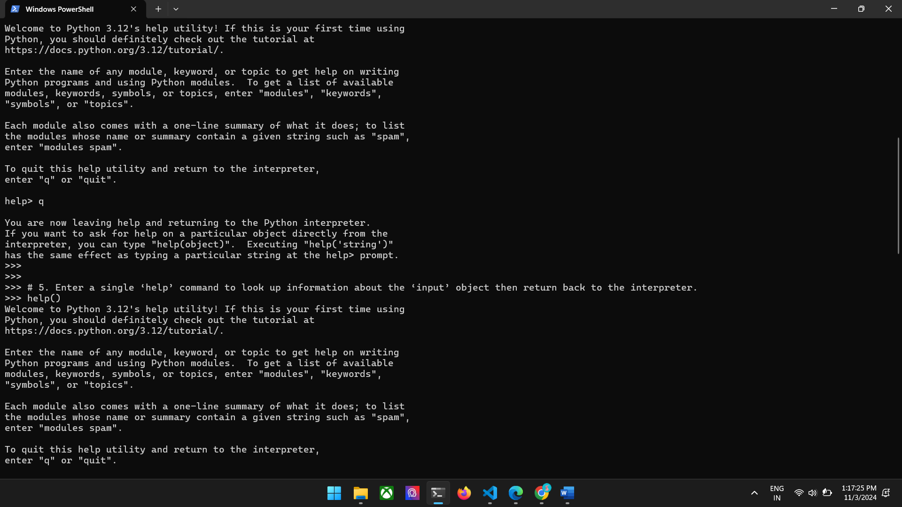

1. Try quitting and then restarting the interpreter several times

**Answer:**

>>>^Z or

>>>exit()

>python

1. Try inputting and executing the code below:

45 + 20

**Answer:**

65

**Output of Question No. 6 and 7:**

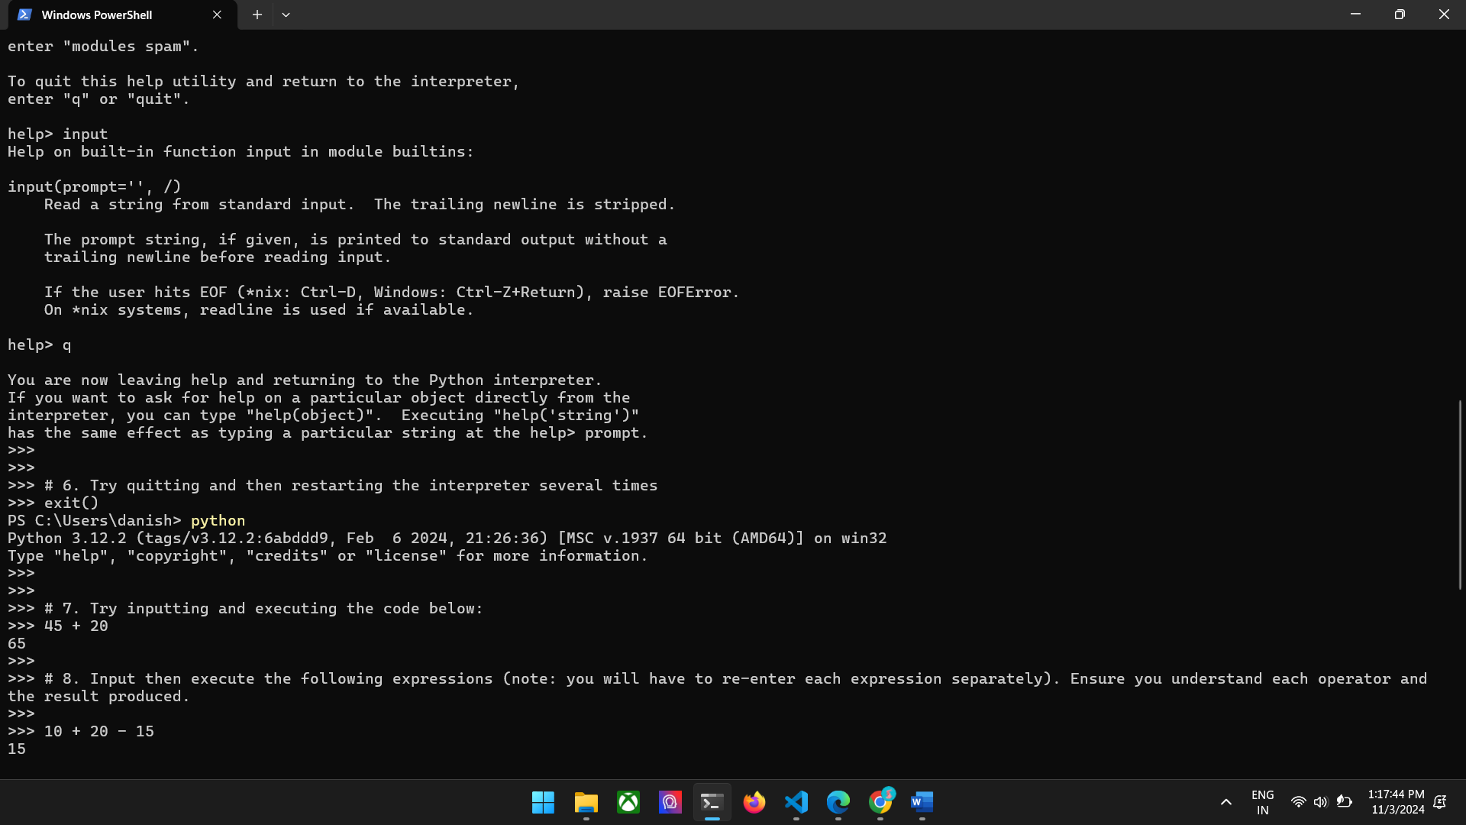

1. Input then execute the following expressions (note: you will have to re-enter each expression separately). Ensure you understand each operator and the result produced.

10 + 20 - 15

10 * 5

100 / 33

100 // 33

10 ** 2

10 % 3

1. To see precedence at work input then execute the following expressions.

10 + 5 * 2

10 - 5 * 10 + 5

5 * 10 ** 2

1. Input and execute the following expressions, then compare the results to those of the previous task.

(10 + 5) * 2

10 - 5 * (10 + 5)

(5 * 10 )** 2

1. Input and execute the following expressions. Notice the different results.

12 + (5 * 2 + 3)

12 + (5 * (2 + 3))

**Output of Question No. 8, 9, 10 and 11:**

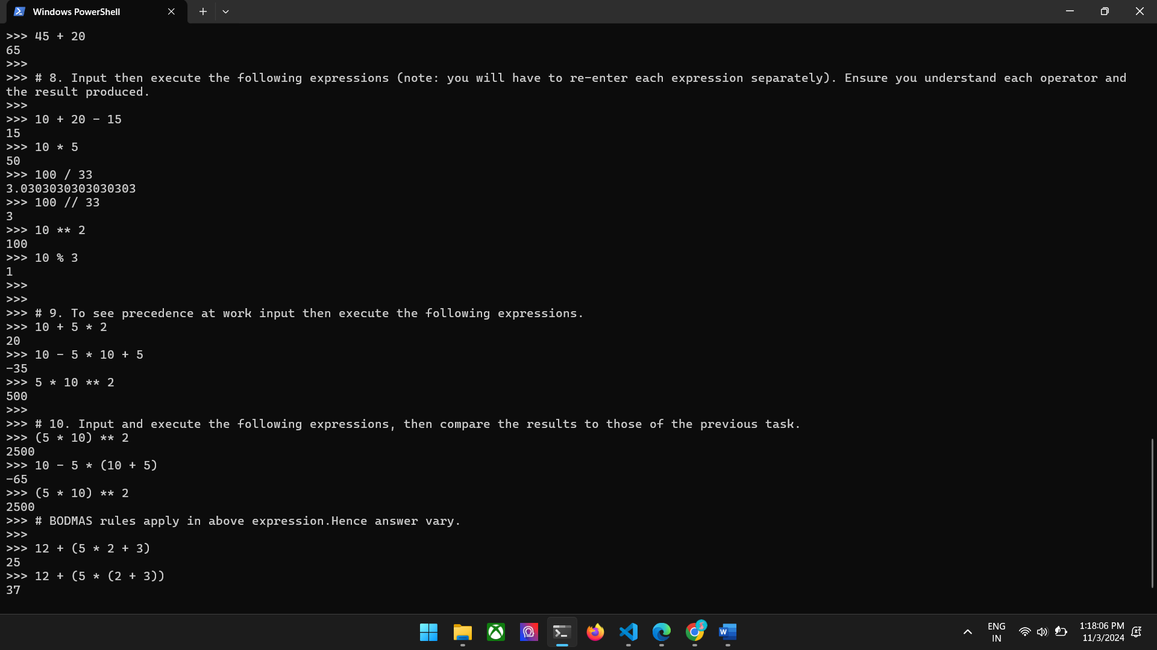

1. Look at each of the phrases below and ensure you understand what each of these means. For any that you do not understand, do a little research to find a definition of each term. This research may involve looking back over these notes, or the associated lecture notes. It may also involve searching for these terms on the Internet.

●    Source code

●    Machine code

●    Interpreter

●    Compiler

●    2GL, 3GL, 4GL

●    Executable

●    Expressions

●    Operators and Operands

●    Syntax Errors

●    Logical Errors

**Answer:**

* **Source Code**: Source code is the set of instructions that a programmer writes to create software.
* **Machine Code**: Machine code (also known as machine language or native code) is a low-level programming language in the form of hexadecimal or binary instructions that execute instructions directly on the computers’ CPU
* **Interpreter**: An interpreter is a program that directly executes the instructions without compilation of the written program code.
* **Complier**: A compiler is a computer program that translates source code written in a high-level programming language into machine code, bytecode, or another programming language
* **2GL**: 2GL stands for second-generation programming language, a low-level programming language that uses assembly language
* **3GL**: 3GL stands for "Third Generation Language" and is a high-level programming language that's more programmer-friendly and machine-independent
* **4GL**: 4GL is a scripting programming language that is interpreted during runtime, used in querying the database or in server.
* **Executable**: an executable is a file that contains a program that can be run by a computer's operating system or a software application
* **Expression**: an expression is a combination of variables, operators, literals, and function calls that evaluates to a value
* **Operator**: An operator is a symbol that tells the compiler or interpreter to perform special mathematical or logical functions. e.g. a= b + c
* **Operand**: an operand is a value or expression that is used to perform an operation.
* **Syntax Error**: A syntax error is an error in the syntax of a coding or programming language, entered by a programmer.
* **Logical Error**: A logical error is an error which occurs when the program compiles and runs without any syntax, run-time, or linker errors, but the output is incorrect or unexpected.