**Introduction to Programming**

**Lab Worksheet**

**Week 8**

**Python**

Name: Shivnath Mahato

Level 4 Section: A

British Id: 10012

LBU Id: c7576124

Level 4 BSc. Hons Computing

Subject: Fundamental of Computer Programming

(FOCP)

The British College (TBC)

**Task:**

**#Week 8 Practical**

1. Write some code that uses an f-string to calculate then display a message stating “The area of a rectangle with a width of 104.32 and a height of 15.654 is ….”. Showing the correct answer at the end of the message.

**Answer:**

width = 104.32

height = 15.654

area_rectangle = width * height

print(f"The area of a rectangle with a width of {width} and a height of {height} is {area_rectangle}")

**Output of Question No. 1:**

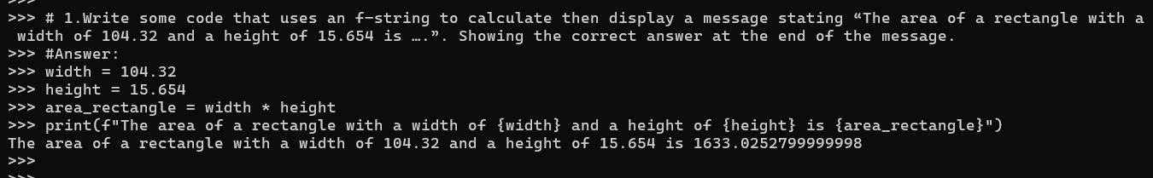

1. Rewrite your earlier code that displayed the area of a rectangle, but include a format specifier that limits the displayed result to three decimal places.

**Answer:**

width = 104.32

height = 15.654

area_rectangle = width * height

print(f"The area of a rectangle with a width of {width} and a height of {height} is {area_rectangle:.3f}")

**Output of Question No. 2:**

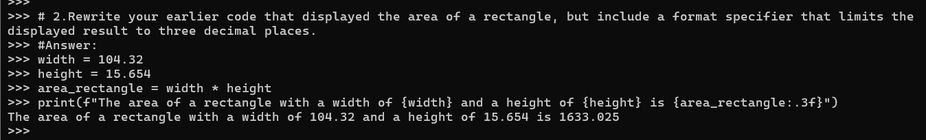

1. Try setting the name and age variables to different values and executing the above print() statement multiple times. Notice the alignment and column width enforced due to the print specifier.

**Answer:**

name = input("Enter your name: ")

age = int(input("Enter your age: "))

print(f"{name:15} - {age:10}")

print(f"{name:10} - {age:<10}")

print(f"{name:10} - {age:>10}")

print(f"{name:15} - {age:>10}")

**Output of Question No. 3:**

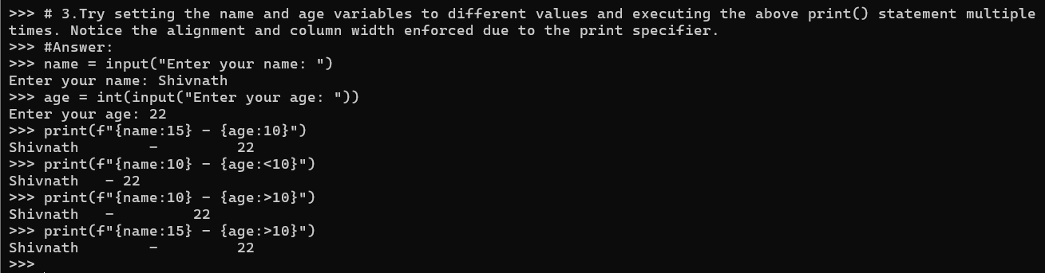

1. Write a print() statement that displays the name and age values, with a column width of 20 for each, both right aligned, and with the age being shown to two decimal places. The fill character should be a dollar symbol $.

**Answer:**

name = input("Enter your name: ")

age = float(input("Enter your age: "))

print(f"{name:$>20} - {age:$>20.2f}")

**Output of Question No. 4:**

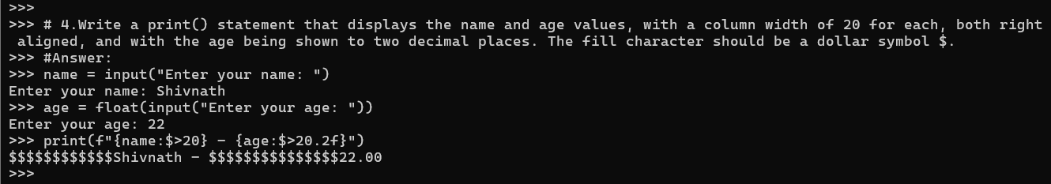

1. Write some code that uses the str.format() method to display the area of a circle with a radius specified by the variable r. Use a keyword replacement field called area to identify the calculated area and refer to this when passing the value to the str.format() method. The output should look like the following, in the case where r is set to 52.

A circle with radius 52 has an area of 8494.8665353068

**Answer:**

import math

radius = 52

area_circle = math.pi * radius **2

print("A circle with radius {0} has an area of {1}".format(radius, area_circle))

**Output of Question No. 5:**

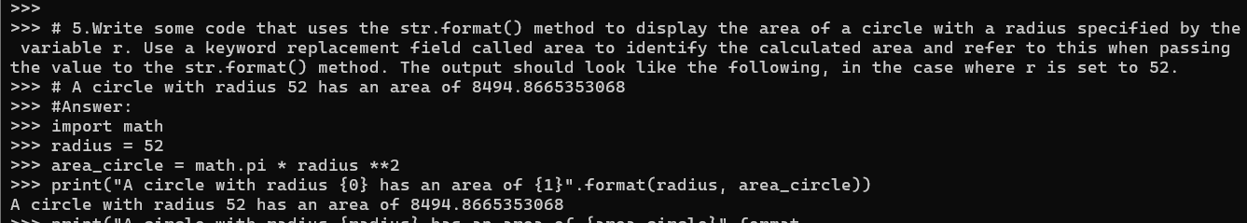

1. Convert the f-string based statement below into an equivalent that uses the str.format() method to generate the same output.

print(f"{name:@^15} - {age:#^10}")

**Answer:**

name = input("Enter your name: ")

age = int(input("Enter your age: "))

print("{name:@^15} - {age:#^10}".format(name=name, age=age))

**Output of Question No. 6:**

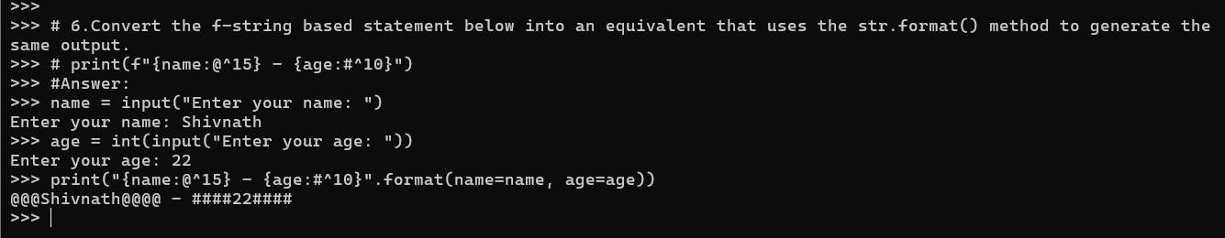

1. Use a text editor to create a file called info.txt and enter the text shown below. Once the file has been created and saved, write a small program that:

* Opens the file,
* reads and prints the contents,
* closes the file.

This is a text file

It contains multiple lines of text

This is the final line within the file

**Answer:**

**File: info.txt**

**Source Code of Question No. 7:**

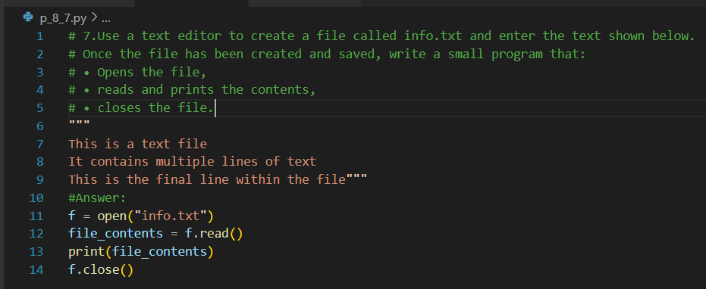

**Output of Question No. 7:**

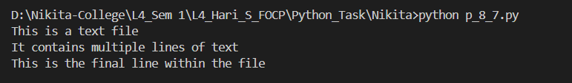

1. Write a small program that opens the info.txt file, then reads and displays each of the three lines of text using calls to the readline() method. Remember to close the file once the content has been read.

**Answer:**

**File: info.txt**

**Source Code of Question No. 8:**

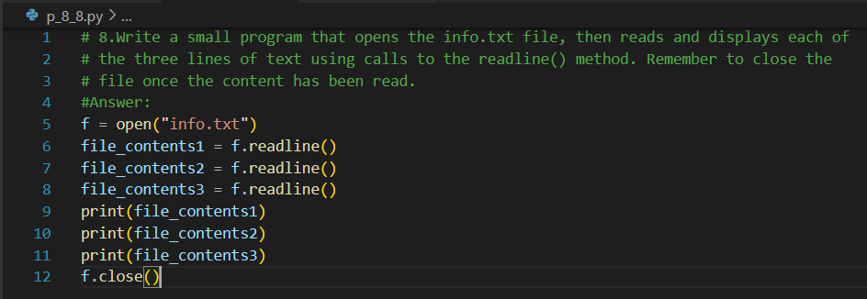

**Output of Question No. 8:**

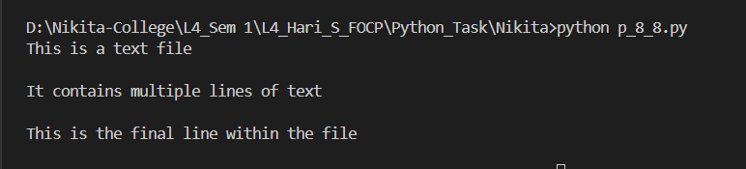

1. Write a small program that opens the info.txt file, then reads and displays each line of text using a for...in loop. Remember to close the file once the content has been read.

**Answer:**

**File: info.txt**

**Source Code of Question No. 9:**

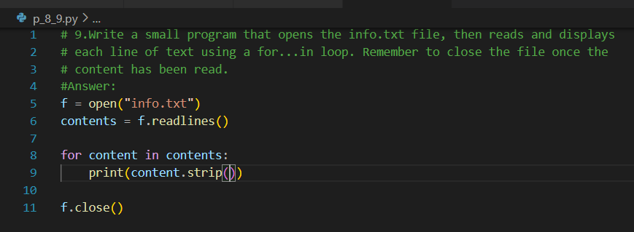

**Output of Question No. 9:**

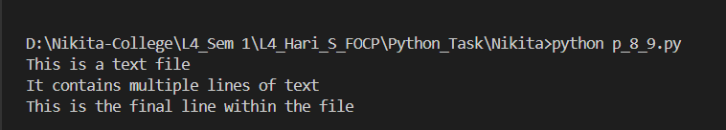

1. Write a small program that opens the "info.txt" file in append (a) mode. Use the write() method to add an extra line of text saying "this is an extra line". Remember to close the file once the content has been read. Open the file with a text editor and examine the contents.

**Answer:**

**File: info.txt**

**Source Code of Question No. 10:**

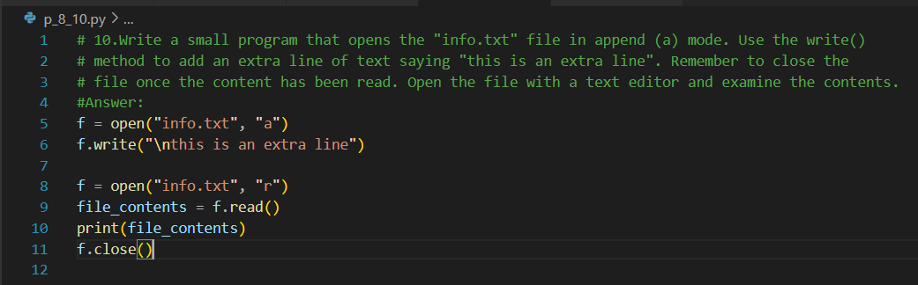

**Output of Question No. 10:**

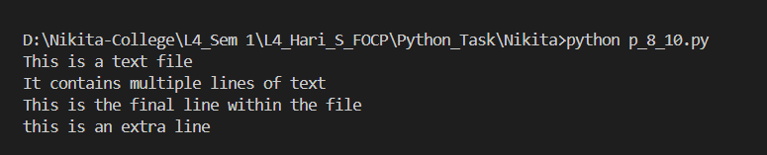

**Output File: info.txt**

1. write a small program that opens the info.txt file, then reads and displays each line of text using a for...in loop. Rather than explicitly call the close() method, use the ‘with’ statement to wrap the file handling code.

**Answer:**

**File: info.txt**

**Source Code of Question No. 11:**

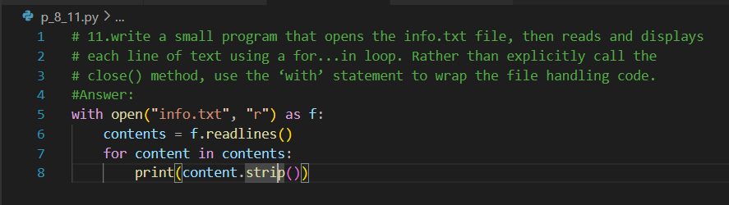

**Output of Question No. 11:**

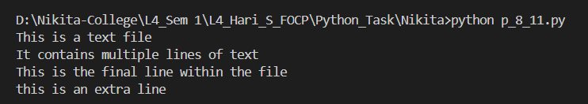

1. Look at each of the phrases below and ensure you understand what each of these means. For any that you do not understand, do a little research to find a definition of each term. This research may involve looking back over these notes, or the associated lecture notes. It may also involve searching for these terms on the Internet.

* ‘f-string’
* Format Specifier
* File modes
* Binary Flies
* Random Access
* Exceptions

**Answer:**

* **‘f-string’:** An f-string (formatted string literal) is a string literal that allows to embed expressions inside curly braces {} directly within the string. F-strings are prefixed with the letter f or F.
* **Format Specifier:** A format specifier is a small string that is included after expressions within the braces; they must be prefixed by a colon ':' character.
* **File modes:** The file modes is specified using a second string type parameter. This can contain a single character that specifies whether the file is to be opened for reading (r), writing (w), appending (a) or reading and writing (r+).
* **Binary Flies:** The file that contains data in the form of bytes, which can represent any type of data, such as images, audio, video, executable code, text etc.
* **Random Access:** Random access means one can move to any part of a file and read or write data from it without having to read through the entire file.
* **Exceptions:** An exception is a type of error that occurs when a syntactically correct Python code raises an error.