CERTIFICATE

A

PYTHON MINI PROJECT REPORT

ON

VISIONALERT AI

SUBMITTED BY

NAME-Shivdatt Anil Vanmane
ROLL NO-68

PRN NO-25062231242523

UNDER THE GUIDANCE OF

Prof. Pallavi Jawalkar


DEPARTMENT OF COMPUTER SCIENCE AND ENGINEERING

P.N.E.S.P.’S

NAGESH KARAJAGI ORCHID COLLEGE OF ENGG.& TECH, SOLAPUR.
An Autonomous Institute
(AFFILIATED TO DR.BABASAHEB AMBEDKAR TECHNOLOGICAL UNIVERSITY LONERE.)
2025-2026

CERTIFICATE

This is to certify that the project entitled VISIONALERT AI has been completed by following student of Second year (CSE) class in a satisfactory manner under my guidance.

NAME-Shivdatt Anil Vanmane
ROLL NO-68

PRN NO-25062231242523

The project is found to be complete in partial fulfillment for the award of Degree of Bachelor in Computer Science & Engineering.

Prof. Pallavi Jawalkar | Dr. V. V. Bag | Dr. B. K. Sonage
PROJECT GUIDE | HOD | PRINCIPAL


DEPARTMENT OF COMPUTER SCIENCE AND ENGINEERING P.N.E.S.P.’S
NAGESH KARAJAGI ORCHID COLLEGE OF ENGG. & TECH, SOLAPUR.
An Autonomous Institute

(AFFILIATED TO DR.BABASAHEB AMBEDKAR TECHNOLOGICAL UNIVERSITY LONERE.)

2025-2026

ACKNOWLEDGEMENT

I would like to express my sincere gratitude to my project guide for their valuable guidance, encouragement, and continuous support throughout the completion of this project. Their suggestions and advice helped me successfully complete this work.

I am also thankful to the Head of the Department and all faculty members for providing the necessary resources and academic support required for this project.

I would like to thank my teacher for their constant motivation and encouragement during the development of this project.

ABSTRACT

The project VisionAlert AI is an intelligent fire and hazard detection system developed using Python, Flask, OpenCV, and YOLOv8 deep learning models to provide real-time surveillance and automated alerting. The system aims to enhance safety by detecting fire, smoke, and human presence through live camera feeds and instantly notifying users with detailed alerts.

The application consists of multiple integrated modules. The Live Monitoring System processes real-time video streams using trained YOLO models (yolov8n.pt, custom fire detection weights) to identify hazardous events with confidence scores. The Alert Management Module generates high-priority notifications when fire or smoke is detected, including object type, confidence level, severity, timestamp, and captured screenshots. Alerts are sent via email and displayed in a dynamic dashboard for quick response.

The system also includes a Snapshot and Recording Feature, which captures images and stores video evidence at the time of detection. The Event Logging and Export Module maintains a history of detections and allows users to export reports (e.g., Excel format) for analysis and documentation. Additionally, configurable settings such as detection confidence, alert cooldown, and object filters (fire, smoke) provide flexibility and control to the user.
The user interface is designed with a modern dashboard layout featuring live camera feed, detection statistics, and alert panels, ensuring an intuitive and responsive experience. VisionAlert AI serves as a smart, automated surveillance solution that minimizes human intervention, enables faster emergency response, and improves safety in environments such as homes, industries, and public spaces.

INDEX

Sr. no. | Title | Page No
1. | Abstract | 4
2. | Introduction | 6
3. | Literature survey | 7
4. | System Architecture | 8
5. | Methodology | 9
6. | System Flow | 11
6. | Output (Screen shots) | 13
7. | Conclusion | 15
8. | References | 16

INTRODUCTION

In today’s rapidly evolving world, ensuring safety and security has become a critical concern across homes, industries, and public spaces. Traditional surveillance systems often rely on manual monitoring, which can lead to delayed responses and increased risk during emergencies such as fire outbreaks. To address these challenges, VisionAlert AI is developed as an intelligent, real-time fire and hazard detection system that leverages the power of artificial intelligence and computer vision.

VisionAlert AI is a comprehensive, software-based surveillance solution built using Python, Flask, OpenCV, and advanced YOLOv8 deep learning models. The system continuously analyzes live video feeds to detect fire, smoke, and other potential threats with high accuracy. Upon detection, it instantly generates alerts containing critical details such as object type, confidence level, severity, timestamp, and captured visual evidence. These alerts are displayed on a modern dashboard and can also be sent via email notifications, enabling quick and informed decision-making.

The platform is designed with a user-friendly interface that includes live monitoring, event logging, snapshot capturing, and report exporting features. It also provides customizable detection settings such as confidence thresholds and alert cooldown periods, ensuring flexibility according to different use cases. By automating hazard detection and minimizing human intervention, VisionAlert AI enhances safety, reduces response time, and offers a reliable solution for smart surveillance systems.

LETRETURE SURVEY

- “Fire Detection Using Deep Learning Techniques”
Authors: Various Researchers
This paper explores the use of deep learning models, particularly Convolutional Neural Networks (CNNs), for detecting fire and smoke in images and videos. It highlights the advantages of automated fire detection over traditional sensor-based systems, such as faster response time and the ability to detect fire visually in large open areas. The study also discusses challenges like false positives due to fire-like colors and environmental conditions.

“Real-Time Fire and Smoke Detection Using YOLO Algorithm”

Authors: Research Scholars in Computer Vision

This research focuses on using the YOLO (You Only Look Once) object detection algorithm for

real-time fire and smoke detection. The paper demonstrates how YOLO provides high-speed and

accurate detection suitable for surveillance systems. It emphasizes the importance of training datasets

and model optimization to improve detection accuracy in different lighting and environmental

conditions.

“Smart Surveillance System Using Computer Vision and IoT”
Authors: Multiple Contributors
This paper presents a smart surveillance system integrating computer vision techniques with IoT for real-time monitoring and alert generation. It discusses how cameras and intelligent algorithms can detect abnormal events and send notifications through cloud platforms. The study highlights scalability, remote monitoring, and automation as key benefits of such systems.

“Deep Learning-Based Video Surveillance for Public Safety”
Authors: Various Researchers
This paper examines the application of deep learning in video surveillance systems for enhancing public safety. It covers object detection, event recognition, and automated alert mechanisms. The authors discuss how AI-driven surveillance reduces human effort and improves response time in emergency situations, while also addressing challenges such as computational cost and real-time processing requirements.

SYSTEM ARCHITECTURE

1. Frontend (Client Side)
Technologies Used: HTML, CSS, JavaScript
Provides an interactive surveillance dashboard for users. Displays live camera feed, detection results, alerts, and event logs in real time. Allows users to start/stop detection, capture snapshots, and manage settings. Sends user requests and detection controls to the backend using HTTP requests.
The frontend acts as the communication bridge between the user and the surveillance system.

2. Backend (Server Side)
Technologies Used: Python, Flask
Handles incoming user requests and manages live video stream processing. Communicates with the AI detection model and processes detection results. Generates alerts, stores logs, screenshots, and recordings, and sends responses to the frontend in real time. Implements error handling and notification services for smooth operation.
The backend controls the core logic and ensures smooth communication between the client and the AI detection system.

3. AI Detection Model (YOLOv8 + OpenCV)
Technologies Used: YOLOv8, OpenCV, Deep Learning
Processes live camera frames using deep learning techniques. Detects fire, smoke, and human presence with confidence scores in real time. Sends detection results to the Flask backend for alert generation and monitoring.
The backend is developed using the Flask framework, and the system integrates YOLOv8 with OpenCV to provide accurate and intelligent real-time hazard detection.

METHODOLOGY

1. Requirement Analysis
The requirements of the FirePro AI system were identified to develop an intelligent real-time surveillance solution. The system needed to capture live video feeds, detect fire and smoke using AI models, and generate instant alerts with screenshots and confidence levels. Additional features such as event logging, snapshot capture, email notifications, and a user-friendly dashboard were also planned.

2. Frontend Development
The user interface was developed using HTML, CSS, and JavaScript. HTML was used to design the structure of the surveillance dashboard. CSS was used to create an attractive and responsive interface. JavaScript was used to update live detection results, alerts, and camera feeds dynamically without reloading the page.

3. Backend Development
The backend was developed using Python and the Flask framework. Flask handles user requests, live video streaming, alert generation, and communication between the frontend and the AI detection model. The backend also manages logs, screenshots, recordings, and report generation.

4. AI Model Integration
YOLOv8 and OpenCV were integrated for real-time fire and smoke detection. The AI model processes video frames, identifies hazardous objects, and generates confidence scores. Detection results are sent to the Flask backend, which then triggers alerts and updates the dashboard.

5. Testing
The system was tested to ensure proper communication between frontend, backend, and AI model components. Real-time detection accuracy, alert generation, video processing, and notification features were verified. The backend is developed using the Flask framework, and the system integrates YOLOv8 with OpenCV to provide accurate and reliable real-time hazard detection.

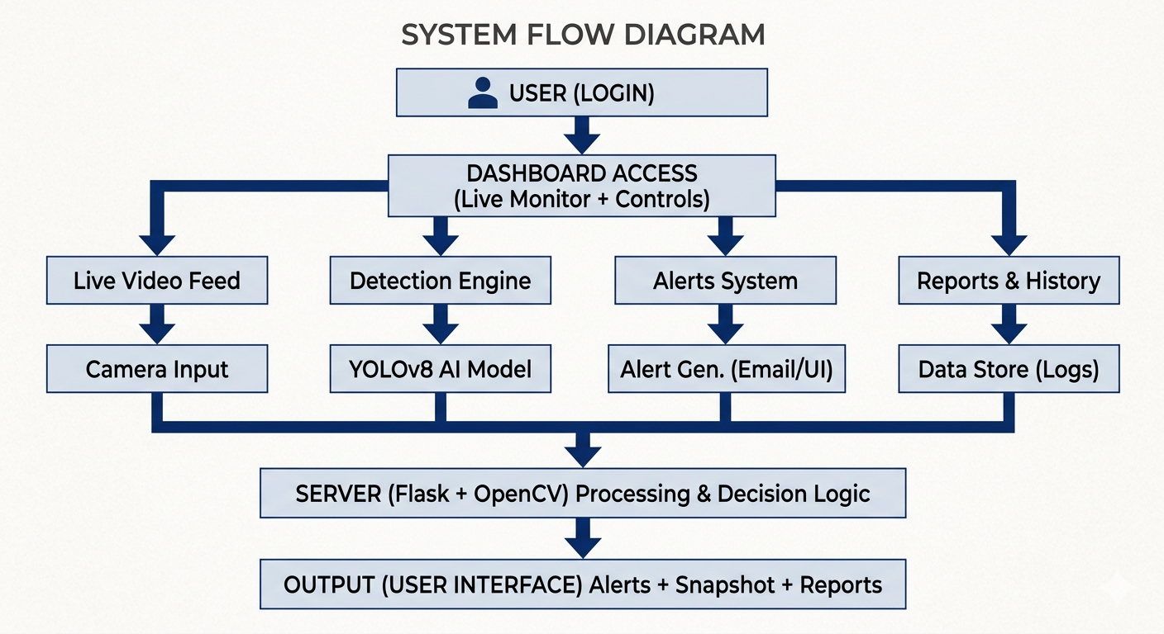

SYSTEM FLOW

Step 1: The user opens the FirePro AI surveillance dashboard and starts live monitoring.
Step 2: The frontend (HTML, CSS, JavaScript) captures the live camera feed and user commands.
Step 3: The frontend sends video frames and control requests to the backend using HTTP requests.
Step 4: The backend (Python/Flask) receives and processes the video stream.
Step 5: The backend sends video frames to the AI detection model for analysis.
Step 6: The AI model (YOLOv8 + OpenCV) analyzes the frames and detects fire, smoke, or human presence.
Step 7: The AI model sends detection results with confidence scores back to the backend.
Step 8: The backend generates alerts, stores logs/screenshots, and sends the processed results to the frontend in JSON format.
Step 9: The frontend displays real-time detection results, alerts, confidence levels, and snapshots to the user instantly.

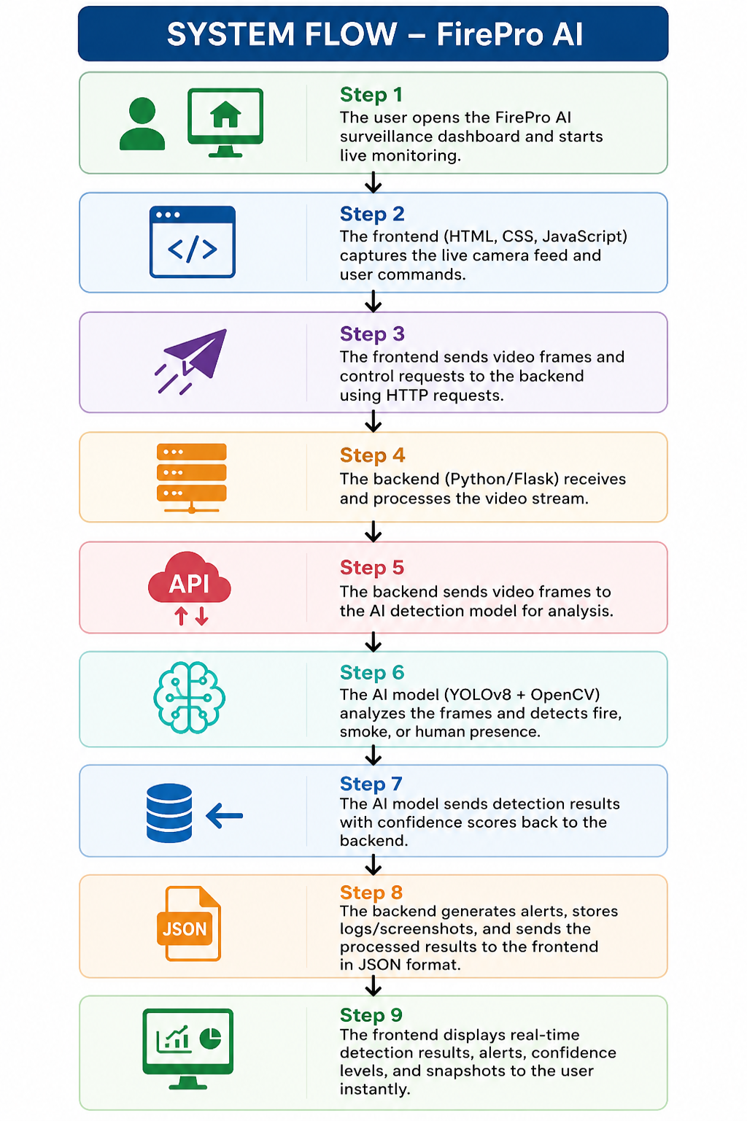

OUTPUT

- Dashboard:

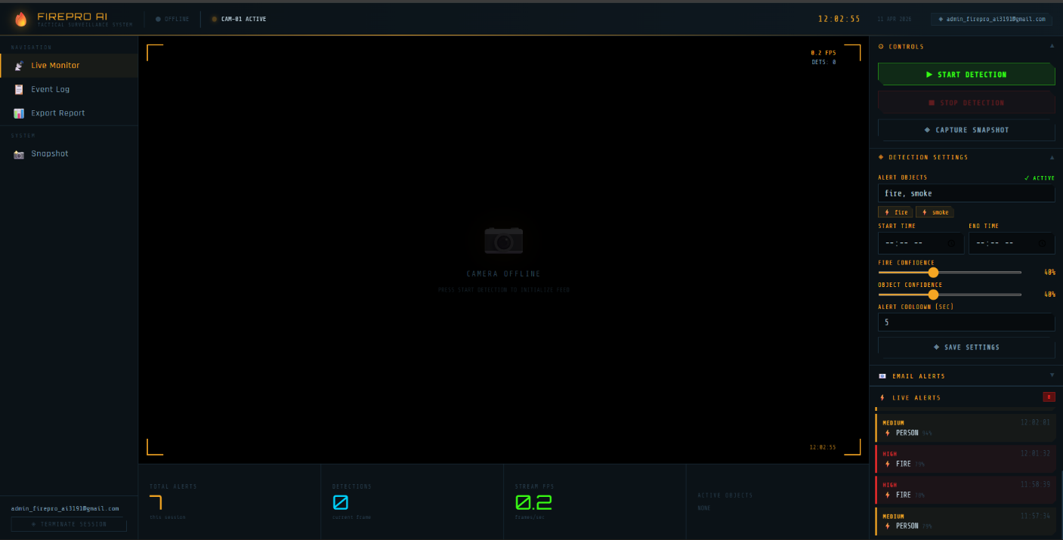

- Event Log:

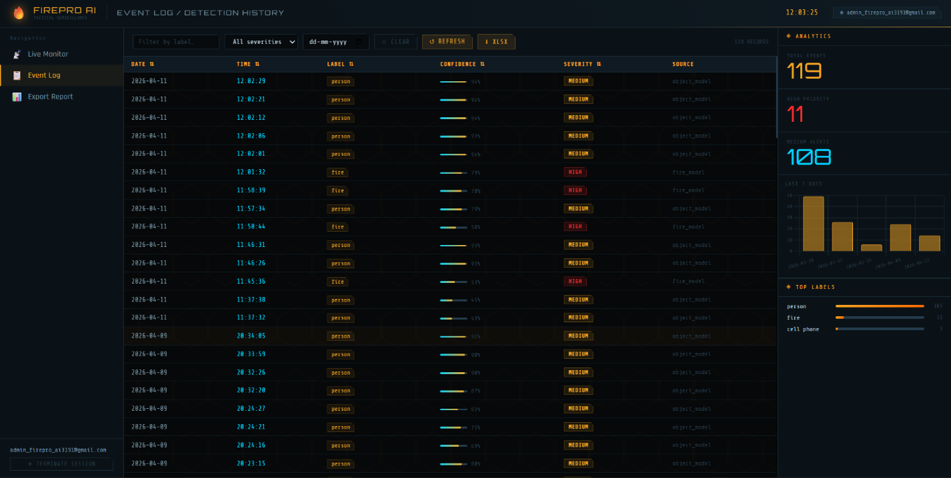

    - Excel Storage:

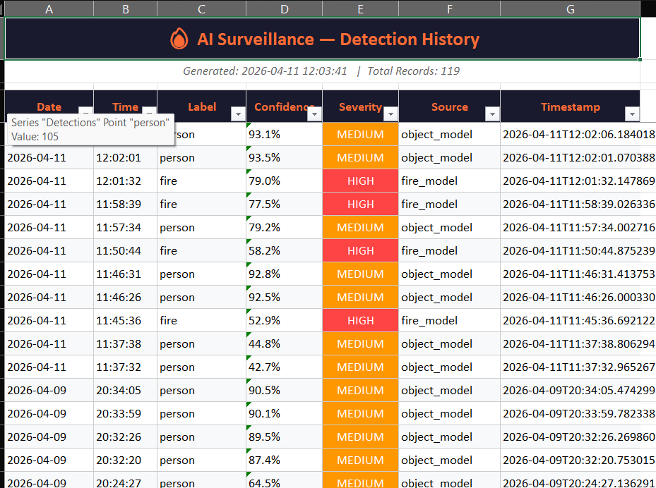

    - E-mail Notifications/Alerts:

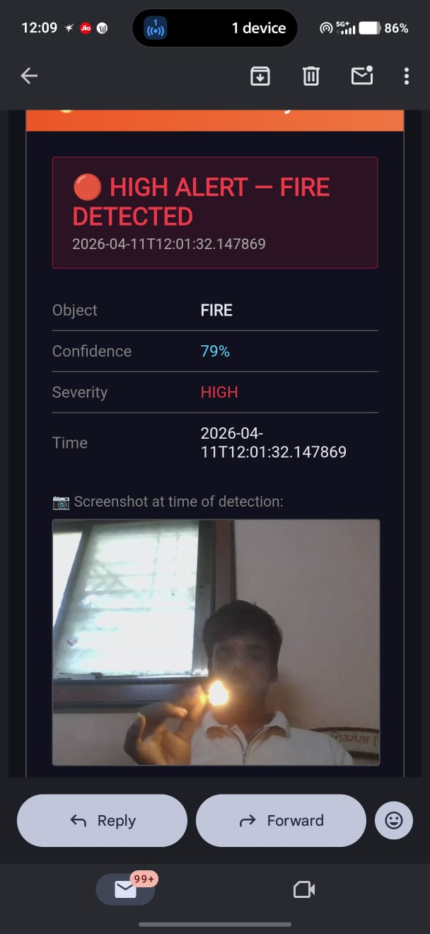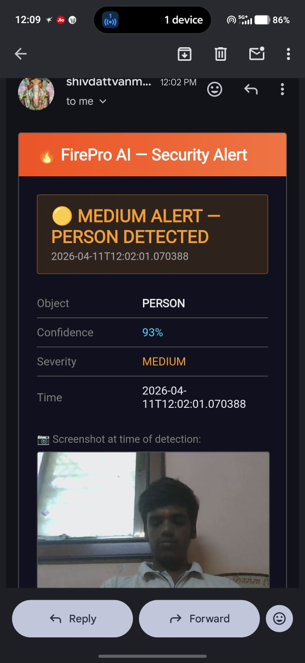
CONCLUSION

The FirePro AI system was successfully developed using HTML, CSS, JavaScript, Python, Flask, OpenCV, and YOLOv8 deep learning models. The system is capable of monitoring live video feeds, detecting fire and smoke in real time, and generating intelligent alerts with confidence scores, timestamps, and visual evidence.

All components including the frontend dashboard, backend processing system, AI detection model, and alert notification system worked together efficiently. The system was tested thoroughly to ensure accurate detection, smooth real-time performance, and reliable alert generation.

Overall, the project demonstrates how Artificial Intelligence and Computer Vision technologies can be effectively used to build smart, automated, and reliable surveillance systems for improving safety and emergency response.

REFERENCES

- Deep Learning
Ian Goodfellow, Yoshua Bengio, and Aaron Courville, MIT Press, 2016.
- Computer Vision: Algorithms and Applications
Richard Szeliski, Springer, 2nd Edition, 2022.
- Artificial Intelligence: A Modern Approach
Stuart Russell and Peter Norvig, Pearson Education, 3rd Edition, 2010.
- OpenCV
“OpenCV Official Documentation.” Available at:
OpenCV Official Website
- Flask Framework
“Flask Official Documentation.” Available at:
Flask Official Website
- Ultralytics YOLOv8
“YOLOv8 Documentation.” Available at:
Ultralytics YOLOv8 Documentation
- Python Programming Language
“Python Official Documentation.” Available at:
Python Official Website
- W3Schools
“HTML, CSS, and JavaScript Tutorials.” Available at:
W3Schools Tutorials
- OpenCV-Python Tutorials
“OpenCV Python Tutorials.” Available at:
OpenCV Documentation Tutorials

