Document naming & revision control

1 Purpose and scope
This procedure gives the five-person MyoMetrics team one consistent way to name, locate, review and revise the controlled files used during the EMG project week. It supports the Thursday QMS audit and the EE22005 Application evidence requirements. It applies to the project charter, planning records, experimental protocol, code releases, results, presentations and QMS documents. This is a short student-project procedure, not a certified ISO 13485 system.

2 Approved folder locations
Repository folder | Controlled content
files/ | Existing source documents, including the signed charter and skills matrix.
qms/ | Naming procedure, document register, D&D / traceability matrix and change evidence.
matlab/ | Reviewed MATLAB scripts (version in file name or tracked Git revision).
results/ | Anonymised summary plots, tables and interpretation.
presentation/ | Slides, storyboard and approved media.
data/ | Only approved anonymised datasets; keep original identifiable recordings outside GitHub.

3 Filename convention
PATTERN AREA_Short_Descriptive_Title_vMAJOR.MINOR.ext
Use letters, numbers and underscores only (plus the dot in the version and extension). Choose a concise descriptive title; avoid spaces, dates as the only identifier, or names such as “final_final”. Dates of experiments belong in the metadata and/or data filename. Keep the version at the end before the extension.
Area prefix | Examples of intended use
QMS | QMS_Naming_Procedure_v0.1.docx; QMS_File_Register_v0.1.xlsx; QMS_DD_Traceability_v0.1.xlsx
PM | PM_Advanced_Project_Management_v0.1.docx; PM_Gantt_Chart_v1.0.pdf
EMG / SW | EMG_Recording_Protocol_v0.1.docx; SW_EMG_Processing_v0.1.m
RES / PRES | RES_EMG_Comparison_v1.0.png; PRES_Results_Slides_v1.0.pptx

4 Version rules
Version | Use | Required action
v0.1, v0.2 … | Drafts not yet agreed by the team | Mark DRAFT in the register; review before use as approved evidence.
v1.0 | First team-approved issue | Record review/approval and commit to the main branch.
v1.1, v1.2 … | Minor correction; purpose unchanged | Brief change summary in the register and Git history.
v2.0 … | Major change to design, scope or method | Re-review dependencies and update the D&D matrix.

5 Document creation and change workflow
- The document owner creates the draft in its designated folder, assigns a version, and enters it into QMS_File_Register.
- A second team member checks legibility, technical correctness, provenance and version. The Project Lead confirms major decisions; the Quality Lead checks QMS consistency.
- For a controlled change, create a short-lived Git branch, commit the updated file, then merge it into main after review. Keep evidence of the branch and merge for the QMS Application claim.
- Update the register with latest version, owner, current path, status, review date, and a concise change description. Superseded files must be clearly identified; do not overwrite raw recordings.
- In Thursday’s audit, navigate from the register to any requested document within 30 seconds. Use the relative repository path, not a private local-computer path.

6 Existing files / exceptions
The already-signed charter and other supplied project files may retain their original filenames to avoid losing links or signatures. Register them as “Legacy name – accepted”, showing their existing /files/ path. If renamed later, preserve the signed PDF and update every dependent reference. Do not change the content of signed artefacts without a new approved issue.

7 Data and evidence integrity
Raw EMG recordings must remain unchanged and retain sampling rate, units, sensor output type (raw/envelope), recording condition, recording date and participant pseudonym in private metadata. Do not add names or identifiable health information to the repository. Outputs from MATLAB should be saved separately, linked to the source recording, and marked as measured results only after actually produced. The D&D matrix contains planned tests, not invented outcomes.

8 Revision history and approval
Version | Date | Summary of changes | Prepared by / approval
0.1 | 02/11/2026 | Initial document-naming and revision procedure, prepared for team review. | MyoMetrics / Approval pending
1.0 | TBD | First reviewed and team-approved issue. | Review / approval TBD
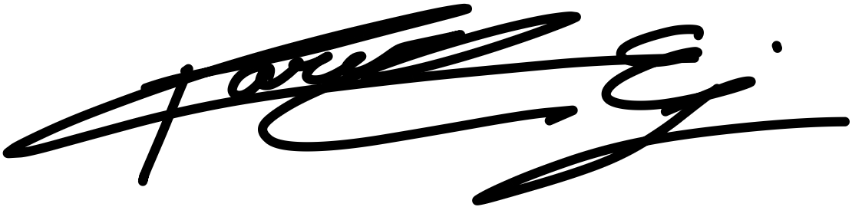
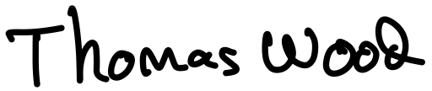
Review and approval: Quality & Documentation Lead: ____________________ Project Lead: ____________________

