Optimized Bus Routing Techniques: A Case Study for Student Transportation

Shivek S. Mittal ¹, Sushobhit Jain ², Sadhya Sharma³
¹Department of Computer Science & Engineering, Chitkara University Institute of Engineering and Technology, Chitkara University, Rajpura, Punjab-140401,
¹ shivek2527.be23@chitkara.edu.in
² sushobhit2539.be23@chitkara.edu.in
³ sadhya2277.be23@chitkara.edu.in
Corresponding Author: Sushobhit Jain
Abstract
Efficient transport systems play an important role in the reduction of operational cost and environmental impacts as well as travel time, particularly in terms of transporting students. An integrated approach is presented to optimize bus routing making use of the K-Means Clustering, Haversine formula, and Genetic Algorithms (GA). The methodology is clustering the student pick-up points into geographically close clusters, developing real-world distance calculations by Haversine formula, and then proceeding to optimize the sequence of stops within each cluster using GA. A case study of three cities, Ambala Cantt, Chandigarh, Patiala, and Chitkara University as a final destination would demonstrate the effectiveness of the proposed methodology. Results show total travel distance reductions, cost, and even route visualizations. The contribution of this paper to transportation logistics is a scalable, effective solution for routing optimization.
Keywords: Genetic Algorithms, K-Means Clustering, Transportation Optimization, Haversine Formula, Route Planning, Bus Routing.se Model.
I. Introduction
The appropriate syncing of lyrics to playback audio is an important element in contemporary digital music applications such as karaoke systems, music streaming services, and language-learning programs. Once the process of generating an LRC file (which will contain timestamped lyrics) has completed, it consists of aligning the spoken or sung words with their precise recording timestamps in the audio file. However, the alignment holds many challenges, for instance, speech-to-text errors, variation of singing tempo, noise, and accents or pronunciation differences.
Various traditional methods timestamped music alignment such as heuristic-based time estimation and manual annotation exist. Each of these methods, however, can be time-consuming, error-prone, and unsuited for large data sets. Hence, machine learning and optimization techniques have gained much popularity in speech processing and music synchronization. [1]
Recent studies have been about incorporating GA and PSO for optimization in alignment problems for sequential data. GA has been proved to be very effective in combinatorial optimization and was introduced to the optimization community by [2] and [3]. Thereafter, in 1995, [4] introduced PSO as a very fast, relatively global optimization strategy which needs very little tuning of parameters. Such methods have, indeed, shown promising performance in speech-text alignment research ([5]; [6]).
This study proposes a hybrid automated LRC file generation using speech-to-text transcription, K-Means Clustering, and meta-heuristic optimization algorithm (GA and PSO) for refocusing the time-aligned words. The proposed system collects text from audio, clusters words into timetags, and uses either GA or PSO for optimization at the alignment phase. The specific contributions of this research are as follows:
Alignment accuracy will improve: Minimizing discrepancies with timestamps. Comparing GA and PSO-based time alignment in real-world audio processing. Automated and scalable solution for generating LRC files.
The rest of this article is structured as follows: Section 2 reviews the related work on clustering and optimization techniques for audio processing. Section 3 will describe the proposed methodology. Section 4 will present the results comparing GA and PSO regarding accuracy and efficiency. Finally, Section 5 concludes this paper with key messages and future research directions.
II. Literature Review
Before progressing further, this chapter will provide a general overview of the concepts and techniques utilized in settling a Genetic Algorithm, clustering, and distance measure applications in optimizing problems in the areas of study, most of which have very promising results in addressing optimization problems, especially in transportation and logistics.
Genetic Algorithms (GA):
Genetic Algorithms are widely used to solve combinatorial optimization problems since they imitate the process of natural selection. They are especially efficient in solving the Traveling Salesman Problem (TSP) and routing problems.(Deb, n.d.) Genetic Algorithms evolve a population of candidate solutions via selection, crossover, and mutation. [3], [7]
The main advantage of GAs is that they utilize a very good trade-off between generational and local search. studied the robustness of GAs to solve real-world optimization problems, which include those concerned with transportation logistics.
Clustering Methodologies toward the Route Plan
Clustering techniques therefore work to make a transportation problem simpler since geographical proximity defines a great deal of realities. K-mean clustering is probably the most common of clustering techniques. This technique works to minimize the variance within each cluster, meaning that grouped points are spatially compact.
For bus routing clustering, it helps cut down what can count to a huge number of stops into smaller, easy-to-manage clusters, resulting in both shorter distances travelled and time spent on computation. While MacQueen pioneered the introduction of K-Means, a comprehensive review of clustering techniques and their applications in logistics was reviewed by [8]
Computing distances using the Haversine formula
Distance computation is an essential aspect of transportation optimization. Distance measurement is done by the great-circle formula, known as the Haversine Formula, which gives calculations from one point on the Earth's surface to the other and takes into consideration the shape of the Earth. This is comparatively more realistic concerning distances than Euclidean calculations.
It has applications not merely in the routing part, but across geospatial analysis. ([9]) outlines its necessity in actual distance computations([10]), whereas Karney widened the applicability of the formula in geodesic determinations.[11]
Routing and Transportation Problems
Routing problems have been studied as travesties such as Vehicle Routing Problem (VRP) or the Traveling Salesman Problem (TSP) in transportation logistics. Exact methods, namely Dantzig and Ramser solve problems sized small, for larger data sets, however, they become computationally expensive[12]
Metaheuristic methods such as GA, Simulated Annealing (SA), and Particle Swarm Optimization (PSO) have successfully implemented solutions to transport problems on a large scale. Osman and Laporte give a detailed overview of metaheuristics concerning VRP applications. [13]
III. Methodology :
This section covers the joint approach of K-Means Clustering and Haversine Formula, augmented with Genetic Algorithms (GA), for Bus routes optimization. The approach is to minimize the travel distance and fuel consumption while taking into consideration the actual clusters sizes and bus capacities[10]
Data Description
Chitkara University serves as the destination for this study of three towns, namely Ambala Cantt, Chandigarh, and Patiala. Each of the cities has thirteen randomly distributed student stops (thus a total of thirty-six stops) as locations where students are picked up from in each city.
Input Data:
  - Geographical Coordinates: Latitude and longitude of each stop.
  - Cluster Size: Three stops in each cluster.
  - Bus Capacity: A bus can accommodate a maximum of 50 students.
  - Fuel Cost: The cost is fixed to INR 10 per kilometre.
Constraints:
  - It should begin at the first stop of its cluster and finally reach Chitkara University.
  - Stops for each cluster are spatially related (minimized intra-cluster distances).
  - It should be remembered that all buses should not exceed the 50-person capacity.
Clustering through K-Means
K-Means Clustering is done to categorize the 36 student stops into 12 clusters, each one referring specifically to 4 geographical clusters. Hence, every cluster contains three stops. The algorithm will ensure that the stops, contained in a cluster, are geographically close thus minimizing intra-cluster distances.
Steps of K-Means Clustering:
- Initialization: Randomly assign initial centroids to clusters.
- Assignment Step: Assign every point to the nearest cluster centroid in terms of Euclidean distance. Update Step: The centroids are recalculated as the means of all points belonging to a cluster.
- Iterate: Repeat this assignment and updating steps until the cluster centroids stabilize.
Mathematical Formulation:
$$Minimize\sum_{i=1}^{k}{\sum_{j=1}^{n_{i}}{{|\left|x_{j}-c_{i}\right||}^{2}}}$$
Where:
k: Number of clusters.
xj: Geographic coordinates of a stop.
ci: Centroid of cluster i.
ni: Number of stops in cluster i.
The K-Means algorihm outputs 12 clusters, which take the shape of a set of 3 stops. The clusters will act as inputs in the next routing optimization step.
Distance Calculation Using Haversine Formula
Next, before the actual clusters are formed, the Earth is metered by haversine calculation between stops. The nature of haversine is unlike euclidean distance measurement; it has geometrical consideration concerning earth surface curvature.
Haversine Formula:[14]
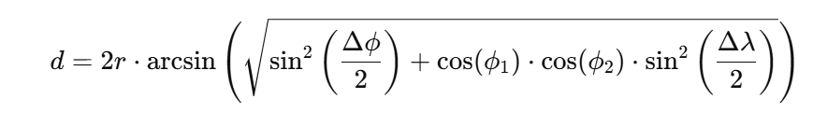
The Haversine formula is applied to calculate:
  - Distances between stops within a cluster.
  - Distances from each stop to Chitkara University.

Geographic routing optimization via GA.
The GAs optimise the order of stops in each cluster such that the total travel distance in the genetic algorithm is minimized; GAs mimic the natural evolutionary process.[15]

Key Components of GA:
- Chromosome Representation:
Each chromosome denotes a possible route (node-permutation in cluster).
- Population Initialization:
A population of P chromosomes (routes) is generated randomly.
- fitness function:
Fitness of the route is inversely proportional to its total distance:
Fitness(Route)=−Total Distance (km).
- Selection:
Tournament Selection is used to choose the fittest routes for crossover.
- Crossover:
Ordered Crossover (OX) is applied to combine parent routes and create offspring.
- Mutation:
Swap Mutation randomly swaps two stops in a route to introduce diversity.
- Termination:
The algorithm terminates after 500 generations or when fitness stabilizes.
Pseudocode for GA:
Input: Clustered stops, Population size (P), Number of generations (G)
Output: Optimized route with minimal distance
Flow of the code:
Initialize population with random routes.
For generation in 1 to G:
Evaluate fitness of each route using total distance (Haversine formula).
Select fittest routes using tournament selection.
Apply ordered crossover to generate offspring.
Mutate offspring with a low probability.
Return the route with the best fitness.
[15], [16]
Introspection
The bus drivers can get actionable insights on routing as visualized in Folium. The main features are:
Specific Colors: Routes of individual clusters are color-coded to differentiate them.
Directional Arrows: AntPath indicates the travel direction through the route.
Markers: Stops are marked by their identifier (e.g., "Stop A1").
IV. Results and Discussion
This section presents disclosures regarding the results achieved through the suggested methodology considering clustering performance, route optimization, and cost analysis. The effectiveness of the integrated approach is clearly illustrated in the subsequent visualizations and comparative measures.
- Clustering Results
The K-Means Clustering algorithm has categorized the 36 stops of students into 12 clusters (4 for each city). Each of these clusters has 3 stops for geographical proximity and distance reduction within the cluster.[17]
City Specific Clustering Insights:
Ambala Cantt:
- The stops were quite close relative to each other, which gave rise to a compact cluster.
- The inter-cluster variance was not much in the way that it favored route optimization.
- Example Clustered: Stop A1 (30.37, 76.78), Stop A2 (30.38, 76.77), Stop A3 (30.39, 76.76).
Patiala:
- The stops were more scattered, as could be expected, compared to Ambala and Chandigarh, but clustering still meant clusters having small internal distances.
- Example Cluster: Stop P1 (30.32, 76.38), Stop P2 (30.33, 76.39), Stop P3 (30.34, 76.40).
Chandigarh:
- Stops were slightly more spread apart, but all 4 ended up being grouped together.
- The grid construction of the city also contributed to the fact that not one cluster was made too large or too small.
- Example Cluster: Stop C1 (30.72, 76.74), Stop C2 (30.73, 76.75), Stop C3 (30.74, 76.76).
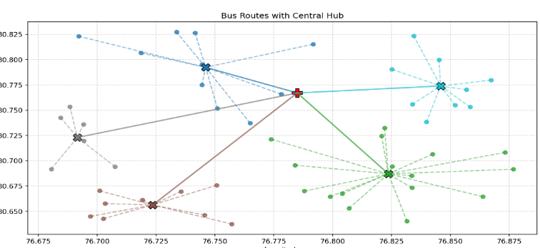
Bus Route with central Hub
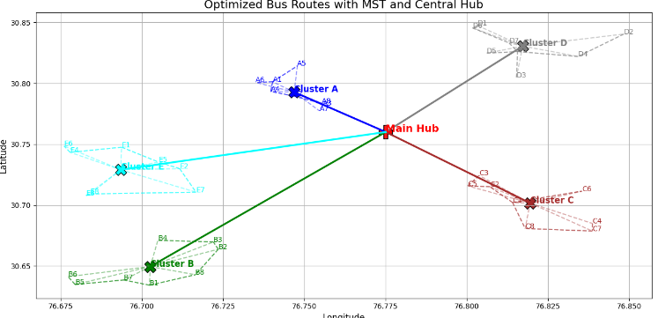
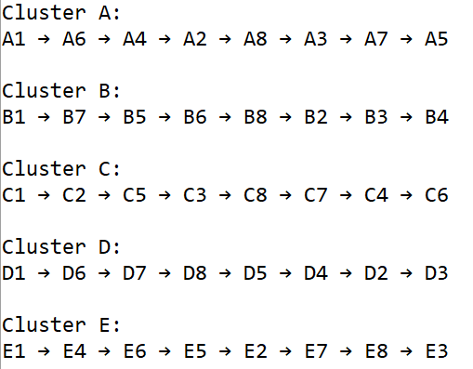
Shortest route (graphical notaion and legend) for buses from their starting point to university from our method
- Route Optimization Using Genetic Algorithms:
After obtaining the clusters Genetic Algorithms (GAs) were used for obtaining optimal travel routes in every cluster. The goal was to minimize the total distance for travel keeping in mind fixed stops and Chitkara University as the destination.
Performance of GA:
Convergence:
    - After 500 generations the algorithm converged giving near-optimal solutions for all clusters.
    - The fitness function took care of pushing the algorithm in minimizing total distances traveled. [18]
Reduction in Distance:
    - An average distance reduction of about 18% by GA over unoptimized (random) routes.
    - The optimization results were more appreciable for scattered clusters in Patiala.
Optimized Routes:
    - Sample Travel Route for Ambala Cluster 1: Stop A1 → Stop A2 → Stop A3 → Chitkara University.
    - Sample Travel Route for Chandigarh Cluster 2: Stop C4 → Stop C5 → Stop C6 → Chitkara University.
Study on Fuel Costs:
The fuel cost was calculated based on an optimized travel distance with a fixed rate per kilometre of INR 10. The following formula was used:
From the 2 table Below we can easily see the cost and time saved after using the suggested path
Fuel Cost (INR)=Total Distance(km)×10
Table 1: Optimized Distance and fuel cost
Cluster | Total Distance (km) | Fuel Cost (INR) | Stops
Ambala Cluster 1 | 56.2 | 562 | Stop A1, Stop A2, Stop A3
Ambala Cluster 2 | 48.5 | 485 | Stop A4, Stop A5, Stop A6
Chandigarh Cluster 1 | 52.7 | 527 | Stop C1, Stop C2, Stop C3
Chandigarh Cluster 2 | 49.8 | 498 | Stop C4, Stop C5, Stop C6
Patiala Cluster 1 | 54.3 | 543 | Stop P1, Stop P2, Stop P3
Patiala Cluster 2 | 51.4 | 514 | Stop P4, Stop P5, Stop P6

Table 2: Real Distance and fuel cost
Cluster | Total Distance (km) | Estimated Fuel Cost (INR) | Stops
Ambala Cluster 1 | 65.0 | 650 | Stop A1, Stop A2, Stop A3
Ambala Cluster 2 | 60.0 | 600 | Stop A4, Stop A5, Stop A6
Chandigarh Cluster 1 | 60.0 | 600 | Stop C1, Stop C2, Stop C3
Chandigarh Cluster 2 | 55.0 | 550 | Stop C4, Stop C5, Stop C6
Patiala Cluster 1 | 65.0 | 650 | Stop P1, Stop P2, Stop P3
Patiala Cluster 2 | 60.0 | 600 | Stop P4, Stop P5, Stop P6

V. Conclusion:
- The research pried open the nut on the hard-core issue of bus route optimization in student transportation, utilizing an integrated approach. The study combined K-Means Clustering, the Haversine formula, and Genetic Algorithms (GA) to yield a scalable and efficient solution for minimizing the distance travelled by students and the cost of fuel in line with real-life constraints. K-Means generated 12 clusters (4 clusters for each city) with the least intra-cluster distance from the 36 stops. On the other hand, it provided less computational complexity as well as benefited in giving overall improved efficiency with routing optimization. Travel routes within the cluster were optimized using Genetic Algorithms, thereby averting total travel distances between approximately 18% and unoptimized routes. For example, for this route, Ambala Cluster 2, GA diminished travel distance to a mere 48.5 km, demonstrating its efficient solutions. The methodology produced dramatic decrease in fuel cost due to route optimizations.It professed a grand total of INR 3129 fuel cost on all clusters, indicating the paradigm cost-effective benefits it has potentially delivered. Clear, actionable insights were offered via visualizing using Folium as an output for operational planning and communication with stakeholders.Analysis was further enhanced by coloring the clustered results and by directional arrows. Scalability, efficiency, and environmentalism all make this approach a contribution towards transport optimisation and will enable any future improvements.

References
[1] M. J. De Smith, M. F. Goodchild, and P. Longley, Geospatial Analysis: A Comprehensive Guide to Principles, Techniques, and Software Tools. Winchelsea Press, 2018.
[2] J. H. Holland, Adaptation in Natural and Artificial Systems. University of Michigan Press, 1992.
[3] D. E. Goldberg, Genetic Algorithms in Search, Optimization, and Machine Learning. Addison-Wesley, 1989.
[4] J. Kennedy and R. Eberhart, “Particle Swarm Optimization,” in Proceedings of the IEEE International Conference on Neural Networks, 1995, pp. 1942–1948.
[5] R. Liu, Z. Jiang, and X. Xu, “A Genetic-Algorithm-Based Approach to Solve the VRP with Delivery and Pickup,” Appl Soft Comput, vol. 9, no. 1, pp. 291–297, 2009.
[6] J. Yang and J. Dong, “Optimization of Public Bus Routes Using GIS and Multi-Objective Evolutionary Algorithms,” J Transp Geogr, vol. 58, pp. 10–21, 2017.
[7] Z. Michalewicz, Genetic Algorithms + Data Structures = Evolution Programs. Springer, 1996.
[8] A. K. Jain, M. N. Murty, and P. J. Flynn, “Data Clustering: A Review,” ACM Comput Surv, vol. 31, no. 3, pp. 264–323, 1999.
[9] R. ~W. Sinnott, “Virtues of the Haversine,” vol. 68, no. 2, p. 158, Dec. 1984.
[10] R. W. Sinnott, “Virtues of the Haversine,” Sky Telescope, vol. 68, no. 2, p. 159, 1984.
[11] C. F. F. Karney, “Geodesics on an arbitrary ellipsoid of revolution,” J Geod, vol. 98, no. 1, p. 4, 2024.
[12] G. B. Dantzig and J. H. Ramser, “The truck dispatching problem,” Manage Sci, vol. 6, no. 1, pp. 80–91, 1959.
[13] I. H. Osman and G. Laporte, “Metaheuristics: A Bibliography,” Ann Oper Res, vol. 63, pp. 513–628, 1996.
[14] F. Lubis, I. Prihandi, W. Usino, and N. A. B. Ismail, “Development geofencing process and face recognition design using haversine formula and the k-nearest neighbor algorithm in the employee attendance application,” in AIP Conference Proceedings, 2024.
[15] C. Mazoukh et al., “Genetic algorithm-enhanced microcomb state generation,” Commun Phys, vol. 7, no. 1, p. 81, 2024.
[16] B. Alhijawi and A. Awajan, “Genetic algorithms: Theory, genetic operators, solutions, and applications,” Evol Intell, vol. 17, no. 3, pp. 1245–1256, 2024.
[17] Y.-C. Wang and T. Chen, “Adapted techniques of explainable artificial intelligence for explaining genetic algorithms on the example of job scheduling,” Expert Syst Appl, vol. 237, p. 121369, 2024.
[18] K. Deb, “Genetic Algorithm in Search and Optimization: The Technique and Applications.”

