<https://github.com/shivemind/csd-340/blob/main/README.md>

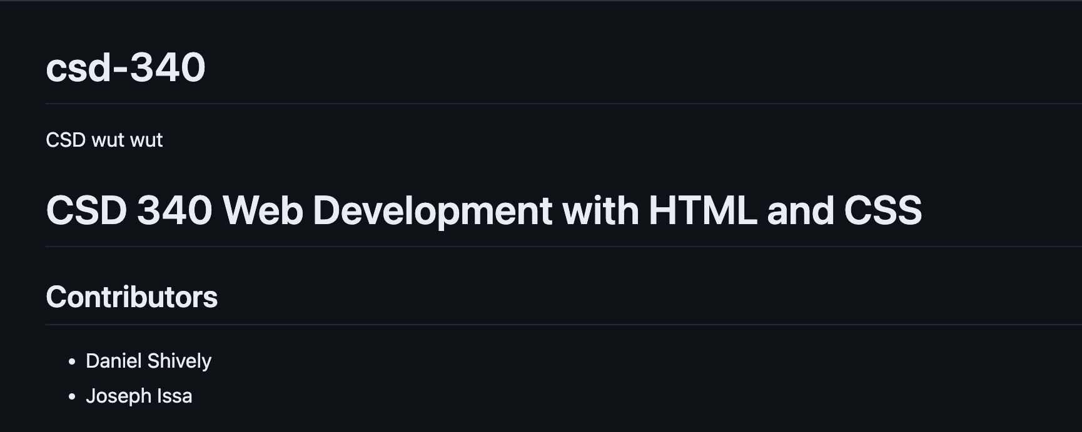

Caption

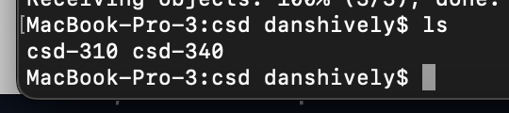

Caption