Assignment 2- Case Study

Stage 3 Lab Activities

SmartCare Domain Modelling
AI OFF -> AI ON -> COMPARE -> VERIFY | 1 hour

A - Requirements Review
Highlight nouns, verbs and business rules in SmartCare v0.2.
Nouns: patient, patient ID, name, phone number, practitioner, practitioner ID, appointment, date and time, status, booking, appointment history, staff, report.
Verbs: register, search, add, book, reject, cancel, retain, record, display.
Business rules: BR-01 a practitioner cannot have two Booked appointments at the same date and time; BR-02 every appointment is for one registered patient and one registered practitioner; BR-03 patient and practitioner IDs are unique; BR-04 a cancelled appointment is never deleted and no longer blocks the time slot; BR-05 an appointment always has exactly one status.

B - Candidate Classes
Record candidate concepts, supporting requirements, state and behaviour.
Patient. Supporting requirements: FR-01, FR-02, FR-03, BR-03. State: patient_id, name, phone. Behaviour: matches_name.
Practitioner. Supporting requirements: FR-04, BR-03. State: practitioner_id, name. Behaviour: none yet.
Appointment. Supporting requirements: FR-05 to FR-09, BR-01, BR-02, BR-04, BR-05. State: patient, practitioner, date_time, status. Behaviour: cancel.
Clinic (optional). Supporting requirements: FR-02, FR-03, FR-06, FR-10, FR-11, BR-01, BR-03. State: the lists of patients, practitioners and appointments. Behaviour: register_patient, add_practitioner, find_patient_by_id, find_patients_by_name, book_appointment, appointments_for_practitioner, appointments_for_patient.
Candidates not kept as classes: Name (attribute), Status (attribute with fixed values), Cancellation (operation), Report (FR-12 is provisional), Staff or Receptionist (a user of the system, not data in it) and Database (technology, not a domain concept).

C - CRC Cards
Create CRC cards for Patient, Practitioner and Appointment.
Patient. Responsibilities: knows its patient ID, name and phone number; says whether its name matches a search. Collaborators: none.
Practitioner. Responsibilities: knows its practitioner ID and name; gives its details so they can be shown with its appointments. Collaborators: none.
Appointment. Responsibilities: knows its patient, practitioner, date and time, and status; cancels itself by changing its status to Cancelled. Collaborators: Patient, Practitioner.
Clinic (optional class). Responsibilities: keeps the lists of patients, practitioners and appointments and keeps IDs unique; books an appointment only if the practitioner is free; finds patients; lists appointments for a practitioner or a patient. Collaborators: Patient, Practitioner, Appointment.

D - UML Model
Draw classes, attributes, operations, associations and multiplicities.
First draft, drawn before the AI review:
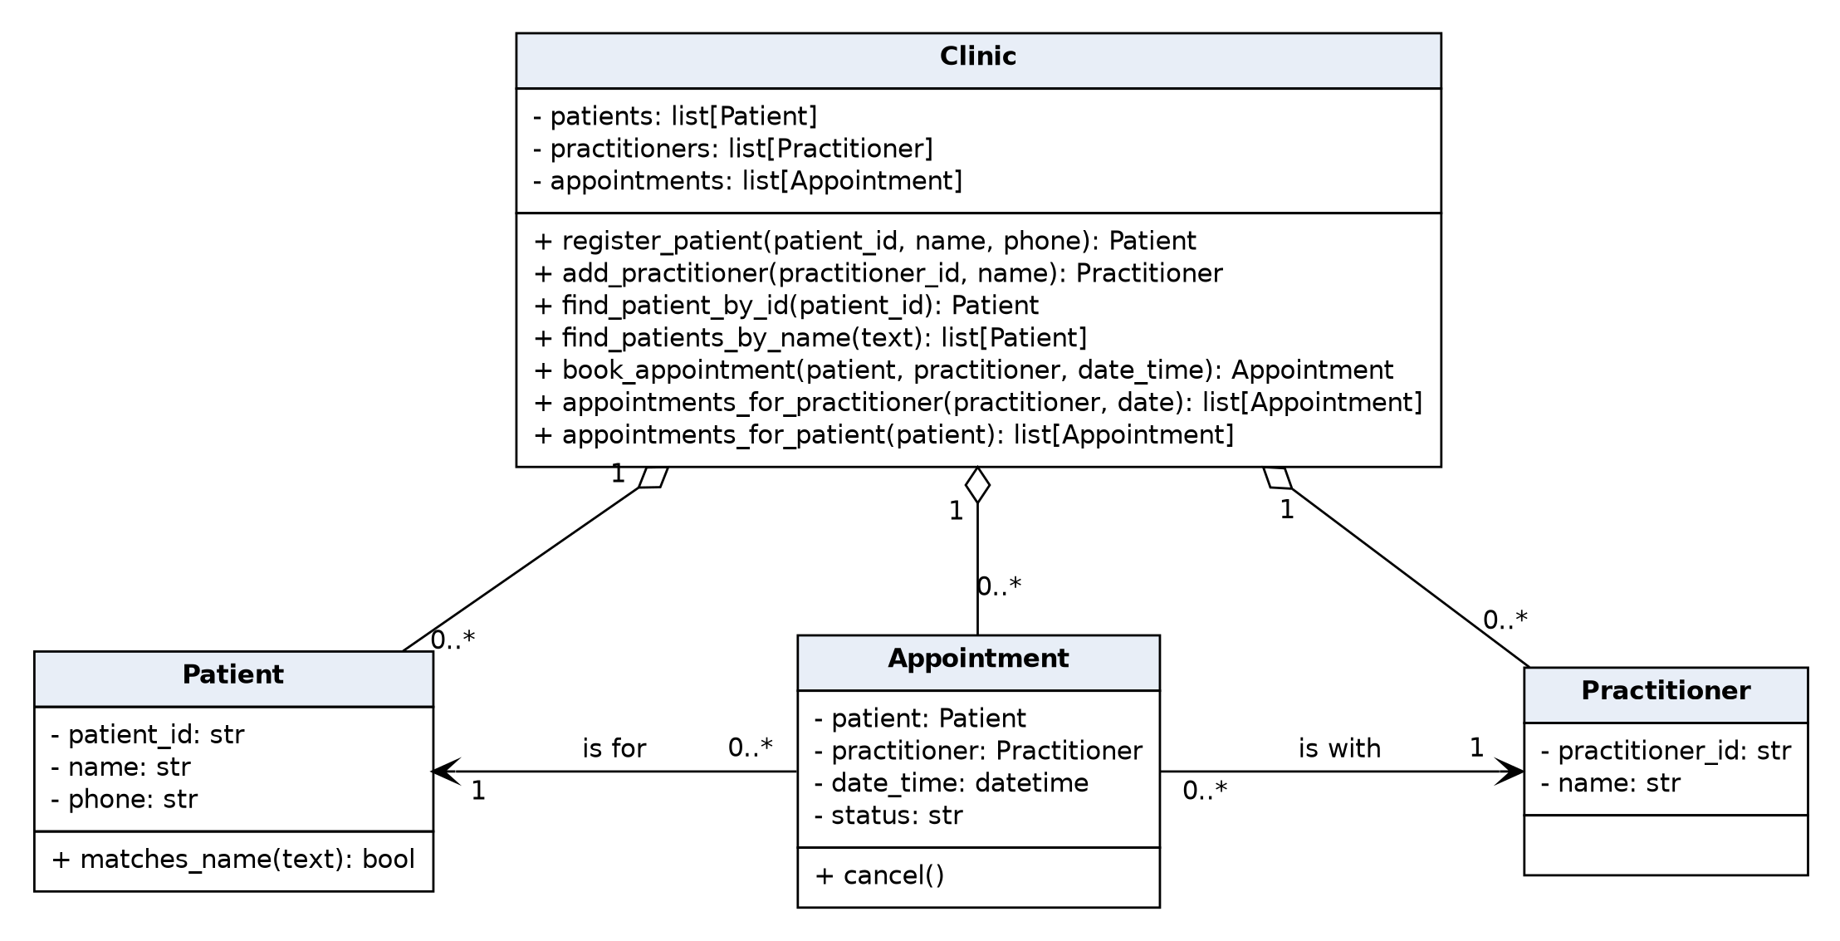
Associations and multiplicities: each Appointment is for exactly one Patient and is with exactly one Practitioner (BR-02). A Patient or a Practitioner can have zero or more Appointments. Clinic holds zero or more Patients, Practitioners and Appointments.

E - AI Design Review
Ask AI to suggest classes and relationships using only confirmed requirements; require supporting requirement IDs.
AI tool used: Claude (Anthropic).
Prompt: Suggest classes and relationships for the SmartCare system using only the confirmed requirements below. For every class and relationship, give the IDs of the requirements that support it. Do not use provisional requirements, assumptions or open questions. (The SmartCare v0.2 functional requirements and business rules were pasted after the prompt.)
Summary of the AI response:
S1. Classes: Patient (FR-01, FR-02, FR-03, BR-03), Practitioner (FR-04, BR-03) and Appointment (FR-05 to FR-09, BR-01, BR-02).
S2. Model the status as an enumeration with Booked, Cancelled and Completed instead of free text (FR-09, BR-05).
S3. Give Appointment its own appointment ID. Once a cancelled appointment is kept and the time is booked again, two appointments share the same practitioner, date and time (FR-07, FR-08, BR-04).
S4. Add an is_booked operation to Appointment, so the rule that only Booked appointments block a time slot is in one place (BR-01, BR-04).
S5. Relationships: Patient 1 to 0..* Appointment and Practitioner 1 to 0..* Appointment (BR-02, FR-10, FR-11). It also suggested that Patient and Practitioner each keep a list of their appointments.
S6. A Person superclass for Patient and Practitioner, because both have a name (FR-01, FR-04). The AI noted that no requirement asks for this.
S7. A Schedule class with time slots for each practitioner (FR-10). The AI noted that working hours are an open question, so this is not confirmed.
S8. A Receptionist class, because the requirements say "staff". The AI noted that logins and roles are an open question.

F - Compare and Decide
Record at least one accepted, modified and rejected AI suggestion.
S1. Patient, Practitioner and Appointment as classes: Accepted. They were already in my draft.
S2. Status as an enumeration: Accepted. Evidence: FR-09 and BR-05. Model change: status: str became status: AppointmentStatus.
S3. An ID for each appointment: Accepted. Evidence: FR-07, FR-08 and BR-04. Model change: appointment_id added. This updates assumption A-03 in SmartCare v0.2.
S4. is_booked on Appointment: Accepted. Evidence: BR-01 and BR-04. Model change: is_booked() added.
S5. Multiplicities, plus appointment lists inside Patient and Practitioner: Modified. The multiplicities are accepted (BR-02). The extra lists are not added, because the same fact would be stored twice. The links stay one-way from Appointment and Clinic answers the queries.
S6. Person superclass: Rejected. Patient and Practitioner only share a name, and no requirement treats them the same way.
S7. Schedule class with time slots: Rejected. Working hours and appointment length are open question Q-04, so there is no confirmed requirement.
S8. Receptionist class: Rejected. Staff are users of the system. Logins and roles are open question Q-05.
The final model after these decisions is the UML class diagram in the Domain Model Workbook (also saved as uml_class_diagram.png).

G - Python Skeletons
Create simple Patient, Practitioner and Appointment class skeletons.
The skeletons are in source-code/smartcare_v03.py: AppointmentStatus, Patient, Practitioner, Appointment and Clinic. Each constructor stores the attributes shown in the UML diagram. Each operation has a docstring naming the requirement it supports, and its body is pass. Output of running the file:
SmartCare v0.3 class skeletons
Patient: P001 Alice Smith 0400 000 001
Practitioner: D01 Dr. John Doe
Appointment: A001 | Alice Smith | Dr. John Doe | 2024-07-20 10:00:00 | Booked
Clinic lists: 0 patients, 0 practitioners, 0 appointments

H - Consistency Check
Check model-code consistency; do not implement full behaviour yet.
I checked the code against the final UML diagram with source-code/check_model.py. It creates one object of each class and checks that every attribute and operation in the diagram exists in the code, that an Appointment holds a Patient and a Practitioner, that a new appointment starts as Booked, and that the enumeration has exactly the three statuses. Output:
Patient
OK Patient has patient_id
OK Patient has name
OK Patient has phone
OK Patient has matches_name
Practitioner
OK Practitioner has practitioner_id
OK Practitioner has name
Appointment
OK Appointment has appointment_id
OK Appointment has patient
OK Appointment has practitioner
OK Appointment has date_time
OK Appointment has status
OK Appointment has cancel
OK Appointment has is_booked
OK Appointment.patient is a Patient
OK Appointment.practitioner is a Practitioner
OK A new appointment has status Booked
AppointmentStatus
OK AppointmentStatus has exactly Booked, Cancelled, Completed
Clinic
OK Clinic has patients
OK Clinic has practitioners
OK Clinic has appointments
OK Clinic has register_patient
OK Clinic has add_practitioner
OK Clinic has find_patient_by_id
OK Clinic has find_patients_by_name
OK Clinic has book_appointment
OK Clinic has appointments_for_practitioner
OK Clinic has appointments_for_patient
27 of 27 checks passed
Result: all 27 checks passed, so the names in the code match the diagram. The operations are stubs that only contain a docstring and pass. Full behaviour is left for Stage 4.

Reflection
What modelling decision was hardest? Where did AI over-design? What evidence supported your final choices?
The hardest modelling decision was where to put the relationship between patients, practitioners and appointments. I could have given Patient and Practitioner their own lists of appointments, but then the same fact would be stored in two places and could get out of step. I decided that an Appointment refers to its one patient and one practitioner, and the Clinic keeps the single list and answers questions such as a practitioner's appointments for a day.
The AI over-designed in three places. It suggested a Person superclass for Patient and Practitioner, a Schedule class with time slots for each practitioner, and a Receptionist class. None of these has a confirmed requirement behind it. Working hours and appointment length are still open questions, and staff are users of the system, not data in it.
My final choices are supported by the SmartCare v0.2 requirements. Each class, attribute and operation traces to a requirement or business rule. For example, BR-02 gives the one-patient, one-practitioner multiplicity, BR-04 is why there is no delete operation, and FR-09 is why status became an enumeration. The AI's appointment ID suggestion was accepted because BR-04 means two appointments can share a practitioner and time.

