SmartCare v0.3 - Domain Model Workbook
Week 6 student resource

Requirement-to-Concept Trace
Requirement | Concept | State/behaviour | Decision
FR-01, BR-03: register a patient with a unique ID, name and phone | Patient | State: patient_id, name, phone | Class
FR-02, FR-03: search for a patient by ID or by name | Clinic, Patient | Behaviour: find_patient_by_id, find_patients_by_name, matches_name | Operations on Clinic, because a search needs the whole list
FR-04, BR-03: add a practitioner with a unique ID and name | Practitioner | State: practitioner_id, name | Class
FR-05, BR-02: book an appointment for one patient with one practitioner | Appointment | State: appointment_id, patient, practitioner, date_time, status | Class that links one Patient and one Practitioner
FR-06, BR-01: reject a double booking | Clinic, Appointment | Behaviour: book_appointment checks existing appointments using is_booked | Rule checked by Clinic, because it needs every appointment
FR-07: cancel an appointment | Cancellation | Behaviour: cancel changes the status | Operation on Appointment, not a class
FR-08, BR-04: keep cancelled appointments | Appointment | State: status stays Cancelled and the record remains | No delete operation in the model
FR-09, BR-05: exactly one status | Status | State: Booked, Cancelled or Completed | Enumeration used by Appointment, not a full class
FR-10: a practitioner's appointments for a date | Clinic, Practitioner, Appointment | Behaviour: appointments_for_practitioner | Operation on Clinic
FR-11: a patient's appointment history | Clinic, Patient, Appointment | Behaviour: appointments_for_patient | Operation on Clinic

CRC Cards

Patient
Responsibilities | Collaborators
Knows its patient ID, name and phone number. | None
Says whether its name matches a search. | None

Practitioner
Responsibilities | Collaborators
Knows its practitioner ID and name. | None
Gives its details so they can be shown with its appointments. | None

Appointment
Responsibilities | Collaborators
Knows its patient, practitioner, date and time, and status. | Patient, Practitioner
Cancels itself by changing its status to Cancelled, and says whether it is still Booked. | AppointmentStatus

Optional class: Clinic
Responsibilities | Collaborators
Keeps the lists of patients, practitioners and appointments, and keeps IDs unique. | Patient, Practitioner, Appointment
Books an appointment only if the practitioner is free, finds patients, and lists appointments for a practitioner or a patient. | Patient, Practitioner, Appointment

UML Class Diagram
Insert/draw UML here. Include defensible relationships and multiplicities.
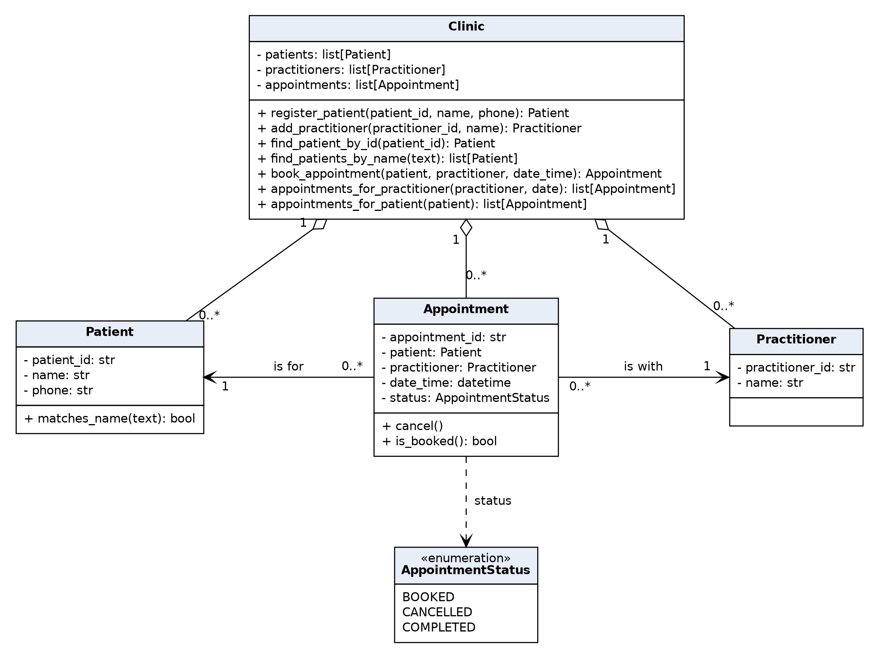

Design Rationale
Explain class selection, responsibility allocation and key relationships.
Class selection: Patient, Practitioner and Appointment are classes because the requirements give each of them its own identity, data and behaviour. Name is an attribute, Cancellation is an operation and Status is an enumeration. Database is a technology choice, not a domain concept. Clinic is the optional class: it holds the three lists so that rules needing every record can be checked.
Responsibility allocation: each object looks after its own data. Appointment changes its own status when it is cancelled and can say whether it is still Booked. Clinic is responsible for the rules that need the whole list, which are unique IDs (BR-03) and no double booking (BR-01), and for searching and listing.
Key relationships: an Appointment is for exactly one Patient and is with exactly one Practitioner (BR-02), and each of them can have zero or more Appointments. The links go one way, from Appointment to Patient and Practitioner, so the fact is stored once. Clinic aggregates zero or more of each class. There is no inheritance, because none of the classes is a kind of another.
Not modelled: the provisional report (FR-12), rescheduling (Q-02), working hours and appointment length (Q-04) and logins (Q-05), because none of them is confirmed.

AI Design Review Record
AI suggestion | Evidence | Decision | Reason | Model change
Model status as an enumeration instead of text. | FR-09, BR-05 | Accepted | A fixed list stops spelling differences, which is the inconsistent status problem. | status: str became status: AppointmentStatus.
Give Appointment its own ID. | FR-07, FR-08, BR-04 | Accepted | A cancelled and a new appointment can share a practitioner and time, so they need separate IDs. | appointment_id added. Updates assumption A-03 in v0.2.
Patient and Practitioner each keep a list of their appointments. | BR-02, FR-10, FR-11 | Modified | The multiplicities are right, but two lists would store the same fact twice. | Multiplicities kept. Links stay one-way from Appointment. Clinic answers the queries.
Add a Person superclass for Patient and Practitioner. | None. They only share a name. | Rejected | No requirement treats them the same way, and inheritance adds complexity. | None.
Add a Schedule class with time slots for each practitioner. | None. Working hours are open question Q-04. | Rejected | Over-design. The only confirmed rule is BR-01. | None.

