SmartCare v0.4 - Domain Implementation Workbook
Week 7 student resource

1. UML-to-Code Trace
UML element | Python element | Implemented? | Notes
Patient class | class Patient in patient.py | Yes | Part B.
Patient attributes: patient_id, name, phone | _patient_id, _name, _phone with read-only properties | Yes | Each is checked by require_text and cannot be empty.
Patient.matches_name(text) | Patient.matches_name | Yes | Ignores upper and lower case. An empty search returns False.
Practitioner class and attributes | class Practitioner in practitioner.py: _practitioner_id, _name, _specialty | Yes | specialty is new. See section 5.
Appointment class and attributes | class Appointment in appointment.py: _appointment_id, _patient, _practitioner, _date_time, _status | Yes | All read-only from outside.
Association: Appointment is for 1 Patient | patient property holding a Patient object | Yes | The constructor rejects anything that is not a Patient (BR-02).
Association: Appointment is with 1 Practitioner | practitioner property holding a Practitioner object | Yes | The constructor rejects anything that is not a Practitioner (BR-02).
AppointmentStatus enumeration | class AppointmentStatus(Enum) | Yes | BOOKED, CANCELLED, COMPLETED.
Appointment.cancel(), is_booked() | Appointment.cancel, Appointment.is_booked | Yes | complete() and InvalidStatusTransitionError added. See section 5.
Clinic class and its operations | None yet | No | The lab limits this stage to the three domain classes. Clinic holds the lists and checks BR-01 and BR-03, so it is left for the next stage.

2. Domain Invariants
Class | Invariant / rule | How protected
Patient | The ID, name and phone are never empty or blank. | require_text in the constructor raises ValueError.
Patient | Details cannot be changed from outside after creation. | Private attributes with read-only properties.
Practitioner | The ID, name and specialty are never empty or blank. | require_text in the constructor raises ValueError.
Appointment | Always has one Patient, one Practitioner and a real date and time (BR-02). | Type checks in the constructor raise TypeError.
Appointment | Has exactly one status, and a new appointment is always Booked (BR-05, FR-05). | The constructor sets BOOKED and takes no status parameter. The status property is read-only.
Appointment | Only Booked can become Cancelled or Completed. A cancelled appointment is kept and cannot be reopened (BR-04). | cancel() and complete() check the current status and raise InvalidStatusTransitionError. There is no delete operation.

3. Composition / Inheritance Decisions
Relationship | Decision | Rationale
Appointment and Patient | Association | An appointment is for a patient. It is not a kind of patient (BR-02).
Appointment and Practitioner | Association | An appointment is with a practitioner. It is not a kind of practitioner (BR-02).
Appointment and AppointmentStatus | Composition (attribute) | The status is a value that belongs to one appointment and is taken from a fixed list.
Patient, Practitioner and a Person superclass | No inheritance | They only share a name. The shared check is one function, require_text, which both classes call.
InvalidStatusTransitionError and Exception | Inheritance | It is a kind of exception, so callers can catch it separately from other errors.

4. AI Pair-Programming Record
AI contribution | Conforms? | Decision | Reason | Verification
AppointmentStatus enum and InvalidStatusTransitionError | Yes | Accepted | Both were agreed in the prompt. | Manual checks, section 5: illegal changes raise the exception.
Private attributes, read-only properties and constructor type checks | Yes | Accepted | They protect BR-02 and BR-05. | Manual checks, sections 2 and 3: wrong types rejected, status cannot be set directly.
A status parameter in the constructor, defaulting to BOOKED | No | Rejected | It lets code create an appointment that is already Cancelled, which skips the transition rules. It is not in the UML, and FR-05 says a new appointment is Booked. | The review run created a Cancelled appointment directly. After removal, "a new appointment starts as Booked" passes.
A transition table with a _change_status helper | Partly | Modified | Correct, but more general than the model needs. Two short checks in cancel() and complete() are simpler to explain. | The same manual checks pass before and after the refactor.
A complete() operation | No, not in the UML | Accepted with a UML change | Without it the COMPLETED status could never be reached. | Manual checks, section 5: Booked to Completed works, Completed to Cancelled is rejected.

5. Updated UML
Insert updated UML only if implementation revealed a justified design change. Explain every change.
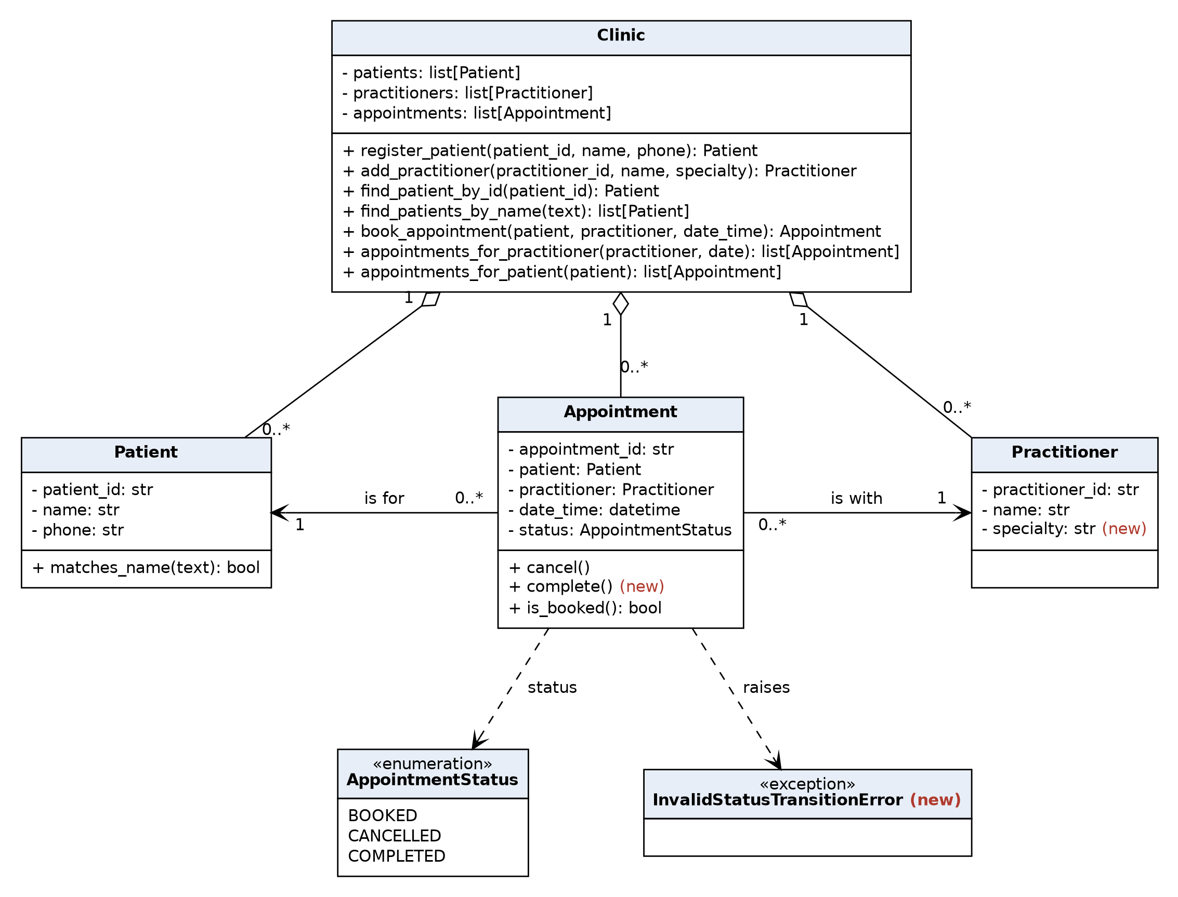
Three changes were made to the v0.3 diagram. They are marked (new).
1. Practitioner gained a specialty attribute. Reason: the Stage 4 lab asks for a Practitioner with an identifier, name and specialty. FR-04 in the requirements should be updated to match, and Clinic.add_practitioner now takes a specialty.
2. Appointment gained a complete() operation. Reason: the enumeration contains COMPLETED, but the v0.3 model had no operation that could reach it.
3. InvalidStatusTransitionError was added. Reason: the model said transitions are protected, but not what happens when one is refused. The exception makes an illegal change visible to the caller.
No relationship or multiplicity changed. Clinic is unchanged and is not implemented in this stage.

