Guide to Slay

# Index:

Index: 1

About: 1

Starting a game: 2

Starting a server on LAN: 3

Game Interface: 4

The Rules of the game: 5

Protection System: 6

Economy Systems: 7

Other Mechanics: 7

# About:

This is a recreation of the game Slay, originally created by Sean O'Connor in 1995, But with over the internet multiplayer.

# Starting a game:

To start a game of slay you must first connect to a game server.

You can either start one locally using the “Start Game on LAN” menu, You automatically join any game you start.  
Or you join a remote server using the “Direct Connect” option and entering its IP address.  
  
Additionally servers on your network may show up in the server list. You can select them and join them directly using the “Connect” button.

: The Launcher main menu

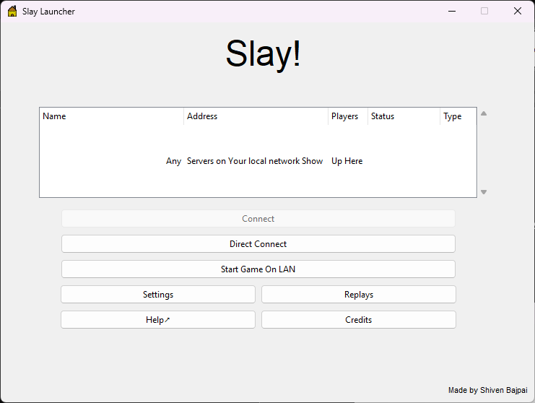

Once you have connected, you will face a waiting screen until sufficient players join the server and the game can begin

# Starting a server on LAN:

Using the “Start game on LAN” option opens the following menu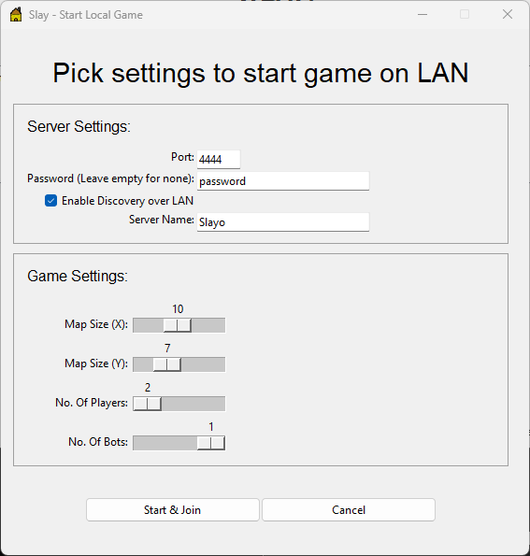

Under the Server settings group:

You can select the port that other players will have to connect to, a password if you wish to make the game private.  
You can enable Discovery over LAN which means the server will automatically show up on the server lists of other players on your network. Enabling this allows you to specify a name for players to recognize your server on the list by

Under the Game Settings group:

You can select the map size and the number of players and number of the players that would be bots. Note that number of players refers to total players and includes bots. You must have atleast one human player in each game.

# Game Interface:

The game interface has 3 simple parts

1. The map
2. The sidebar
3. The end turn button

The map displays the current state of the game.

You can play units using drag and drop mechanics.

Similar drag and drop mechanics are used to purchase from the shop

Use the end turn button when you’re done making all your moves for the current turn

3: The Game Interface

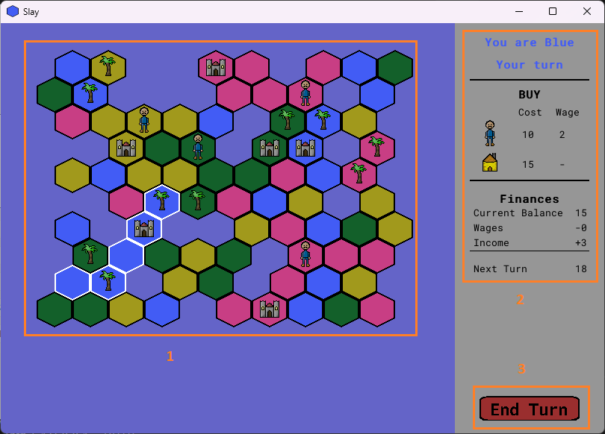

The active city and its land will be highlighted with white outlines. Simply click on land belonging to a certain city to select it. The information on the side panel always corresponds to the active city and the shop displays options based on the active city.

Anything you purchase from the shop can only be used by the active city that purchased it.

# The Rules of the game:

The main objective of slay is simple: To take control of the entire map.  
The game ends when only cities of one player are left standing

To achieve this goal, you must capture more land  
Capturing land requires units

There are 5 types of units in slay

4: The units of slay

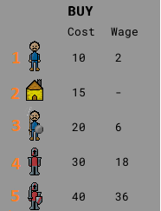

1. The peasant
2. The outpost
3. The spearman
4. The baron
5. The knight

The outpost alone is stationary and cannot be used for capturing, and is a defensive unit instead

All units besides the outpost also come with a per turn cost for upkeep besides their purchase cost.  
If the city runs out of money to pay for its units, All the units shall perish in the next round. Leaving behind graves

Other things you will find in the game include:

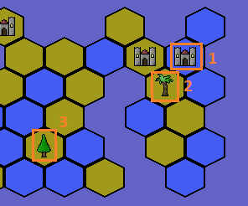

1. The city
2. Palm Trees
3. Pine Trees

# Protection System:

Every cell on the map that is attached to a city is “protected” by adjacent allied cells.  
So for an enemy unit to capture a cell. Its tier must be higher than the tier of the unit on the target cell or on any of the cells neighbouring the target cell.

Cities provide the same level of protection as peasants.  
Therefore you need spearmen or higher to take over cities and surrounding land  
Outposts provide the same level of protection as spearmen.  
Therefore you need barons or higher to take over outposts and surrounding land  
  
Placing your forces evenly around your highest tier units Is a good bet as any enemy force would have to have an even higher tier unit to chip at your forces.

# Economy Systems:

The economy is relatively simple

For every piece of land you own. Your city gains 1 gold in income every turn  
Your city spends some of this gold in wage costs for your soldiers  
Any leftover gold gets stored in the city’s balance  
  
Do note that each disconnected city has ITS OWN SEPARATE ECONOMY  
  
You can spend this balance to purchase new units

There are also trees. Any piece of land covered by a tree does not produce income.  
Hence it is important to balance removal of trees besides whilst fighting your enemies.  
  
Trees are removed simply by moving any unit onto the cell they occupy  
  
Trees are randomly placed at the start of a game and then spread across the map.

Different trees have different patterns of spreading.  
Pine trees spread slowly in all directions  
Palm trees are spread very fast but only along the coastline.  
  
Graves left behind by units also turn into trees after a turn

If the land on which a city is located is captured, it will relocate if possible.  
But any money saved up and stored as balance in that city will be lost.

If the land of a city is separated into two parts by an attacking force.  
The section no longer connected to its city will become a new city, with no money in its balance  
Income and wage cost of both cities will be recalculated depending on the land and units connected to them  
  
Thus cutting off your enemy’s forces from their city is an effective tactic. As the new city formed will not have any balance or sufficient income to keep up the forces now in its land and the entire encircled force will likely perish next turn. For the same reason, it’s a good idea to leave behind units along narrow corridors to prevent such moves

Those are all the rules of the game. Even with those basic rules, many a stratagem can be formed.  
Have fun

# Other Mechanics:

If a single cell is cut off from the mainland, it will not become its own city.  
Similarly when a city is relocated, if there is only a single cell left. The city will not relocate and will be permanently lost instead.

When a city is relocated, if there are no open spaces nor trees that can be replaced with the city, The city will not relocate. The city is lost and all of its units perish

In games containing bots, The game also ends when the last human player loses their final city, with the bot with most land under its control at the end of that round being declared winner