An Internship Report
Of
Artificial Intelligence

Submitted
To
School of Computer Science and Engineering
IILM University, Greater Noida, U.P.

In partial fulfilment of the requirement of degree of
B-Tech (CSE- Artificial Intelligence & Machine Learning)

By
Roll Number of Student:- 25SCS1003004154
Name of Student: SHIVENDRA SHRIVASTAV
Batch: 2026-27

CANDIDATE'S DECLARATION

I, SHIVENDRA SHRIVASTAV, do hereby declare that the internship report titled "Artificial Intelligence" has been completed by me to fulfil the requirement for the award of the degree of Bachelor of Technology in Computer Science and Engineering. All the references have been quoted and I have not taken as such any material from any other source. I affirm that this report is my own and has not been submitted to any other institute for any degree/diploma requirement, and further I shall be solely responsible for any kind of copyright violation in this regard.
Signature:-
Student Name: SHIVENDRA SHRIVASTAV
Roll No.: 25SCS1003004154

ACKNOWLEDGEMENT

I am using this opportunity to express my gratitude to everyone who supported me throughout the Internship Program. I am thankful for their aspiring guidance, invaluably constructive criticism and friendly advice during this work. I am sincerely grateful to them for sharing their truthful and illuminating views on a number of issues related to this work.
I would like to thank Codec Technologies and the AICTE National Internship Portal team for providing me the opportunity and the structured platform to learn and gain hands-on exposure in the domain of Artificial Intelligence. I am also thankful to my institute, IILM University, Greater Noida, and the faculty of the School of Computer Science and Engineering for their continuous support and encouragement.
I express my gratitude to my parents for their blessings.
Signature:
Student Name: SHIVENDRA SHRIVASTAV
Roll No.: 25SCS1003004154

TABLE OF CONTENTS

1. Candidate's Declaration i
2. Acknowledgement ii
3. Internship Completion Certificate -
4. Project Description 1
4.1 Introduction 1
4.2 Organization Profile 2
4.3 Problem Statement 3
4.4 Project Objectives 3
4.5 Scope of the Project 4
4.6 Technologies and Tools Used 4
4.7 System Architecture 5
4.8 Methodology 6
4.9 Expected Outcomes 7
4.10 Certificate of Completion 8
5. Bibliography/References 9

3. INTERNSHIP COMPLETION CERTIFICATE

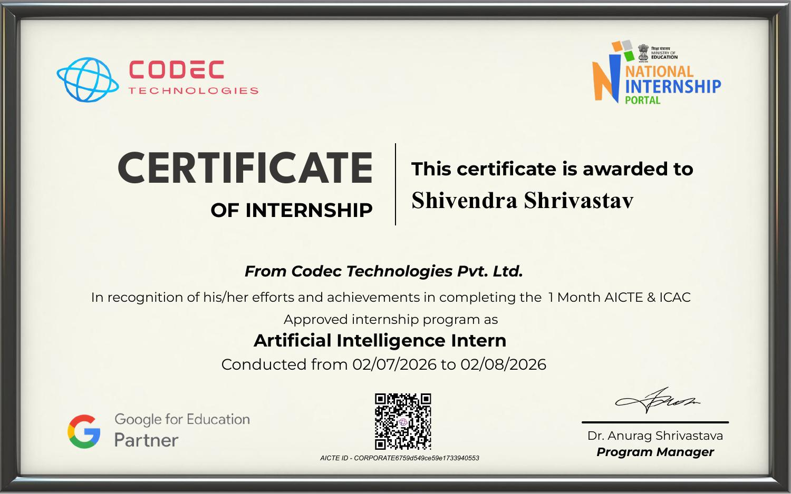

Internship Offer Letter

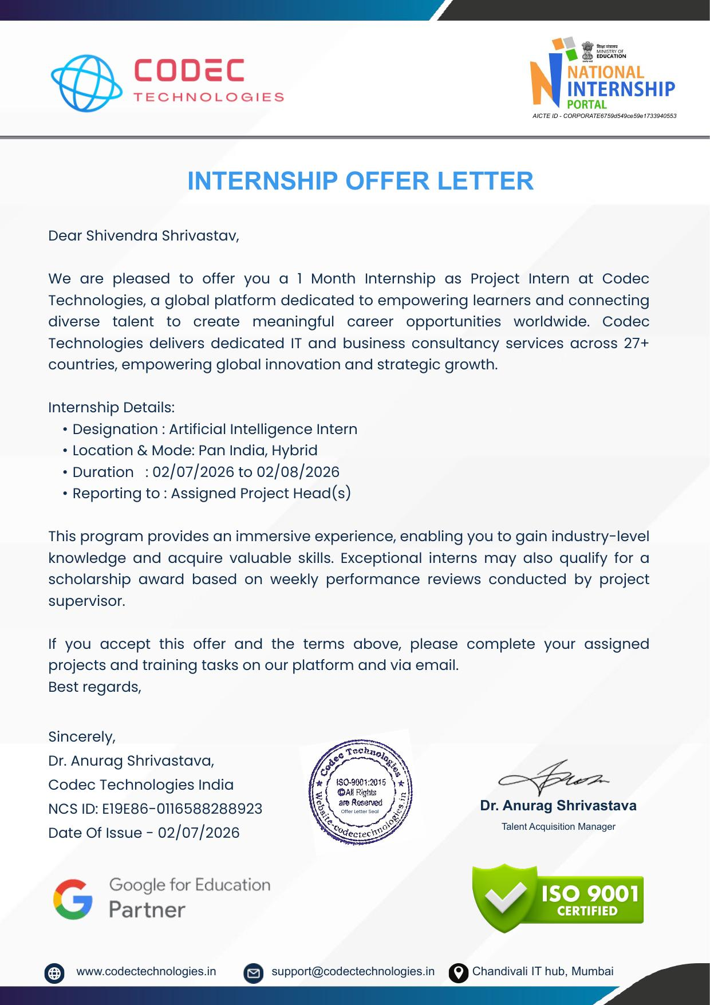

4. PROJECT DESCRIPTION

4.1 Introduction
This report presents a detailed account of the 1-month internship undertaken at Codec Technologies, in the domain of “Artificial Intelligence”. The internship was carried out from 02 July 2026 to 02 August 2026, in Pan India, Hybrid mode, as part of the requirement of the Bachelor of Technology (Computer Science and Engineering) programme at IILM University, Greater Noida. The primary aim of this internship was to bridge the gap between theoretical understanding of Artificial Intelligence and Machine Learning and their real-world, industry-level application. Over the course of the programme, the intern was exposed to industry-relevant tools and practices used to take AI/ML concepts from a learning stage to practical, project-based implementation under the guidance of an assigned Project Head.
The internship followed a structured curriculum that combined conceptual learning with hands-on assignments, weekly performance reviews conducted by the project supervisor, and project documentation. On successful completion of all the assigned projects and training tasks, an Internship Certificate was awarded by Codec Technologies.

4.2 Organization Profile
Codec Technologies is a global platform dedicated to empowering learners and connecting diverse talent to create meaningful career opportunities worldwide. The organization delivers dedicated IT and business consultancy services across 27+ countries, empowering global innovation and strategic growth. Codec Technologies is an ISO 9001:2015 certified organization and a recognized Google for Education partner. It operates internship programmes under the AICTE National Internship Portal (NIP) framework (AICTE ID: CORPORATE6759d549ce59e1733940553) and is headquartered at the Chandivali IT Hub, Mumbai. The organization collaborates with academic institutions across India to design industry-aligned internship programmes that help engineering students strengthen their employability and gain practical exposure to emerging technology domains such as Artificial Intelligence, IT consultancy, and business strategy.

4.3 Problem Statement
Although a large number of engineering students learn to build Machine Learning and Artificial Intelligence models during their academic coursework, very few get exposure to the practices required to apply such models to real, industry-relevant problems. Building an accurate model or solution is only one part of the AI lifecycle; understanding how such solutions are scoped, developed, tested, and reviewed under professional guidance is an equally important and often overlooked skill. The problem addressed by this internship was to understand and practically implement, under the guidance of an assigned Project Head, an end-to-end Artificial Intelligence project — from requirement analysis and model/solution development to testing, documentation, and review.

4.4 Project Objectives
- To understand the complete Artificial Intelligence project lifecycle and industry terminology used in professional AI practice.
- To gain hands-on experience in developing and testing AI/ML based solutions under the guidance of an assigned Project Head.
- To learn how AI solutions are exposed to and consumed by end applications through APIs and integration layers.
- To understand basic containerization and deployment practices used to make AI solutions portable and reliable.
- To build a working understanding of automation workflows and AI agents used in real business use cases.
- To gain exposure to security, privacy, and quality considerations while working on AI-driven solutions.
- To learn to work in a hybrid, distributed project team and report progress through structured weekly reviews.
- To apply the above concepts in a real-world, project-based assignment as part of the internship.

4.5 Scope of the Project
The scope of this internship spans the practical aspects of the Artificial Intelligence project pipeline — starting from understanding the problem and requirements, to building and testing an AI-based solution, and finally documenting and presenting the outcomes to the assigned Project Head. The internship also covered exposure to automation workflows and AI-driven business use cases relevant to Codec Technologies' consultancy operations. The internship was carried out in Pan India, Hybrid mode and did not involve deployment on any live client production system.

4.6 Technologies and Tools Used
- Programming & Development: Python
- API Development & Integration: FastAPI / REST APIs
- Containerization Basics: Docker
- Generative AI & Agent Frameworks: LangChain, LlamaIndex
- Application Integration: Streamlit / Gradio based demos
- Collaboration & Reporting: Weekly performance review documentation, email and platform-based reporting to the Project Head
- Data & Retrieval: Vector databases and Retrieval-Augmented Generation (RAG) concepts

4.7 System Architecture
The general architecture followed during the internship for an Artificial Intelligence based solution can be summarized in the following layers:
- Model Layer: A trained Machine Learning / Generative AI model forms the core intelligence layer of the solution.
- API Layer: The model or solution logic is exposed as a service using FastAPI, supporting request/response based interactions.
- Containerization Layer: The application and its dependencies are packaged for portability and consistency across environments.
- Application/Agent Layer: AI agents and workflows built with frameworks such as LangChain, along with front-ends built using Streamlit/Gradio, consume the underlying AI logic.
- Review Layer: The assigned Project Head reviews progress and output quality through weekly performance reviews.

4.8 Methodology
The internship followed a structured, week-wise methodology combining conceptual learning, hands-on work, and weekly performance reviews, as summarized in the table below.
Week | Module | Description
1 | Onboarding & AI Foundations | Onboarding with Codec Technologies, introduction to the assigned project, AI/ML lifecycle concepts, environment setup, and requirement analysis for the assigned Artificial Intelligence project.
2 | Solution Development & API Integration | Hands-on development of the AI/ML based solution, and exposing its functionality through APIs for integration into a demo application, under the guidance of the assigned Project Head.
3 | Testing, Automation & Review | Testing and refining the solution, exploring automation workflows and AI agent concepts, and incorporating feedback from the weekly performance review.
4 | Documentation & Final Submission | Final testing and optimization of the solution, preparation of project documentation, and submission of the completed project and training tasks to the Project Head.
Each week concluded with a check-in with the assigned Project Head to evaluate progress, and the final week required submission of the completed project and training tasks, in line with the terms of the internship offer.

4.9 Expected Outcomes
- Ability to contribute to the development of an AI/ML based solution as part of an industry team.
- Practical understanding of exposing AI solutions through APIs and basic containerization practices.
- Hands-on exposure to AI agent and automation workflow concepts used in business applications.
- Understanding of AI security, privacy, and quality considerations while integrating AI into applications.
- Experience working in a hybrid, Pan-India project team with structured weekly performance reviews.
- A completed project assignment demonstrating practical application of Artificial Intelligence concepts, reviewed and signed off by the assigned Project Head.

4.10 Certificate of Completion
The Internship Offer Letter and the Internship Completion Certificate issued by Codec Technologies, confirming successful completion of the 1-month internship as an Artificial Intelligence Intern, are attached in Chapter 3 of this report.

5. BIBLIOGRAPHY/REFERENCES

1. Codec Technologies, “Internship Offer Letter,” NCS ID: E19E86-0116588288923, Date of Issue: 02 July 2026.
2. Codec Technologies, “Certificate of Internship – Artificial Intelligence,” AICTE ID: CORPORATE6759d549ce59e1733940553, Conducted from 02 July 2026 to 02 August 2026.
3. FastAPI Documentation, https://fastapi.tiangolo.com/
4. Docker Documentation, https://docs.docker.com/
5. LangChain Documentation, https://python.langchain.com/
6. Streamlit Documentation, https://docs.streamlit.io/

