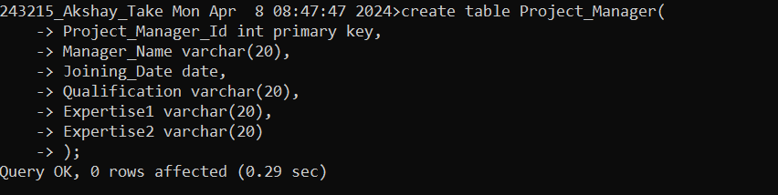

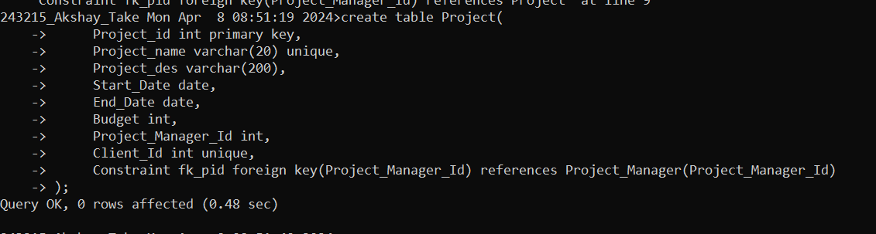

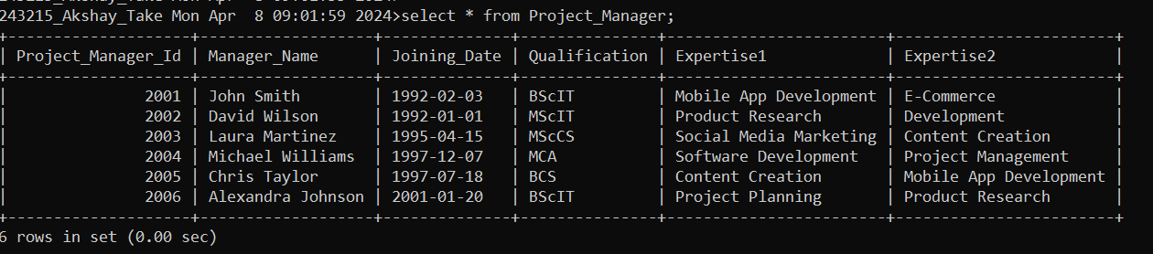

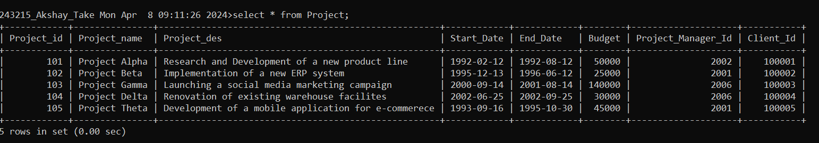

1> nested query use ke hai



2> datediff ka use kiya hai , having clause use kiya hai

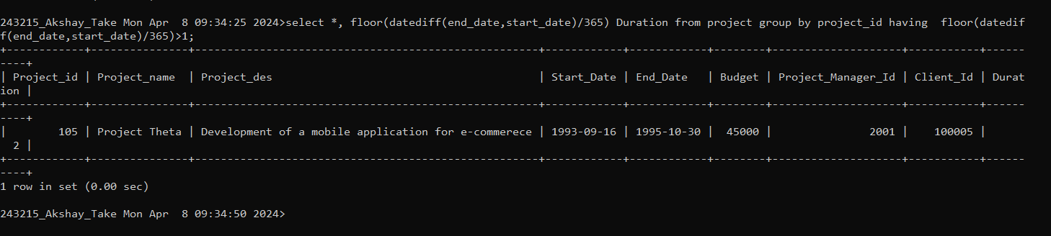

3>

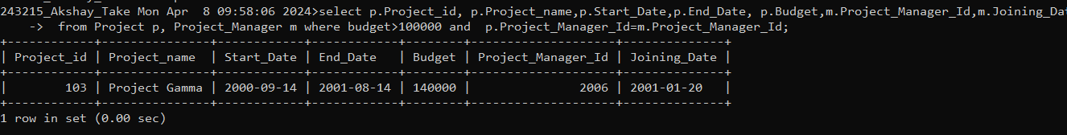

4> YHA prr “ in “ ka use kiya hai

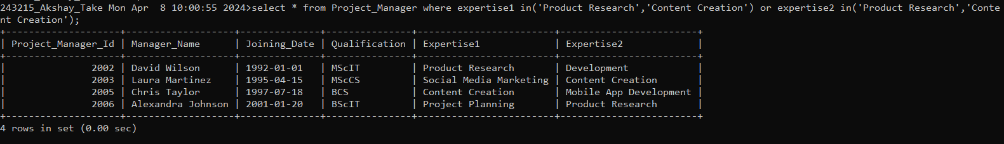

5>

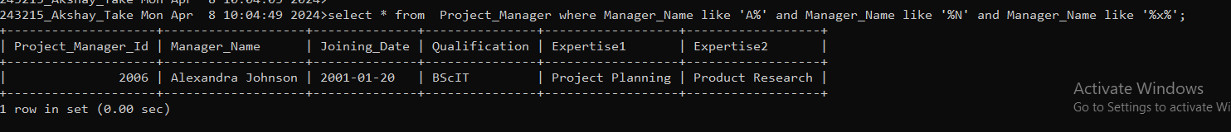

MONGODB

1>

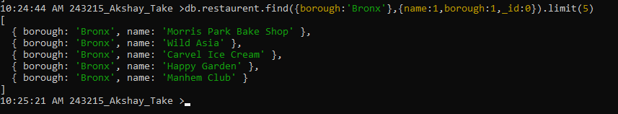

3>

db.restaurent.find({},{name:1,borough:1,cuisine:1,_id:0})