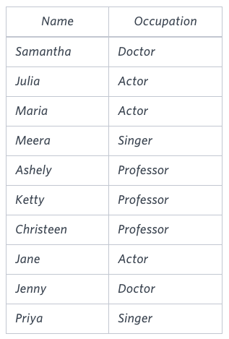

/*

1. ORDER BY Names in OCCUPATIONS followed by the profession's first letter

2. COUNT of each Occuption count ORDER BY ASC, with the output There are a total of [occupation_count] [occupation]s. If there's a tie, ORDER BY occuption

*/

SELECT CONCAT(Name, “(“, LEFT(occupation,1), “)”) AS a FROM occupations

UNION

SELECT CONCAT(“There are a total of “, COUNT(occupation),” “, lower(occupation),”s”,”.”)

FROM occupations

GROUP BY occupation

ORDER BY a

COUNT(1):

* Contrary to a popular misconception, the “1” in COUNT(1) does not refer to counting values in the first column.
* Instead, it counts the total number of rows, just like COUNT(*).
* The results for COUNT(1) and COUNT(*) are identical.
* There is no performance difference between them; both use the entire table to calculate the count

======= right ans neeche wala======

Select concat(name, '(', left(occupation, 1), ')')

from occupations

order by name;

Select concat("There ", if(count(*) > 1, "are", "is"), " a total of ", count(*), " ", lower(occupation),

if(count(*) > 1, "s.", "."))

from occupations

group by occupation

order by count(occupation);