MA374 Financial Engineering Lab

Assignment - 1

Name - Shivendu Mishra
Roll No - 200123050

Question - 1

M(Number of Subintervals) | Price of Call Option | Price of Put Option
1 | 38.16763502522771 | 19.94171724772522
5 | 34.90653251138063 | 16.680614733878123
10 | 33.62502175314765 | 15.399103975645158
20 | 33.85944948849385 | 15.633531710991278
50 | 33.98118436571931 | 15.75526658821741
100 | 34.011160984790834 | 15.785243207287396
200 | 34.01957870440791 | 15.793660926904362
400 | 34.01913176900702 | 15.793213991506963

From the table above, we observe that the price of the call option converges to a value around 34.02 as the value of M increases, whereas it converges to a value of 15.79 for the corresponding put option. Theoretically, the value of M can be any positive integer. However for computation we must set it to a value such that the machine is able to calculate the final stock prices that is S(0)*

Checking for no arbitrage condition of the model

We know that the risk neutral probabilities for binomial asset pricing model is given by and q = 1-p. By first fundamental theorem of asset pricing we know that a market has no arbitrage if and only if there exists a risk neutral measure i.e which simplifies to . I have checked this condition in my programe.

Question-2

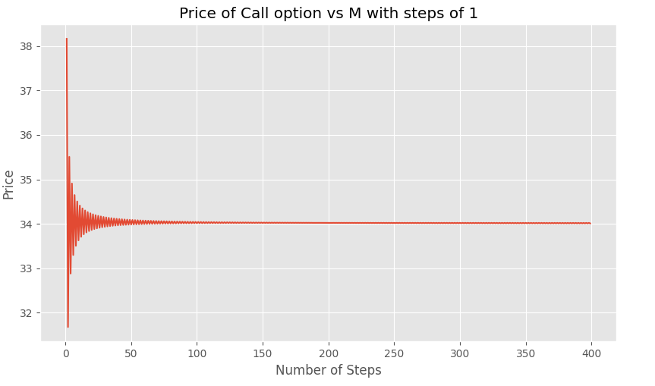

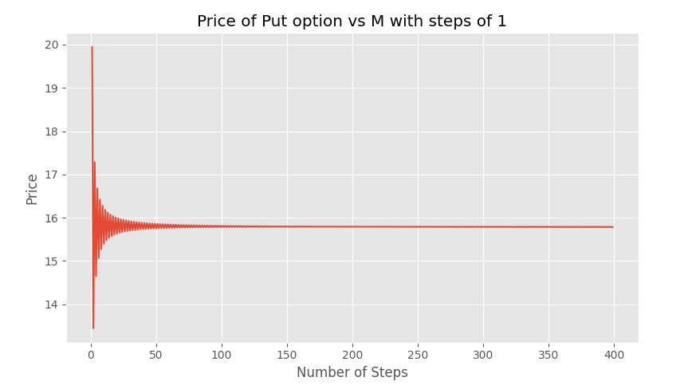

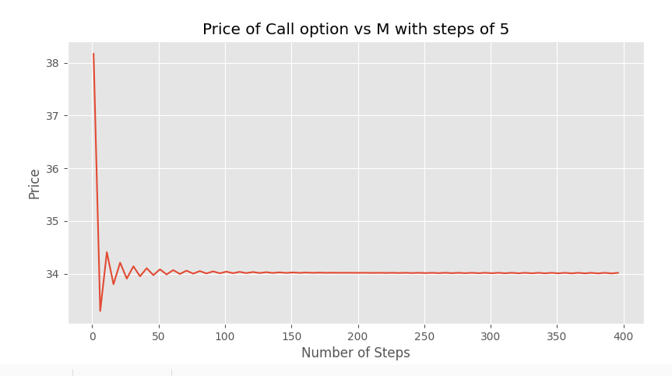

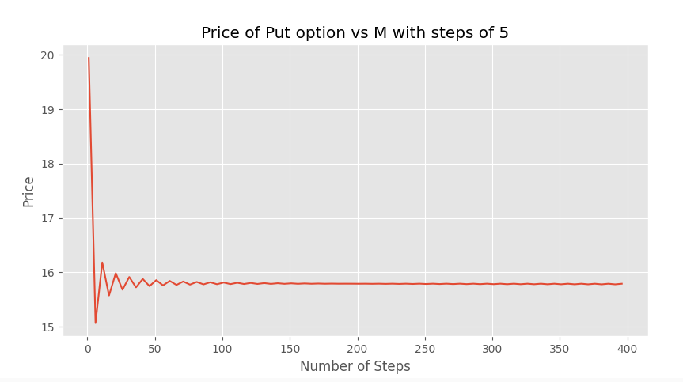

Observations

- Value of the European call converges to a value of around 34.02 and value of the put option convergest to around 15.79 .
- As the value of M increases deviation in the options prices decreases
- Option prices oscillates around the final convergence value
Question - 3

Note - On running the q3.py file csv files will be created with file name Price_n.csv for all the given time values where n denotes the number of steps corresponding to that time or n = 4*t. Below are the screenshot of the csv files

For t = 0
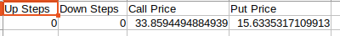

For t = 0.5

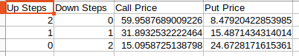

For t = 1

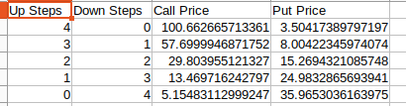

For t = 1.5

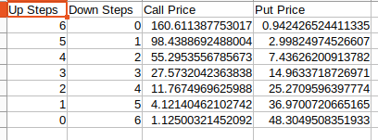

For t = 3
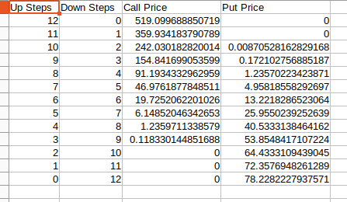

For t = 4.5

