MA374 Financial Engineering Lab
Assignment-10

Name - Shivendu Mishra
Roll Number - 200123050
email - m.shivendu@iitg.ac.in

Question - 1

Simulating GBM paths

For an asset following geometric brownian motion, we have for two time points i and i+1:

Now we know that increments of brownian motion follow normal distibution with mean 0 and variance equal to the time difference between the two points hence the above equation can be written as:-

Where is Z is generated from the standard normal distribution.Hence I used the above formulae in order to obtain an interative scheme to simulate a path for a Brownian motion . Note that I generated random number from standard normal distribution using library function, however this can also be done using methods such as Marsaglia Bray and Box Muller method.Also, for the risk neutral world we know that the price process is given by:-

Hence for the risk neutral world is replaced by the riskfree rate r and hence our working equation is:-

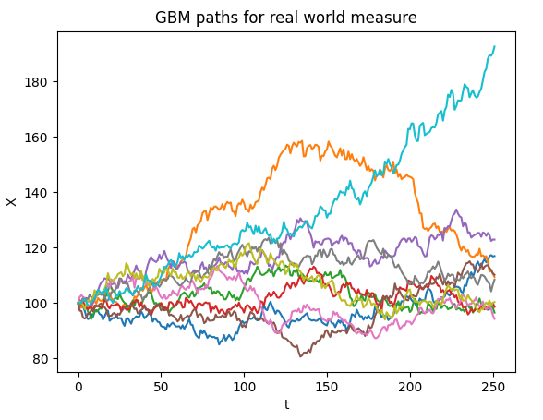
Below are the screenshot of the simulation of the Geometric Brownian Motion:-
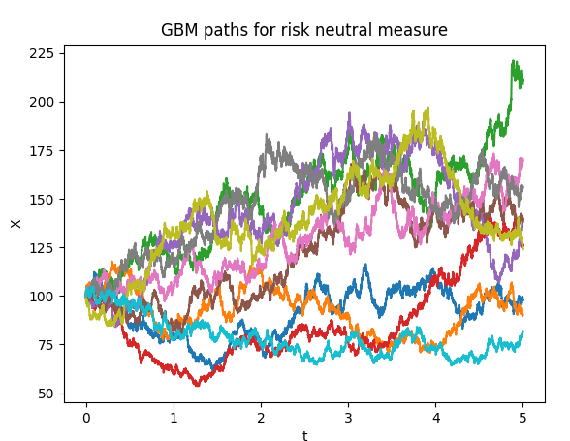
Calculating price of Asian Options

Under the assumptions of the classical Black Scholes Model, we know that the price of an Asian call option is given by:-

Note that here K denotes the strike price denotes the average of the stock process during the time from t to T and Q denotes that we are considering the risk neutral world . the supersript denotes that we are taking conditional expectation with information known upto time t. Now I used the standard Monte Carlo technique in order to estimate the value of this estimate. I generated 1000 GBM paths and caluclated the corresponding value of the expression whose value is to be calculated and took its mean in order to generate an unbiased estimate of the price which is nothing but Monte Carlo Simulation. Note that for put option the payoff becomes:-

I used the same technique to esimate the price of the corresponding put option.Below are the reults:-

Strike Price | Price of Call Option | Price of Put Option
105 | 1.6493783118013534 | 5.956205592596507
110 | 0.6633298999332037 | 9.670040270764032
90 | 11.233607024351965 | 0.2407335131047908

We can clearly observe that the price of Asian call option decreases with increases in Strike Price whereas the reverse is true for an Asian Put option.

Sensitivity Analysis

I varied the different parameters S,K,t,r and volatility and studied the variation of the Asian call and put option. The screenshot of the plots are given from the next page.Note that the default parameters are K = 95,r = 0.05,volatility = 0.1,S0 = 100,T = 0.5 years.
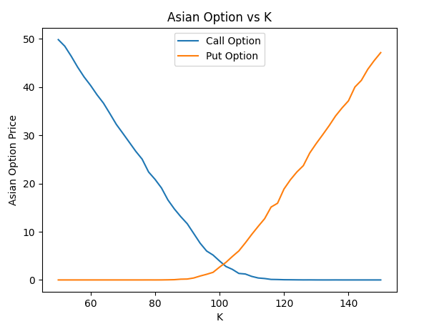
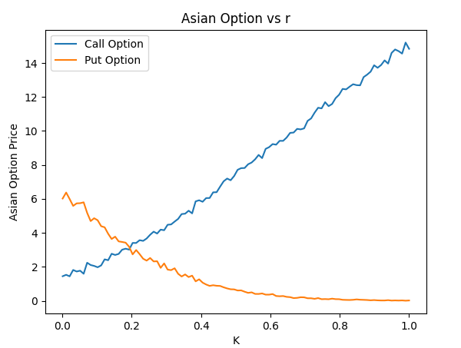
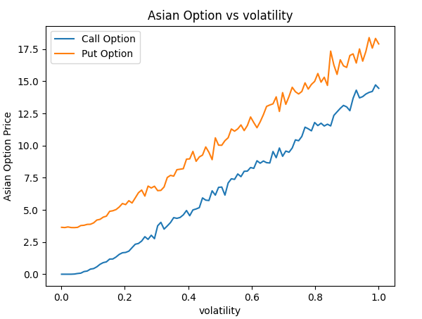
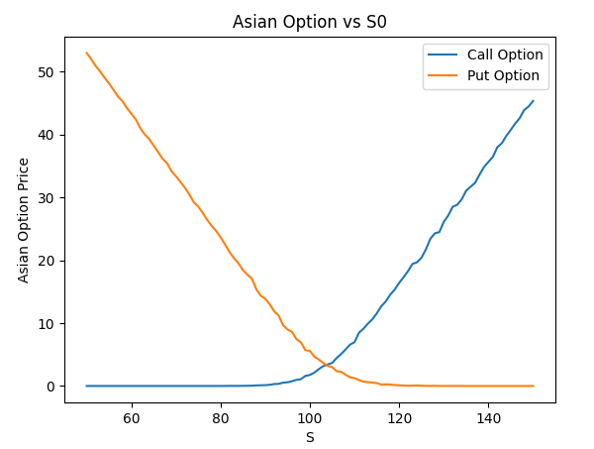
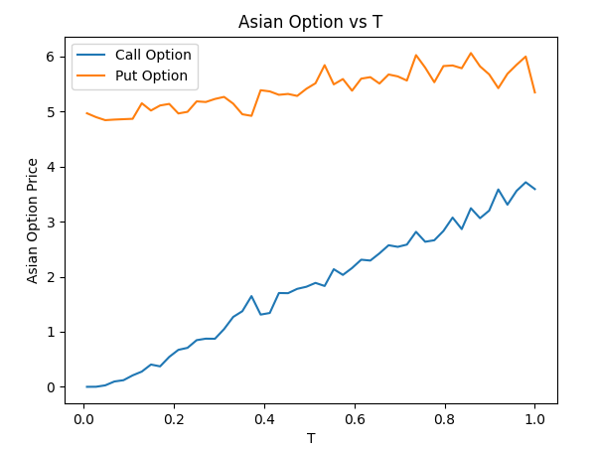

Applying Variance Reduction Techniques

I have used two methods for variance reduction in this assignment. Below is a brief description and results obtained for both the methods.

Method 1 - Use of Antithetic Variables

By Box-Muller Method we know that generates a number from the standard normal distribution. where belong to the uniform distr Now let = f(U) be the option price calculated using the corresponding uniform random numbers and = f(1-U) be the price estimated using 1-U as the uniform random number. Note that we can do this as 1-U follows un iform (0,1) if U follows uniform(0,1). Now we use 0.5*(f(U) + f(1-U)) as our estimator. Note that we get a variance reduction by the following argument:-

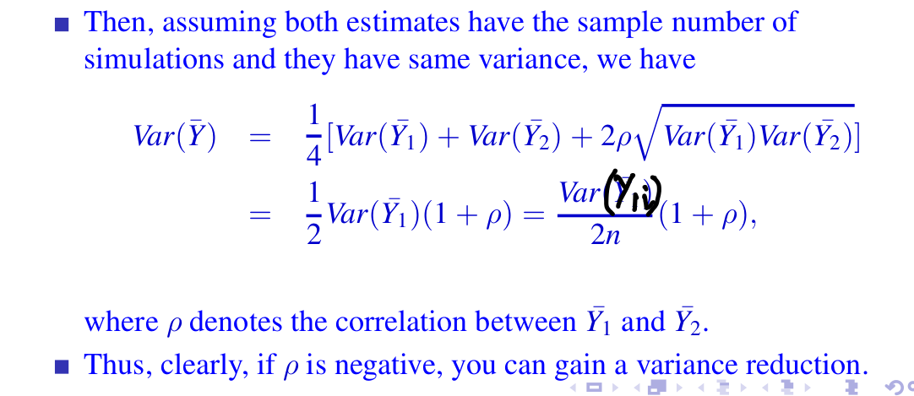
No
Since U's and 1-U are clearly negatively correlated we expect to get a variance reduction.

Method 2 - Use of Control Variates

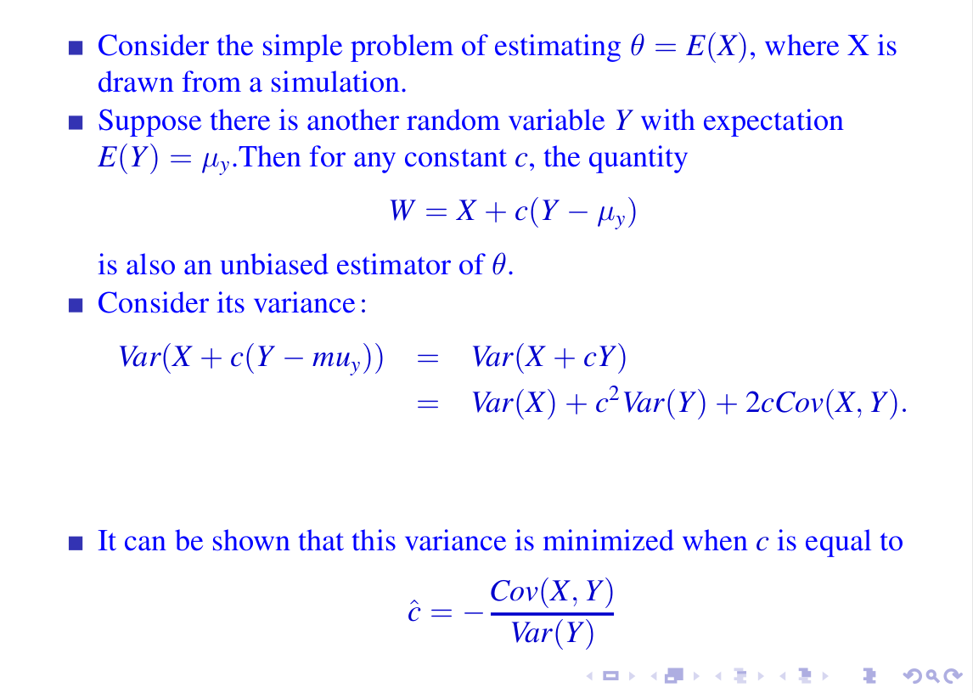

Note that I have taken Y as N(0,1) distribution.
Results

Strike Price | Call Price using Antithetic | Put Price using Antithetic | Call Price using control variate | Put Price using control variate
105 | 1.366966247156037 | 5.1928014160257 | 1.6832384994660 | 5.2236368385977
110 | 0.582208234393422 | 8.8711263088284 | 0.7379685592619 | 9.1266009509586
90 | 11.01963198775503 | 0.1486301400645 | 10.900717868025 | 0.165694199340

Variance analysis of Call Option

Strike Price | Variance using standard method | Variance using antithetic | Variance using control variate
105 | 13.42057110806873 | 11.68024814352956 | 13.889974953914212
110 | 5.247609523604521 | 2.9800082133979187 | 2.7155190422486717
90 | 55.76739919312384 | 46.58198571501015 | 50.167899791012424

Variance analysis of Put Option

Strike Price | Variance using standard method | Variance using antithetic | Variance using control variate
105 | 29.3721493213351 | 27.83312947197535 | 30.403325871924412
110 | 45.139743054621164 | 38.722165537455915 | 48.025601976123575
90 | 1.000248136138663 | 0.9954004489561092 | 1.0775876594303697

Observations
- We can clearly observe that the antithetic method of variance redunction gives the best results as compared to the control variate for variance reduction
- Earlier, we have quantitatively demonstrated that the variance reduction is achieved.This claim is even more supported by the constructed plots.(On the next pages)
- On careful analysis, the fluctuations in the plots seem to be less than the case when variance reduction was not applied. So, the scheme achieves its goal.
- The nature of the plots is consistent with our expectations, which is explained in the last question
Sensitivity Analysis with variance reduction method(Antithetic)

