MA374 Financial Engineering Lab
Assignment – 11

Name – Shivendu Mishra
Roll Number – 200123050
email id - m.shivendu@iitg.ac.in

Question – 1 (Vasicek Model)
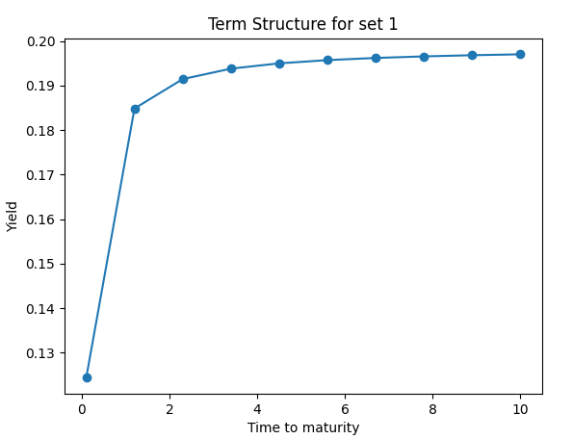
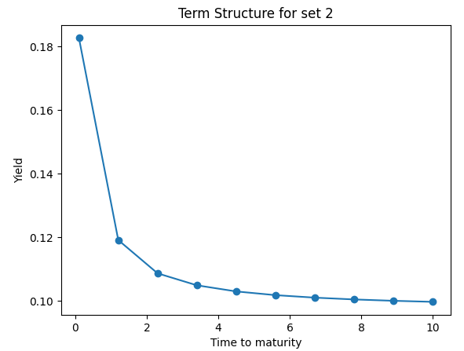

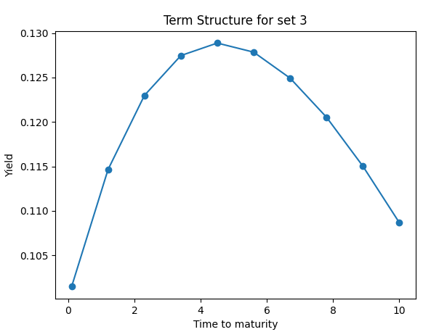

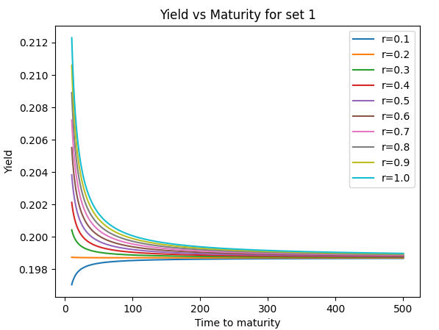
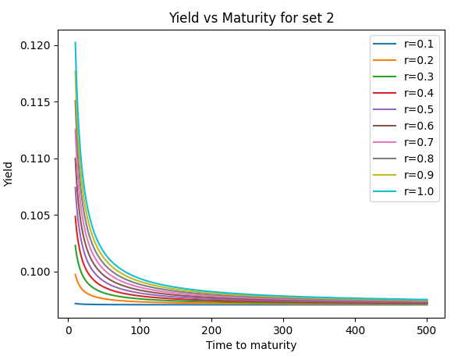
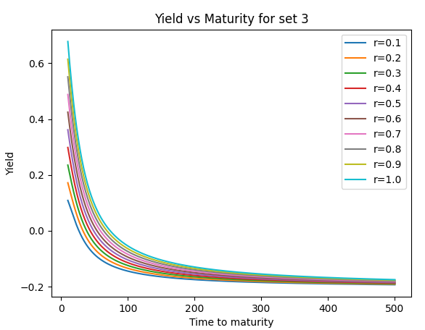
Question – 2 (CIR Model)
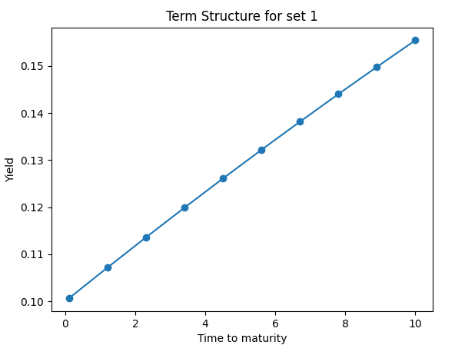
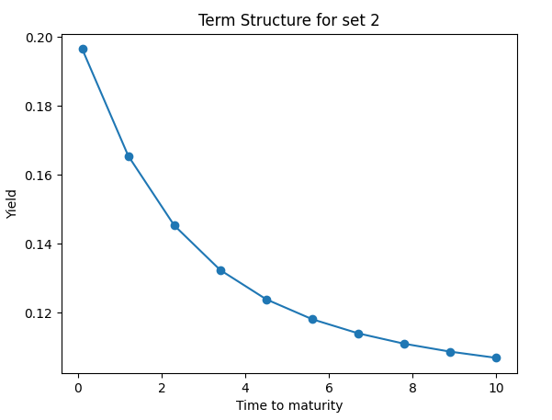
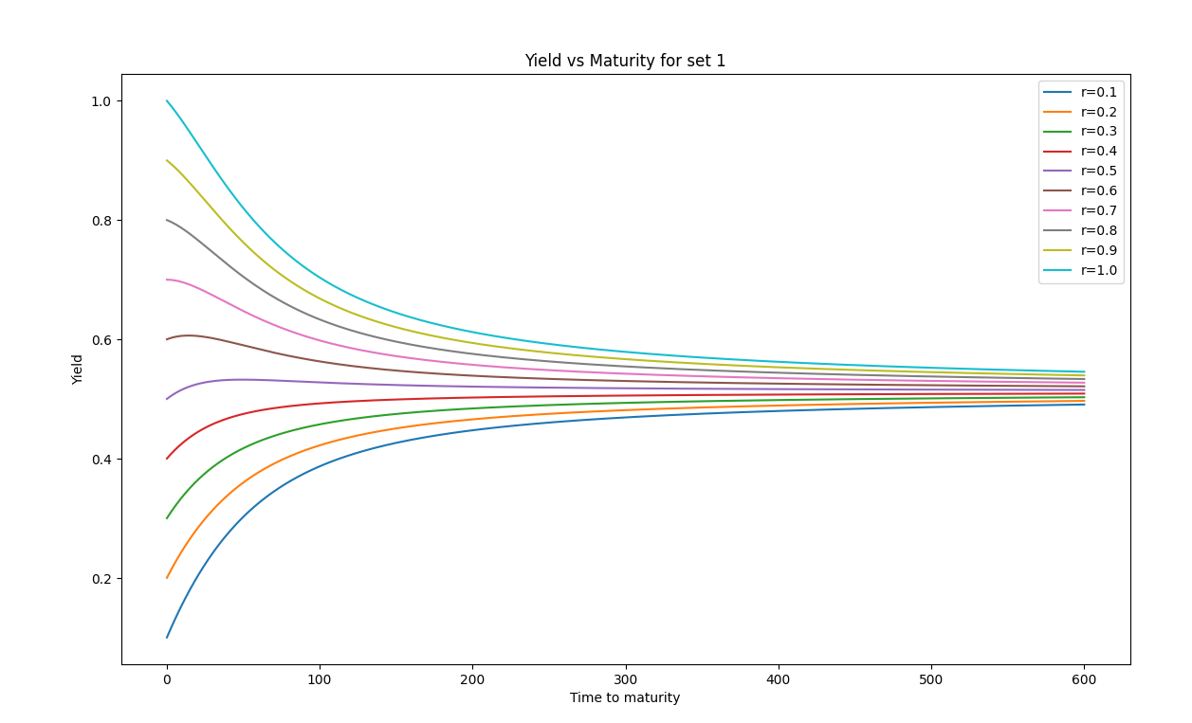
Theory and Formulae used

Vasicek Model

The risk neutral process r satisfies:-

The Zero-coupon bond prices can be found through:-

Here:-

Now the continuously compounded zero coupon yield can be found out by:-

Cox=Ingersoll-Ross (CIR) Model

The risk neutral process r satisfies:-

The Zero-coupon bond prices can be found through:-

Here:-

Now the continuously compounded zero coupon yield can be found out by:-

Observations

Vasicek Model

1. The yield of the bond price converges to a particular value as the maturity period is increased to sufficiently high value, irrespective of the value of r(0) taken.
2. The term structure of parameters set for 10 time units show strikingly different behaviour. For the first parameter set, the yield increases and then converges. For the second one, the yield decreases and then converges, while for the last one, the yield curve has a “hump” in it.
3. The phenomenon of mean reversion is observed since high interest rate has negativetrend while the low interest rate has positive trend to the reversion level. This is due to the fact that the Vasicek Model incorporates mean reversion.

CIR Model

1. The yield of the bond price converges to a particular value as the maturity period is increased to sufficiently high value, irrespective of the value of r(0) taken.
2. The term structure of parameters set for 10 time units show strikingly different behaviour. For the first parameter set, the yield increases and then converges. For the second one, the yield decreases and then converges, while for the last one, the yield curve has a “hump” in it.
3. The phenomenon of mean reversion from the plots is observed. This is due to the fact that the model assumes mean reversion towards a long-term normal interest rate level.

