MA374 Financial Engineering Lab
Assignment - 03

Name - Shivendu Mishra
Roll Number -200123050
email id - m.shivendu@iitg.ac.in

Question - 1

In this problem we have to write a program to find the inital price of an American Call and Put option using the data given below and also do the sensitivity analysis with respect to the various parameters .

Given Data - S(0) = 100 , K = 100,T = 1,M = 100,r = 8%,

In order to implement this I used the standard binomial pricing algorithm which we use for the pricing of European option with slight modification. Let denote the price of an American option at the ith step of a binomial model starting with sate 0, clearly we have to find . The formulae used with continuous compounding conventions is:-

and q = 1-p

also . The formulae is similar for put option with obvious changes. I implemented the above algorithm in an iterative fashion and calculated the price of American Call and American Put option as follows:-

Price of American Call Option = 12.123047074012453
Price of Amercian Put Option = 5.279837145989147

Sensitivity Analysis

I performed sensitivity analysis by changing the parameters S(0),K,r,and M and plotted the results . I have attached the screenshots of the plot below:-

Variation with S(0)
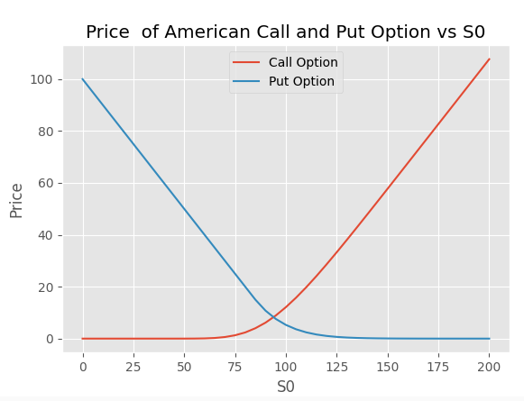

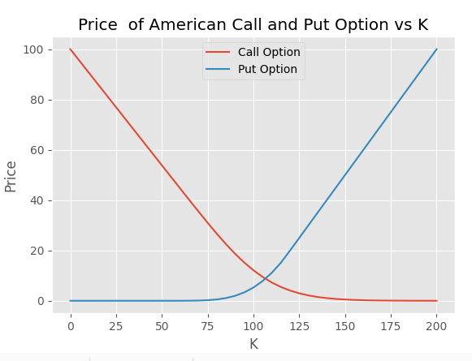
Variation with K
Variation with r
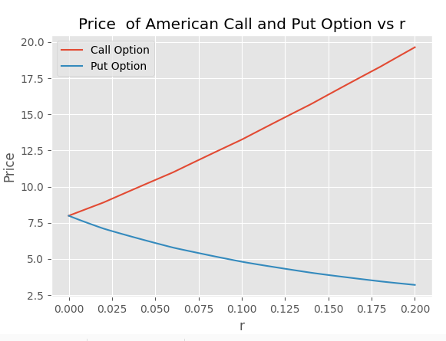

Variation with

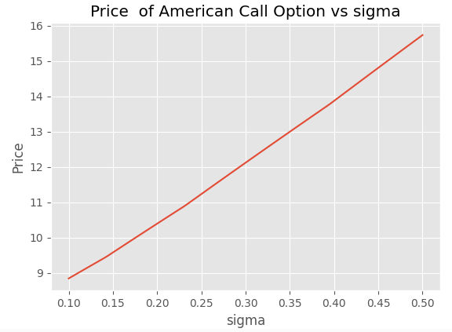
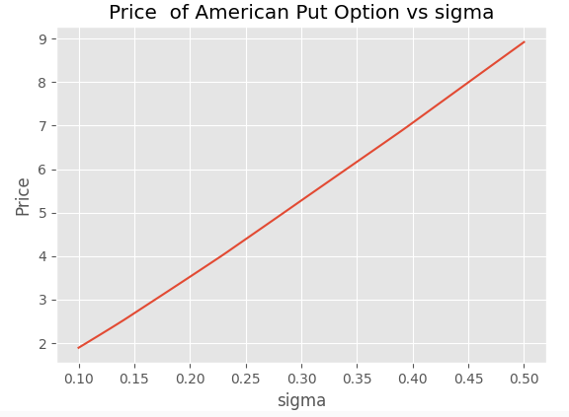

Variation with M

K = 95
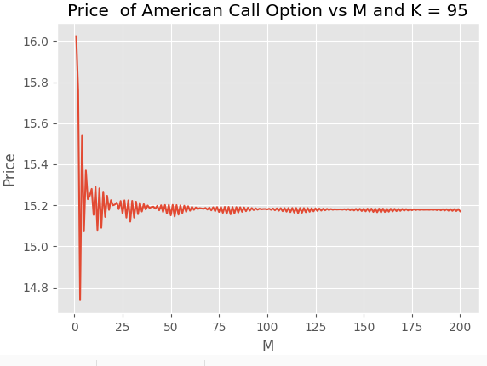
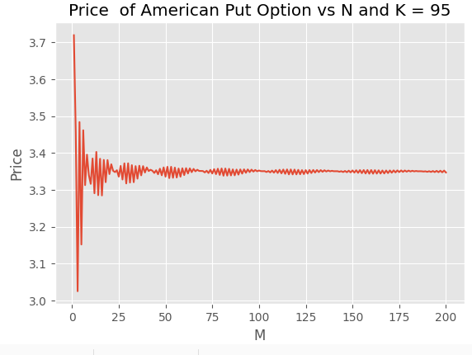

K = 100
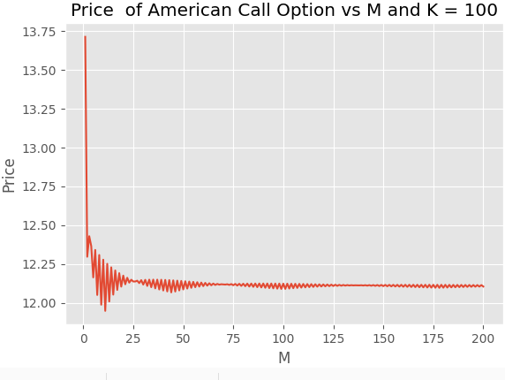
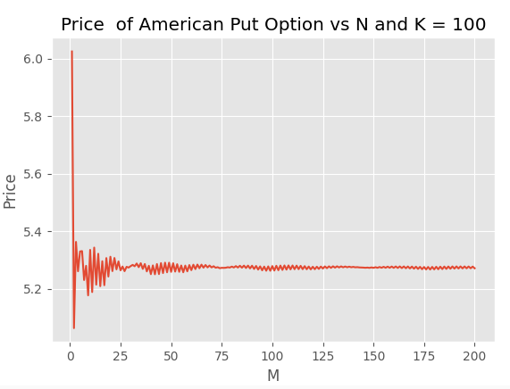

K = 105
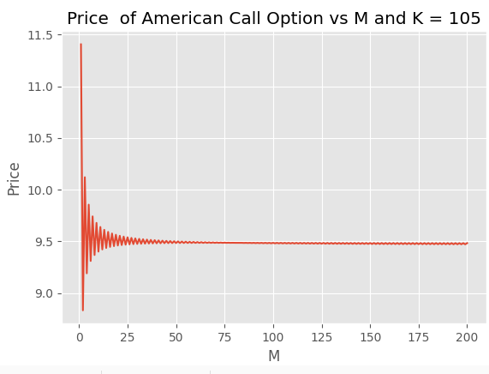

Question - 2

In this problem we have to calculate the price of a European Lookback option with the same S(0),r,as in the previous problem . Let denote the price of a lookback option at step i of the binomial model. Then by using the standard binomial pricing algorithm we have:-

I used a brute force algorithm by iterating through all paths and calculating the payoff at all paths then backtracking to calculate the prices and the summary of results are given below . Since we had to examine the computation time for the next problem, I took extra values of M like 26 and 27 in order to analyze the maximum value of M the algorithm can handle.

Value of M | Lookback Option Price | Time of Computation (seconds)
5 | 9.119298985864688 | 0.00025463104248046875
10 | 10.080582906831008 | 0.0033855438232421875
25 | 11.00349533564632 | 284.42060589790344
26 | 11.036041506227324 | 583.7798318862915
27 | Did not terminate | xxxxxxxxxxxxxxxxx
50 | Did not terminate | xxxxxxxxxxxxxxxxx

Note - Since this is a naive alorithm, it has a time complexity of O(). So clearly calculating the option price at a value like M = 50 is not feasible.

We can observe from the table that as the value of M increases the lookback option prices increases very slowly to a value around 12

Intermediate option prices for M = 5

t = 0
9.119298985864688
t = 1

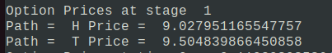

t = 2

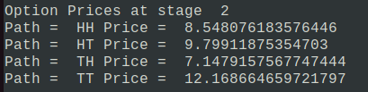

t = 3
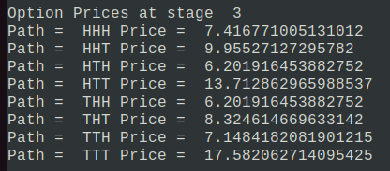

t = 4

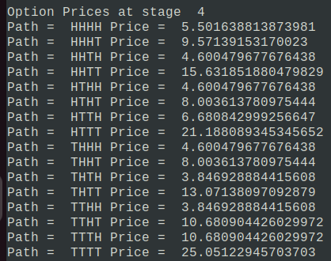

t=5

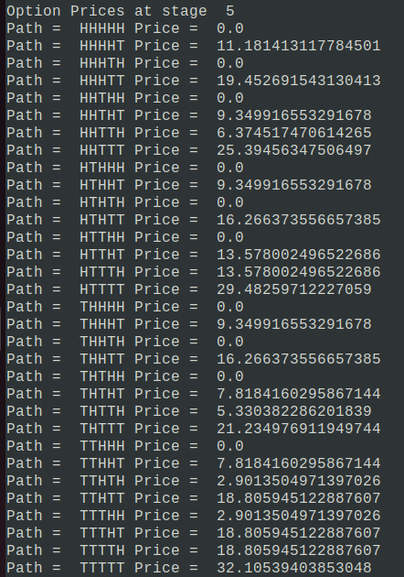

Question - 3

In this problem we have to find the price of the previous lookback option using a computationally efficient algorithm (Markov based) . The formuale used to calculate the prices using the Markov based algorithm is given below:-

Here denotes the max operation and denotes the maximum value of stock upto the state i. I implemented the above algorithm by a recursive procedure and used a hash table to store the price at each state as a cache in order to reduce the time complexity to going into exponential. The summary of the results are tabulated below:-

Value of M | Lookback Option Price | Time of Computation (seconds)
5 | 9.11929898586469 | 8.749961853027344e-05
10 | 10.08058290683101 | 0.0033855438232421875
25 | 11.00349533564632 | 0.03838396072387695
50 | 11.510862222177268 | 1.9405438899993896
75 | 11.745911763985793 | 51.930853605270386

Intermediate Option Prices

I printed the option prices at different time points in (S,) format. Since the option price depend on these two values only at a particular time.

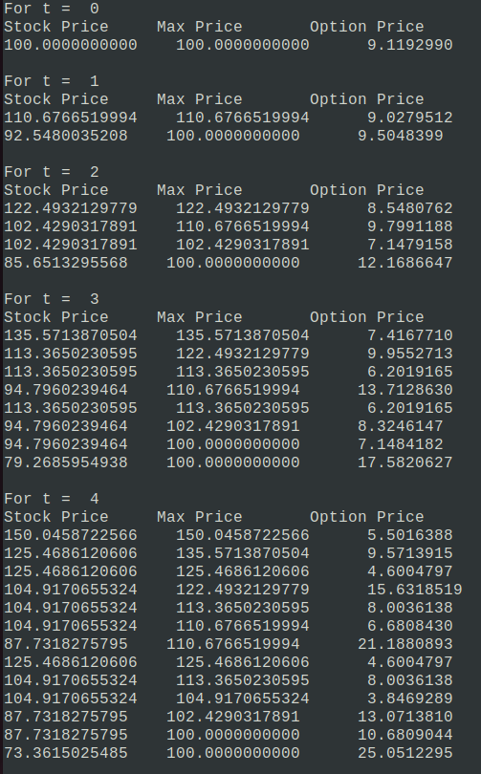

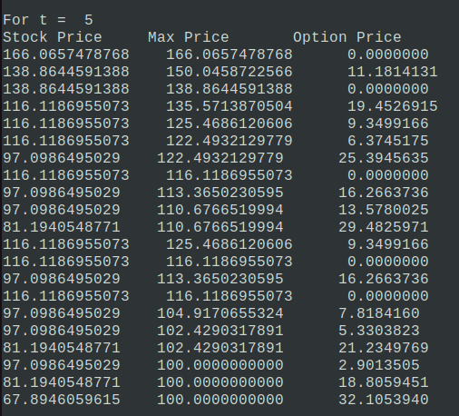
Comparing the two algorithms

Below is the table comparing the run time of the two algorithms for different values of M(Note that all time values are in seconds):-
Value of M | Naive Binomial Algorithm | Efficient Algorithm(Markov Based)
5 | 0.00025463104248046875 | 8.749961853027344e-05
10 | 0.0033855438232421875 | 0.0033855438232421875
25 | 284.42060589790344 | 0.03838396072387695
26 | 583.7798318862915 | 0.04182553291320801
50 | Computationally Infeasible | 1.9405438899993896
75 | Computationally Infeasible | 51.930853605270386
100 | Computationally Infeasible | System crashed due to less memory

Time complexity - For the naive algorithm the time complexiy is O() whereas for the Markov based algorithm it is O( )

Max Value of M - The naive algorithm requires exponential memory and time so it is impractical to use for high values like 50. We can use it to get results upto values like 25 or 26. The time almost doubled on increasing M from 25 to 26 showing the limitations of the algorithm. The markov based algorithm has cubic memory and time constraints. It ran fine upto 75 however the pc crashed on M = 100 due to insufficient RAM.

Question - 4

I used a similar recursive algorithm like the 2nd problem for the inefficient algorithm which is present in q4_inefficient.py. The efficient Markov based code is similar to the inefficent one just that we have cached the different states in order to reduce the compuation time . Note that the parameters used to calculate the European Call Prices are same as in the first question of this assignment .

Below is the comparison of computation time of the two algorithms :-(Times are in seconds)
Value of M | Call Option Price | TIme using Inefficient algorithm | Time using Markov algorithm
5 | 12.163185946764589 | 8.082389831542969e-05 | 3.337860107421875e-05
10 | 12.277327819222997 | 0.0010025501251220703 | 0.00012087821960449219
25 | 12.136745963232949 | 15.301544666290283 | 0.0012311935424804688
50 | 12.08536151007218 | Computationally infeasible | 0.009396791458129883
100 | 12.123047074012444 | Computationally infeasible | 0.0842740535736084
500 | 12.10864990170941 | Computationally infeasible | 16.866027116775513
1000 | XXXXXXXXXXX | Computationally infeasible | Recursion depth exceeded

Time complexity - For the naive algorithm the time complexiy is O() whereas for the Markov based algorithm it is O( )

Max Value of M - The naive algorithm requires exponential memory and time so it is impractical to use for high values like 50. We can use it to get results upto values like 25 or 26. The time almost doubled on increasing M from 25 to 26 showing the limitations of the algorithm. The markov based algorithm has quaadratic memory and time constraints. It ran fine upto values like M = 500 but the system gave recursion depth exceeded on M = 1000. However we can write an iterative version of the Markov algorithm(as done in 1st and 2nd assignments of this course) in order to obtain oprices till a value of M around M = 5000.

