MA374 Financial Engineering
Assignment - 4

Name - Shivendu Mishra
Roll Number - 200123050
email - m.shivendu@iitg.ac.in

Question - 1
Note - In order to run the code you must have numpy,matplotlib and pandas library installed

Given data:-
;

Part - (a)

In order to construct and plot the Markowitz efficient frontier using the given data, I first calculated the minimum variance portfolio that can be constructed using the given stocks. This was calculated as follows:-

Note that u is the uniform vector given by (1,1,1).
After this I calculated the different portfolios on the minimum variance line by varying the rate of return using the below formulae:-
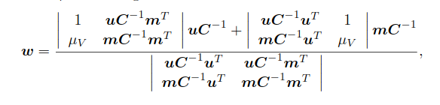

After this, I calculated the risk involved with the corresponding portfolio using. Now I plotted the tuples of the form (on the XY plane . Note that the values of are plotted with different color in order to differentiate the Markowitz Effiicient Frontier from the other part of the curve . I have attached the picture of the obtained polt on the next page.Note that on runnig my code I got

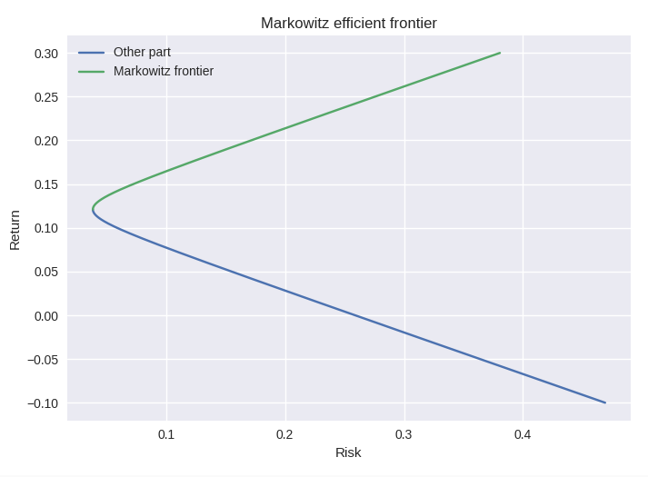
Note that all the values in the plots are absolute values and are NOT converted to percentage.

Part - (b)
I chose 10 random points on the Markowitz Fronter and printed the corresponding portfolio and also saved the result in a spreadsheet "markowitz.csv" whose screenshot is shown below. Note that w1,w2,w3 are the weights corresponding to the three stocks.

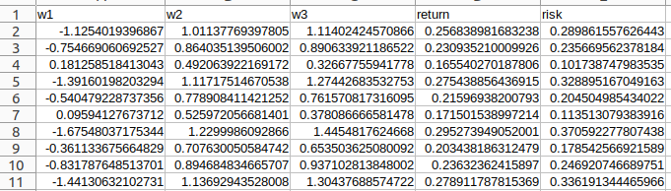
Part - (c)

In order to estimate the maximum and minimum return at 15% risk, I used interpolation method as there is no direct formulae of calculating return from risk. I used the interpolate2d function available in the scipy library in python3 which uses cubic spline interpolation. I provided the function with the same (x,y) values for risk and return that was used to calculate the Markowitz curve and the bottom part of the minimum variance line respectively. Interpolation of the bottom part provides the minimum return whereas the upper part provides the maximum return.The values obtained are as follows:-

Minimum return for 15% risk = 5.244684128495352%
Weights for minimum return:
[ 1.79984337 -0.1512198 -0.64862357]

Maximum return for 15% risk = 18.955479956989688%
Weights for maximum return:
[-0.16243566 0.62866033 0.53377534]

Part - (d)

In order to calculate the portfolio with return 18% I just used the formulae given on the first page to calculate the weights and then the formulae of risk.

Risk at 15% return = 13.056827100982646%
Weights at 15% return : [-0.02568807 0.57431193 0.45137615]

Part - (e)

The equation of the capital market line is given by:-

Where are weights of the market portfolio which can be calculated by:-
where
From the above equations . Now we can easily plot this line on python alongside the minimum variace line as shown below:-
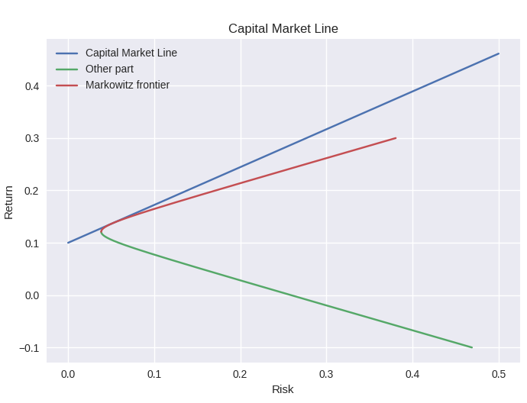
On calculating .
Plugging these values we get the equation of CML as:-

Part - (f)

For a given value of risk I first found the return using the CML equation found above . After that I used the below equation to solve for the risk free weight for the return:-

Now we can compute the weight of the risky assets by the below formula:-

The tabulated values of the result obtained for 10% and 25% risk are given below
Risk | Return | w1 | w2 | w3
10% | 17.226494% | 1.16853953 | 0.64577185 | 0.1537552 | -0.96806657
25% | 28.066236% | 2.92134883 | 1.61442961 | 0.384388 | -3.920166442

Question - 2

In order to plot the Markowitz Efficient Frontier with no short selling, I just rejected the portfolios having any one of the weights as negative. In order to calculate the MVL with only two secuites. I just set one weight at a time to 0 and calculated the risk and return for weights in [0,1] and satisfying . The feasible region was obtained by considering all portfolies satisfying
w1 + w2+ w3 = 1 . and .The plot is shown below:-

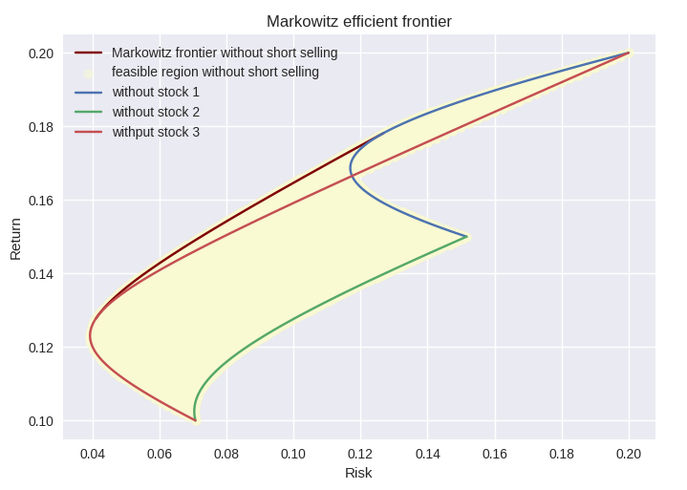
Now to calculate the equations satisfied by the weights on the MVL, I obtained the weights for the minimum variance portfolio and then plotted them two at a time. I also found the equation by approximating the slope and the y-intercept. The equations and plots are given below:-

w1 vs w2

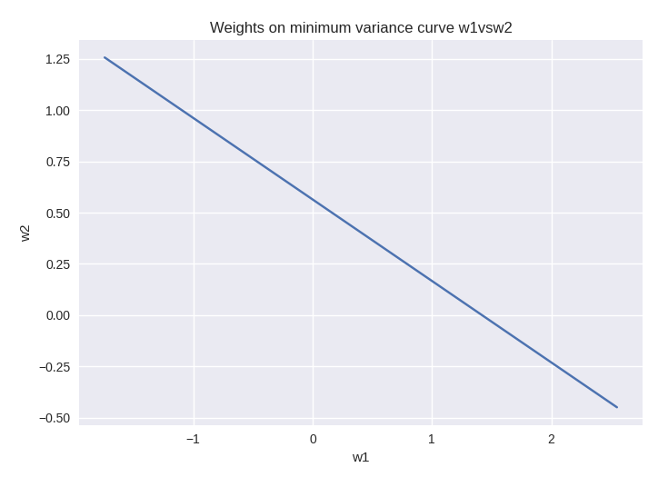
Equation of line: w2 = -0.40 w1 + 0.56

w2 vs w3
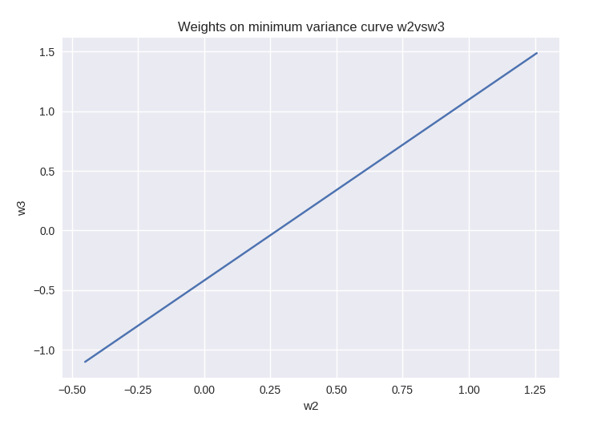

Equation of line: w3 = 1.52 w2 + -0.42
w3 vs w1
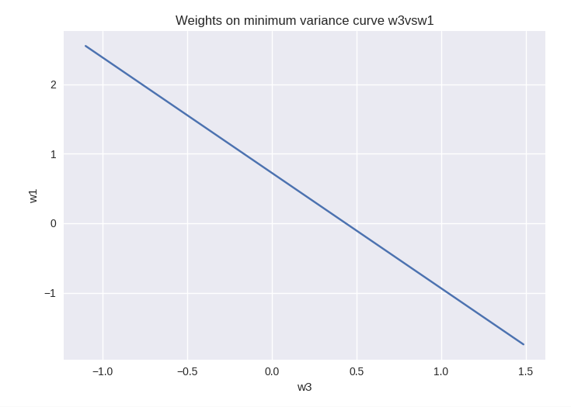
Equation of line: w1 = -1.66 w3 + 0.72

Question - 3

Part - (a)

The data for the stocks had been collected for the time period between 01/01/2018 to 01/01/2023 on monthly basis (total 60 data points).
The companies considered are Apple, Amazon, Facebook, Google, IBM, Intel, Microsoft,Netflix, Nike, and Tesla. The monthly return was obtained as the difference in stock prices between beginning of 2 consecutive months. Then annual return was calculated suitably. I read the csv file and caluculated the covariance matrix C and the mean vector M. Then I applied the same formulaes in order to plot the Markowitz frontier as used in the first problem.The screenshot of the plot is given in the next page:-

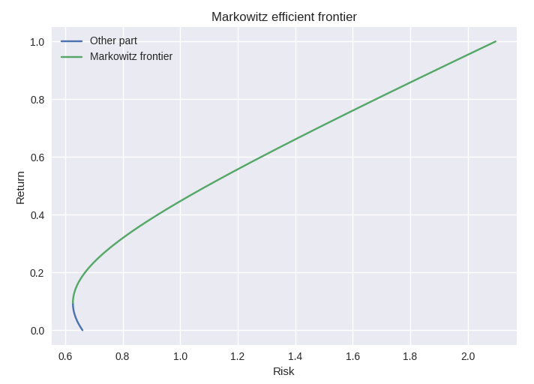
Part - (b)

The market portfolio was also calculated using the same forumales as used in the first problem with :-
Market Return
Market Risk
Market Weights
Part - (c)

The equation of the Capital Marekt Line was obtained and plotted in a same way as the first problem.
Equation of CML:
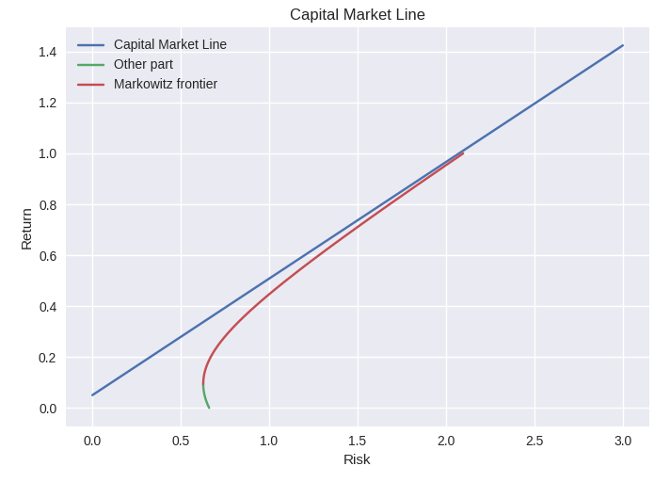
Part - (d)

The equation of the security market line is given by:-
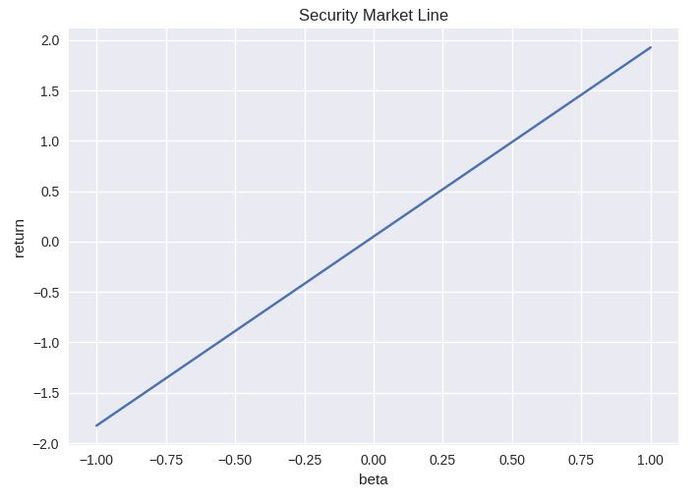
For our case the equation is given by .Below is the required plot:-

