MA374 Financial Engineering Lab
Assignment - 5

Name - Shivendu Mishra
Roll Number - 200123050
email - m.shivendu@iitg.ac.in

Information about the data used:-

bsedata1.csv

Stocks in Index Stocks not in Index

Stock Name | Stock Symbol
Titan | TITAN.BO
Idbi | IDBI.BO
TVS Motor | TVSMOTOR.BO
Bosch | BOSCHLTD.BO
Gail | GAIL.BO
Yes Bank | YESBANK.BO
Voltas | VOLTAS.BO
Marico | MARICO.BO
Union Bank | UNIONBANK.BO
Berger Paint | BERGPAINT.BO

Stock Name | Stock Symbol
Infosys | INFY.BO
Reliance | RELIANCE.BO
HDFC Bank | HDFCBANK.BO
Axis Bank | AXISBANK.BO
Bharti Airtel | BHARTIAIRTL.BO
ICICI BANK | ICICIBANK.BO
Vedanta | VEDL.BO
Cipla | CIPLA.BO
Baja Auto | BAJAJ-AUTO.BO
Nestle India | NESTLEIND.BO

Note - In order to calculate the returns, I have calculated the daily returns at all posible data points and multiplied the data by length/5 to convert them into annual values
nsedata1.csv

Stocks in Index Stocks not in Index

Stock Name | Stock Symbol
Bhel | BHEL.NS
Dabur | DABUR.NS
Colgate | COLPAL.NS
MRF | MRF.NS
Gail | GAIL.NS
Havells | HAVELLS.NS
Poonawalla | POONAWALLA.NS
Bosch | BOSCH.NS
Union Bank | UNIONBANK.NS
Godrej | GODERJ.NS

Stock Name | Stock Symbol
UPL | UPL.NS
Wipro | WIPRO.NS
Asian Paints | ASIANPAINT.NS
Tech Mahindra | TECHM.NS
Eicher Motors | EICHERMOT.NS
ICICI BANK | ICICIBANK.NS
NTPC | NTPC.NS
Larsen & Tubro | LNT.NS
Coal India | COALINDIA.NS
Grasim | GRASIM.NS

Constructing the Markowitz Efficient Frontier

In order to construct and plot the Markowitz efficient frontier using the given data, I first calculated the minimum variance portfolio that can be constructed using the given stocks. This was calculated as follows:-

After this I calculated the different portfolios on the minimum variance line by varying the rate of return using the below formulae:-
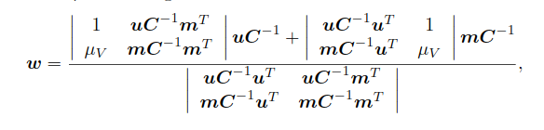
After this, I calculated the risk involved with the corresponding portfolio using. Now I plotted the tuples of the form (on the XY plane . Note that the values of are plotted with different color in order to differentiate the Markowitz Effiicient Frontier from the other part of the curve . Plot for bsedata1
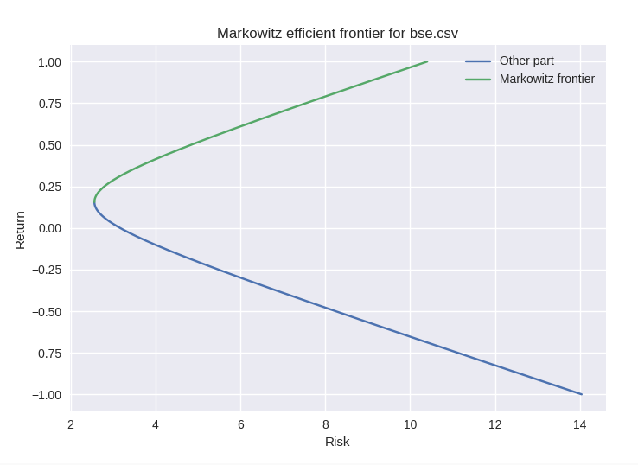

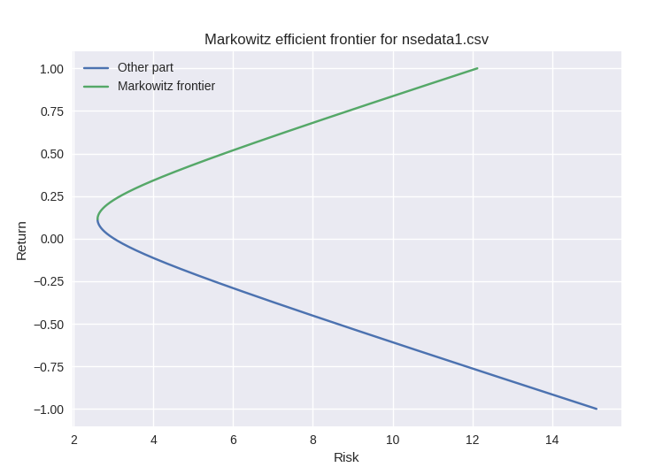
Plot for nsedata1
Market Portfolio

The market return and risk values were simply calculating by finding the mean and the standard deviation of the data otained pertaining to the required index value. The values obtained are given below.

Bse return = 13.1371% Nse return = 13.11176%
Bse risk = 3.101106722 Nse risk - 3.1028759

Capital Market Line (CML)

The equation of the capital market line is given by:-

Where are the risk and return of the market portfolio respectively calculated in the last part.The plot and equation of the CML using the market portfolio as each index is shown below:-
For bsedata1
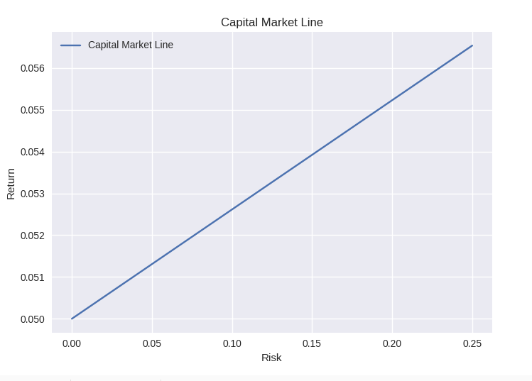
Equation of CML :
For nsedata1
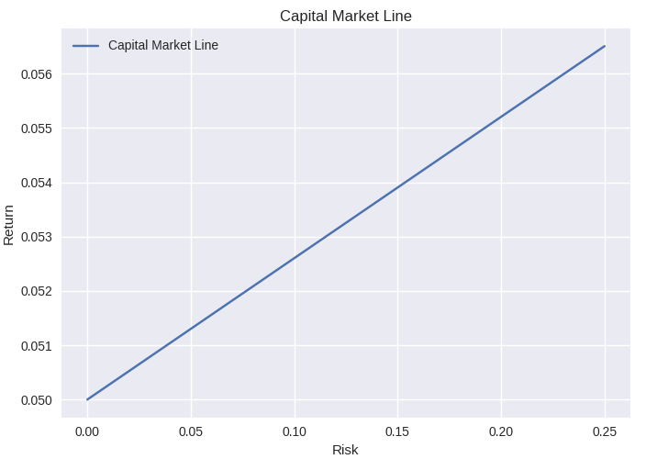
Equation of CML :

Security Market Line (SML)

The equation of the security market line is given by:-. In this part apart from plotting and finding the SML, I have also plotted the value of index and non index stocks in the same plot alongside there corrseponding returns. This is because we have to draw inference about these stocks from the SML . The equations and plots are given in the next page.
Note that to calculate the value of a stock, I have used the formulae:-

Here K is the return of the stock are the return and risk of the market portfolio already calculated and Cov represents the covariance.
For bsedata1
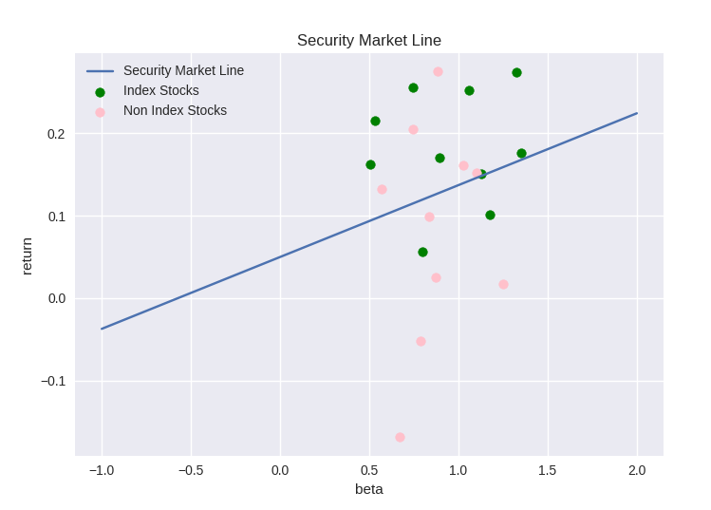
Equation of SML :

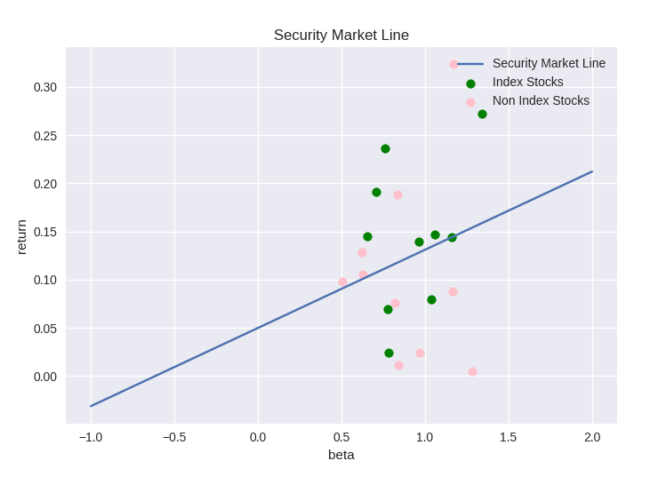
For nsedata1
Equation of SML :
Tabulation of values

For bse1data

Index Stocks(Upto 3 decimal places)

Stock Name | Stock Symbol | Beta Value ()
Infosys | INFY.BO | 0.745
Reliance | RELIANCE.BO | 1.056
HDFC Bank | HDFCBANK.BO | 1.128
Axis Bank | AXISBANK.BO | 1.352
Bharti Airtel | BHARTIAIRTL.BO | 0.893
ICICI BANK | ICICIBANK.BO | 1.326
Vedanta | VEDL.BO | 1.174
Cipla | CIPLA.BO | 0.505
Baja Auto | BAJAJ-AUTO.BO | 0.797
Nestle India | NESTLEIND.BO | 0.531

Non Index Stocks(Upto 3 decimal places)

Stock Name | Stock Symbol | Beta Value ()
Titan | TITAN.BO | 0.883
Idbi | IDBI.BO | 1.001
TVS Motor | TVSMOTOR.BO | 1.028
Bosch | BOSCHLTD.BO | 0.870
Gail | GAIL.BO | 0.787
Yes Bank | YESBANK.BO | 0.668
Voltas | VOLTAS.BO | 0.835
Marico | MARICO.BO | 0.569
Union Bank | UNIONBANK.BO | 1.253
Berger Paint | BERGPAINT.BO | 0.744
For nse1data

Index Stocks(Upto 3 decimal places)

Stock Name | Stock Symbol | Beta Value ()
UPL | UPL.NS | 0.961
Wipro | WIPRO.NS | 0.652
Asian Paints | ASIANPAINT.NS | 0.759
Tech Mahindra | TECHM.NS | 0.709
Eicher Motors | EICHERMOT.NS | 1.038
ICICI BANK | ICICIBANK.NS | 1.340
NTPC | NTPC.NS | 0.7745
Larsen & Tubro | LNT.NS | 1.05
Coal India | COALINDIA.NS | 0.7808
Grasim | GRASIM.NS | 1.576

Non Index Stocks(Upto 3 decimal places)

Stock Name | Stock Symbol | Beta Value ()
Bhel | BHEL.NS | 1.1677
Dabur | DABUR.NS | 0.623
Colgate | COLPAL.NS | 0.507
MRF | MRF.NS | 0.8201
Gail | GAIL.NS | 0.838
Havells | HAVELLS.NS | 0.835
Poonawalla | POONAWALLA.NS | 1.168
Bosch | BOSCH.NS | 0.966
Union Bank | UNIONBANK.NS | 1.284
Godrej | GODERJ.NS | 0.630

Observations

- We can clearly observe that in case of the BSE data the stocks that were included in the index had a value closer to the security market line whereas for the non index stocks it is spread out in a random manner
- Below table shows the comparison of the calculated beta values to actual values obtained online . We can clearly see that the values are close to each other:-

Stock Name | Calculated Beta | Actual Beta
Infosys | 0.745 | 0.683
Cipla | 0.505 | 0.500
Bharti Airtel | 0.893 | 0.938
HDFC BANK | 1.128 | 0.844
Asian Paints | 0.759 | 0.769
NTPC | 0.774 | 0.856
UPL | 0.961 | 1.06

