MA374 Financial Engineering Lab
Assignment - 7

Name - Shivendu Mishra
Roll Number - 200123050
email id - m.shivendu@iitg.ac.in

Question - 1

In order to calculate the price of the European call and Put option in the classical Black Scholes Merton framework, we use the below formulae for the call option price:-

Now from the above relations we can calculate the price of a European Call option in the classical BSM framework. For put option we use the put-call parity:-

I implemented the below formuales in my program and calculated the price of a European call and put option in the classical BSM framework. The paramters chosen were as follows:-
t = 0,s = 1,k=1,, r = 0.05 , T = 1
The price of European Call and Put option were as follows:-

C(t,s) = 0.255232 P(t,s) = 0.206461
Question - 2

Plot of C(t,s) as a function of t alone for given values of t
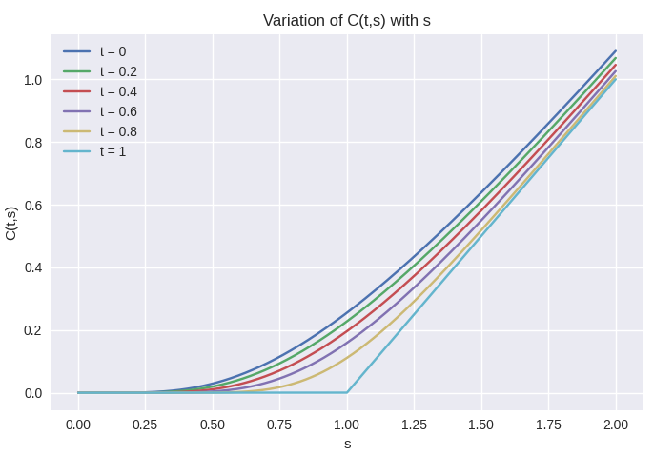
Plot of P(t,s) as a function of t alone for given values of t
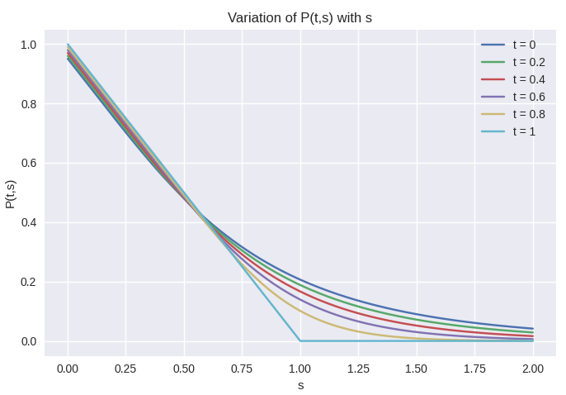
Plot of C(t,s) as a function of t alone for given values of t (3D)

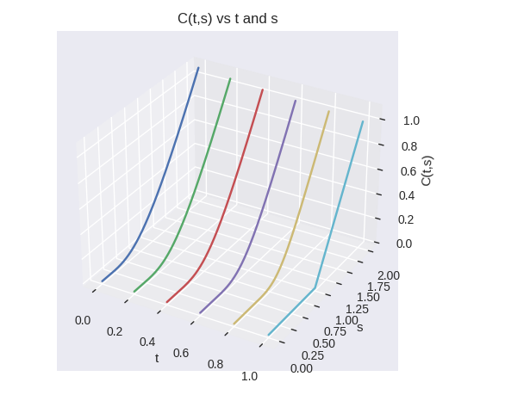
Plot of P(t,s) as a function of t alone for given values of t (3D)
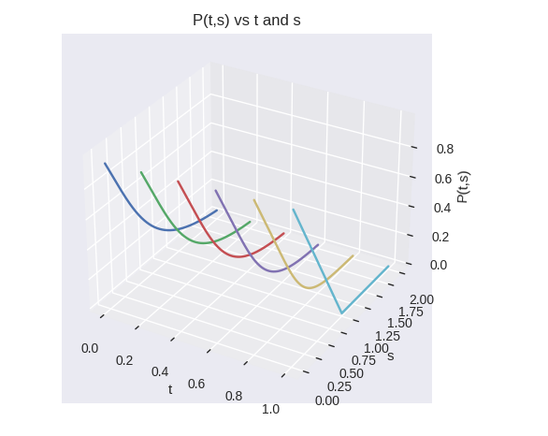
Question - 3

C(t,s) as a smooth surface over t,s plane

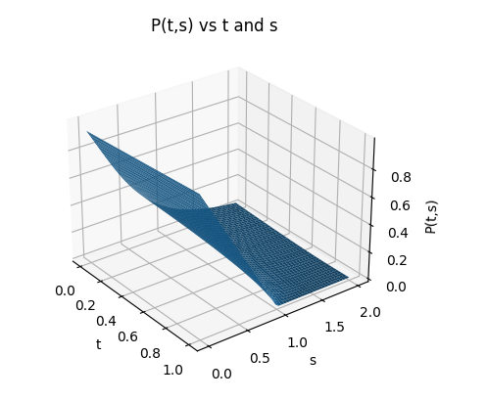

P(t,s) as a smooth surface over t,s plane
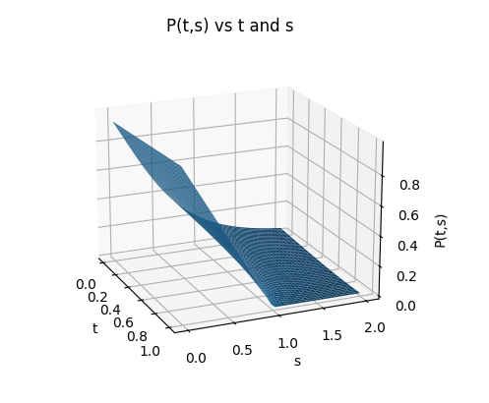

Question - 4

Plot of C(t,s) with k for different values of s
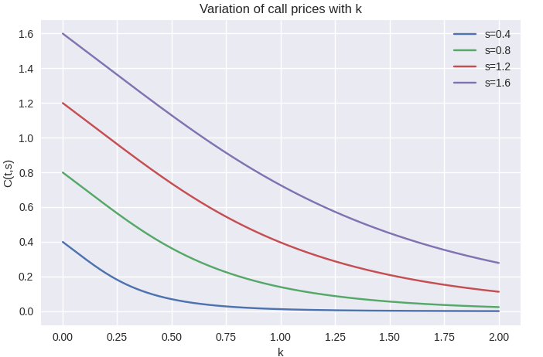
Plot of P(t,s) with k for different values of s
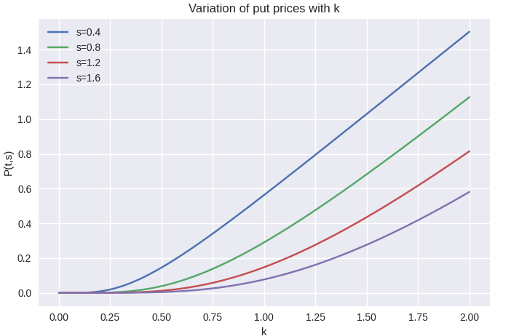
Plot of C(t,s) with k for different values of t
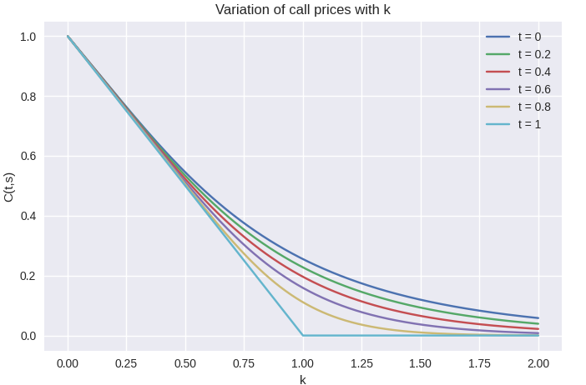
Plot of P(t,s) with k for different values of t
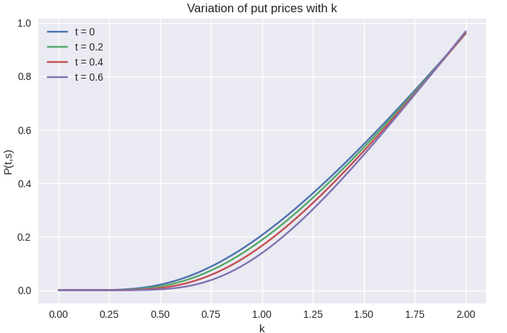

Plot of C(t,s) with for different values of s
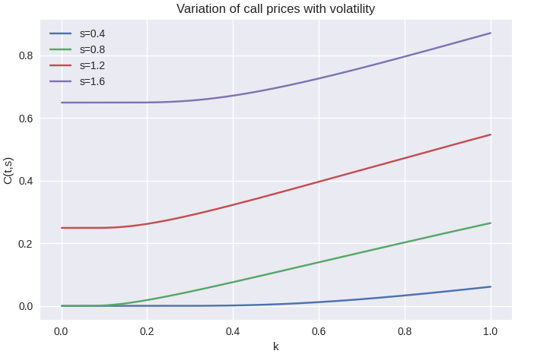
Plot of P(t,s) with for different values of s
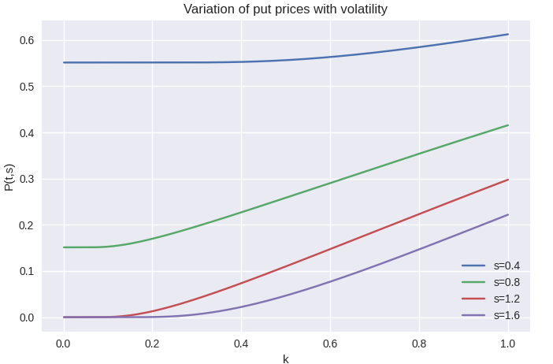

Plot of C(t,s) with for different values of t
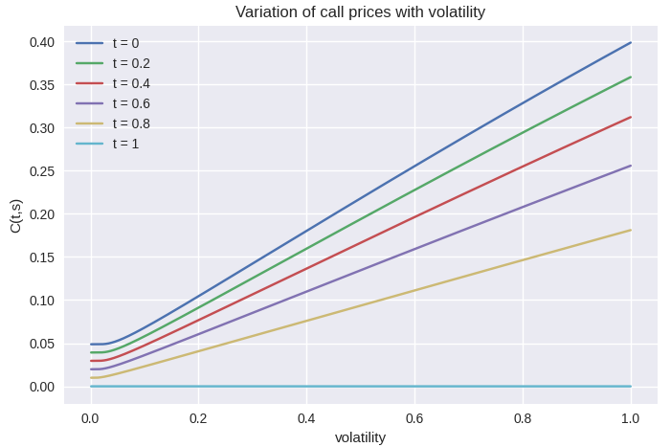

Plot of P(t,s) with for different values of t
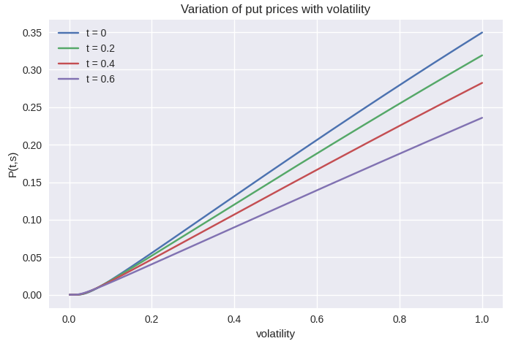
Plot of C(t,s) with r for different values of s
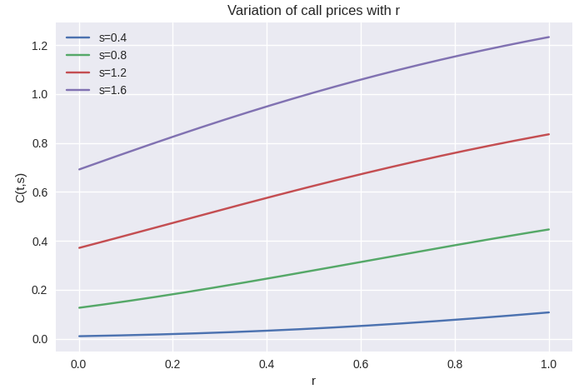
Plot of P(t,s) with r for different values of s
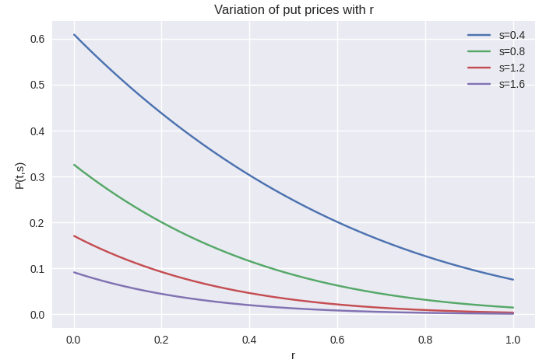

Plot of C(t,s) with r for different values of t
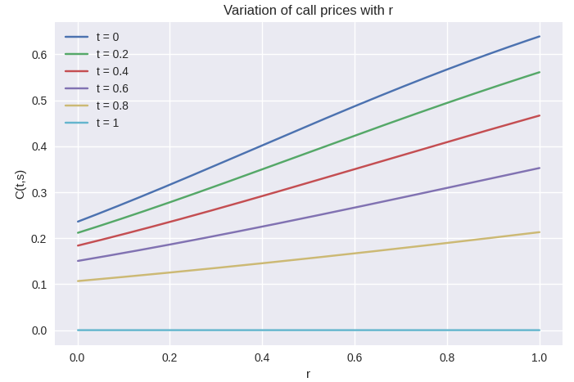

Plot of P(t,s) with r for different values of t
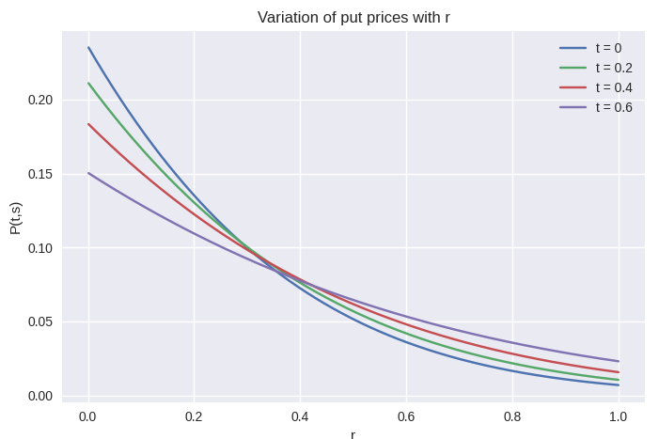
Surface plot of C(t,s) vs t and k
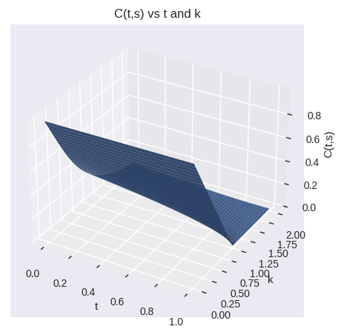

Surface plot of P(t,s) vs t and k
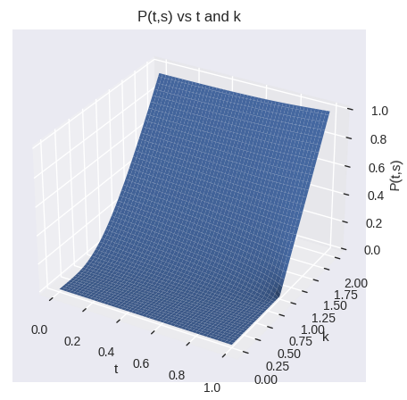

Surface plot of C(t,s) vs t and
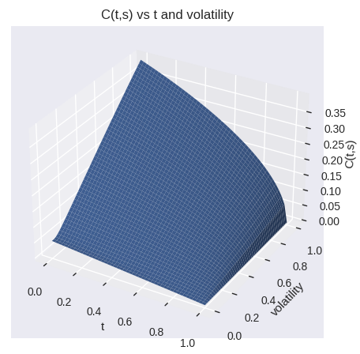

Surface plot of P(t,s) vs t and
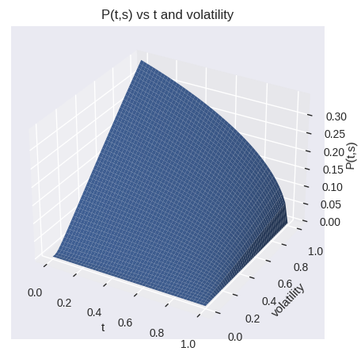

Surface plot of C(t,s) vs t and r
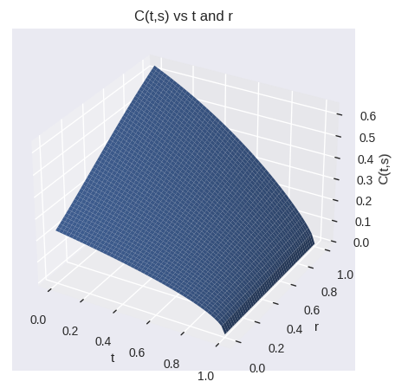

Surface plot of P(t,s) vs t and r
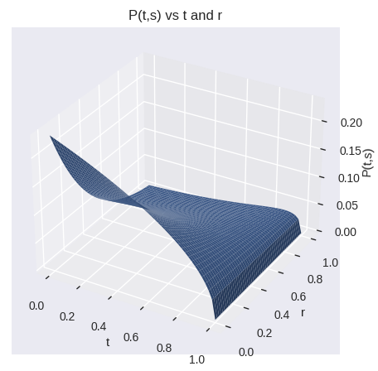

Surface plot of C(t,s) vs t and T
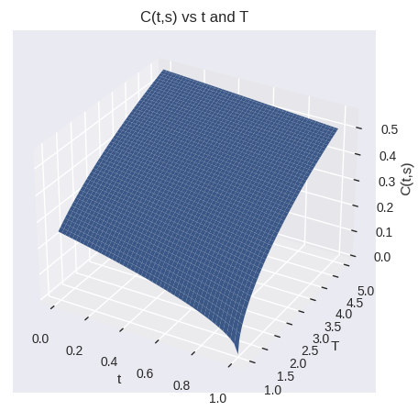

Surface plot of P(t,s) vs t and T
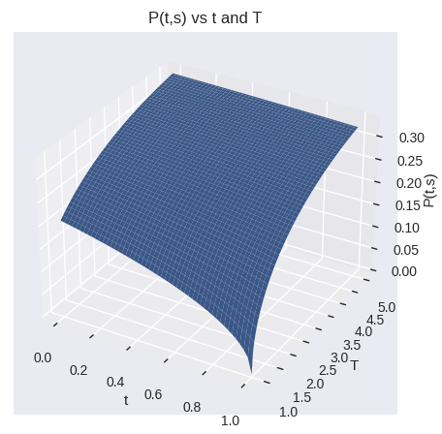

Surface plot of C(t,s) vs s and k
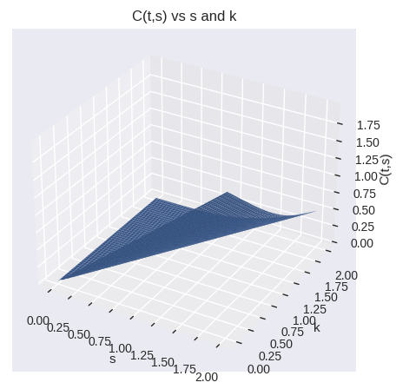

Surface plot of P(t,s) vs s and k
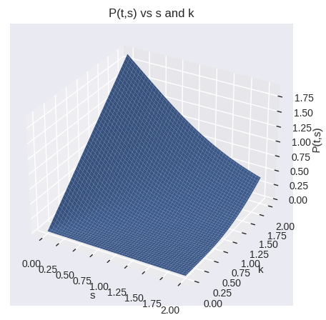

Surface plot of C(t,s) vs s and
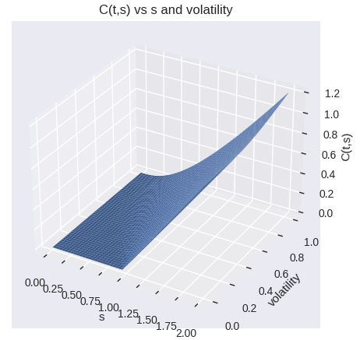

Surface plot of P(t,s) vs s and
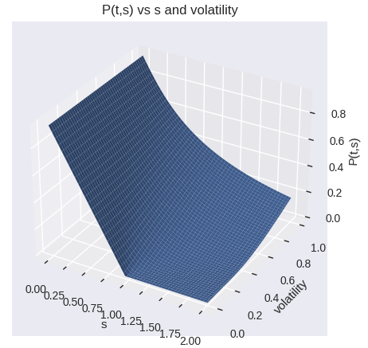

Surface plot of C(t,s) vs s and r
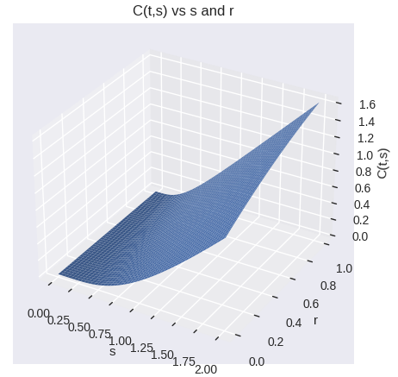

Surface plot of P(t,s) vs s and r
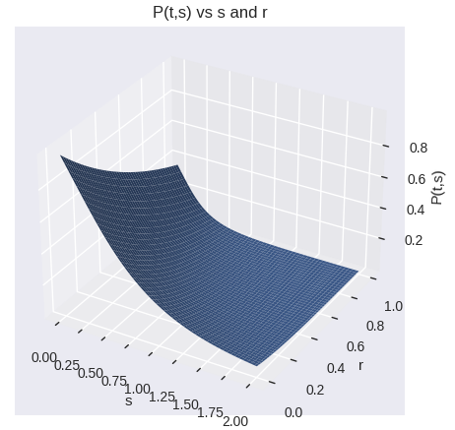

Surface plot of C(t,s) vs s and T
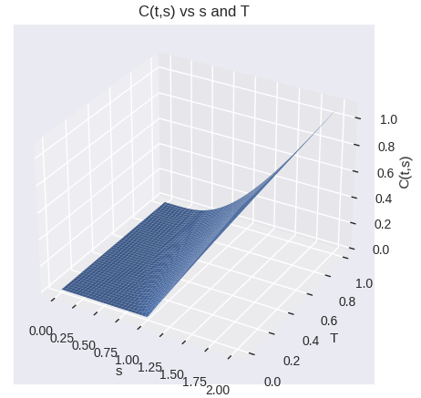

Surface plot of P(t,s) vs s and T
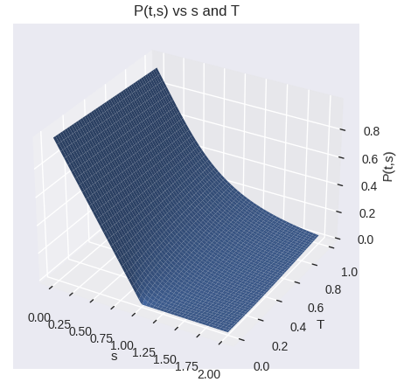

Surface plot of C(t,s) vs k and
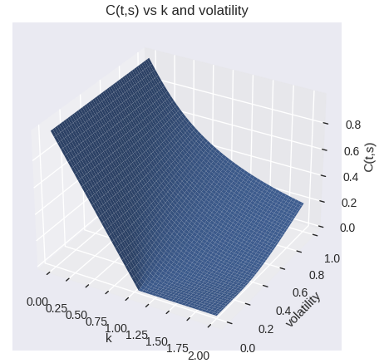

Surface plot of P(t,s) vs k and
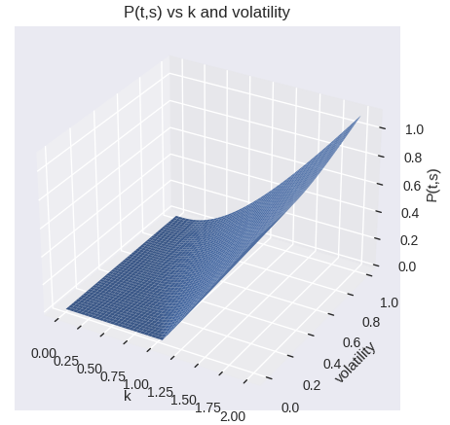

Surface plot of C(t,s) vs k and r
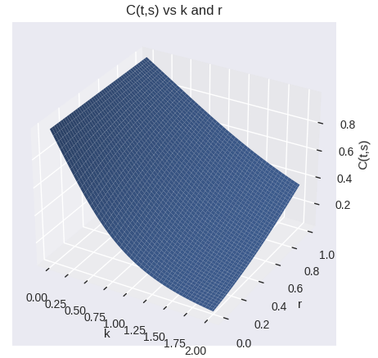

Surface plot of P(t,s) vs k and r
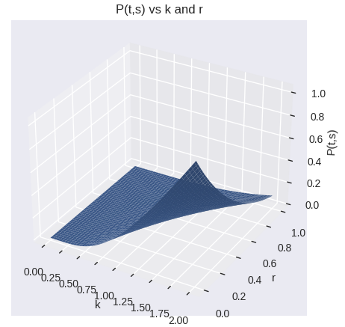

Surface plot of C(t,s) vs k and T
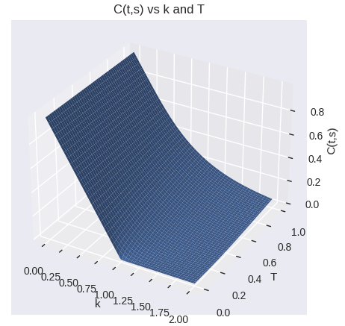

Surface plot of P(t,s) vs k and T
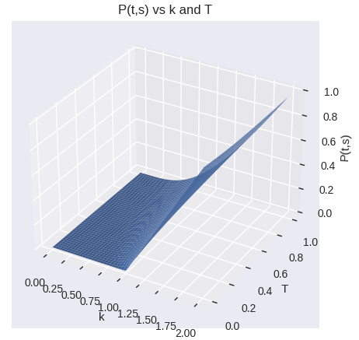

Surface plot of C(t,s) vs and r
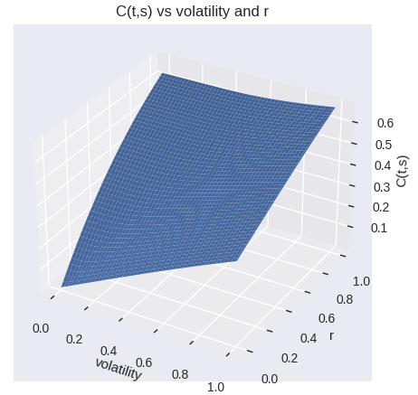

Surface plot of P(t,s) vs and r
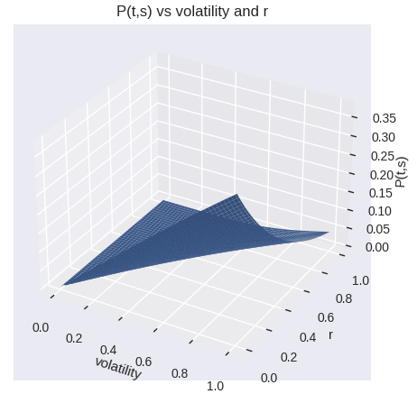

Surface plot of C(t,s) vs and T
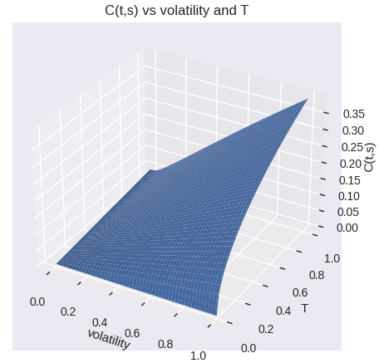

Surface plot of P(t,s) vs and T
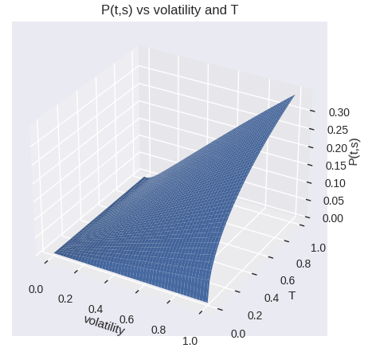

Surface plot of C(t,s) vs r and T
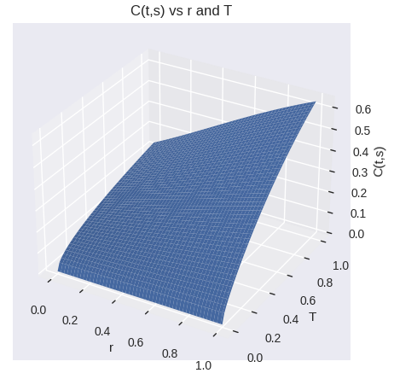

Surface plot of P(t,s) vs r and T
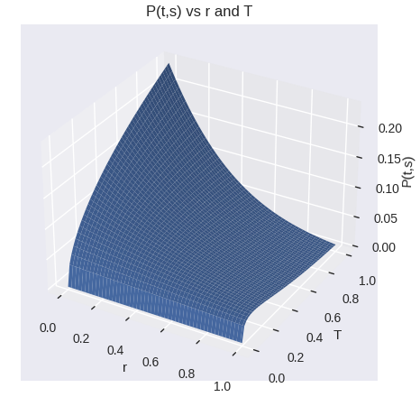

Tabulation of values
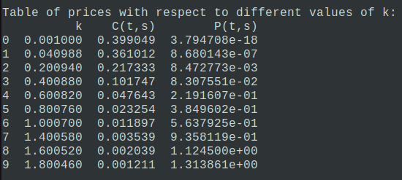
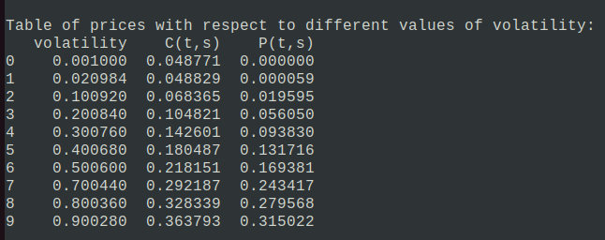

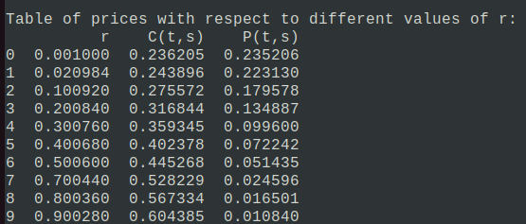
Question - 5 Incorporating Dividends

In order to incorporate dividends in the analysis, I considered the stock to be such that it pays dividends at a rate of a continuously. According to the classical BSM setup the formulae for call and put option in this case would be:-

Now from the above relations we can calculate the price of a European Call option in the classical BSM framework. For put option we use the put-call parity:-

I implemented the below formuales in my program and calculated the price of a European call and put option in the classical BSM framework. The paramters chosen were as follows:-
t = 0,s = 1,k=1,, r = 0.05 , T = 1
Now, I repeated question 4 of the previous problem and did sensitivity analysis of C(t,s) and P(t,s). In this case I also did sensitivity analysis with respect to the parameter a. I took the value of a to be a = 0.3
Sensitivity Analysis
Plot of C(t,s) with k for different values of s
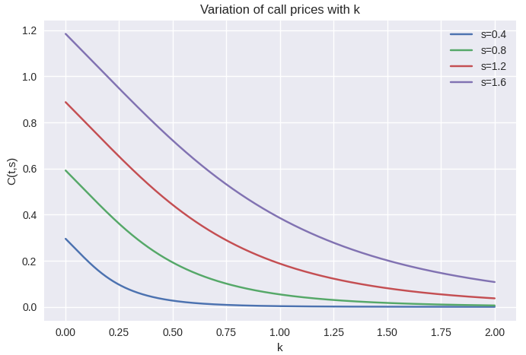
Plot of P(t,s) with k for different values of s
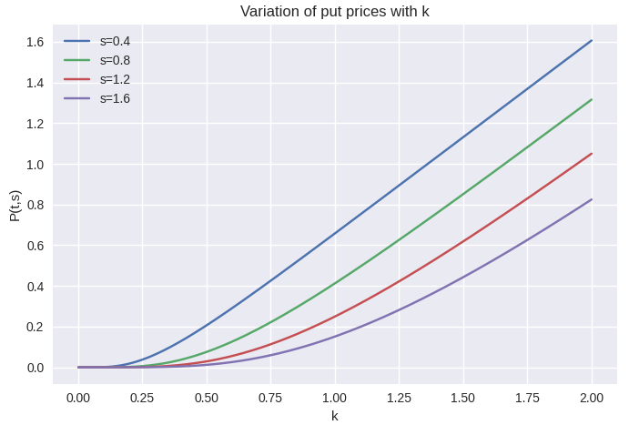

Plot of C(t,s) with k for different values of t
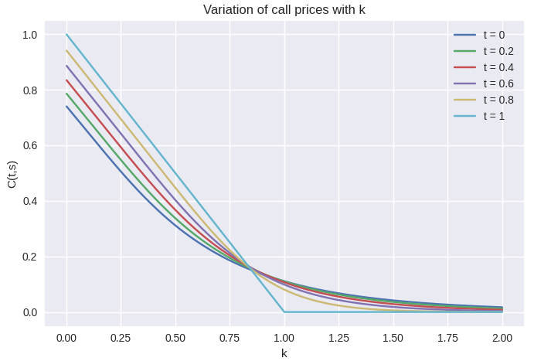
Plot of P(t,s) with k for different values of t
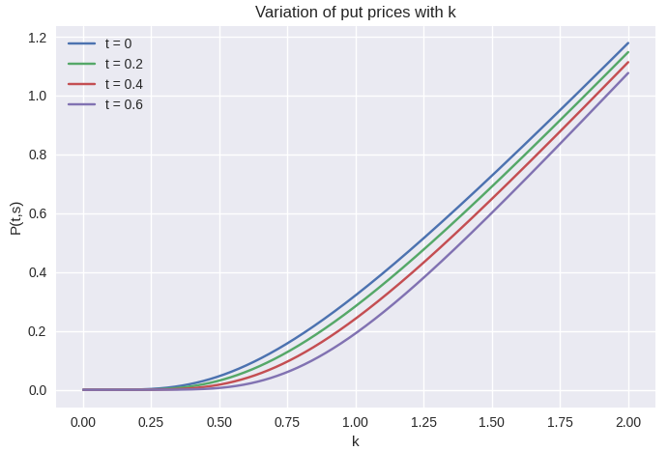

Plot of C(t,s) with for different values of s
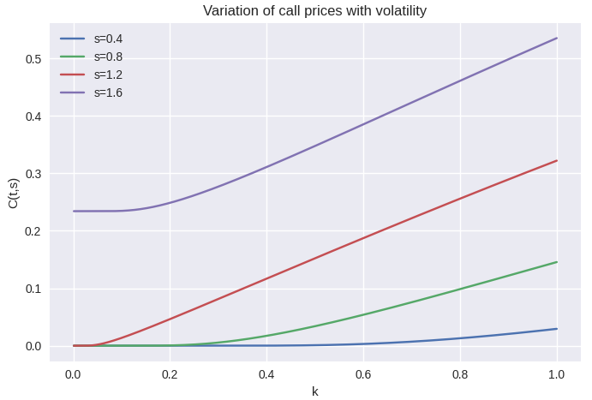
Plot of P(t,s) with for different values of s
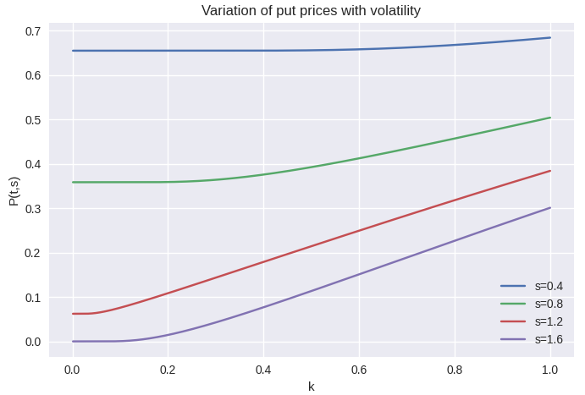

Plot of C(t,s) with for different values of t
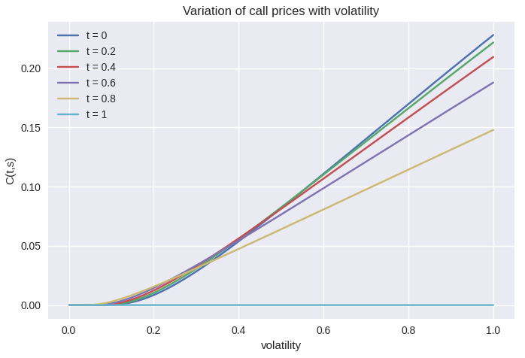

Plot of P(t,s) with for different values of t
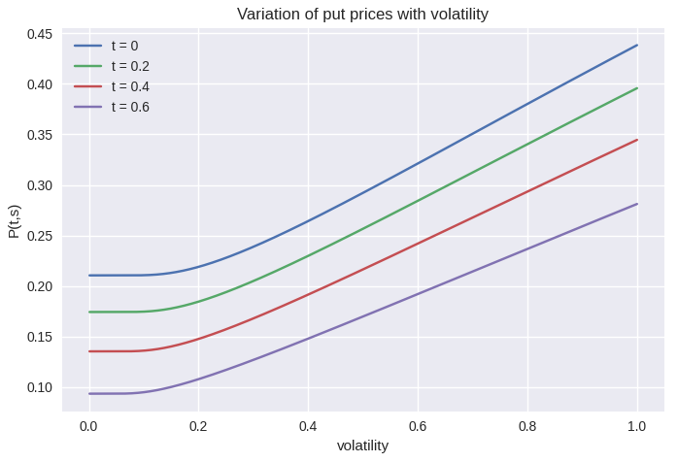
Plot of C(t,s) with r for different values of s
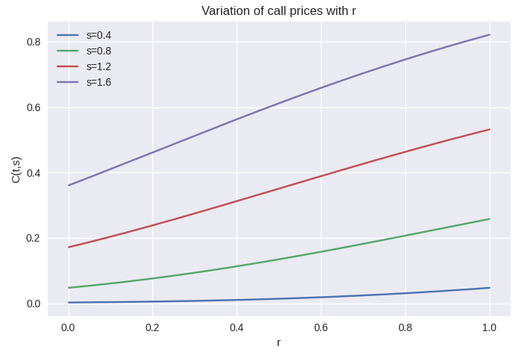
Plot of P(t,s) with r for different values of s
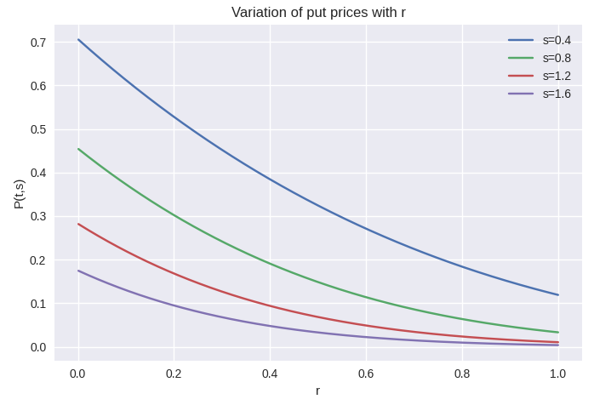

Plot of C(t,s) with r for different values of t
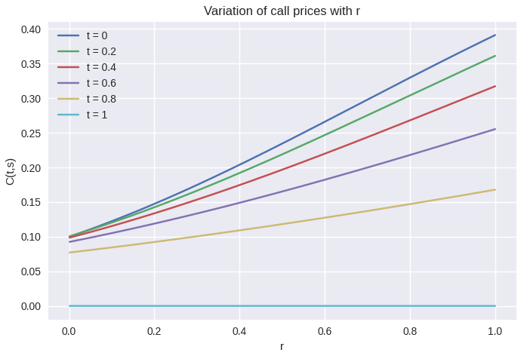

Plot of P(t,s) with r for different values of t
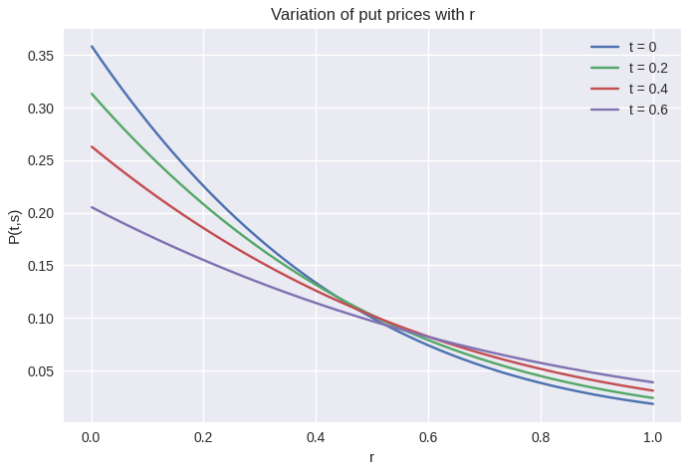
Surface plot of C(t,s) vs t and k
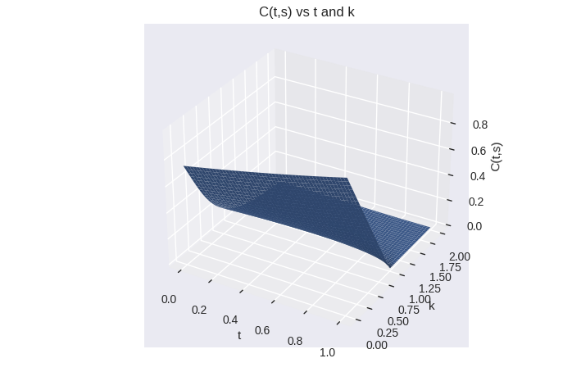

Surface plot of P(t,s) vs t and k
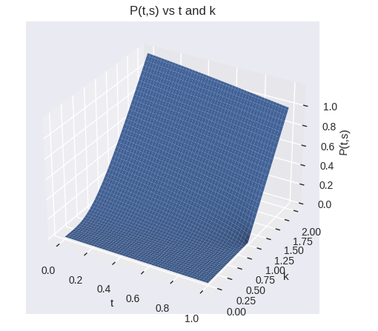

Surface plot of C(t,s) vs t and
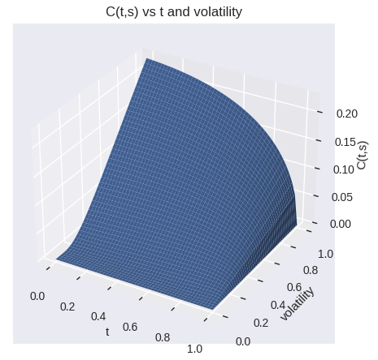

Surface plot of P(t,s) vs t and
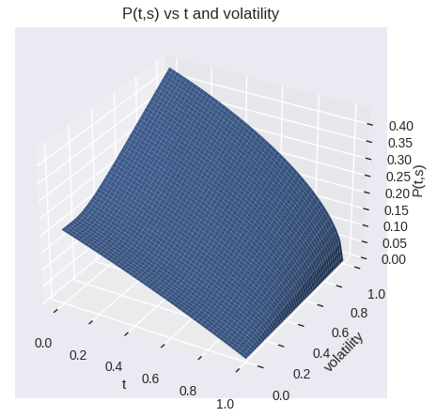

Surface plot of C(t,s) vs t and r
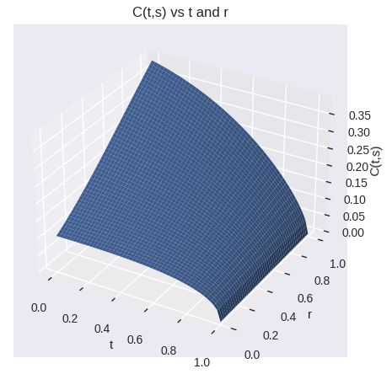

Surface plot of P(t,s) vs t and r
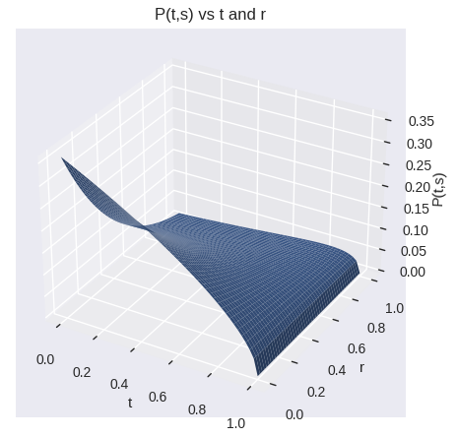

Surface plot of C(t,s) vs t and T
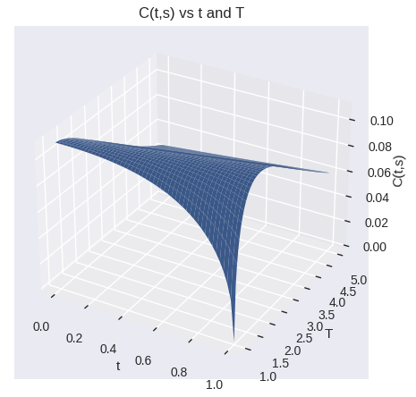

Surface plot of P(t,s) vs t and T
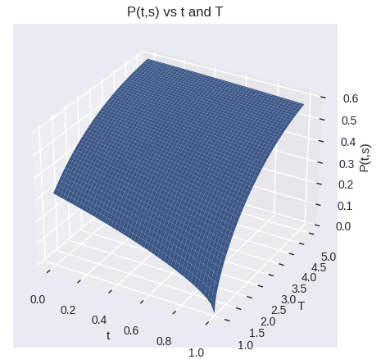

Surface plot of C(t,s) vs s and k
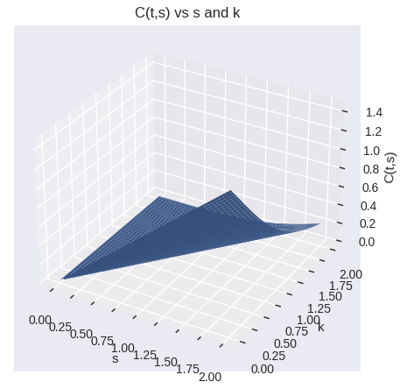

Surface plot of P(t,s) vs s and k
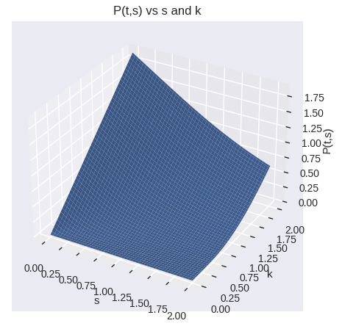

Surface plot of C(t,s) vs s and
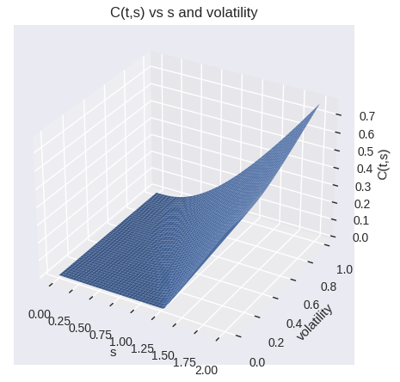

Surface plot of P(t,s) vs s and
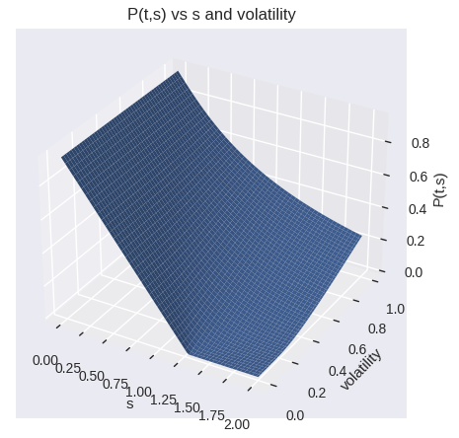

Surface plot of C(t,s) vs s and r
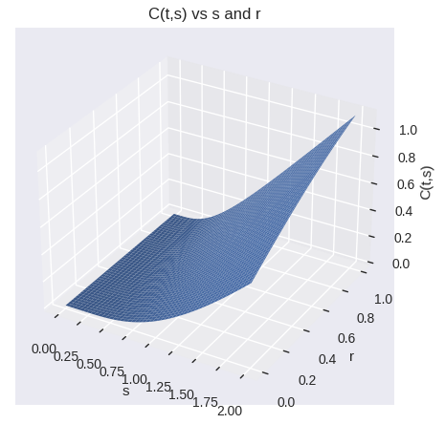

Surface plot of P(t,s) vs s and r
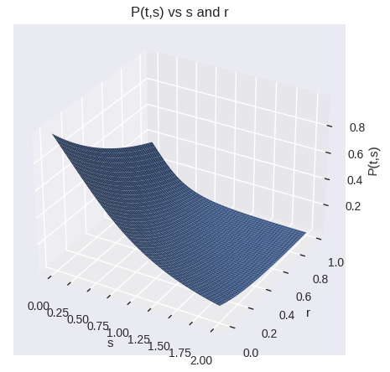

Surface plot of C(t,s) vs s and T
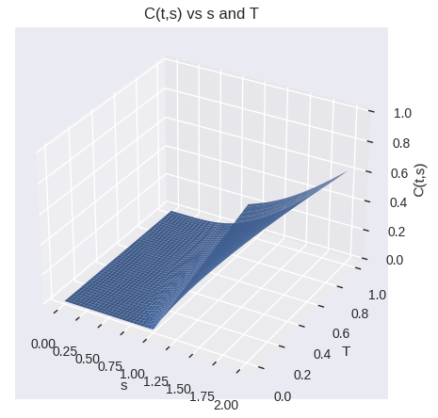

Surface plot of P(t,s) vs s and T
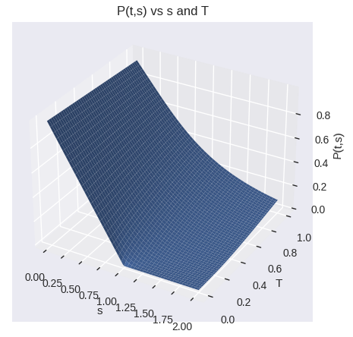

Surface plot of C(t,s) vs k and
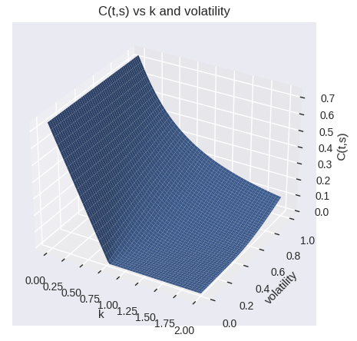

Surface plot of P(t,s) vs k and
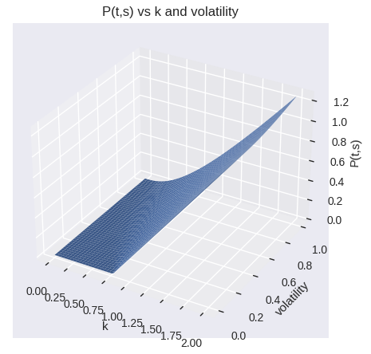

Surface plot of C(t,s) vs k and r
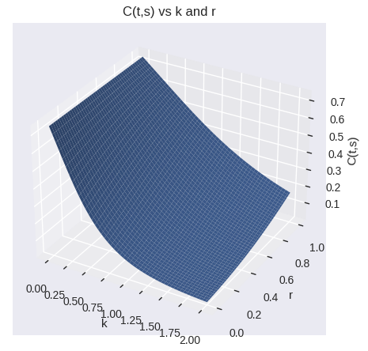

Surface plot of P(t,s) vs k and r
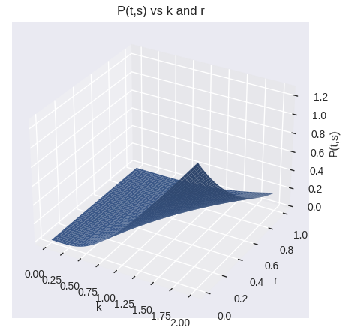

Surface plot of C(t,s) vs k and T

Surface plot of P(t,s) vs k and T
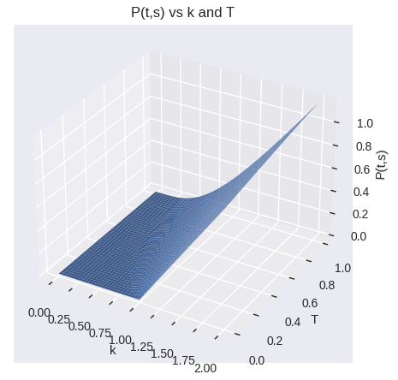

Surface plot of C(t,s) vs and r
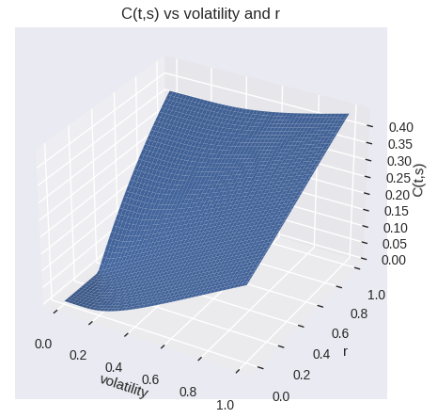

Surface plot of P(t,s) vs and r
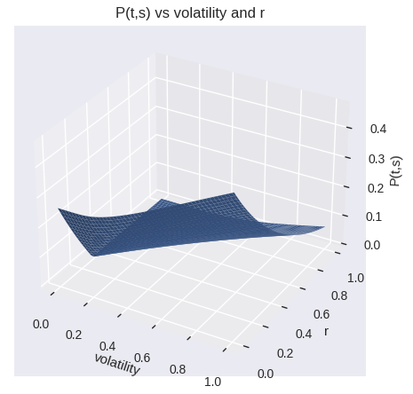

Surface plot of C(t,s) vs and T
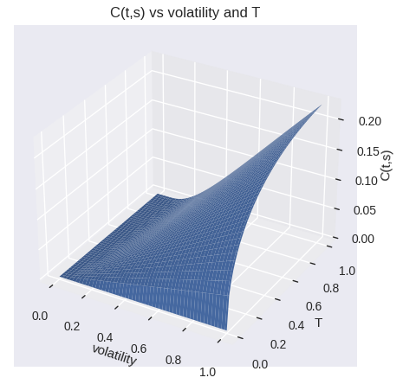

Surface plot of P(t,s) vs and T
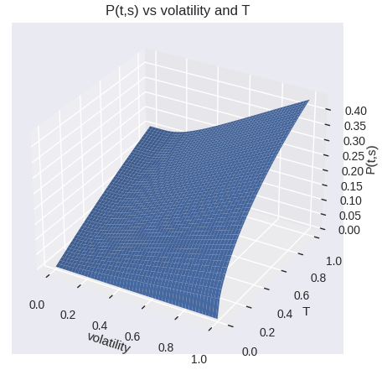

Surface plot of C(t,s) vs r and T
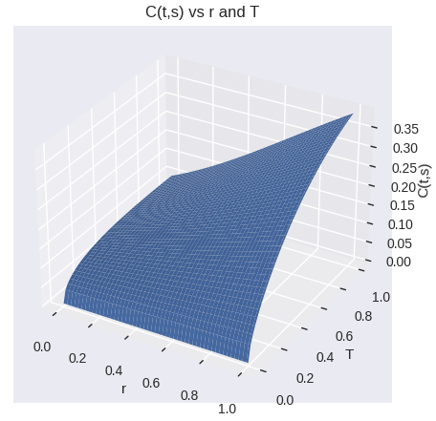

Surface plot of P(t,s) vs r and T
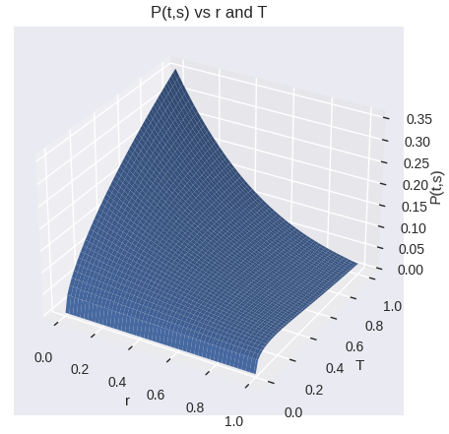
Plot of C(t,s) with a for different values of s
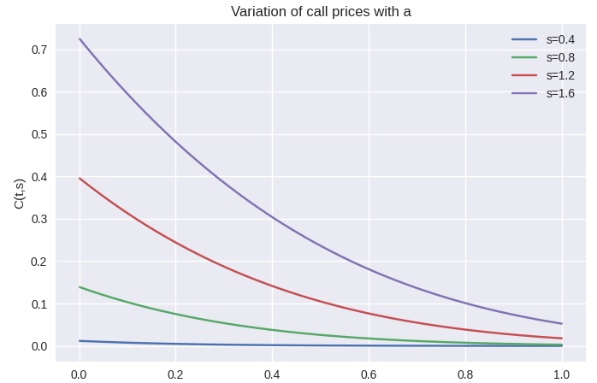
Plot of P(t,s) with a for different values of s
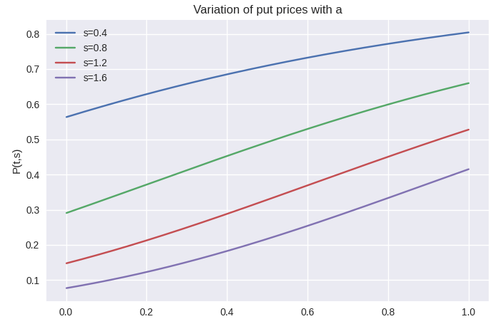

Plot of C(t,s) with a for different values of t
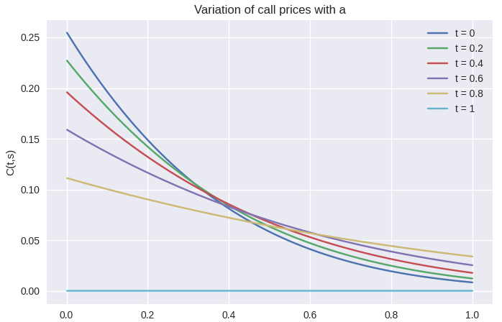
Plot of P(t,s) with a for different values of t
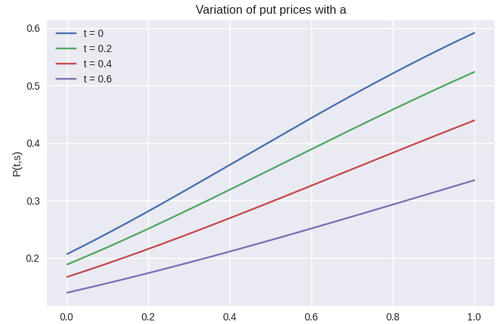
Surface plot of C(t,s) vs a and t
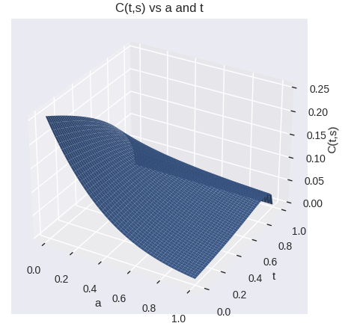

Surface plot of P(t,s) vs a and t
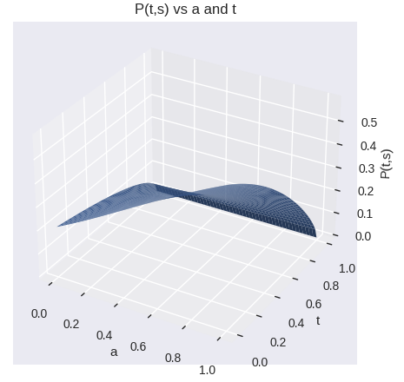
Surface plot of C(t,s) vs a and s
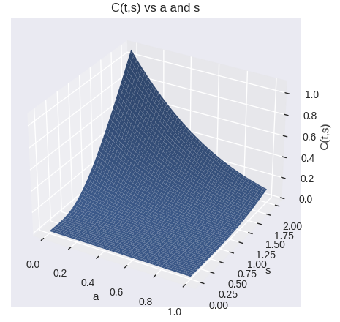

Surface plot of P(t,s) vs a and s
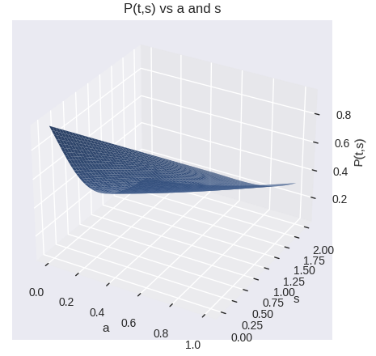
Surface plot of C(t,s) vs a and k
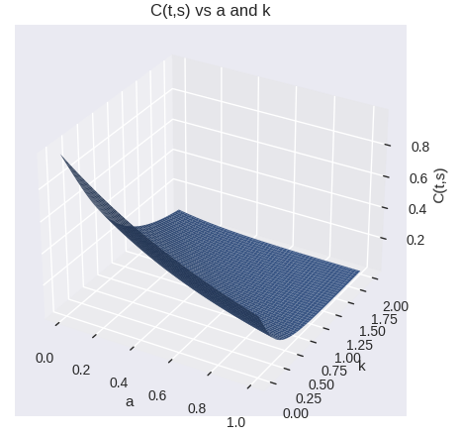

Surface plot of P(t,s) vs a and k
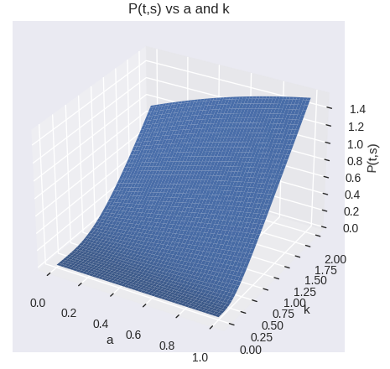

Surface plot of C(t,s) vs a and
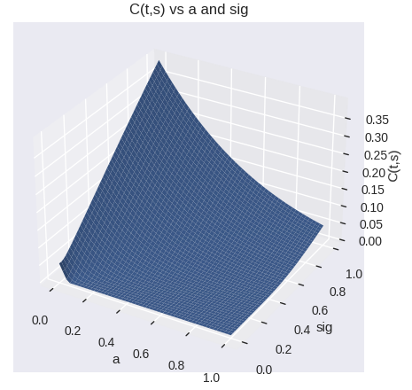

Surface plot of P(t,s) vs a and
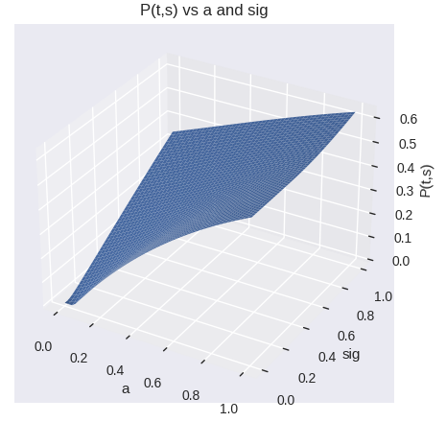

Surface plot of C(t,s) vs a and r
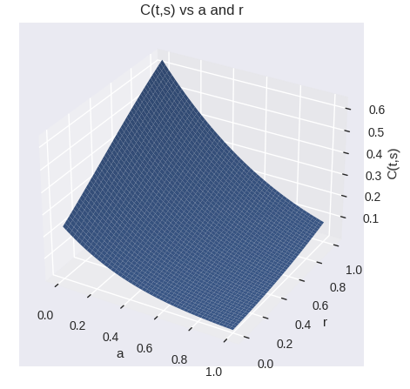

Surface plot of P(t,s) vs a and r
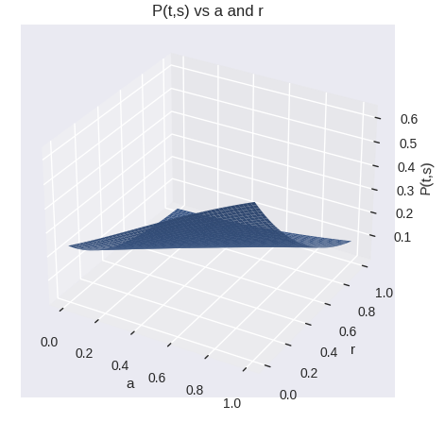

Surface plot of C(t,s) vs a and T
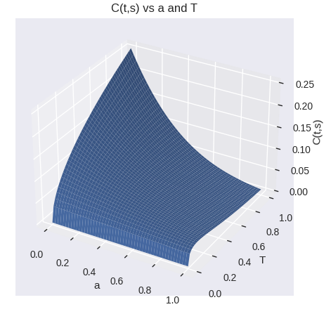

Surface plot of P(t,s) vs a and T
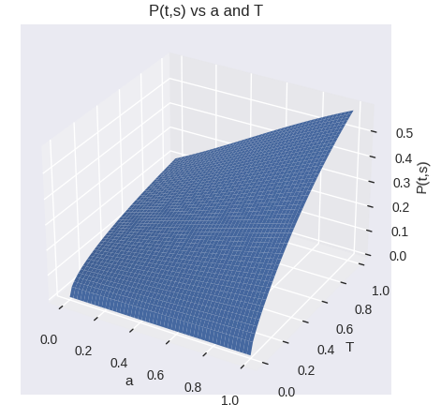

Tabulation of values


