MA374 Financial Engineering Lab
Assignment - 9

Name - Shivendu Mishra
Roll Number - 200123050
email - m.shivendu@iitg.ac.in

Question - 1

I collected option price data of five stocks for the duration of 28-Feb-2023 to 30-Mar-2021 from the NIFTY50 index. The stocks considered are:-
- AsianPaint
- ICICI BANK
- Tech Mahindra (TECHM)
- Wipro
- UPL
Question - 2

Theory for Part - (b)

In order to find the implied volatility we note that the call option price according to the BSM formulae is given by the following relations:-

Now from the data collected, we know the value of C(t,s) lets say P hence we need to find the roots of the equation where

Now we use Newton method in order to estimate the value of sigma . We use:-

Note that f'(x) is the Vega of the call option and can be found to be equal to

Theory for Part - (c)

I estimated historical volitility using the following technique:-

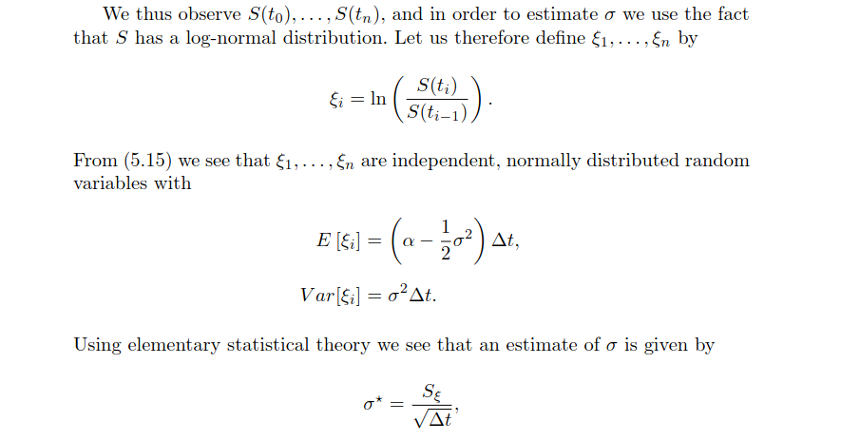

I am attaching the required results for part a,b and c of the 2nd problem for each stock from the next page:-

NOTE - OBSERVATIONS FOR ALL THE PARTS ARE IN THE LAST PAGES

NIFTY

Part - (a)
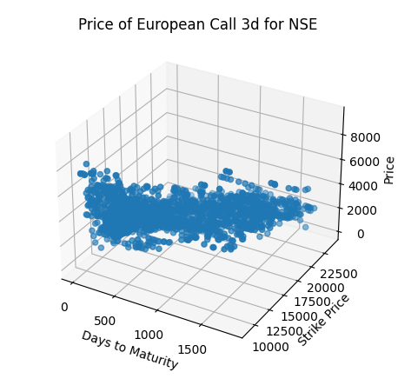

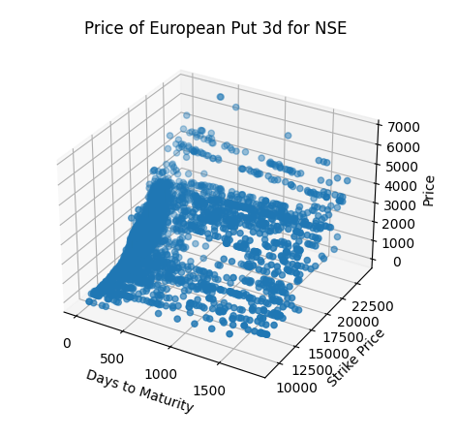
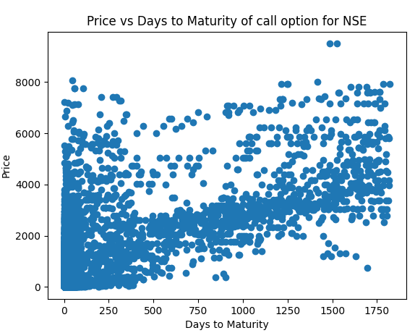
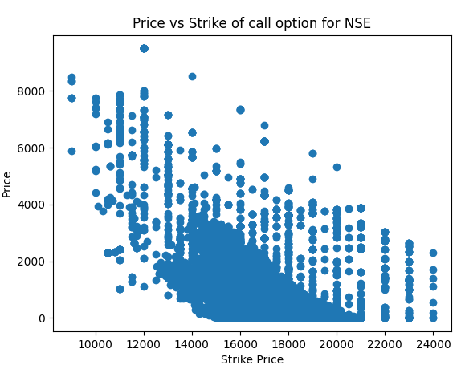

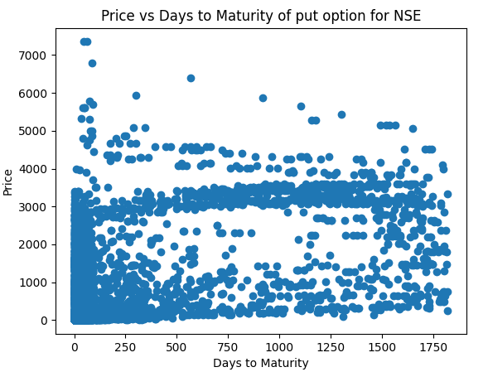
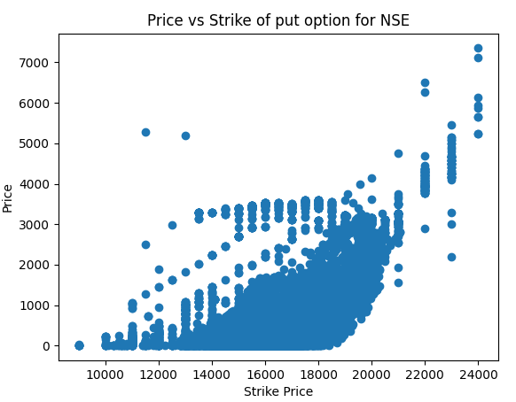
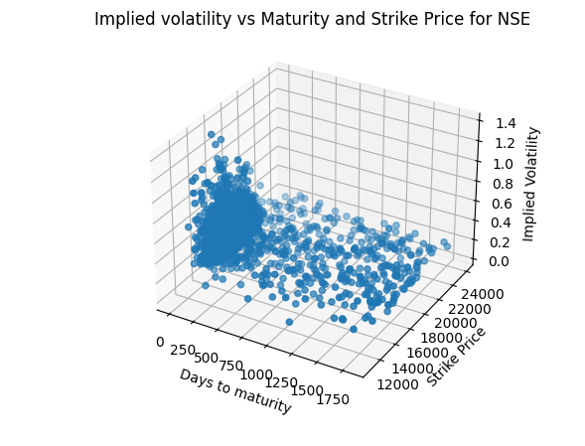
Part - (b)

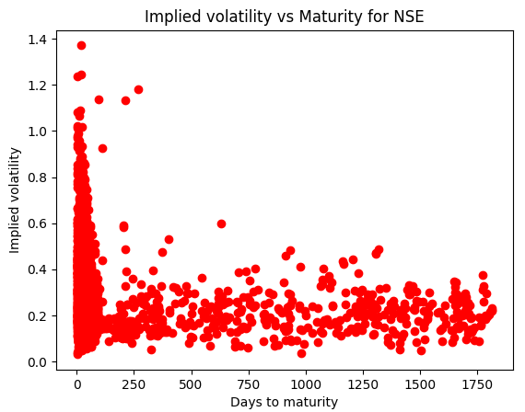
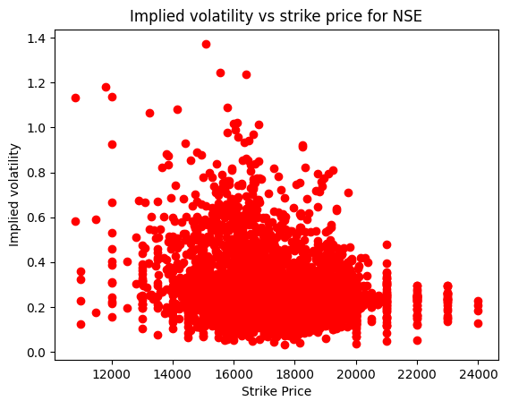
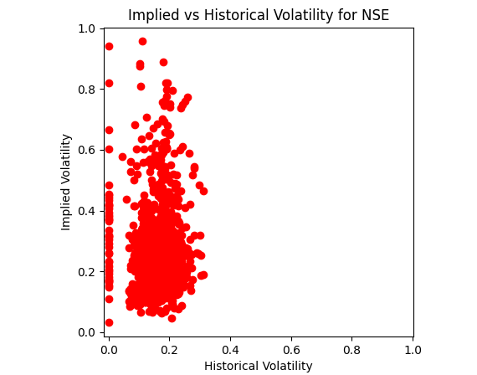
Part - (c)

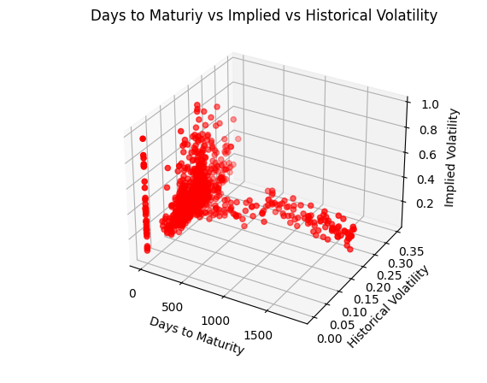
I am attaching the screenshot of tabulated values of implied and historical volatility of 15 randomly chosen points from my dataset for comparison

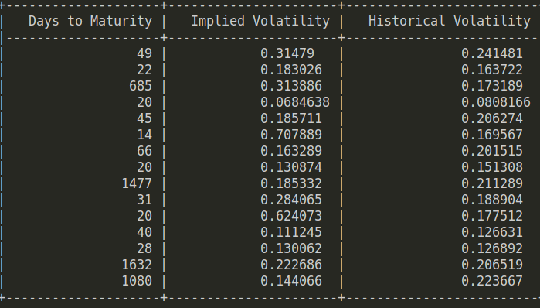
ASIANPAINT

Part - (a)
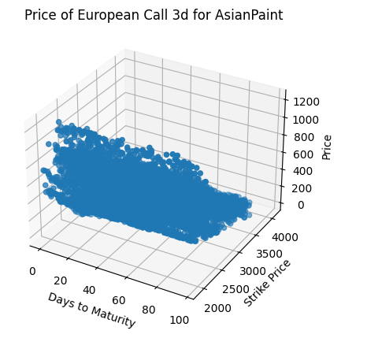

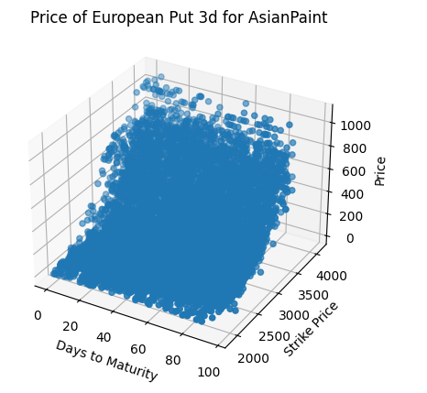
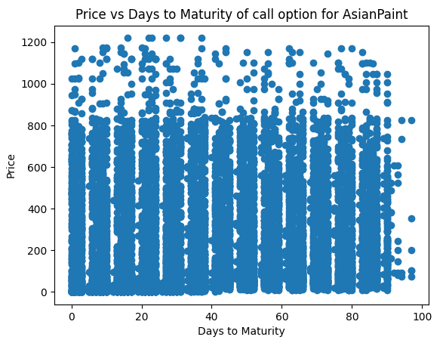
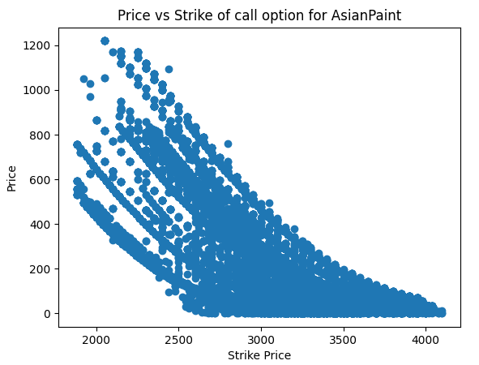

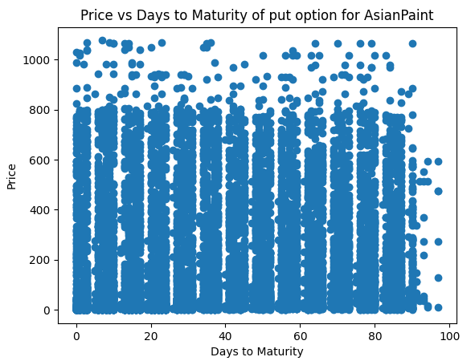
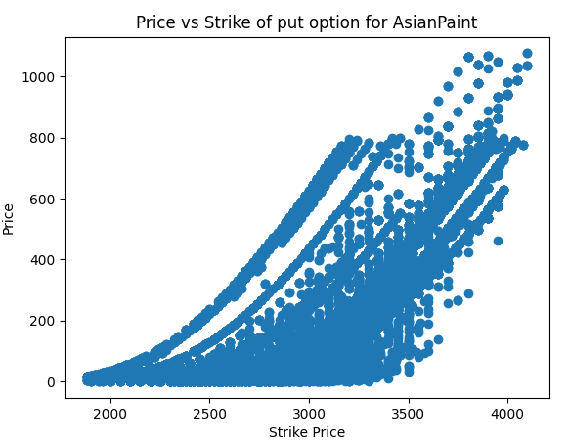
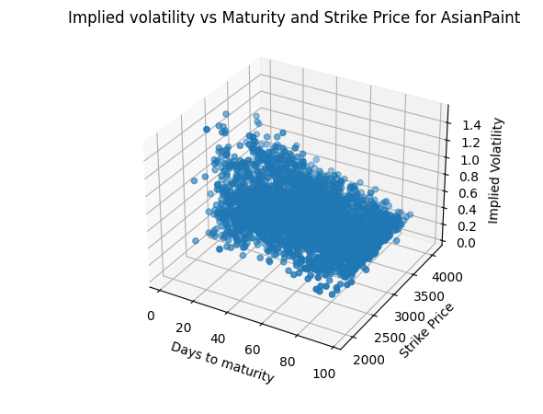
Part - (b)

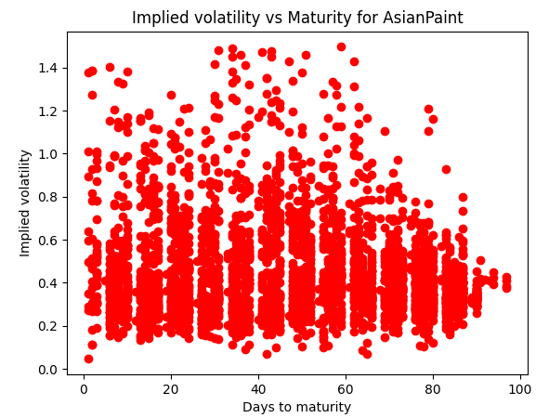
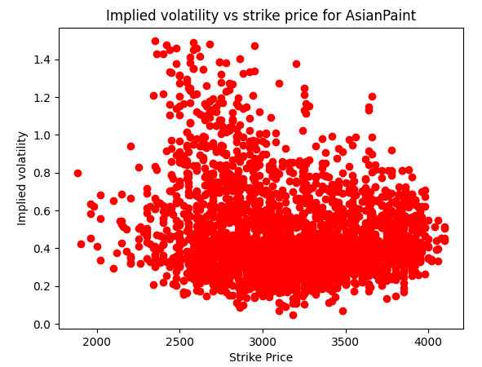
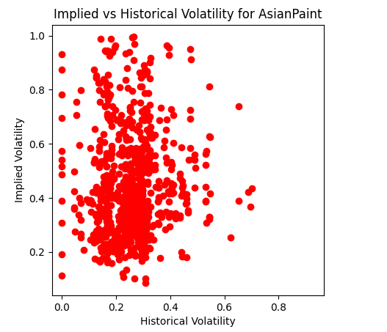
Part - (c)

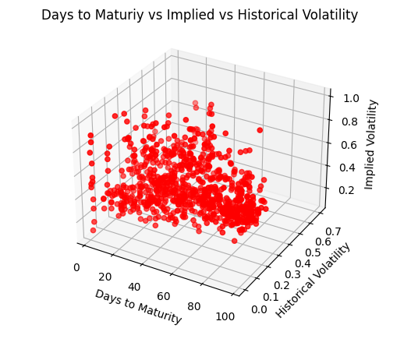
I am attaching the screenshot of tabulated values of implied and historical volatility of 15 randomly chosen points from my dataset for comparison

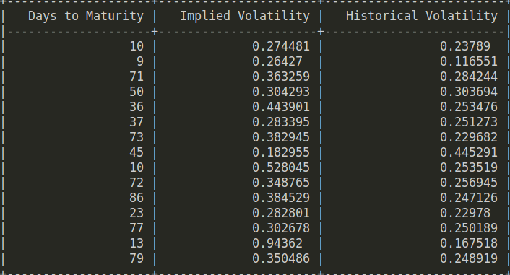
ICICIBANK

Part - (a)
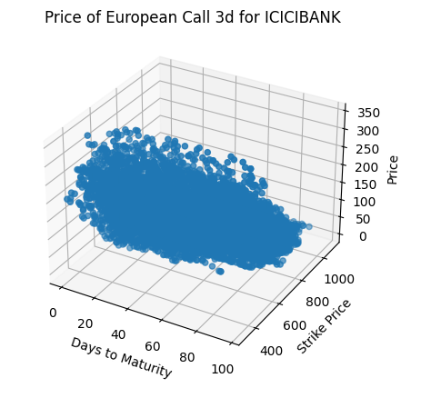

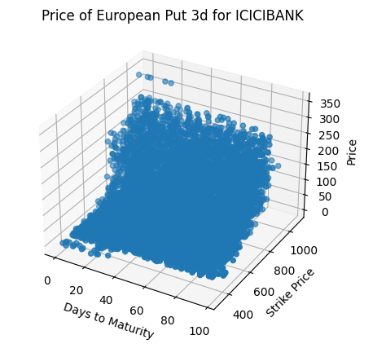
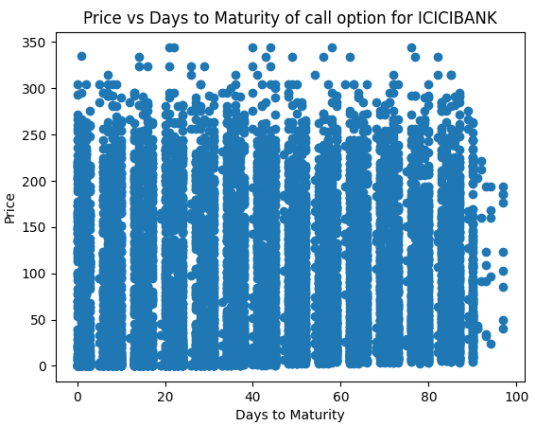
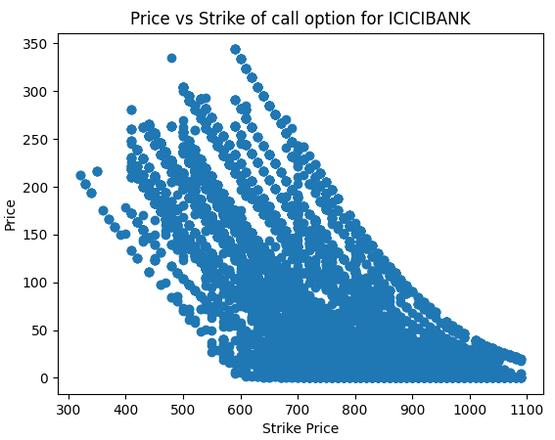

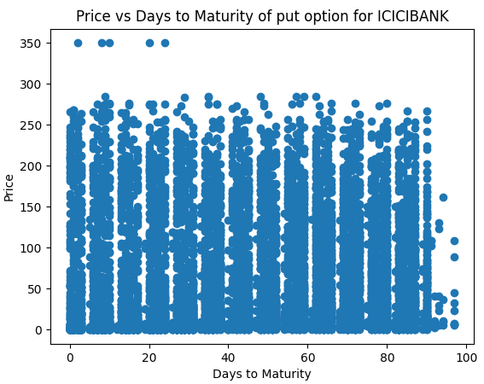
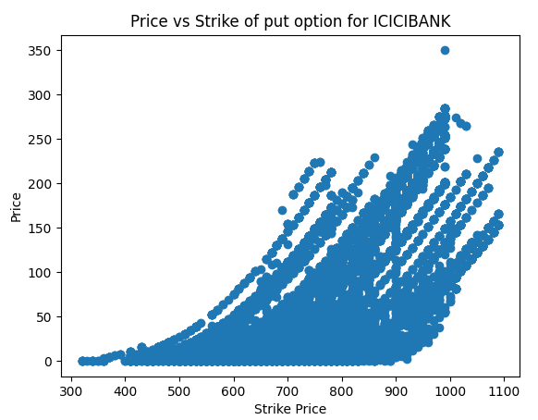
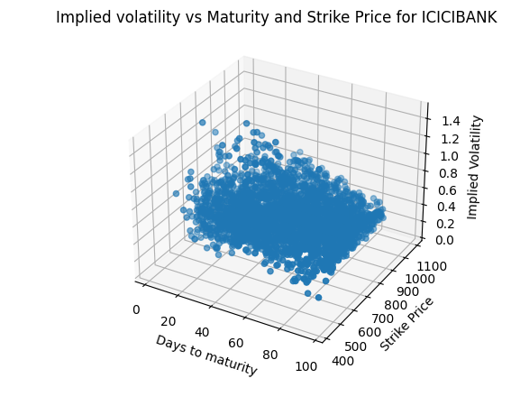
Part - (b)

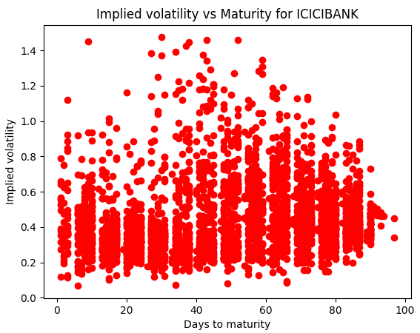
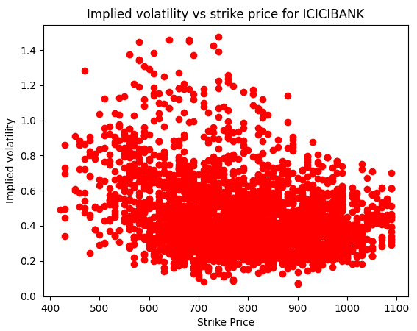
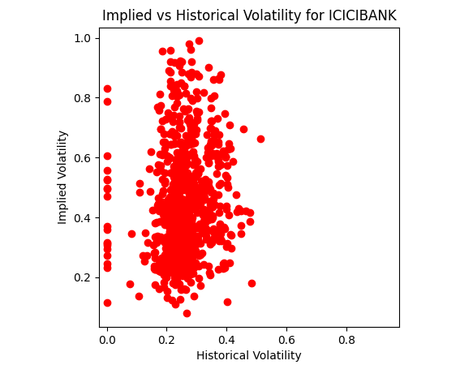
Part - (c)

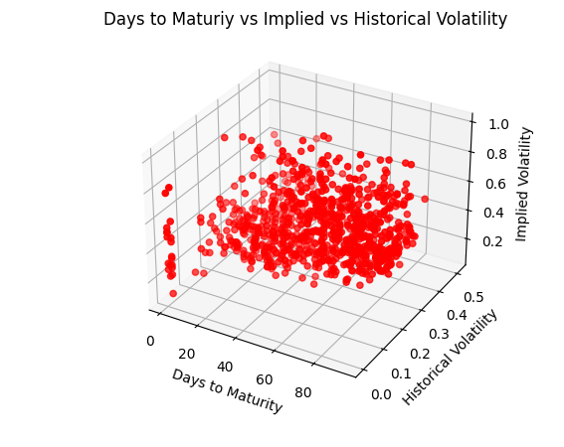
I am attaching the screenshot of tabulated values of implied and historical volatility of 15 randomly chosen points from my dataset for comparison

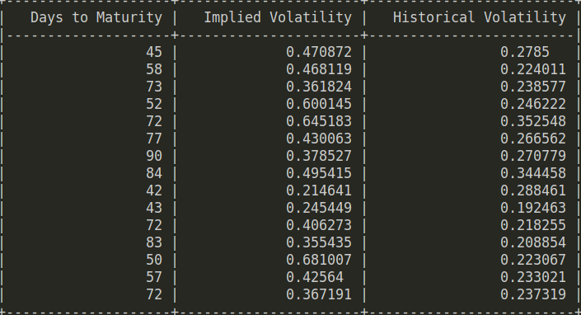
TECHM

Part - (a)

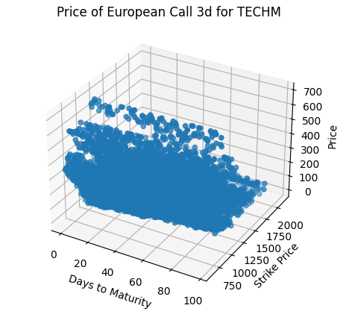

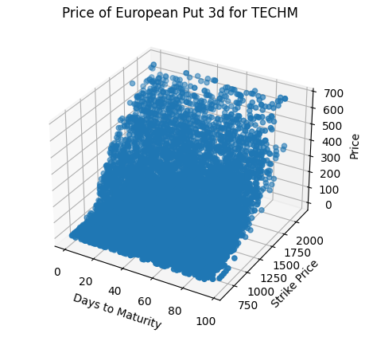
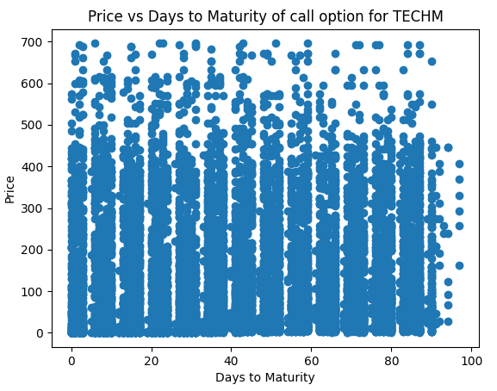
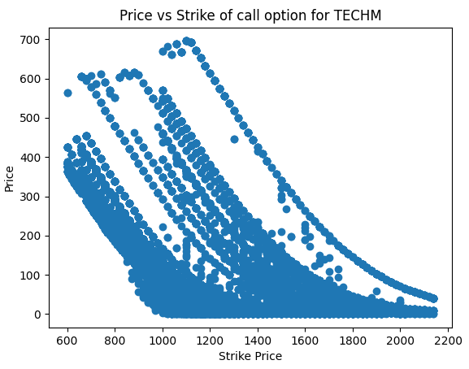

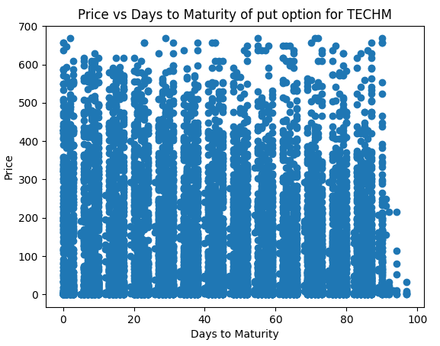
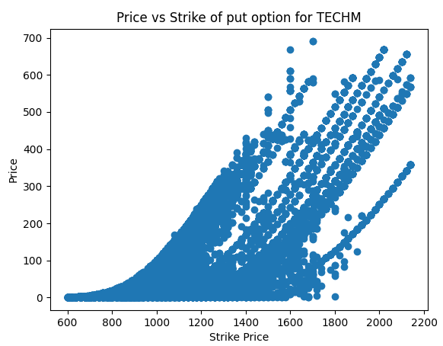
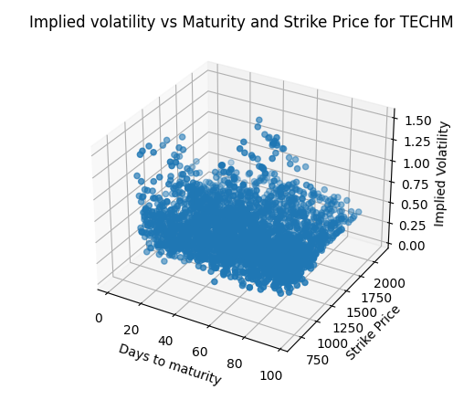
Part - (b)

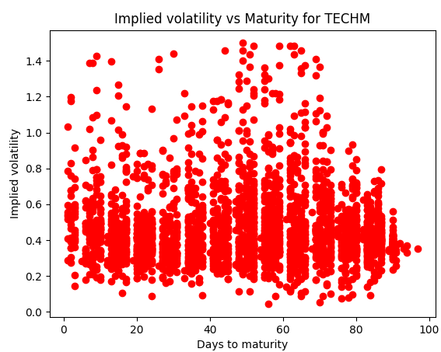
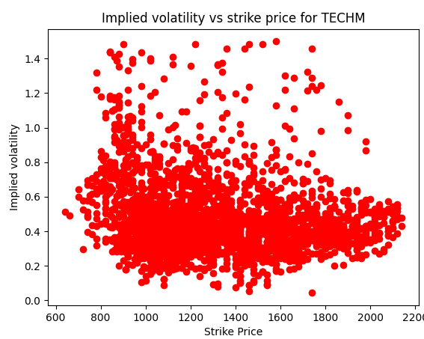
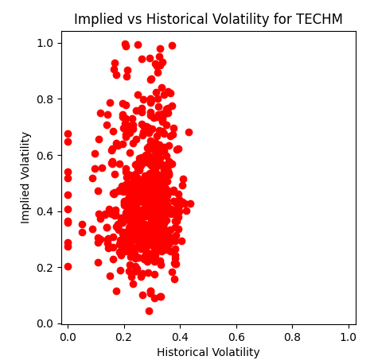
Part - (c)

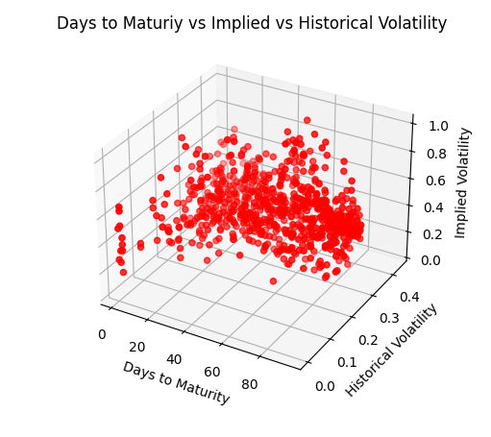
I am attaching the screenshot of tabulated values of implied and historical volatility of 15 randomly chosen points from my dataset for comparison

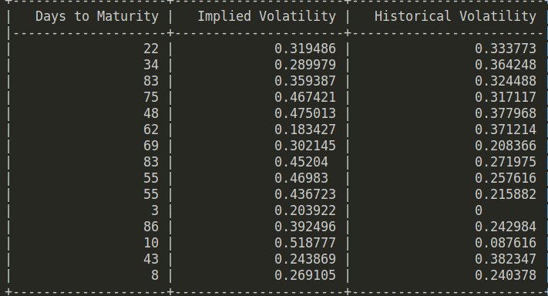
WIPRO

Part - (a)
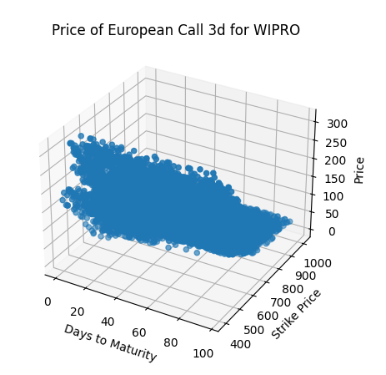

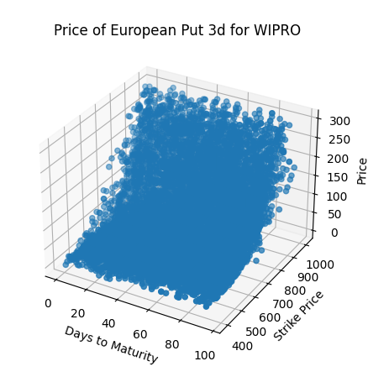
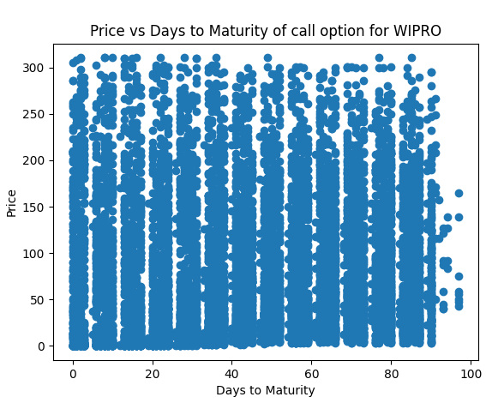
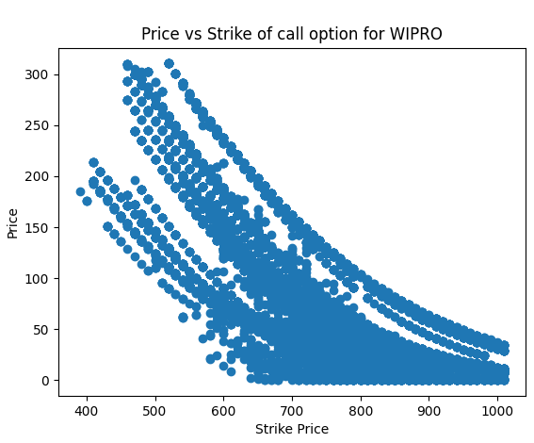

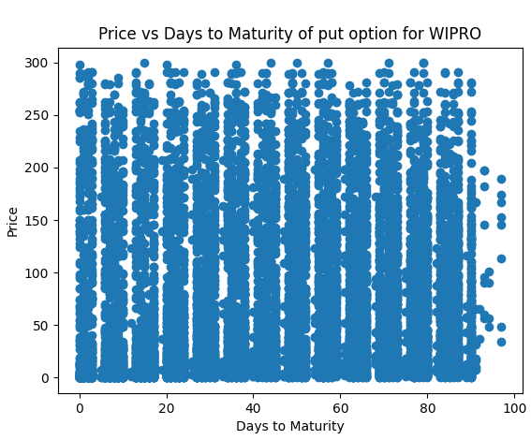
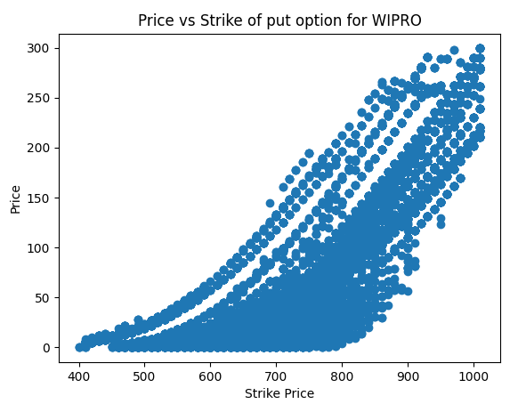
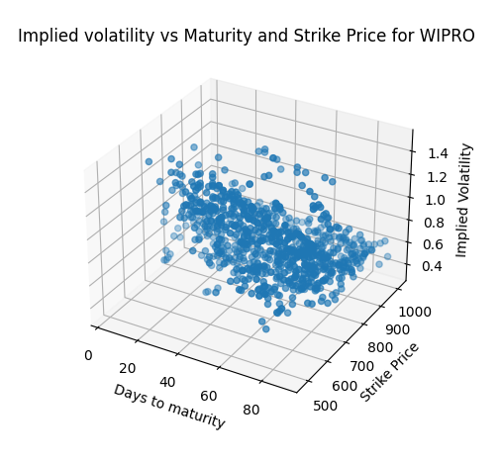
Part - (b)

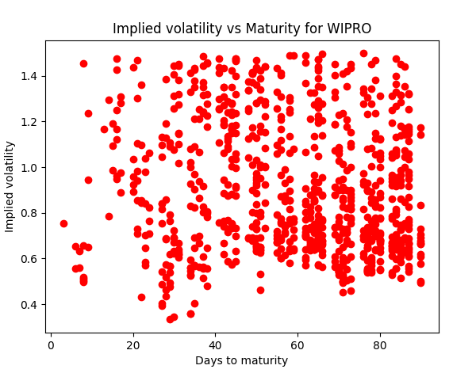
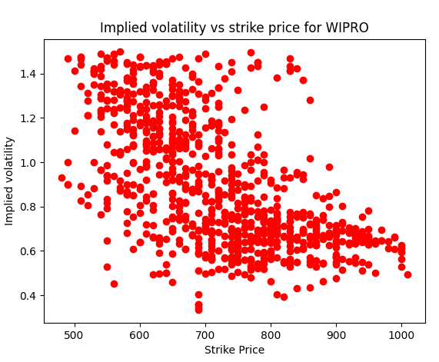
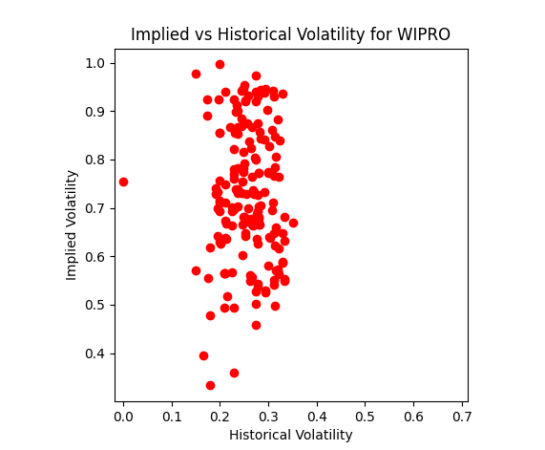
Part - (c)

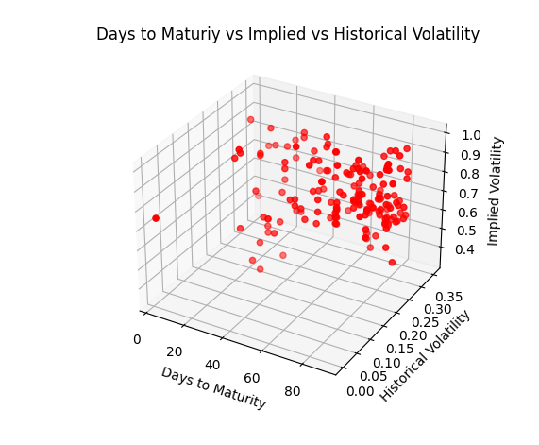
I am attaching the screenshot of tabulated values of implied and historical volatility of 15 randomly chosen points from my dataset for comparison

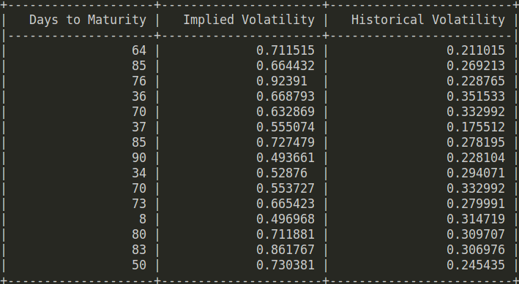
UPL

Part - (a)
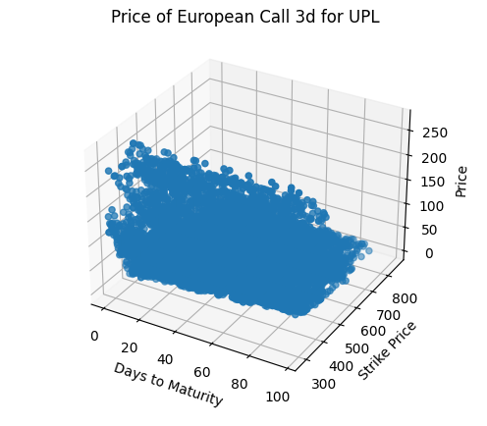

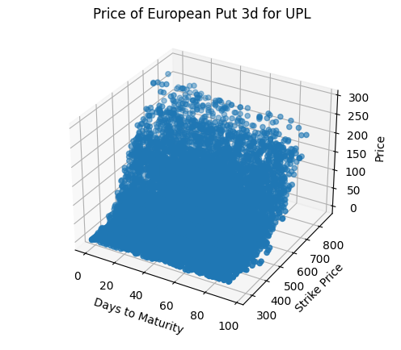
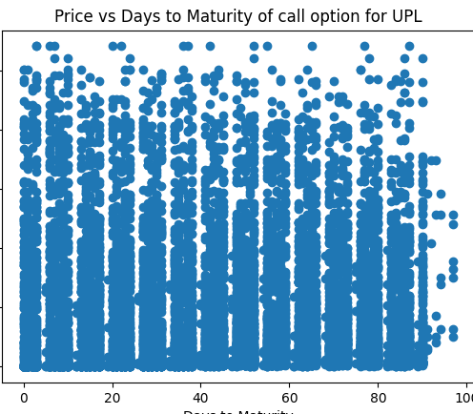
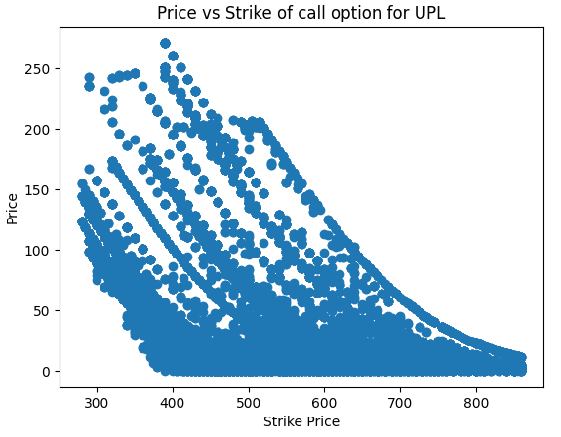

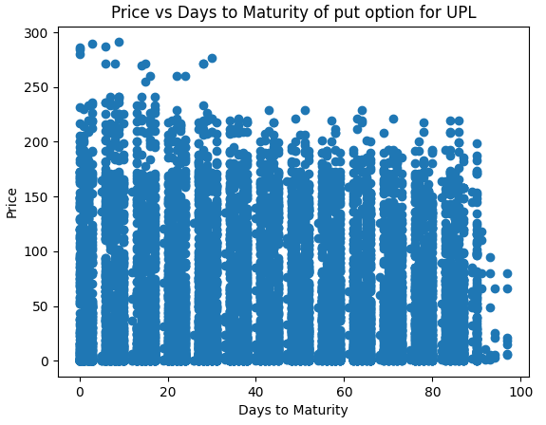
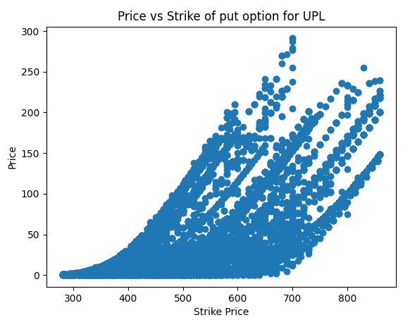
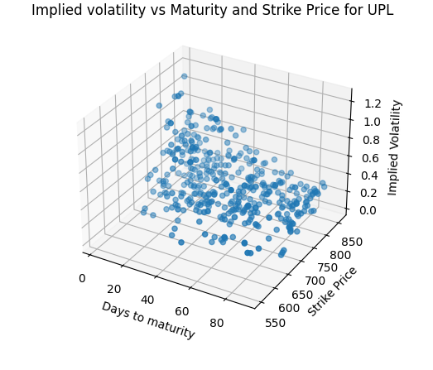
Part - (b)

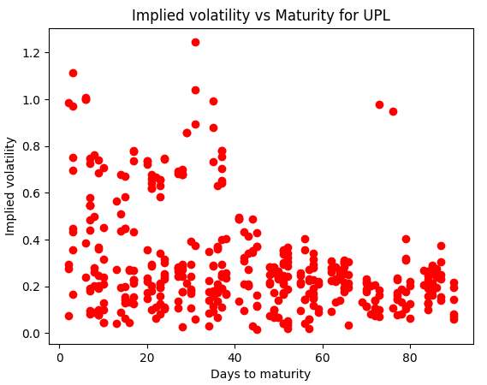
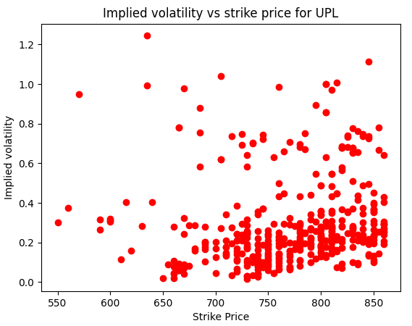
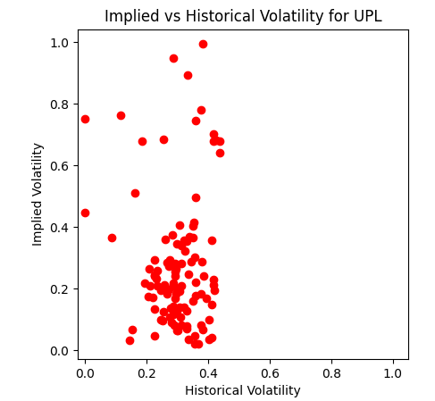
Part - (c)

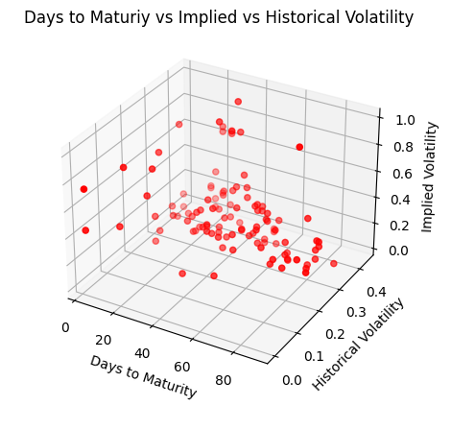
I am attaching the screenshot of tabulated values of implied and historical volatility of 15 randomly chosen points from my dataset for comparison

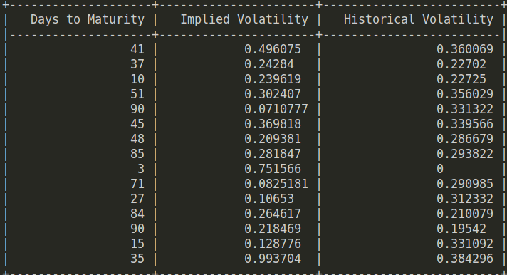
Observations

Some important points

- Since the number of data points is extremely large I have used random sampoling to sample about 10000 data points for plotting and about 5000 points for volatility analysis
- The code for implied volatility takes about 1 minute to run
- The data shown for implied vs historical volatility on output only comprises of about 15 points but the complete data is saved in the historical volatility folder for each stock as a csv file
- On running the code there might be some runtime warnings which correspond to the divergence of Newton's method at certain points casuing overflow or underflow. I have rejected these data points in this experiment.

Observations for part(a)

- We can clearly observe that the price of call option decreases with the strike price whereas for put option it increases. This is consistent with the pricing formulae of the classical Black Scholes model.
- But the plot for call option and put option with maturity doesn’t exactly match with our expectations. The general trend is that the price of call option tends to increase while that of put option tends to decrease with an increase in maturity period.
- This may be due to the fact that that the market is affected due to many other factors and also that we are considering options of varying strike prices hence the general trend is disturbed.

Observations for part(b)

- Theoretically, the implied volatility is generally a convex function of strike price, and the curve so formed is known as the Volatility Smile. This behaviour is prominent in stocks such as ASIANPAINT,ICICIBANK,TECHM whereas for the other stock we do not see evidence of such behaviour
- The volatility generally tends to decrease for larger maturity values, but for some of the above plots this nature is not observed.
Observations for part(c)

- On observing the scatter plot of implied and historical volatility we can see that they are somewhat positively correlated and the values are quite similar to each other in most of the cases
- However the implied volatility in general reaches higher values as compared to the historical volatility which is mostly in the range (0,0.3). The implied volatiltiy on the other hand as certain outliers which take value of about 1.5.
- The plot for historical vs implied volatility very well captures this relation. Other plots show the dependence of different types of volatility with varying strike price and maturity.

