FUNCTION

Q1) Calculate nCr binomial coefficient for n and r.

Q2) WAF to print all the prime no. up to n.

BINARY NUMBER

Q1) WAP to find binary of given decimal number

Q2)Wap to find decimal number from a Given binary number

Bitwise Operator

Q1)Figure out if a number is power of 2 without using loop.

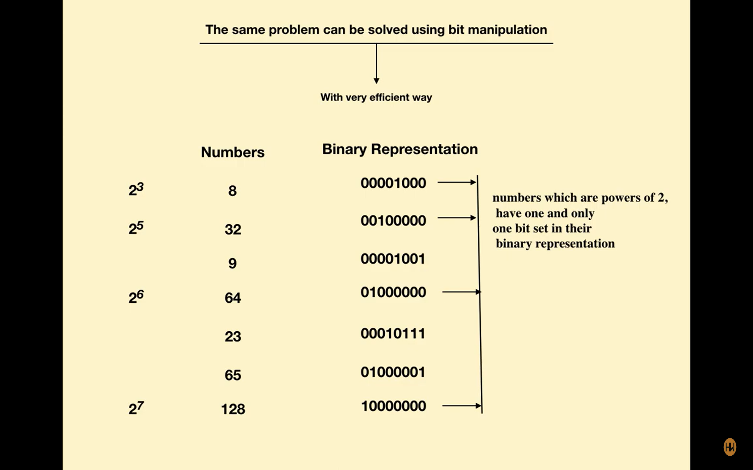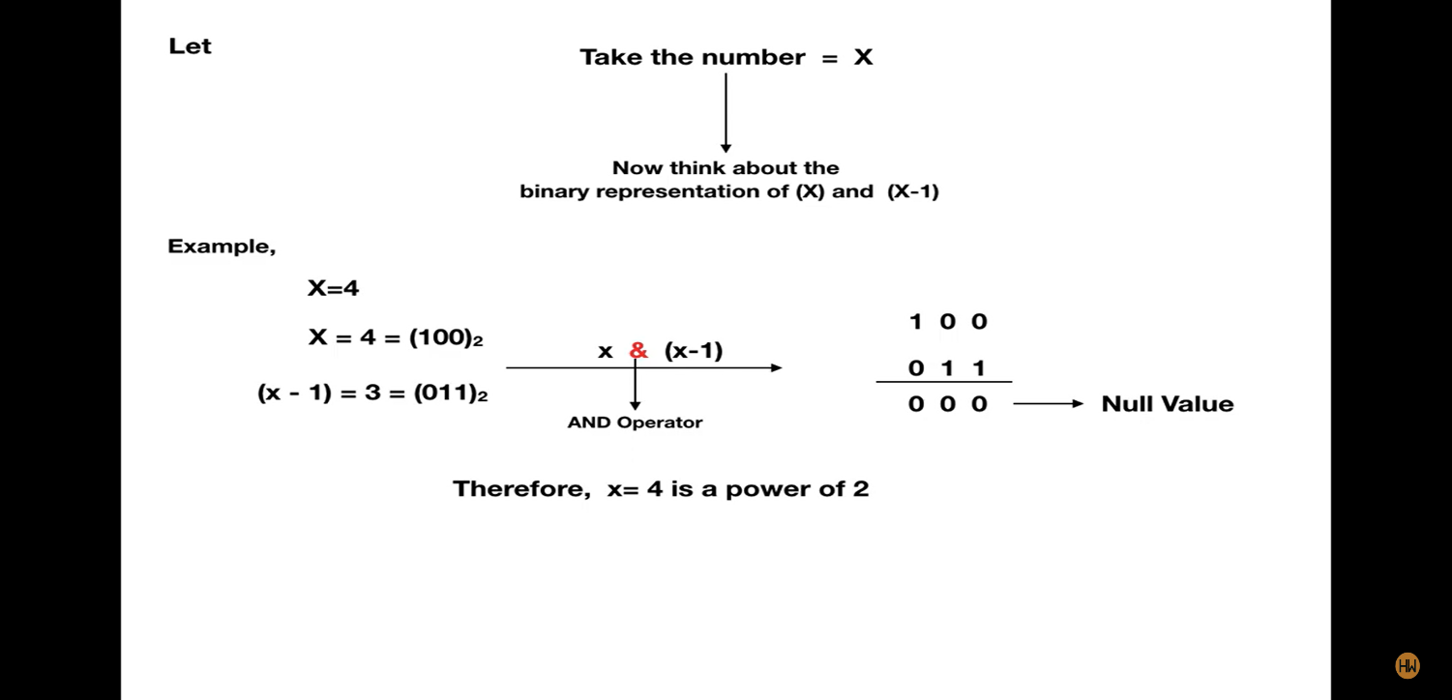

Q2)WAF to reverse an integer n.