Invention Disclosure Form (IDF)
MapMind: Vision-Based Indoor Floor Plan Understanding and Natural-Language Navigation Using Local Large Language Models
Date of Submission: ______________________________ (to be completed at the time of actual submission; no date is fixed in the supplied materials).
A patent application must meet the following criteria in order to apply for patent: the invention must be new (novel), must involve an inventive step (non-obviousness), must be capable of industrial application, and must be fully disclosed in the application. The present disclosure is prepared on this basis.
Stages of Completion of Project (Tick the appropriate)
Stage | Selected
Ideation | ☐ No
Ongoing work | ☐ No
Prototype | ☐ No
Working model | ☑ Yes
Results Validated | ☐ No

Selection note: the complete end-to-end system (CV pipeline, graph construction, A* routing, grounded local LLM interface and interactive web application) is fully implemented and runs offline on commodity CPU hardware, qualifying MapMind as a working model. ‘Results Validated’ is not ticked because all results to date come from internal testing (117 automated regression tests and three bundled demo plans); no independent or ground-truth benchmark evaluation has yet been performed.
Following details must be provided by the inventor(s) who wishes to apply for patent:
1. Title of Invention
“MapMind: A Vision-Based Indoor Floor Plan Understanding and Natural-Language Navigation System Using Local Large Language Models” — an end-to-end, fully offline software system that automatically converts an unannotated 2D raster architectural floor-plan image into a navigable topological graph and answers natural-language navigation queries with hallucination-guarded, locally hosted LLMs.
2. List All Inventors
Field | Inventor 1 - Details
Name | Dr. Seema Bangareswara Hegde
Designation | Professor
Department | Department of Computer Science and Engineering (CSE)
Address | Global Academy of Technology, Ideal Home Town, R R Nagar, Bengaluru-98
Email and phone number | Not provided in the supplied materials - confirmation required
Nationality | Indian

Field | Inventor 2 - Details
Name | To be confirmed at submission — student inventor(s) of the MapMind project; names are not stated in the supplied project materials (the attached technical report contains placeholder author fields)
Designation | To be confirmed at submission
Department | To be confirmed at submission
Address | To be confirmed at submission
Email and phone number | To be confirmed at submission
Nationality | To be confirmed at submission

Field | Inventor 3 - Details
Name | To be confirmed at submission
Designation | To be confirmed at submission
Department | To be confirmed at submission
Address | To be confirmed at submission
Email and phone number | To be confirmed at submission
Nationality | To be confirmed at submission

Note (please include additional names and details of inventors as needed): inventorship under patent law reflects actual contribution to the conception of the invention; every student who conceived any claimed feature must be listed, and those who only implemented assignments must not. The inventor list above must therefore be finalised by the applicants before filing.
3. Is this a funded project?
No. (As recorded on the master form. If any institutional or sponsored-project funding is later involved, the funding body's IP policy must be checked before filing.)
4. Is this work bound by any contractual agreement?
No / Not Applicable. (As recorded on the master form; licenses held by building blocks — e.g., OpenCV (Apache-2.0), NetworkX (BSD-3), Streamlit (Apache-2.0), Ollama (MIT) — are permissive open-source licenses and do not restrict ownership of the invention, but this should be re-confirmed at filing.)
5. Is the invention a product or a process?
Product — the invention is claimed as an end-to-end navigation software system (product). The disclosure also covers the associated method of operation of that system, so both a product claim set and one method claim are proposed (see item 13).
6. Has this work been disclosed to the public before?
No. The work has not been published, commercially launched, exhibited or deposited publicly. Internal academic reviews, viva sessions and supervisor discussions are not counted here; any public presentation, journal/conference submission or public demo should occur only after the patent application is filed, or with guidance from the institution's IP cell.
7. Proposed Abstract of the Invention
Indoor wayfinding in hospitals, campuses and shopping centres is difficult because GPS is unavailable indoors, while the architectural floor plans such buildings almost always possess are plain raster images that machines cannot parse: converting them into a navigable representation has so far required manual CAD tagging, costly beacon deployments (Wi-Fi/BLE/UWB), or deep-learning pipelines needing large annotated datasets and cloud GPUs. MapMind removes all of these dependencies with a fully offline, edge-deployable system combining classical computer vision, topological graph pathfinding and privacy-preserving local Large Language Models. A deterministic multi-stage CV pipeline on a commodity CPU performs resolution normalisation, adaptive chromatic separation of wall ink from coloured door symbols, text-artifact suppression, candidate-driven adaptive morphological gap closing, Hough-transform wall merging, and connected-component segmentation of free space into rooms and corridors. A dual-source door detector combines colour-based door parsing with region-gap analysis and associates doorways to rooms by orthogonal ray probing. The extracted elements are synthesised into a weighted NetworkX graph whose edge costs model exact centroid→door→centroid walking paths, enabling door-centre-aware A* routing. Queries are answered by locally hosted LLMs (via Ollama) guarded by a deterministic verification layer that rejects ungrounded spatial claims and substitutes rule-based, route-faithful instructions. A dense 33-unit mall plan is parsed in about 2.0 s on CPU and the system is backed by 117 passing automated regression tests.
8. Key Words
Indoor navigation; floor-plan understanding; classical computer vision; morphological gap closing; wall detection; room segmentation; dual-source door detection; ray probing; topological graph; A* search; door-centre-aware routing; local Large Language Model; Ollama; grounding verification; edge deployment; privacy; offline navigation.
9. Background of the Invention
(i) Indoor positioning is an unsolved infrastructure problem. GPS ends at the building door; inside malls, hospitals and campuses, satellite signals are attenuated by concrete and steel. Existing remedies — dense arrays of BLE beacons, Wi-Fi fingerprinting, UWB anchors — achieve localised accuracy only while imposing high hardware cost, maintenance and fragile recalibration.
(ii) Raster floor plans are universally available but machine-unreadable. Virtually every building has an architectural floor plan as a static raster image, yet turning it into a navigable network has required manual CAD vectorisation or deep-learning parsers that need thousands of labelled samples and GPUs.
(iii) Conversational wayfinding with cloud LLMs raises privacy and hallucination concerns: cloud models would transmit proprietary layouts and visitor queries to third parties — unacceptable in corporate, medical or defence premises — and their spatial hallucinations (invented rooms, skipped doors, fabricated turns) are well documented.
(iv) Naive graph routes render as straight centroid-to-centroid lines that visibly cut through walls because doorway positions are ignored. No prior approach identified in the applicant's survey combines a training-free classical CV parser, door-centre-aware weighted routing and a grounded, fully local LLM interface in one offline product.
10. What problems does the invention address and how is it able to overcome the limitations/problems of the existing technologies?
Limitation of existing technologies | How MapMind overcomes it
GPS denied indoors; wayfinding depends on staff or fixed signage. | Computes navigation entirely from the building's own raster floor plan — no satellite or ad-hoc infrastructure required.
Beacon systems (Wi-Fi/BLE/UWB) need costly hardware and recurrent calibration. | Zero site-side hardware; deployment reduces to uploading an existing floor-plan image.
Manual CAD annotation of rooms/doors is slow, error-prone, not scalable. | Classical CV extracts walls, rooms, corridors and doors automatically in seconds, with no annotation.
Deep-learning parsers need labelled datasets, GPUs, and generalise poorly. | Deterministic geometry-driven CV needs no training data and runs on a commodity CPU.
Cloud LLM interfaces leak layouts and queries to third parties. | All inference runs on a locally hosted Ollama runtime; no data leaves the machine.
LLM spatial hallucinations mislead users. | A grounding verifier rejects any LLM text referencing objects outside the computed route or asserting unsupported turns, and substitutes a rule-based explanation.
Naive routes cut through walls. | Routes are costed and rendered as centroid → door-centre → centroid polylines.

11. Detailed Explanation of the Invention, along with working examples
11.1 System overview
MapMind is organised as five cooperating stages, executed in sequence:
- CV pipeline (OpenCV): parse_floorplan() converts the raster drawing into a structured FloorPlan object (Pydantic model) holding walls, rooms, corridors, doors and diagnostics.
- Graph construction: NavigationGraphBuilder builds an undirected NetworkX graph whose nodes are rooms/corridor segments and whose edges are doorways.
- Navigation: a query parser resolves intent; an A* pathfinder computes the route; a local OllamaClient optionally drafts instructions.
- Grounding: a response generator validates the LLM text against the computed route and falls back to a deterministic explanation when required.
- Interface: a Streamlit web app (Detection, Navigation and Graph tabs) plus an end-to-end NavigationService from the CLI (main.py).
11.2 Stage 1 — resolution normalisation and chromatic separation
Every image is standardised to a configurable maximum working dimension (default 1200 px on the longest side) with scale factors preserved for reversible coordinate mapping. Because walls are drawn in near-black ink while door symbols use colour, achromatic separation classifies a pixel as structural if max(R,G,B) − min(R,G,B) ≤ 28 and intensity ≤ 175 (workable ranges 20–40 and 140–190).
11.3 Stage 2 — typographic text-artifact suppression
Printed labels otherwise binarise as clusters of bogus short walls that shatter rooms. Connected components of the wall mask are purged when their bounding-box side spans 0.006–0.08 of the working dimension, fill ratio lies in 0.25–0.85, area ratio is at most 0.0015, and they show no contact with the continuous wall skeleton. This mechanism lets one default configuration parse both a 5-room apartment and a dense 33-unit mall.
11.4 Stage 3 — candidate-driven adaptive morphological gap closing
Closing must seal scanning breaks but not genuine doorways. MapMind tests six candidate gap ratios γ ∈ {0.030, 0.040, 0.050, 0.060, 0.075, 0.090}, runs morphological closing for each and automatically selects the ratio maximising the yield of valid enclosed regions — removing brittle per-plan parameter tuning.
11.5 Stage 4 — wall extraction and collinear merging
A Canny edge map of the closed mask feeds a Probabilistic Hough transform. Hundreds of collinear fragments are merged by greedy clustering (angular difference ≤ 7.5°, endpoint separation ≤ 0.012 of the working dimension), and a support test discards phantom lines by requiring ≥ 52% of a candidate wall's pixels to lie on verified wall mass.
11.6 Stage 5 — room and corridor segmentation
The free-space mask (inverse of the closed wall mask) is decomposed with 8-connectivity. Border-touching components are exterior; internal components below 0.004 of the image area or thinner than 0.022 of the working dimension are rejected. A region becomes a corridor when its aspect ratio ≥ 4.0, minimum dimension ≤ 0.16 of image size and solidity ≥ 0.20; all other enclosed regions become rooms.
11.7 Stage 6 — dual-source door detection with orthogonal ray probing
Door candidates are generated from two independent sources and unioned: (a) chromatic door symbols via targeted colour filtering (BGR ≈ (173,130,176), tolerance 30); and (b) region-gap candidates, where dilated masks of adjacent rooms intersect pairwise to expose boundary openings. Candidates with centroids closer than 5.5% of image size are de-duplicated, and each surviving door is associated with its two parent rooms by orthogonal ray probing: horizontal/vertical rays cast up to 10% of the image dimension record the first distinct region label on each side, and the probe axis yielding two distinct regions at minimal aggregate centroid-to-door distance fixes the door's orientation and connectivity.
11.8 Stage 7 — navigation graph synthesis with door-aware edge weights
Rooms and corridors become graph vertices at their centroids; every confirmed doorway adds an undirected edge. Unlike hop-count or naive centroid-distance graphs, the edge weight models the true walking distance: ω(u, v) = ||c(u) − c(d)|| + ||c(d) − c(v)||, so traversal costs reflect walking through the physical door opening.
11.9 Stage 8 — door-centre-aware A* path planning
Routes are computed with A* using an admissible, consistent Euclidean centroid-distance heuristic, giving provably optimal paths. Isolated regions (e.g., a unit with no detected door) yield a clear ‘not navigable’ result rather than a bogus route.
11.10 Stage 9 — natural-language query understanding
A regular-expression and keyword parser classifies each query into one of four intents — navigate, where_is, how_many and clarification_needed — and normalises slot spellings (‘room 101’, ‘room1’, ‘the corridor’) against the live topological inventory, with an optional LLM fallback for parsing.
11.11 Stage 10 — grounded local LLM explanation with guardrails
When conversational instructions are requested, the verified route and room inventory are injected into the system prompt of a locally hosted Ollama model (default qwen3.5:4b; runtime-switchable without restart). A post-generation verifier rejects LLM text introducing rooms/doors outside the route or turn directions unsupported by graph geometry, and substitutes a deterministic rule-based explanation. Every non-LLM function works without Ollama, so the navigation core is deterministic.
11.12 Stage 11 — interactive user interface
A Streamlit 1.38 web app presents Detection, Navigation and Graph tabs; users load a built-in demo plan or upload their own PNG/JPG/JPEG up to 20 MB. A CLI (main.py) exposes the same features with a --no-llm deterministic mode.
11.13 Implementation stack
Python 3.12; OpenCV 4.x; NetworkX 3.3; Pydantic; Streamlit 1.38; Ollama HTTP client (local LLM, no cloud APIs); pytesseract hook (optional OCR, disabled by default); pytest (117-test suite); matplotlib.
11.14 Working examples (internal test evidence, not independent validation)
Benchmark plan | Image size | Observed internal result
Sample plan (synthetic academic baseline) | 600 × 400 px | 5 rooms + 1 corridor extracted; navigation query ‘from Reception to Room 104’ answered with correct path, doors and cost.
Apartment plan (real residential layout) | 800 × 600 px | 6 rooms + 1 corridor extracted; full route and door-aware trajectory overlay rendered.
Commercial mall plan (real, dense) | 650 × 904 px | 33 units, 118 verified walls and 38 functional doors extracted in about 2.0 s on CPU; only one unit (Room_26, flush gate without swing clearance) remained isolated. Before the robustness fixes the same plan fragmented into 5 distorted rooms with 138 spurious wall segments.

All three plans were exercised by the project's automated regression suite (117 tests; 117 passed in 55.61 s on CPU), covering preprocessing, coordinate transformation, Hough merging, adaptive closing, door-pair uniqueness, graph consistency, A* optimality, query parsing and grounding rejection. These are internal developer tests; no ground-truth benchmark or third-party evaluation has been conducted.
12. Attachments: drawings, reports, papers, charts or other materials that may aid in the description
The following materials (generated by the MapMind project and supplied with this disclosure) are attached as Annexures A–H at the end of this document:
- Annexure A — Fig. 1: MapMind system architecture (raster floor plan → CV parsing → topological graph → grounded LLM query resolution → door-aware trajectory rendering).
- Annexure B — Fig. 2: full CV pipeline walkthrough on the apartment plan, stage by stage (input raster, threshold mask, gap closing, Hough walls, room/corridor segmentation, doors, final annotated plan).
- Annexure C — Fig. 3: full CV pipeline walkthrough on the office plan.
- Annexure D — Fig. 4: full CV pipeline walkthrough on the sample plan.
- Annexure E — Fig. 5: dual-panel (spatial + topological) navigation graphs for the sample, apartment and office plans.
- Annexure F — Fig. 6: feature-level close-ups (door symbols, stairwell walls, thin corridor walls, room boundaries) demonstrating detection detail.
- Annexure G — Fig. 7: generalisation comparison across sample, apartment and mall plans (units, walls, doors, latency), and Fig. 8: quantitative before/after results panel for the mall plan.
- Annexure H — the full IEEE-style technical report (MapMind_IEEE_Paper.pdf), the application source code, and JSON artifacts (data/processed/floorplan.json and navigation_graph.json) demonstrating machine-readable outputs.
Note: all figures are actual project outputs/images generated from the pipeline's own data artifacts; none is an artist's impression.
13. What are the aspects of your disclosure that you want to claim/monopolise?
Proposed Claims — the following features are proposed for protection. The claims below are an applicant's draft intended for professional claims-drafting; they do not guarantee patentability.
1. A computer-implemented system for automatically converting an unannotated two-dimensional raster floor-plan image into navigable indoor guidance, the system characterised in that it comprises: a deterministic classical computer-vision extraction module that detects walls, enclosed rooms, corridors and doorways directly from the raster image using adaptive chromatic separation, typographic text-artifact suppression, candidate-driven morphological gap closing, Hough-transform line merging with support validation and connected-component spatial segmentation, without requiring training data, ground-truth annotation or GPU acceleration; a dual-source doorway detection module that generates door candidates both from colour-encoded architectural door symbols and from region-gap analysis of adjacent free-space boundaries, and associates each doorway to its two parent regions by casting orthogonal probe rays; a topological graph module that constructs an undirected weighted navigation graph in which rooms and corridors are vertices and doorways are edges whose weights are computed as the sum of Euclidean distances between a region centroid, the door centre and the other region centroid; a door-centre-aware A* path-planning module; and a query interface coupled to a locally hosted large language model runtime together with a deterministic grounding-verification module that rejects ungrounded model output and substitutes rule-based route-faithful instructions.
2. The system as claimed in claim 1, wherein the computer-vision module normalises the input image to a configurable maximum working dimension (default 1200 pixels), and separates structural wall ink from chromatic door symbols by classifying a pixel as structural when its channel spread is at most a predetermined achromatic threshold (workable range 20–40, default 28) and its intensity is below a wall cut-off value (workable range 140–190, default 175).
3. The system as claimed in claim 1, wherein the text-artifact suppression module discards connected components whose bounding-box side lies between about 0.006 and 0.08 of the working image dimension, whose fill ratio lies between 0.25 and 0.85 and whose area ratio does not exceed 0.0015, unless the component structurally contacts the continuous wall skeleton, whereby printed labels cease to be misread as walls.
4. The system as claimed in claim 1, wherein the morphological gap-closing step evaluates a ranked set of candidate gap ratios (workable range 0.03–0.09 of the image dimension, e.g., {0.030, 0.040, 0.050, 0.060, 0.075, 0.090}) and automatically selects the ratio that maximises the number of geometrically valid enclosed regions, whereby one configuration adapts from small apartments to densely packed mall plans without per-plan tuning.
5. The system as claimed in claim 1, wherein the dual-source doorway module generates a first class of candidates by colour-filtering door symbols and a second class by intersecting dilated masks of adjacent rooms to expose boundary openings, merges duplicate candidates within a centroid distance of at most 5.5% of image size, and applies geometric size bounds to reject implausible candidates.
6. The system as claimed in claim 1, wherein the door-to-region association employs orthogonal ray probing in which horizontal and vertical rays are cast up to about 10% of the image dimension and the probe axis yielding two distinct regions at the minimal aggregate centroid-to-door distance is selected as the door's orientation and connectivity.
7. The system as claimed in claim 1, wherein each graph edge between regions u and v joined by doorway d is assigned the traversal cost ω(u, v) = ||c(u) - c(d)|| + ||c(d) - c(v)||, and the A* planner uses a Euclidean centroid-distance heuristic that is admissible and consistent, whereby the computed route and its rendered polyline pass through door centres rather than clipping walls.
8. A method for enabling natural-language indoor navigation from an unannotated raster floor-plan image, the method comprising:
a. normalising the image to a working resolution and applying adaptive achromatic/chromatic separation to derive a structural wall mask and a colour-symbol mask;
b. suppressing typographic artifacts and adaptively closing wall gaps from a candidate set of closing kernels;
c. extracting merged wall line segments and segmenting enclosed free space into rooms and corridors;
d. detecting doorways via dual-source (colour-symbol and region-gap) candidate generation and associating each doorway with two parent regions by orthogonal ray probing;
e. constructing an undirected weighted topological graph whose edge weights equal the centroid-to-door-centroid path length;
f. parsing a natural-language user query into an intent with source and destination slots resolved against the Graph inventory;
g. computing an optimal route with door-centre-aware A* search; and
h. generating a natural-language itinerary using a locally hosted LLM and verifying the output against the computed route before presentation.
9. The method as claimed in claim 8, wherein step (h) comprises validating that the generated text references only rooms and doorways present in the computed route and asserts no directional turns unsupported by graph geometry, and, upon failure of said validation, substituting a deterministic instruction text derived from the graph, whereby ungrounded LLM output can never reach the user.
10. The method as claimed in claim 8, wherein every step from (a) to (g) executes entirely on a local commodity-CPU processor without network connectivity, and the LLM of step (h) runs on a locally hosted Ollama runtime so that neither the floor plan nor the user query is transmitted to any external server.
Legal note: patentability (novelty, inventive step, industrial applicability, software-claimable subject matter in the chosen jurisdiction) must be assessed by a patent attorney after a formal prior-art search; the above claims are not legal advice.
14. Novelty/inventiveness search conducted?
A formal patent-database novelty search has not yet been conducted. What has been performed, during preparation of the attached technical report, is a structured literature/prior-art review using public sources (IEEE Xplore, Google Scholar, ICCV/SCIA/DAS/ICRA proceedings and public open-source repositories):
- Beacon/UWB/Wi-Fi positioning surveys confirm sensor infrastructures carry hardware and calibration cost [1], [2].
- Deep-learning floor-plan parsers (CubiCasa5K, Raster-to-Vector) require large labelled corpora and GPUs, and output segmentation masks rather than navigable graphs [3], [7].
- Classical heuristic vectorisation exists but does not combine dual-source door detection, adaptive multi-candidate closing and door-weighted routing [6], [9].
- No identified prior work couples a training-free classical CV parser with door-centre-weighted A* routing and a hallucination-guarded local LLM interface in one fully offline product.
Action before filing: a professional novelty search is recommended against Espacenet, WIPO PATENTSCOPE, USPTO and the Indian Patent Office InPASS database, covering IPC class G06F 30/13 (2D design/floor plans), G01C 21/00 (navigation), G06T 7/00 (image analysis) and G06F 40/30 / G06N 3/0 (language models).
15. Would a person of “average” skill in the area have arrived at the invention with knowledge in the public domain?
No — in the applicants' assessment (to be confirmed by formal search and legal counsel) — for the following reasons:
- No single public-domain reference teaches the claimed combination: a training-free deterministic CV parser, a dual-source door detector with orthogonal ray-probe association, door-centre-aware edge weighting and a hallucination-guarded local LLM interface, integrated and running offline on a CPU.
- Following the mainstream deep-learning path would require annotated datasets and GPU training and would not yield the deterministic, edge-deployable behaviour achieved here; the classical-CV path alone does not produce the multi-candidate adaptive closing that reconciles apartments and dense malls under one configuration.
- The routing innovation is non-obvious: modelling edge weight as the exact centroid→door→centroid walk changes which routes are perceived as optimal and eliminates wall-clipping routes.
- The grounding-verifier-plus-deterministic-fallback pattern was not found in the surveyed LLM-navigation literature.
This is the applicants' reasoned position only; inventiveness is ultimately a legal determination.
16. Broad workable ranges for all parameters involved in the invention
All parameters are expressed as ratios of the working image size wherever possible, so identical defaults apply to small apartments and large malls. Distances within the invention are pixel-based Euclidean metrics (physical metre conversion requires a scale calibration and is not implemented).
Parameter | Broad workable range | Default used in MapMind | Purpose
Working resolution (max_dimension) | 800–1600 px | 1200 px | Bounded latency with consistent spatial kernels
Input image format / size | PNG / JPG / JPEG up to 20 MB | 20 MB cap | Robust web upload handling
Achromatic channel spread (achromatic_delta) | 20–40 | 28 | Separate black structural ink from coloured door symbols
Wall value cut-off (wall_value_max) | 140–190 | 175 | Intensity ceiling for structural pixels
Adaptive threshold block ratio / C | 0.03–0.06 / 5–12 | 0.045 / 8.0 | Adaptive local thresholding of wall ink
Gap-closing candidate ratios | 0.03–0.09 (6 candidates) | {0.030, 0.040, 0.050, 0.060, 0.075, 0.090} | Adaptive morphological closing that preserves doorways
Text-artifact side span (of max dim) | 0.004–0.10 | 0.006–0.08 | Reject printed labels masquerading as walls
Text-artifact fill ratio | 0.20–0.90 | 0.25–0.85 | Typographic bounding-box plausibility
Wall merge angular tolerance | 5–10° | 7.5° | Collinear Hough merge decision
Wall merge distance (of max dim) | 0.008–0.02 | 0.012 | Collinear segment gap bridging
Wall support fraction | 0.50–0.60 | 0.52 | Phantom wall-line rejection
Room minimum area ratio | 0.002–0.01 | 0.004 | Discard noise fragments; accept genuine rooms
Room minimum dimension ratio | 0.015–0.03 | 0.022 | Reject sliver artifacts
Corridor aspect ratio | 3.0–6.0 | 4.0 | Distinguishes corridors from rooms
Corridor max width (of max dim) | 0.10–0.25 | 0.16 | Corridor classification
Door symbol tolerance (BGR) | 20–45 | 30 | Colour-symbol detection robustness
Door centroid dedup distance (of max dim) | 0.03–0.08 | 0.055 | Merging duplicate door candidates
Ray probe max distance (of max dim) | 0.05–0.15 | 0.10 | Door-to-room associate limit
LLM request timeout (Ollama) | 10–60 s | 30 s | Local model responsiveness
LLM model selection | Any locally installed Ollama model | qwen3.5:4b | Explanation generation; runtime-switchable without restart
Processing latency (observed, CPU) | Commodity laptop CPU, no GPU | ≈2.0 s (33-unit mall plan) | Inverse of throughput; measured internally only

Note: measured latency values are internal observations on one commodity machine and not independently validated; the stated workable ranges are the applicants' tuning knowledge (common general technical sense of the design), not yet registry-verified against the full parametric space.
17. References
- H. Liu, H. Darabi, P. Banerjee and J. Liu, “Survey of wireless indoor positioning techniques and systems,” IEEE Trans. Syst., Man, Cybern. C, vol. 37, no. 6, pp. 1067–1080, Nov. 2007.
- F. Zafari, A. Gkelias and K. K. Leung, “A survey of indoor localization systems and technologies,” IEEE Commun. Surveys Tuts., vol. 21, no. 3, pp. 2568–2599, 2019.
- A. Kalervo, J. Ylioinas, M. Häikiö, A. Karhu and J. Kannala, “CubiCasa5K: a dataset and an improved multi-task model for floorplan image analysis,” Proc. SCIA, 2019, pp. 28–40.
- J. Huang et al., “A survey on hallucination in large language models,” ACM Computing Surveys, vol. 57, no. 2, pp. 1–37, 2024.
- M. Basiri, A. M. Amiri and P. Pelletier, “Indoor navigation assistance for visually impaired people: a survey,” IEEE Access, vol. 6, pp. 4143–4158, 2018.
- S. Macé, H. Locteau, E. Valveny and S. Tabbone, “A system to detect rooms in architectural floor plan images,” Proc. IAPR DAS, 2010, pp. 167–174.
- C. Liu, J. Wu, P. Kohli and Y. Furukawa, “Raster-to-Vector: revisiting floorplan parsing with end-to-end vectorization,” Proc. IEEE ICCV, 2017, pp. 2110–2118.
- P. E. Hart, N. J. Nilsson and B. Raphael, “A formal basis for the heuristic determination of minimum cost paths,” IEEE Trans. Syst. Sci. Cybern., vol. 4, no. 2, pp. 100–107, 1968.
- J. Afzal, C. B. Barber and J. M. O'Kane, “Topological map extraction from architectural floor plans,” Proc. IEEE ICRA, 2014, pp. 2580–2586.
- Ollama Foundation, “Ollama: get up and running with large language models locally,” GitHub, 2024, github.com/ollama/ollama.
- R. Smith, “An overview of the Tesseract OCR engine,” Proc. ICDAR, vol. 2, 2007, pp. 629–632.
- A. Hagberg, P. Swart and D. S Chult, “Exploring network structure, dynamics and function using NetworkX,” Los Alamos National Laboratory, Tech. Rep. LA-UR-08-05495, 2008.
Applicant Details
1. Applicant Details (Full Names, Nationality and Addresses)
Field | Details
Full name | Dr. Seema Bangareswara Hegde
Nationality | Indian
Designation | Professor, Department of CSE
Address | Global Academy of Technology, Ideal Home Town, R R Nagar, Bengaluru-98
Email and phone number | Not provided in the supplied materials - confirmation required

The applicant details above reproduce the information provided in the master form. Contact details and any additional applicant(s) (e.g., the institution, or student applicants) must be confirmed before filing.
2. Any additional notes or remarks
All technical statements in this form are drawn from the supplied MapMind project materials (source code, README, IEEE-style technical report and internal test results). Internal test outcomes are clearly marked as internal; no independent validation, ground-truth accuracy figure or guaranteed patentability is asserted.
- Inventorship of the student contributor(s) who participated in conception must be finalised (names, contacts, addresses).
- The formal novelty search against patent databases (Espacenet, InPASS, PATENTSCOPE) remains to be performed; the item-14 survey supports but does not replace it.
- No public disclosure has taken place; publication or public demonstration should follow filing.
- The work is not a funded project and is not bound by a contractual agreement, per the master form; any change in funding status must be re-declared.

Annexures: Supporting Figures
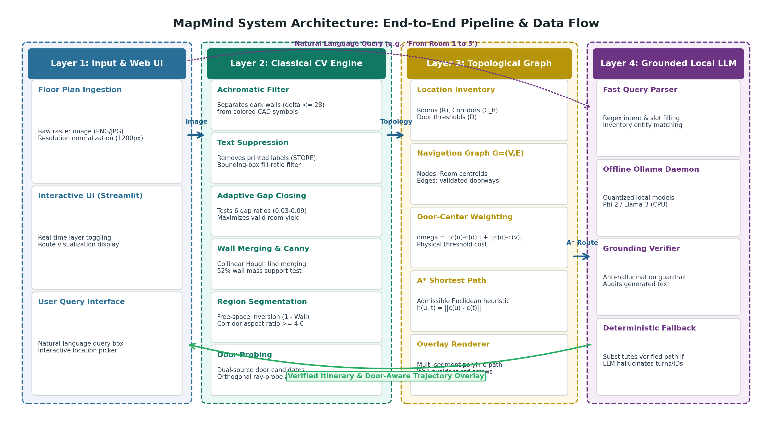
Annexure A — Fig. 1. MapMind system architecture: data flow from raw raster floor plan through classical CV parsing and topological graph synthesis to grounded local-LLM query resolution and door-aware trajectory rendering.

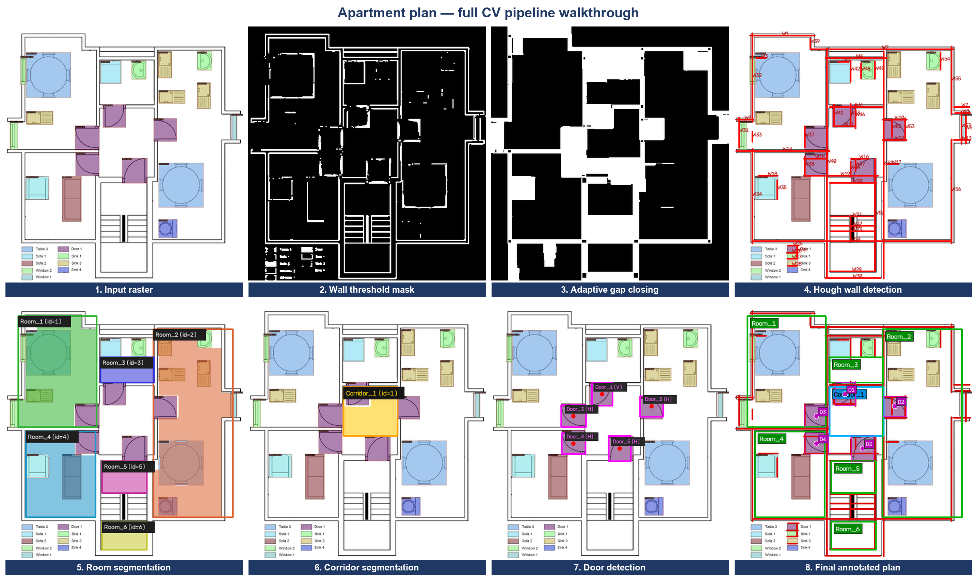
Annexure B — Fig. 2. Complete eight-stage CV pipeline walkthrough on the apartment plan: input raster; wall threshold mask; adaptive candidate-driven gap closing; Hough wall detection; connected-component room and corridor segmentation; door detection; final annotated floor plan.

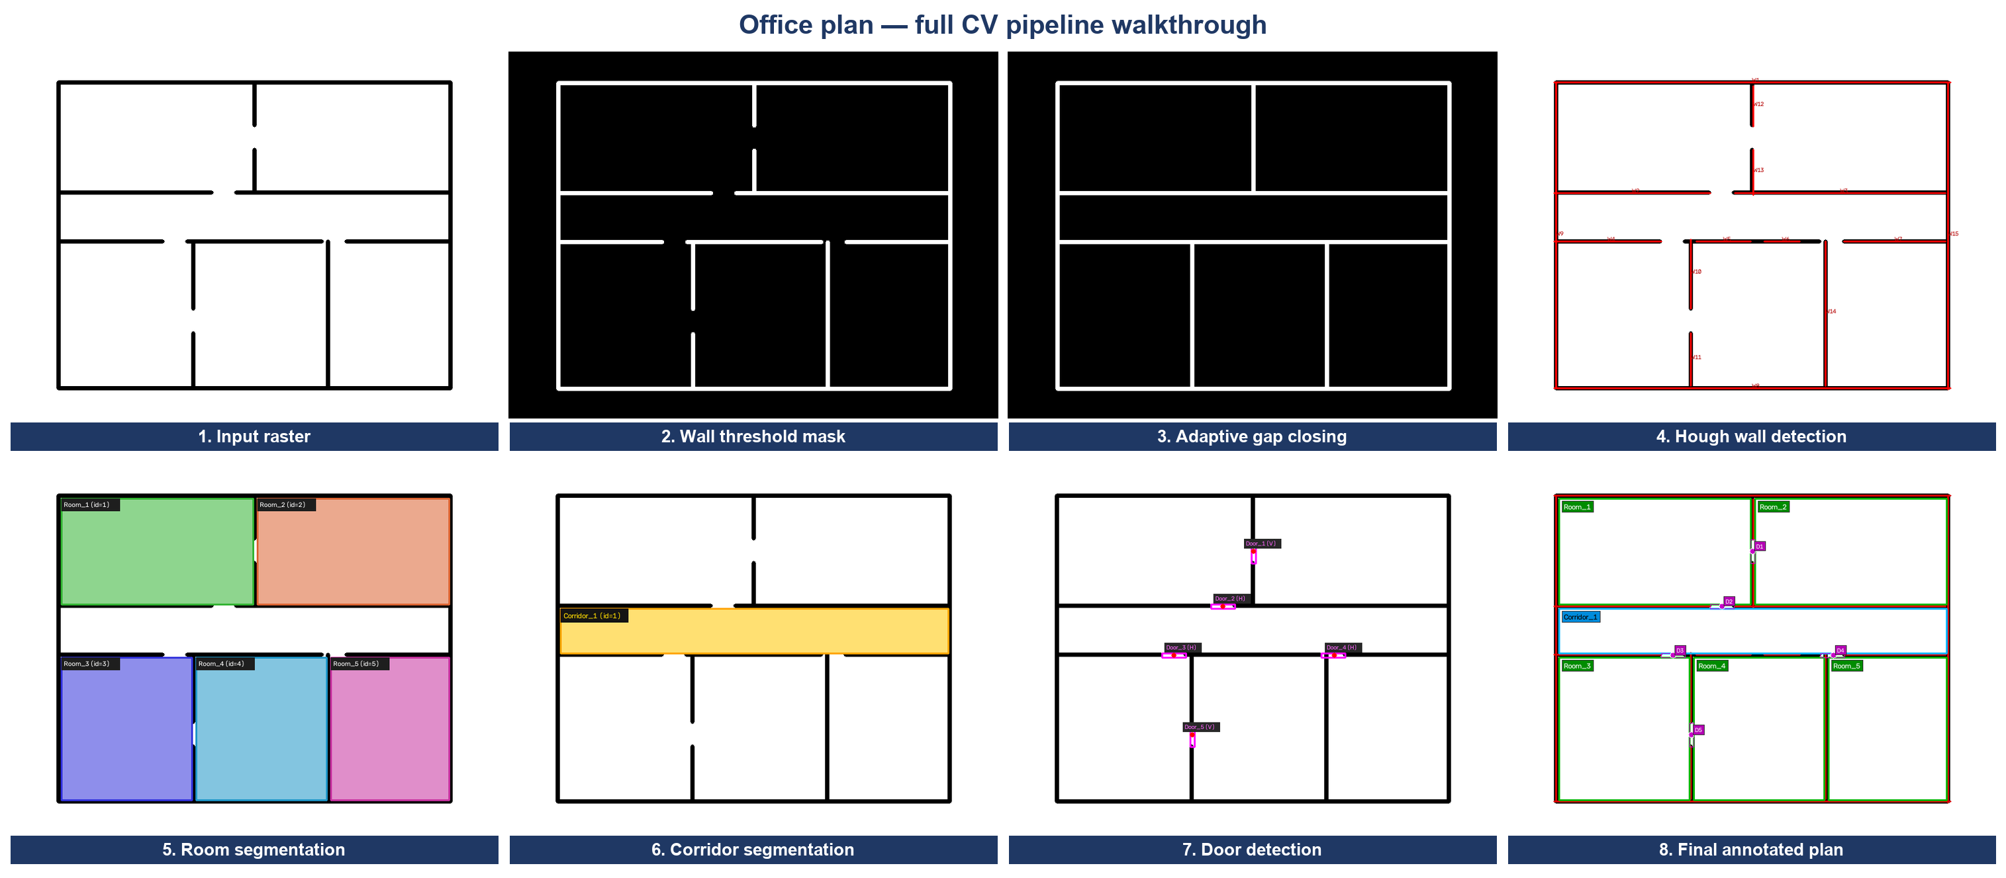
Annexure C — Fig. 3. The same eight-stage pipeline generalising to the office plan with identical default parameters.

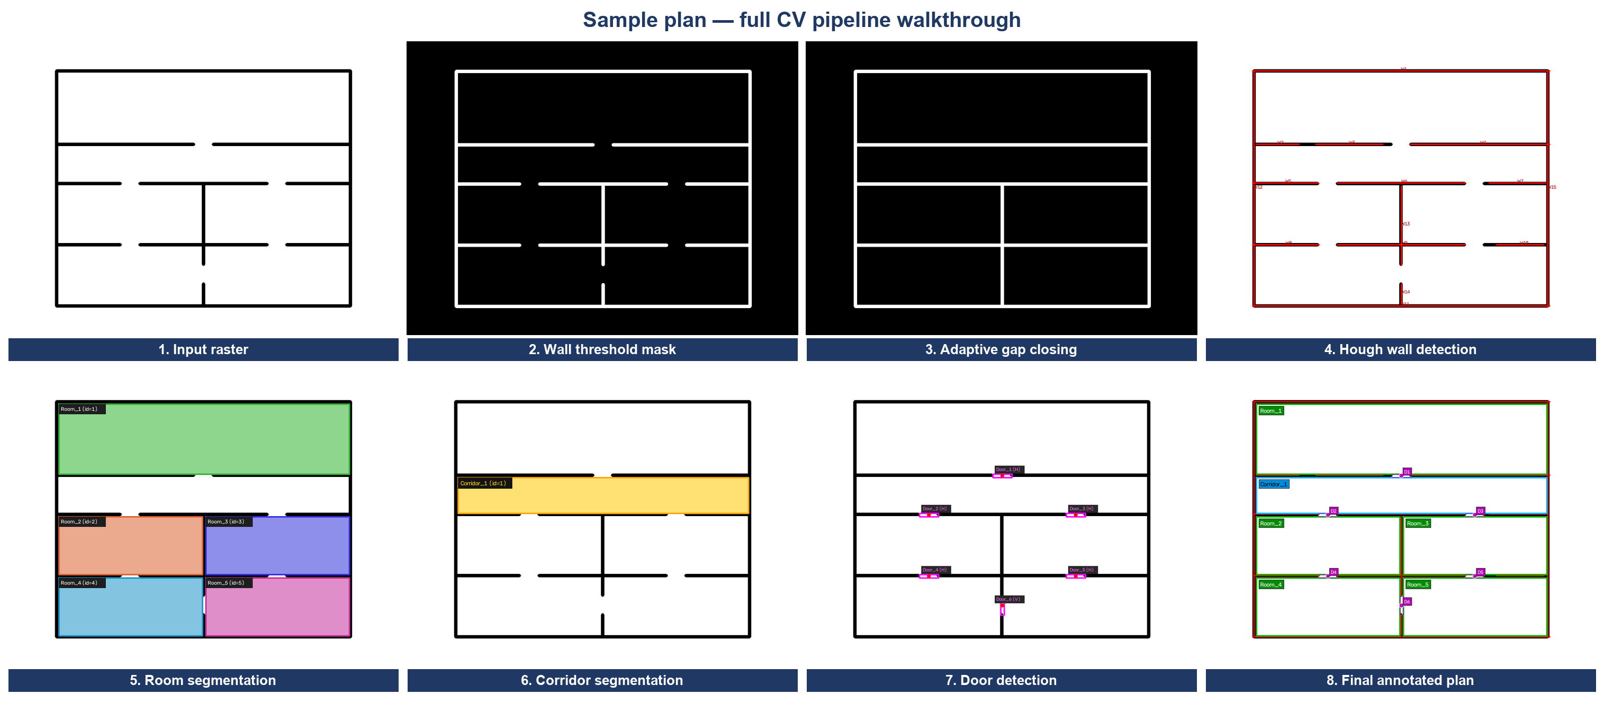
Annexure D — Fig. 4. The same eight-stage pipeline on the synthetic sample plan (5 rooms + 1 corridor).

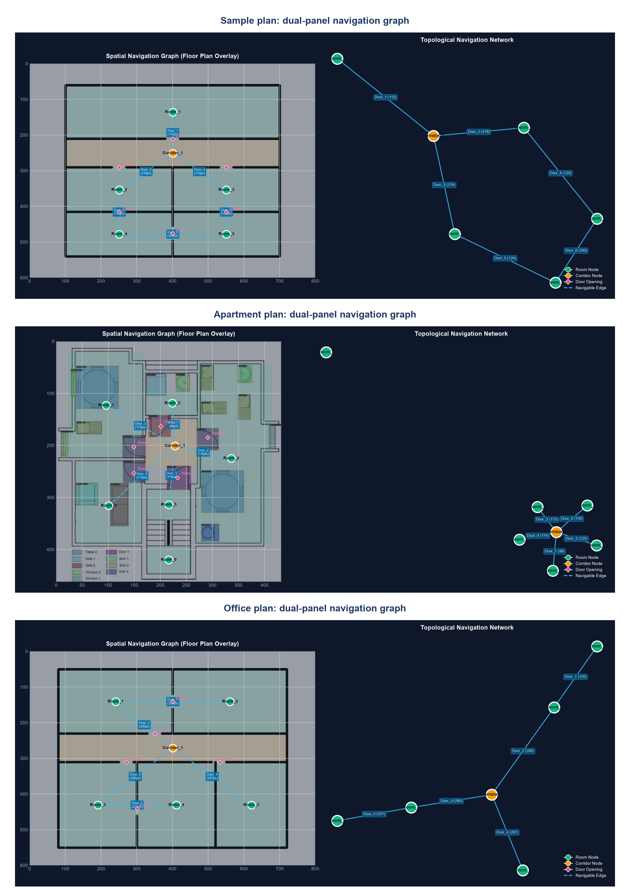
Annexure E — Fig. 5. Dual-panel navigation graphs for the sample, apartment and office plans: spatial layout with door-aware routes (left) and topological NetworkX structure (right).

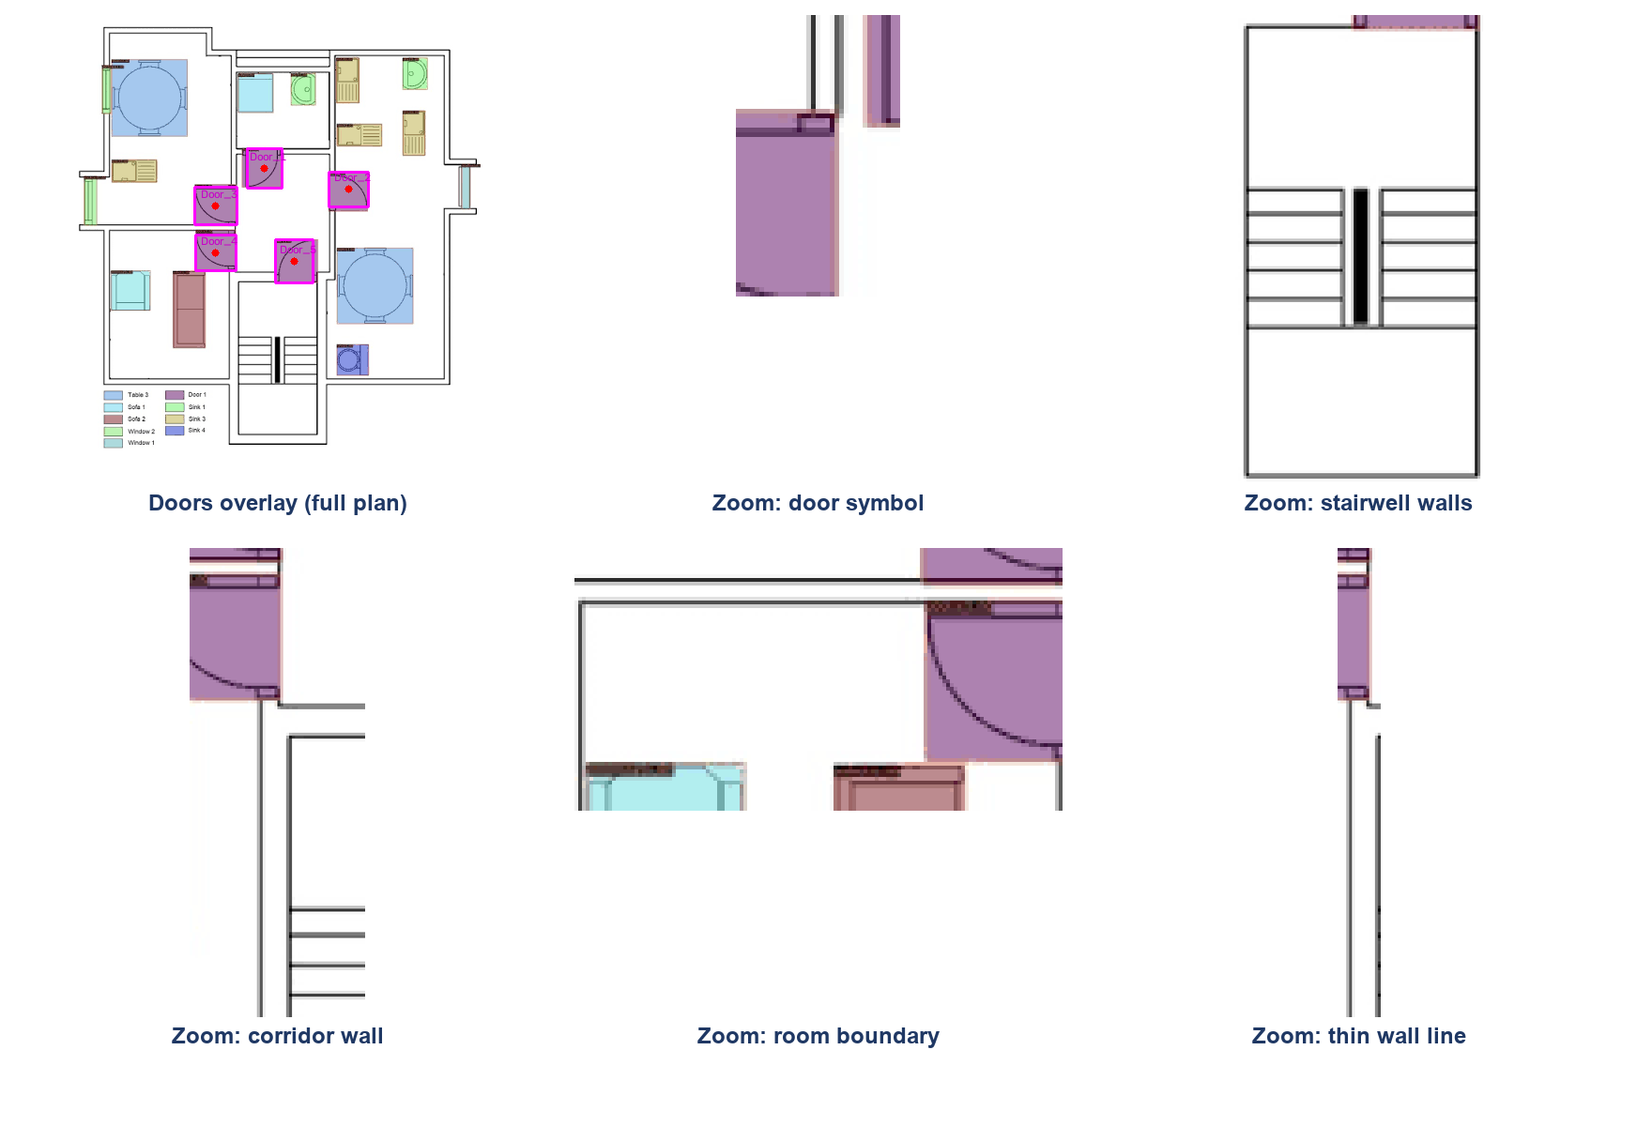
Annexure F — Fig. 6. Feature-level close-ups (nearest-neighbour upscaling): door symbol, stairwell walls, thin corridor wall lines and room boundaries actually detected from the input raster.

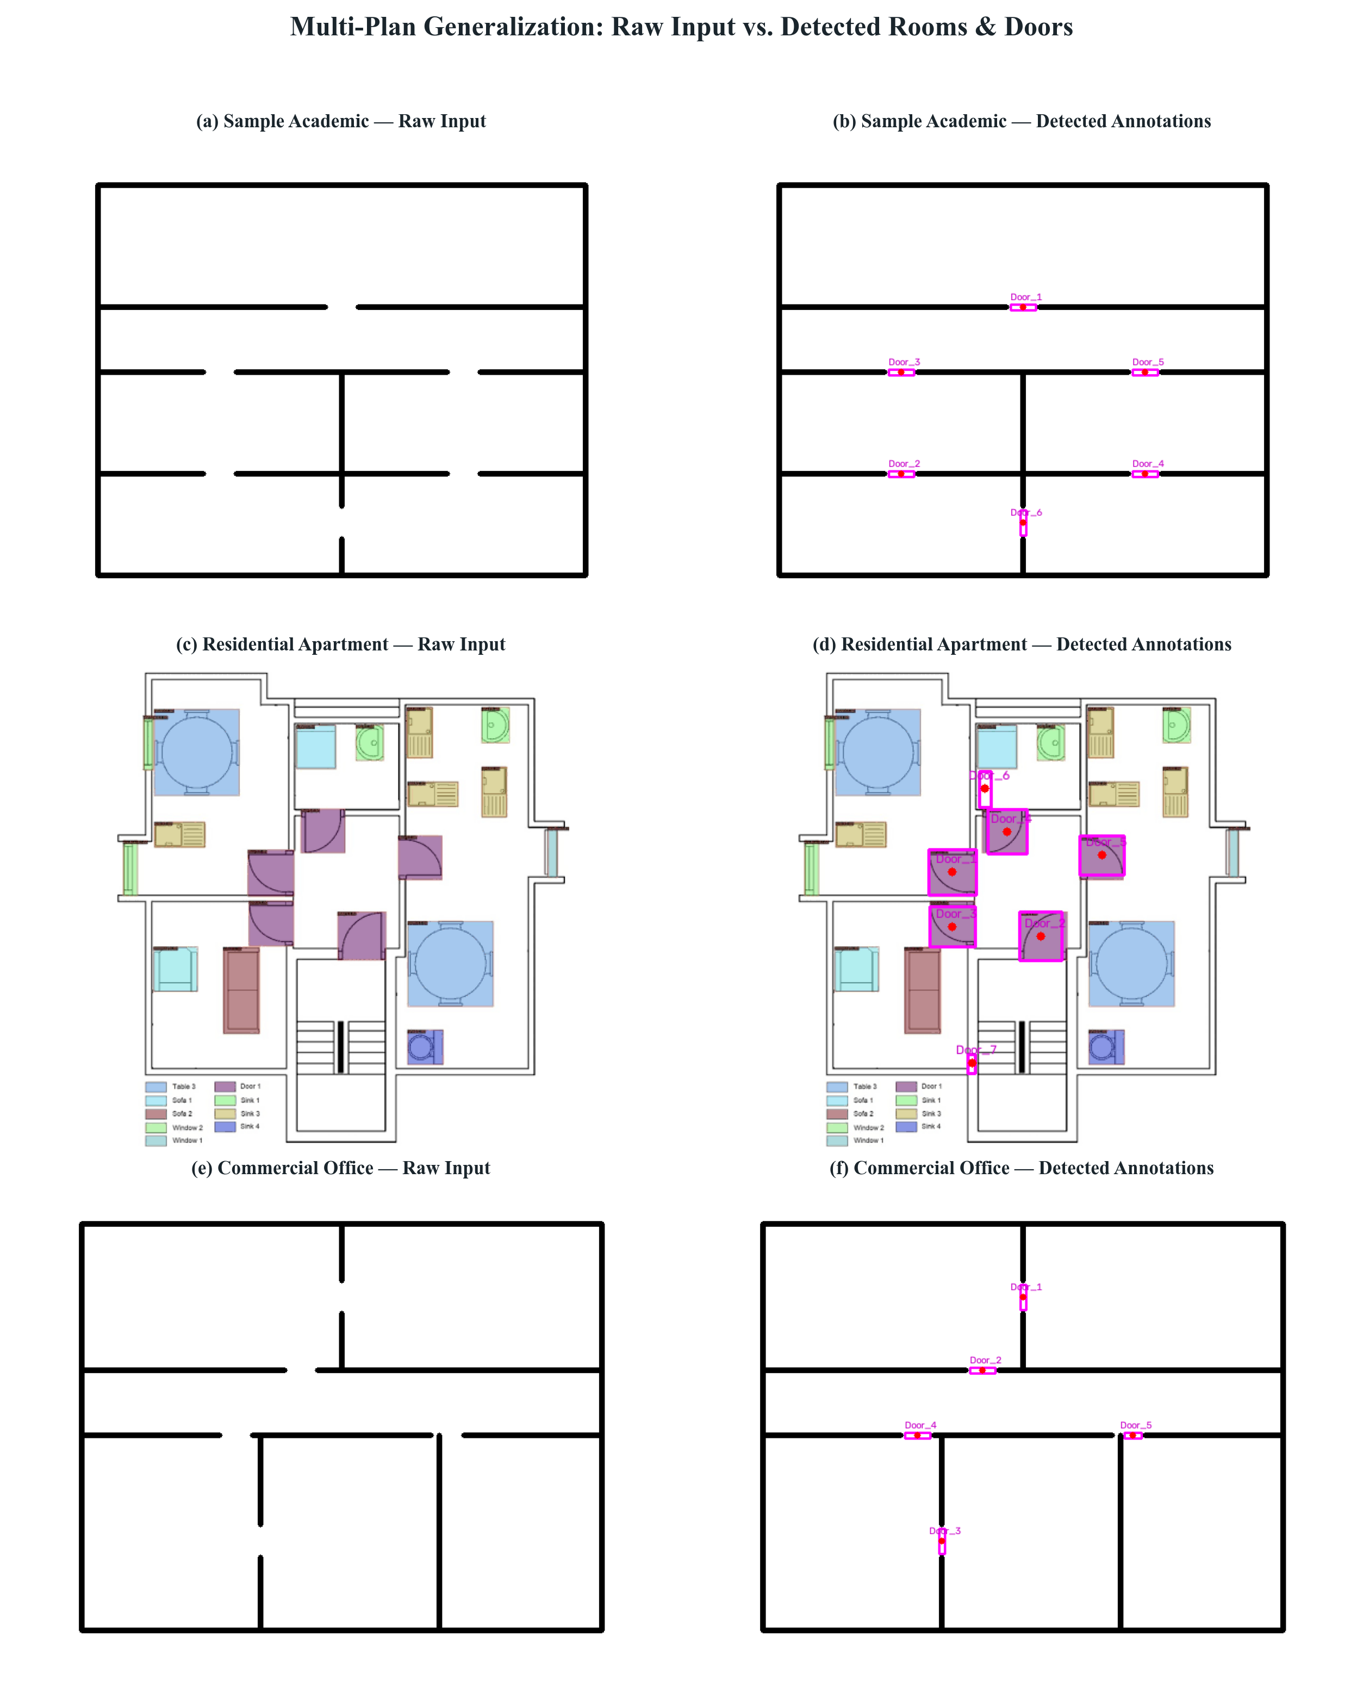
Annexure G — Fig. 7. Generalisation across sample, apartment and commercial-mall plans (units, walls, doors, latency).

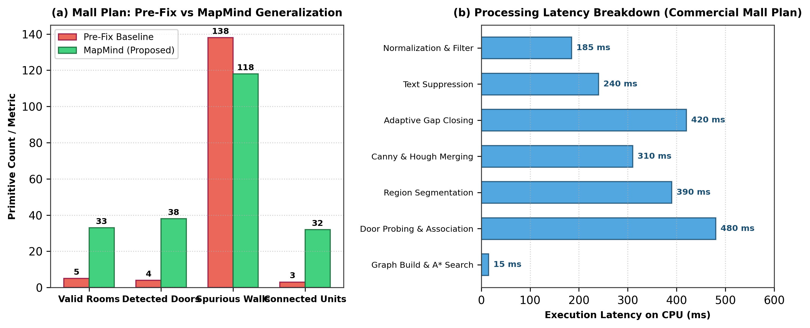
Annexure G — Fig. 8. Quantitative detection results panel (before/after the robustness fixes on the mall plan).

