O(Alpha)
Evaluation Summary and User Testing Readout
Solution suitability, simulated proxy user feedback, and next research plan
Prepared for: O(Alpha) product and submission planning
Date: 8 July 2026
Evidence status: Expert/self evaluation, heuristic walkthrough, and simulated proxy persona review completed
Integrity note: No public launch, real user survey, or actual participant interview has been conducted yet
Recommended claim for the submission
The team used expert/self evaluation, a cognitive walkthrough / heuristic evaluation, and a simulated 10-person proxy persona review. Real participant interviews, low-fidelity tests, surveys, and high-fidelity usability tests are prepared as privacy-safe protocols but should not be marked as completed until fielded with real users.

1. Executive Summary
O(Alpha)'s core paper-trading workflow is understandable and safety-aware: users select a risk profile, run and accept a backtest, launch or terminate a paper agent, and are prevented from changing settings while a portfolio agent is active. The largest product gap is trust calibration. Users need stronger paper-only messaging, visible strategy evidence, and operational freshness indicators before they can confidently judge the system.
- Core workflow health: usable, with average simulated ease of 3.4/5.
- Trust confidence: moderate at 2.9/5, mainly because evidence is not visible enough in the UI.
- Transparency: weakest area at 2.5/5; validation proof is stronger in repo artifacts than in the app screens.
- Safety: active-agent settings lock was the most consistently positive signal, raised by 10/10 proxy personas.
- Top improvement: repeat paper-only / no brokerage orders messaging near Launch Agent, P&L, backtest acceptance, and settings.

2. Evaluation Methods
Method | Status | Select now? | Evidence or next step
Expert / self evaluation | Completed | Yes | Review of docs, frontend flows, safety behavior, and validation story.
Cognitive walkthrough / heuristic evaluation | Completed | Yes | Task walkthrough across onboarding, dashboard, launch/terminate, settings, and evidence discovery.
Simulated user focus group | Completed, simulated | Yes, labelled simulated | Ten proxy personas; six from parallel subagent reviews and four local synthetic personas.
Actual user focus group / interview | Not conducted | No | Private 10-person protocol prepared for future fielding.
Low-fidelity usability testing | Not conducted | No | Figma/wireframe task protocol prepared.
Survey of potential users | Not fielded | No | 50-person survey plan and item bank prepared.
High-fidelity usability testing | Not conducted with real users | No | Seeded-account working prototype protocol prepared.
Table 1. Evaluation method status. The actual-user methods are ready to field but not yet completed.

3. Data Snapshot
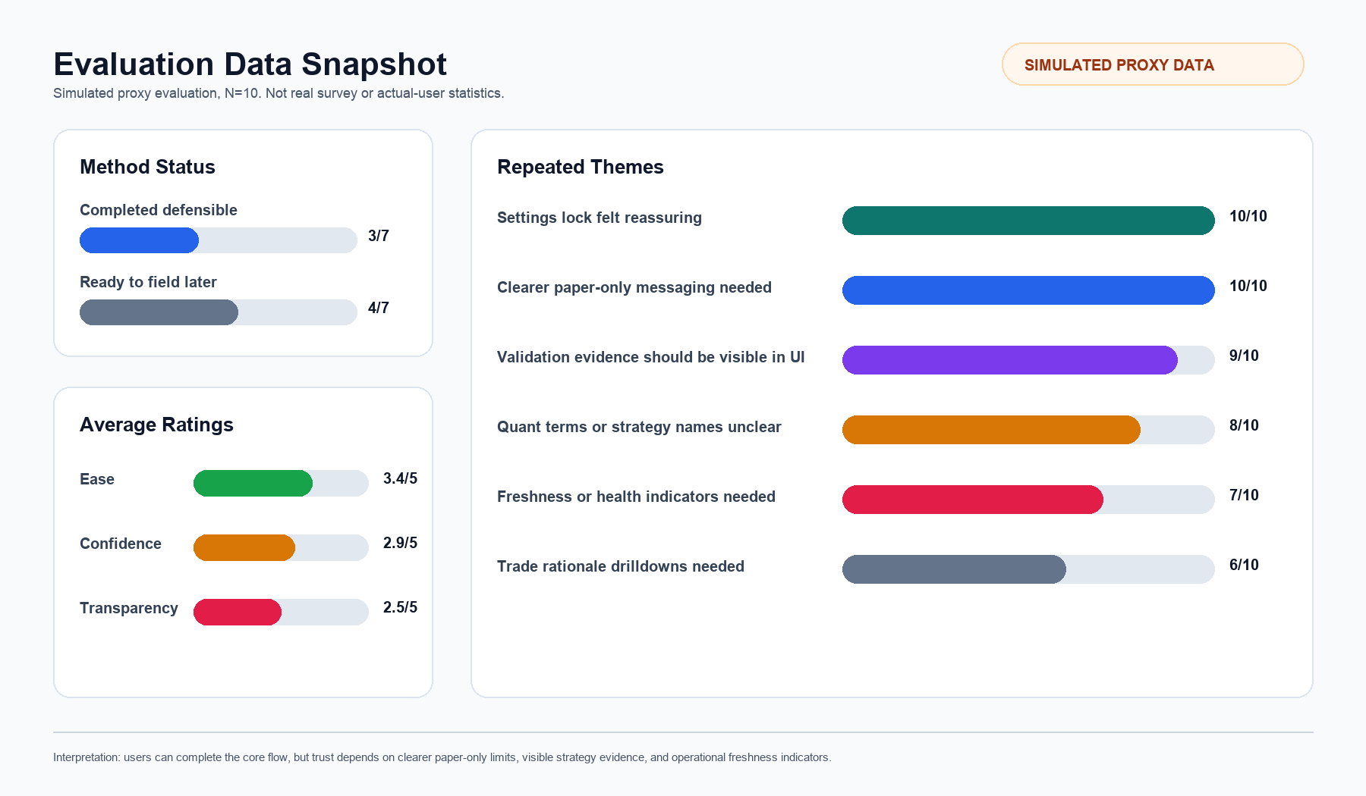
Figure 1. Summary visualization from simulated proxy evaluation data, N=10. Not real survey statistics.
Metric | Value | Meaning
Completed defensible methods | 3 / 7 | Expert/self evaluation, cognitive walkthrough, simulated user focus group.
Ready-to-field methods | 4 / 7 | Actual users, low-fi usability, survey, and high-fi usability protocols prepared.
Average ease rating | 3.4 / 5 | Users can likely complete the core flow.
Average confidence rating | 2.9 / 5 | Trust is moderate and needs stronger proof.
Average transparency rating | 2.5 / 5 | Evidence visibility and explanation are the biggest weaknesses.
Paper-only clarity requested | 10 / 10 | All proxy personas wanted clearer no-live-orders messaging.
Strategy evidence requested | 9 / 10 | Most proxy personas wanted DSR, PBO, benchmark, and report provenance in the UI.
Table 2. Headline data from the simulated proxy review and evaluation plan.

4. Evaluation Findings By Method

4.1 Expert / Self Evaluation
The expert review found that O(Alpha) is suitable as a controlled paper-trading prototype and research-to-paper workflow demo. It should not be presented as a live-trading product or as self-evidently validated without stronger in-product evidence surfaces.
Feature | Rating | Analysis | Suggested improvement
Product scope | 4/5 | Research and paper trading scope is clearly safer than live trading. | Repeat paper-only scope near risky-feeling actions.
Onboarding | 3.5/5 | Risk profile, strategy choice, backtest, and acceptance create a coherent setup path. | Explain what the backtest does and does not prove.
Settings safety | 4.5/5 | Active-agent settings lock is strong and consistent with fail-closed safety. | Keep backend as source of truth; add user-friendly reason copy.
Dashboard observability | 3/5 | Dashboard categories are right, but freshness and health state are not prominent enough. | Add latest bar date, last snapshot, heartbeat, and stream state.
Strategy evidence | 2.5/5 | Validation evidence is mostly in docs/reports instead of user-facing cards. | Add evidence drawer with DSR, PBO, benchmark, OOS trades, costs, and report path.

4.2 Cognitive Walkthrough / Heuristic Evaluation
Task / heuristic | Rating | Analysis | Suggested improvement
Onboarding completion | 3.5/5 | Users can select a risk profile, choose a matching strategy, run a backtest, and accept it. | Add beginner explanations for risk, Sharpe, Max DD, and historical simulation limits.
Agent launch / terminate | 4/5 | The main action is understandable and the lifecycle model is clear. | Add paper-only badges beside Launch Agent and portfolio value.
Settings while active | 4.5/5 | Settings are locked while a portfolio agent is running, preventing confusing mid-run changes. | Keep controls disabled and add concise reason text.
Evidence discovery | 2/5 | Users must leave the product to verify promotion artifacts and report lineage. | Add report links and validation metadata directly to strategy cards.
Dashboard status | 3/5 | The dashboard shows portfolio categories but not enough stale/error/last-updated state. | Add freshness, active run ID, heartbeat, and stream status.
Copy clarity | 3/5 | Some labels are polished but less direct than users need. | Use plain labels such as Save settings, Saving, Settings locked, and Run backtest.

5. Simulated User / Persona Testing
Evidence boundary
The table below represents simulated proxy personas, not actual users. It is useful for planning product improvements and future research, but it should not be labelled as real user testing.

Ratings below are overall averages across ease, confidence, and transparency signals.
User / persona | Feature tested | How they felt | Analysis | Suggestions for improvement
Beginner paper trader | Onboarding, dashboard, launch | 3.3/5 | Could complete onboarding and launch a paper agent, but was unsure about Sharpe, Max DD, h63, LGBM, and demo/live distinction. | Add tooltips and visible Paper only / no brokerage orders labels.
Risk-aware retail investor | Strategy proof, trades, settings | 2.7/5 | Liked safety boundaries but could not fully verify strategy quality from the UI. | Add evidence-aware strategy cards and trade audit drawers.
Quant hobbyist | Backtest evidence, catalog proof | 3.0/5 | Understood the workflow but wanted DSR, PBO, costs, benchmarks, and report links. | Show Promote, DSR, PBO, benchmark, OOS trades, costs, and report path.
Skeptical product manager | Onboarding narrative, proof | 3.0/5 | Saw a coherent product story but felt proof was mostly in docs rather than screens. | Add a plain-language proof panel after onboarding and on the dashboard.
Reliability-focused engineer | Lifecycle, health, failure state | 3.3/5 | Trusted the settings lock, but wanted more operational diagnostics. | Add last refresh, active run ID, heartbeat, stream state, and failure reason.
Finance student | Learning, backtest interpretation | 3.0/5 | Found onboarding approachable but might read Accept Backtest as this strategy is good. | Change acceptance copy to acknowledge historical paper simulation limits.
Compliance-minded reviewer | Claims, disclaimers, audit trail | 2.5/5 | Wanted claims to match artifact-backed evidence and paper-only limits. | Add compliance-safe no-advice, no-live-order, and artifact lineage labels.
Active trader / power user | Trade activity, exports, drilldowns | 2.8/5 | Wanted faster inspection of trades, alerts, and allocation changes. | Add trade detail drawer with target weight, previous/current position, fill price, timestamp, and related alert.
Cautious nontechnical saver | Safety, plain language | 2.7/5 | Liked guardrails but felt the product was technical and could over-trust the backtest. | Add plain-language safety mode and clearer empty/demo states.
Privacy-conscious evaluator | Seeded demo, reproducibility | 3.0/5 | Wanted to review without exposing personal financial data. | Create deterministic demo script with seeded users and paper-only portfolios.

6. Theme Counts And Product Interpretation
Theme | Proxy count | Product interpretation
Settings lock felt reassuring | 10 / 10 | Keep the active-agent safety guardrail as a core product proof point.
Clearer paper-only messaging needed | 10 / 10 | Repeat no-live-orders language near every risky-feeling action.
Validation evidence should be visible in UI | 9 / 10 | Expose strategy proof rather than requiring users to inspect repo reports.
Quant terms or strategy names unclear | 8 / 10 | Add tooltips and beginner-mode explanations.
Freshness or health indicators needed | 7 / 10 | Make backend freshness, stream status, latest bar date, and heartbeat visible.
Trade rationale drilldowns needed | 6 / 10 | Explain why a simulated trade happened and how allocation changed.

7. Recommended Improvements
Priority | Area | Recommendation | Reason
P0 | Paper-only clarity | Add persistent Paper only / no brokerage orders labels near Launch Agent, P&L, onboarding backtest acceptance, and settings. | Reduces accidental over-trust and improves evaluator confidence.
P0 | Strategy evidence | Add evidence-aware cards or drawers with promotion status, DSR, PBO, benchmark, OOS trades, cost stress, report path, and model artifact requirements. | Brings the project's strongest validation story into the product UI.
P1 | Demo and empty states | Replace realistic fallback values with explicit demo, unavailable, or empty states. | Prevents missing backend state from looking like real performance.
P1 | Dashboard health | Show latest bar date, last portfolio snapshot, last agent evaluation, active run ID, heartbeat, and stream connection state. | Improves reliability trust and operational transparency.
P1 | Trade audit drawer | Show triggering strategy, target weight change, previous/current position, simulated fill price, timestamp, and related alert. | Answers the common why did this happen question.
P2 | Education layer | Add tooltip explanations for Sharpe, Max DD, DSR, PBO, active sleeve, regime, LGBM, h63, leverage, stop-loss, and take-profit. | Makes the product more approachable for beginner users.

8. Future Real-Participant Research Plan
Method | Target sample | Privacy-safe setup | Status
Actual user focus group / interviews | 10 participants | 45-60 minute private sessions with seeded demo accounts; no real portfolio data. | Not completed.
Low-fidelity usability testing | 5-8 participants | Figma or wireframe tests for onboarding, evidence drawer, dashboard status, and settings lock. | Not completed.
Survey of potential users | 50 respondents | Private survey covering trust, safety expectations, strategy evidence, and feature priorities. | Not fielded.
High-fidelity usability testing | 8-12 participants | Working prototype with seeded account; measure task success, assists, trust, safety comprehension, and SUS. | Not completed.
The best next evidence step is a private high-fidelity usability test with five real participants using seeded accounts. This would provide stronger evidence than additional simulated personas while avoiding public launch and protecting privacy.

9. Simulated Proxy Survey Results
Evidence boundary
The results below come from a simulated 50-person proxy survey run through subagents. They are useful as fast product-planning and investor-narrative signals, but they are not real survey responses and should not be represented as actual user research.

The proxy survey was segmented into 20 beginner/intermediate potential users, 15 risk-aware or technical potential users, and 15 evaluator/compliance/finance-student personas. Ratings are weighted by segment size.
Simulated survey metric | Weighted result | Interpretation
Concept clarity | 4.1 / 5 | The concept is easy to understand when framed as research-first paper trading.
Paper-only understanding | 4.4 / 5 | The paper-only positioning lands well and should be repeated visually in product.
Trust after safety guardrails | 4.1 / 5 | Active-agent locks and no-live-trading positioning are strong trust builders.
Desire for validation evidence | 4.7 / 5 | Report-backed strategy evidence is the strongest conversion driver.
Interest in beginner education | 4.2 / 5 | Guided explanations remain valuable, especially for beginner and student audiences.
Likelihood to try private demo | 3.9 / 5 | Private demo interest is positive but depends on clarity, simplicity, and proof.
Proxy segment | N | Segment signal
Beginner/intermediate investing users | 20 | Concept clarity 4.1; paper-only 4.4; trust 4.2; validation evidence 4.6; education 4.5; demo likelihood 3.9.
Risk-aware / technical users | 15 | Concept clarity 4.1; paper-only 4.5; trust 4.3; validation evidence 4.8; education 3.7; demo likelihood 4.0.
Evaluator / compliance / finance-student users | 15 | Concept clarity 4.1; paper-only 4.4; trust 3.9; validation evidence 4.7; education 4.3; demo likelihood 3.8.
Strongest positive signal: the product is compelling when positioned as a paper-only research lab with visible safety controls and report-backed strategy evidence. Main funding-readiness gap: actual demo usage, real participant feedback, and credible proof that users return after the first session.
- Simulated quote: "The safety-lock framing makes it feel more like a research lab than a trading bot, which is the right direction."
- Simulated quote: "Report-backed validation is the part I care about most. Show me the evidence and I'll spend time with it."
- Simulated quote: "If it stays clearly paper-only and teaches the reasoning behind strategies, I can see this being useful for finance students without encouraging risky behavior."

10. Potential User Survey Instrument
Survey status
A real potential-user survey has not been fielded yet. The instrument below is ready to use with 50 real potential users, but real-world results should only be reported after actual responses are collected and anonymized.

Module | Survey item | Response type | Why it matters
Screener | How would you describe your investing or trading experience? | Beginner / intermediate / advanced / none | Segments results by experience level.
Screener | Have you used a paper-trading, investing, or backtesting tool before? | Yes / no | Separates familiar users from first-time users.
Concept clarity | I understand that O(Alpha) is for paper trading only. | 1-5 agreement | Checks whether the safety scope is understood.
Trust | I would want to see validation evidence before launching an automated strategy. | 1-5 agreement | Tests demand for report-backed proof.
Reverse-coded trust | A five-year backtest alone is enough for me to trust a strategy. | 1-5 agreement | Flags over-trust in simple backtests.
Safety concern | I am concerned about accidentally placing real trades. | 1-5 agreement | Measures need for stronger no-live-orders messaging.
Evidence | I would find DSR, PBO, benchmark, and report links useful on strategy cards. | 1-5 agreement | Validates the evidence-card roadmap.
Education | I would use short explanations for terms like Sharpe, drawdown, PBO, and DSR. | 1-5 agreement | Validates beginner education features.
Dashboard value | Rank the most important dashboard information. | Ranking | Prioritizes P&L, positions, trades, alerts, strategy proof, and data freshness.
Open response | What would make you trust this product more? | Open text | Captures unmet trust requirements.
Open response | What would make you stop using this product? | Open text | Captures blockers and safety concerns.

11. Honest Rating Positioning For Submission
The current ratings should remain as recorded. A stronger funding or submission story can still be made by separating current evidence from target outcomes after the recommended improvements. The target column below is a roadmap goal, not a claimed result.
Metric | Current evidence | Target after improvements | How to earn the target
Ease | 3.4 / 5 | 4.0+ / 5 | Add tooltips, clearer backtest acceptance copy, and beginner-mode explanations.
Confidence | 2.9 / 5 | 4.0+ / 5 | Surface paper-only labels, proof panels, and report-backed strategy evidence.
Transparency | 2.5 / 5 | 4.1+ / 5 | Add DSR, PBO, benchmark, OOS trades, costs, report path, and dashboard freshness indicators.
Simulated survey appeal | 4.1-4.7 / 5 | Validate with real users | Field the prepared 50-person survey and compare real responses to the proxy benchmark.
Safety clarity | 10 / 10 proxy theme | Maintain 10 / 10 | Keep active-agent lock, backend fail-closed guard, and explicit no-live-order messaging.

Appendix: Source Artifacts
- docs/evaluation/solution_suitability_evaluation_2026-07-05.md
- docs/evaluation/solution_suitability_visual_summary_2026-07-05.md
- docs/evaluation/solution_suitability_metrics_2026-07-05.csv
- docs/evaluation/solution_suitability_charts_2026-07-05.svg
- docs/evaluation/simulated_proxy_survey_results_2026-07-08.csv
- docs/evaluation/potential_user_survey_questionnaire_2026-07-08.csv
- README.md, docs/submission/OALPHA_README.md, onboarding, dashboard, settings, activity, and strategy catalog evidence files.

