National University of Singapore

CS1101S — Programming Methodology
AY2024/2025 Semester 1
Final Assessment
Time allowed: 2 hours
SOLUTIONS

INSTRUCTIONS
- This QUESTION PAPER contains 25 Questions in 10 Sections, and comprises 24 printed pages, including this page.
- The ANSWER SHEET comprises 6 printed pages.
- Use a pen or pencil to write your Student Number in the designated space on the front page of the ANSWER SHEET, and shade the corresponding circle completely in the grid for each digit or letter. DO NOT WRITE YOUR NAME!
- You must submit only the ANSWER SHEET and no other documents. Do not tear off any pages from the ANSWER SHEET.
- All questions must be answered in the space provided in the ANSWER SHEET; no extra sheets will be accepted as answers.
- Write legibly with a pen or pencil (do not use red color). Untidiness will be penalized.
- For multiple choice questions (MCQ), shade in the circle of the correct answer completely.
- The full score of this assessment is 100 marks.
- This is a Closed-Book assessment, but you are allowed to bring with you one double-sided A4 / letter-sized sheet of handwritten or printed notes.
- Where programs are required, write them in the Source §4 language. A reference of some of the pre-declared functions is given in the Appendix of the Question Paper.
- In any question, unless it is specifically allowed, your answer must not use functions given in, or written by you for, other questions.

Section A: Orders of Growth [11 marks]

(1) [2 marks] (MCQ)
What is the order of growth in space of the function func1?

function func1(n) {
return n <= 1 ? n : func1(n - 1) + func1(n - 1);
}

A. | Θ(1) | E. | Θ(n ³ )
B. | Θ(log n) | F. | Θ(n log n)
C. | Θ(n) (answer) | G. | Θ(2^{n} )
D. | Θ(n ²) | H. | Θ(n^{1/2} )

(2) [3 marks] (MCQ)
What is the order of growth in time of the above function func1?

A. | Θ(1) | E. | Θ(n ³ )
B. | Θ(log n) | F. | Θ(n log n)
C. | Θ(n) | G. | Θ(2^{n} ) (answer)
D. | Θ(n ²) | H. | Θ(n^{1/2} )

(3) [3 marks] (MCQ)
What is the order of growth in space for applications func2(arr, 0) with respect to the length n of arr?

function func2(arr1, i) {
const len = array_length(arr1);
if (i === len) {
return 0;
} else {
let arr2 = [];
for (let j = 0; j <= len; j = j + 1) {
arr2[j] = arr1[j];
}
return arr2[i] + func2(arr1, i + 1);
}
}

A. | Θ(1) | E. | Θ(n ³ )
B. | Θ(log n) | F. | Θ(n log n)
C. | Θ(n) | G. | Θ(2^{n} )
D. | Θ(n ²) (answer) | H. | Θ(n^{1/2} )

(4) [3 marks] (MCQ)
What is the order of growth in time for applications func2(arr, 0) with respect to the length n of arr?
A. | Θ(1) | E. | Θ(n ³ )
B. | Θ(log n) | F. | Θ(n log n)
C. | Θ(n) | G. | Θ(2^{n} )
D. | Θ(n ²) (answer) | H. | Θ(n^{1/2} )

Section B: Recursion [11 marks]

(5) [5 marks]

Complete the declaration of the function is_prefix, which takes as arguments a list xs and a list ys and returns true if xs is a prefix of the list ys, (i.e. if ys starts with all elements of xs in the same order) and returns false otherwise. You can assume that ys is a non-empty list.
For example,

is_prefix(null, list(1, 2, 3)); // returns true
is_prefix(list(1, 2), list(1, 2, 3)); // returns true
is_prefix(list(2, 3), list(1, 2, 3)); // returns false
is_prefix(list(1, 3), list(1, 2, 3)); // returns false
is_prefix(list(1, 2, 3), list(1, 2, 3)); // returns true

Write your answer only in the dashed-line box(es).

function is_prefix(xs, ys) {

return is_null(xs) ? true

: !is_null(ys) && head(xs) === head(ys)

? is_prefix(tail(xs), tail(ys))

: false ;

}

(6) [3 marks] (MCQ)
What type of process does the function z does give rise to for i = 0 and j = null, when k grows bigger and bigger?

function z(i, j, k) {
return i > k ? j : z(i + 1, pair(j, i), k);
}

A. | An iterative process (answer)
B. | A recursive process
C. | Not enough information to determine.

(7) [3 marks] (MCQ)
What type of process does the function g give rise to for growing integers x?

function g(x) {
const f = (x, y) => x;
return x === 0 ? f : g(x - 1)(f, x);
}

A. | An iterative process
B. | A recursive process (answer)
C. | Not enough information to determine.

Section C: Higher Order Functions [7 marks]

(8) [2 marks]

Implement the function logging_function that takes a unary function fn and a string log, and returns a new logging function. This new function, when called with an argument, should return a pair whose head is the result of applying fn to the argument and the tail is the log string. For example,

const add_one = logging_function(x => x + 1, "+1");
const multiply_two = logging_function(x => 2 * x, "*2");
add_one(1); // returns [2, "+1"]
multiply_two(2); // returns [4, "*2"]

Write your answer only in the dashed-line box(es).

function logging_function(fn, log) {

return x => pair(fn(x), log);
}

(9) [5 marks]

Implement the function compose that takes two unary “logging functions” (as in the above question) fn1 and fn2, and returns a new function. This new function, when called with an argument x, should return a pair whose head is the result of applying fn2(fn1(x)) and the tail is a concatenated string of the logs from both functions.
For example,

const f1 = compose(add_one, add_one);
f1(1); // returns [3, "+1+1"]
const f2 = compose(add_one, multiply_two);
f2(1); // returns [4, "+1*2"]
const f3 = compose(f2, multiply_two);
f3(1); // returns [8, "+1*2*2"]

Write your answer only in the dashed-line box(es).

function compose(fn1, fn2) {
function wrapper(x) {

const a = fn1(x);

const b = fn2(head(a));

return pair(head(b), tail(a) + tail(b));

}
return wrapper;
}
Section D: Tombstone Diagrams [6 marks]

(10) [6 marks]

You are tasked with reviving the classic game Super Mario Bros., originally developed for the Nintendo Entertainment System (NES), an iconic but now obsolete gaming console. Your goal is to enable this game to run on the latest PlayStation 5 (PS5) console.
Since NES's hardware uses custom 6502 assembly language, simply transferring the game to the PS5 is not straightforward. To make this possible, you are considering two primary approaches: I) using a hardware emulator to mimic the NES hardware and II) translating the assembly code using compilers or interpreters.
- You found a hardware emulator for 6502 written in JavaScript. PS5 has an inbuilt JavaScript interpreter.
- You are keen to run the game natively in PS5 hardware. Propose a method to achieve this. You have access to one compiler of your choosing. You also have access to an x86 PC for the compilation.
Show the tombstone diagrams for both solutions. Include the final execution step, showing how the code, once processed through the emulator, interpreter, or compiler, is executed on the actual processor of the modern machine.

I.
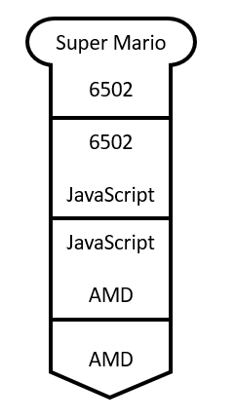
PS5
PS5
II.

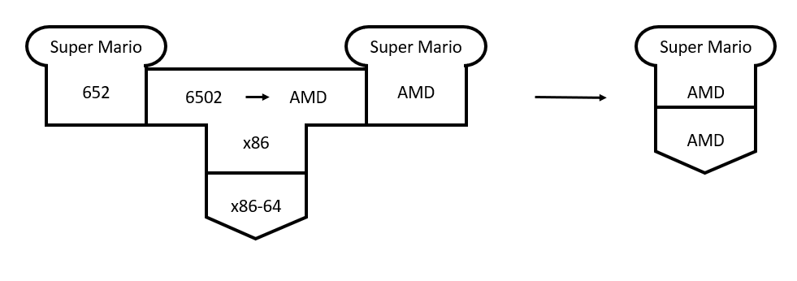
PS5
PS5
PS5
PS5

Section E: Binary Trees [13 marks]

A binary tree is either empty or has an entry, a left branch and a right branch, where the entry is a number and the left and right branches are binary trees.

The root node of a binary tree is at depth 0. The right branch and the left branch of the root node are at depth 1 and so on.

You can access binary trees using only the following functions, which provide the binary tree abstraction:

- is_empty_tree(tree) — Tests whether the given binary tree tree is empty.
- is_tree(x) — Checks if x is a binary tree.
- left_branch(tree) — Returns the left subtree of tree if tree is not empty.
- entry(tree) — Returns the value of the entry of tree if tree is not empty.
- right_branch(tree) — Returns the right subtree of tree if tree is not empty.
- make_empty_tree() — Returns an empty binary tree.
- make_tree(value, left, right) — Returns a binary tree with entry value, left subtree left, and right subtree right.

You must use this abstraction for all the questions in this section, and should not make any assumption about how binary trees are represented and implemented.

(11) [3 marks] (MCQ) [This question has been voided]
Select the correct response to complete the declaration of the function max_depth, which takes as argument a binary tree and returns the maximum depth of the tree.
function max_depth(t) {
if (is_empty_tree(t)) {
return <EXP1>
} else {
return <EXP2>
}
}
<EXP1> | <EXP2>
A. 0 | 1 + max_depth(left_branch(t))  + max_depth(right_branch(t))
B. 0 | math_max(max_depth(left_branch(t)),  max_depth(right_branch(t)))
C. 0 | math_max(1 + max_depth(left_branch(t)),  1 + max_depth(right_branch(t)))
D. 1 | math_max(1 + max_depth(left_branch(t)),  1 + max_depth(right_branch(t)))
E. 1 | math_max(max_depth(left_branch(t)),  max_depth(right_branch(t)))
F. 1 | max_depth(left_branch(t))  + max_depth(right_branch(t)))
G. 1 | - + max_depth(left_branch(t))  + max_depth(right_branch(t))
(12) [5 marks]

Complete the implementation of the count_leaves_at_depths function, which takes as argument a binary tree t and returns an array of length max_depth(t). In the returned array, the value at position i contains the number of leaves at depth i.

function count_leaves_at_depths(tree){
const ans = [];
const max_d = max_depth(tree);

// initialize ans array with zero values for all depths

for(let i = 0; i < max_depth(cadet_names); i = i + 1){
ans[i] = 0;
}

function help(tree, depth) {

if( !is_empty_tree(tree) ){

const left = left_branch(tree);
const right = right_branch(tree);

if (is_empty_tree(left) && is_empty_tree(right)) {
ans[depth] = ans[depth] + 1;
} else {
help(left, depth + 1);
help(right, depth + 1);
}

}
}
help(tree, 0);
return ans;
}

(13) [5 marks]

Monotonically Increasing path (MI-path) is defined as a path in a binary tree, starting at the root node and ending at a leaf node where, every visited node along the path has a value larger than its parent.
Complete the implementation of longest_mi_path, which takes as arguments a tree and returns the length of the longest MI-path in the tree. If there are no MI-paths it should return 0.

You can assume the tree only contains positive integers as entries.

function longest_mi_path(t){

function help(t, p){
if (is_empty_tree(t)){

return 0;

} else {

if (entry(t) > p) {
const ans1 = 1 + help(left_branch(t), entry(t));
const ans2 = 1 + help(right_branch(t), entry(t));
return math_max(ans1, ans2);
} else {
return 0;
}

}
}

return help(t, -1);
}

Section F: Ordering Arrays [10 marks]

In this section, consider the following functions:

function map_array(f, A) {
const len = array_length(A);
for (let i = 0; i < len; i = i + 1) {
A[i] = f(i, A[i]);
}
}

function sort_ascending(A) {
const len = array_length(A);
for (let i = len - 1; i >= 1; i = i - 1) {
for (let j = 0; j < i; j = j + 1) {
if (A[j] > A[j + 1]) {
const temp = A[j];
A[j] = A[j + 1];
A[j + 1] = temp;
}
}
}
}

(14) [5 marks]

Complete the declaration of the function sort_descending, which takes as argument an array of numbers, and sorts the array elements in descending order. For example,

const AA = [3, 9, 2, -5, 1, 6, 5, -2, 3, 8];
sort_descending(AA);
AA; // evaluates to [9, 8, 6, 5, 3, 3, 2, 1, -2, -5]

Your answer must consist of at most three statements, and each statement must be an application of the function map_array or sort_ascending. Write each statement in one of the three dashed-line boxes.

function sort_descending(A) {

map_array((i, x) => -x, A);

sort_ascending(A);

map_array((i, x) => -x, A);

}

(15) [5 marks]

Complete the declaration of the function reverse_array, which takes as argument an array of numbers, where every number x is 0 ≤ x < 1000, and arranges the array elements in reverse order. For example,

const AA = [3, 9, 2, 1, 6, 5, 3, 8];
reverse_array(AA);
AA; // evaluates to [8, 3, 5, 6, 1, 2, 9, 3]

Your answer must consist of at most three statements, and each statement must be an application of the function map_array, sort_ascending, or the function sort_descending from the preceding question. Write each statement in one of the three dashed-line boxes.

function reverse_array(A) {

map_array((i, x) => i * 1000 + x, A);

sort_descending(A);

map_array((i, x) => x % 1000, A);

}

Section G: Tensors [20 marks]

In mathematics and physics, first-order numerical objects are called vectors and second-order objects are called matrices. In this question, the size of a vector specifies how many numbers it contains, so a vector of size 3 has three numbers. We represent vectors using arrays of numbers, whose indices start with 0. Therefore, if V is a vector of size 3, we can access all its components using V[0], V[1], and V[2]. We represent matrices by arrays of arrays of numbers, so we can access the last (bottom right) number of a 5 x 5 matrix M by M[4][4].

The notion of a tensor generalizes the order of numerical objects. A vector is called a first-order tensor, and a matrix is a second-order tensor. We assume that multidimensional tensors are hypercubic: They have a uniform size in every order. A second-order size-5 tensor (matrix) has 5 x 5 = 25 numbers, and a third-order size-4 tensor has 4 x 4 x 4 = 64 numbers. In this question, we assume that the size of a tensor is always greater than or equal to 1. As a special case, any number is considered to be a zero-order tensor of any size greater than or equal to 1. We represent tensors using arrays, whose indices start with 0. Therefore, if T is an order-4 size-3 tensor, T[0][1][2][0] returns a number.

(16) [5 marks]

Write a function make_tensor that takes a non-negative integer n as first argument and an integer k greater than or equal to 1 as second argument and returns an order-n size-k tensor whose numbers are all 0.

Examples:

const t1 = make_tensor(2, 2);
display(t1); // [[0, 0], [0, 0]]

const t2 = make_tensor(4, 3);
display(t2); // [ [ [[0, 0, 0], [0, 0, 0], [0, 0, 0]],
// [[0, 0, 0], [0, 0, 0], [0, 0, 0]],
// [[0, 0, 0], [0, 0, 0], [0, 0, 0]]],
// [ [[0, 0, 0], [0, 0, 0], [0, 0, 0]],
// [[0, 0, 0], [0, 0, 0], [0, 0, 0]],
// [[0, 0, 0], [0, 0, 0], [0, 0, 0]]],
// [ [[0, 0, 0], [0, 0, 0], [0, 0, 0]],
// [[0, 0, 0], [0, 0, 0], [0, 0, 0]],
// [[0, 0, 0], [0, 0, 0], [0, 0, 0]]]]

Only use the provided spaces to complete the function make_tensor.

function make_tensor(n, k) {
if (n === 0) {
return 0;

} else {
const t = [];
for (let i = 0; i < k; i = i + 1) {
t[i] = make_tensor(n - 1, k);
}
return t;

return t;
}
}

(17) [5 marks]

Write a function tensor_write that takes an order-n size-k tensor t, an array of indices idxs, and a number v as arguments and writes v to t at the given position indicated by idxs. You can assume that the size of the array idxs is n and that each element of idxs is a non-negative integer smaller than k. The function tensor_write should return undefined.

Example:

tensor_write(t2, [0, 1, 2, 0], 88); // writes number 88 into tensor t2
// where t2 is as above
display(t2[0][1][2][0]); // displays 88

Only use the provided space to complete the function tensor_write.

function tensor_write(t, indices, v) {

for (let i = 0; i < array_length(indices) - 1; i = i + 1) {
t = t[indices[i]];
}
t[array_length(indices) - 1] = v;

}

(18) [5 marks]
Write a function tensor_order that takes a tensor as argument and returns its order.

Examples:

display(tensor_order(44)); // displays 0
display(tensor_order([6, 5, 4, 3])); // displays 1
display(tensor_order([[1,1], [2,2]]); // displays 2
display(tensor_order(t2)); // displays 4, if t2 as above

Only use the provided space to complete the function tensor_order.

function tensor_order(t) {

return is_number(t)
? 0
: tensor_order(t[0]) + 1;

}

(19) [5 marks]

Write a function tensor_add that takes as arguments two tensors t1 and t2 of the same order and size and returns a tensor of the same order and size in which the numbers in each position are the results of adding the numbers of t1 and t2 at the same position. The function tensor_add must not modify the two argument tensors.

Example:

display(tensor_add(33, 44)); // displays 77
display(tensor_add([[10, 20], [30, 40]], [[1, 2], [3, 4]]));
// displays [[11, 22], [33, 44]]

Only use the provided space to complete the function tensor_add.

function tensor_add(t1, t2) {
if (is_number(t1) && is_number(t2)) {

return t1 + t2;

} else {
const t3 = [];

const len = array_length(t1);
for (let i = 0; i < len; i = i + 1) {
t3[i] = tensor_add(t1[i], t2[i]);
}
return t3;

}
}

Section H: Streams [14 marks]

(20) [3 marks] (MCQ)

What is the result of evaluating the following Source program in list notation?

function add_streams(s1, s2) {
return pair(head(s1) + head(s2),
() => add_streams(stream_tail(s1),
stream_tail(s2)));
}

const strm = pair(1, () => pair(2, () => add_streams(strm, strm)));
eval_stream(strm, 10);

A. | list(1, 2, 2, 4, 8, 16, 32, 64, 128, 256)
B. | list(1, 2, 2, 4, 4, 6, 6, 8, 8, 10)
C. | list(1, 2, 2, 4, 4, 8, 8, 16, 16, 32) (answer)
D. | list(1, 2, 4, 8, 16, 32, 64, 128, 256, 512)
E. | list(1, 2, 4, 6, 8, 10, 12, 14, 16, 18)
F. | list(1, 2, 2, 4, 6, 8, 10, 12, 14, 16)
G. | The program causes an error.

(21) [3 marks] (MCQ)

What is the result of evaluating the following Source program in list notation? (The function add_streams is given in the preceding question.)

const strm =
pair(1, () => pair(2, () => add_streams(strm,
pair(4, tail(strm)))));
eval_stream(strm, 10);

A. | list(1, 2, 5, 6, 9, 10, 13, 14, 17, 18)
B. | list(1, 2, 5, 7, 10, 12, 15, 17, 20, 22)
C. | list(1, 2, 6, 8, 14, 22, 36, 58, 94, 152)
D. | list(1, 2, 5, 3, 7, 8, 10, 15, 18, 25)
E. | list(1, 2, 5, 4, 10, 6, 15, 8, 20, 10)
F. | list(1, 2, 5, 4, 10, 8, 20, 16, 40, 32) (answer)
G. | The program causes an error.

(22) [4 marks] (MCQ)

What is the sequence of values printed by the display function when the following Source program is evaluated? (Refer to the Appendix for the implementation of stream_ref.)

function dpair(x, y) {
display(x);
return pair(x, y);
}
const stm = dpair(1, () => dpair(2, () => dpair(3, () => stm)));
stream_ref(stm, 6);
stream_ref(stm, 6);

A. | 1 2 3 2 3 2 3
B. | 1 2 3 2 3 2 3 2 3 (answer)
C. | 1 2 3 2 3 1 2 3 2 3
D. | 1 2 3 1 2 3 1 2 3
E. | 1 2 3 1 2 3 1 2 3 1 2 3
F. | 1 2 3 2 3 1 2 3
G. | 1 2 3 1 2 3

(23) [4 marks] (MCQ)

Consider the function memo_fun from the lectures:

function memo_fun(fun) {
let already_run = false;
let result = undefined;

function mfun() {
if (!already_run) {
result = fun();
already_run = true;
return result;
} else {
return result;
}
}
return mfun;
}

What is the sequence of values printed by the display function when the following Source program is evaluated? (The function dpair is declared in the preceding question.)

const stm = dpair(1, memo_fun(() => dpair(2, () => dpair(3, () => stm))));
stream_ref(stm, 6);
stream_ref(stm, 6);

A. | 1 2 3 3 3 3 (answer)
B. | 1 2 3 3
C. | 1 2 3 3 1
D. | 1 2 3 3 1 2 3 3
E. | 1 2 3 3 1 2 3 1 2 3 1
F. | 1 2 3
G. | 1 2 3 1 2 3

Section I: Recursive evaluator [3 marks]

Consider the following modified version of the recursive evaluator of the textbook. The changes are highlighted in bold.

function evaluate(component, env) {
return is_literal(component)
? literal_value(component)
: is_name(component)
? lookup_symbol_value(symbol_of_name(component), env)
: is_application(component)
? apply(evaluate(function_expression(component), env),
list_of_values(arg_expressions(component), env),
env)
…
: error(component, "unknown syntax -- evaluate");
}

function apply(fun, args, env) {
if (is_primitive_function(fun)) {
return apply_primitive_function(fun, args);
} else if (is_compound_function(fun)) {
const result = evaluate(function_body(fun),
extend_environment(
function_parameters(fun),
args,
env));
return is_return_value(result)
? return_value_content(result)
: undefined;
} else {
error(fun, "unknown function type -- apply");
}
}

(24) [3 marks] (MCQ)

What is the result of running the following program using this modified evaluator?

const f = x => y => x + y;
const x = 4;
f(2)(3);

A. | 4 | E. | error: unbound name x
B. | 5 | F. | error: unbound name y
C. | 6 | G. | error: unbound name f
D. | 7 (answer) | H. | none of the other options

Section J: CSE machine [5 marks]

The CSE machine includes env instructions to handle environments in function calls. During the execution of call instructions, env instructions are placed on the control so that the environment at the time of the function call is restored when the function returns.

You saw in the lectures that proper tail calls in JavaScript do not create env instructions because the environment at the time of the function call is not needed after the function returns.

Another case when env instructions are not necessary is when the environment to be used for evaluating the function body is the same as the environment at the time of the function call. Consider this example:

const ones_stream = () => pair(1, ones_stream); // 1
const ones = ones_stream(); // 2
head(tail(tail(ones)())()); // 3

The application of ones_stream in line 2 creates the env instruction in the control, shown here just before it is executed.

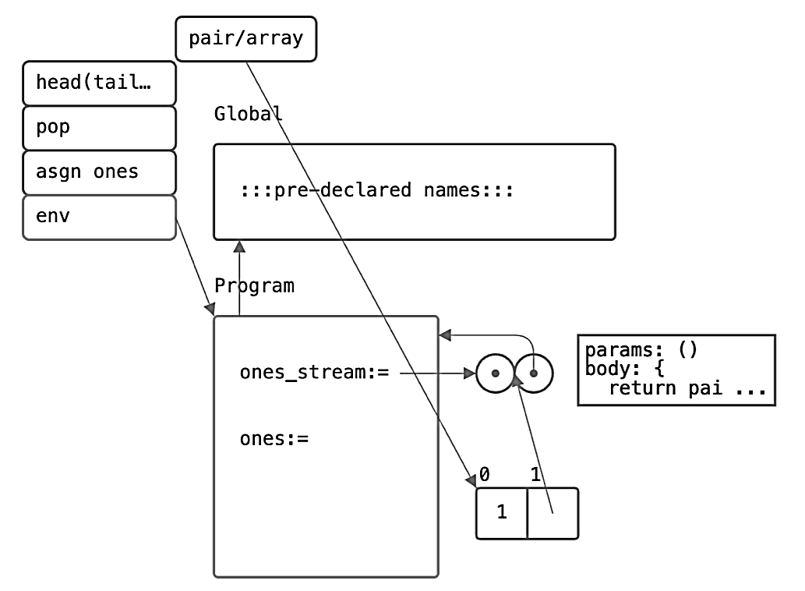

The environment that was used for evaluating the body of ones_stream is the same as the environment that the env instruction is about to restore. The env instruction therefore does nothing: It is unnecessary.

(25) [5 marks]

Modify the CSE machine for simple functions to avoid the creation of unnecessary data structures when the environment to be used for evaluating the function body is the same as the environment at the time of the function call. Only change the program by filling the indicated boxes. Do not make any other modifications. Your modification must not change the result of evaluating any given Source program.

function evaluate(program) {
let C = list(make_block(program));
let S = null; E = the_global_environment;
while (! is_null(C)) {
const command = head(C);
C = tail(C);
if (…) { …
} … else if (is_call_instruction(command)) {
const arity = call_instruction_arity(command);
let args = null; let n = arity;
while (n > 0) {
args = pair(head(S), args);
S = tail(S); n = n - 1;
}
const fun = head(S);
S = tail(S);
if (is_primitive_function(fun)) {
S = pair(apply_primitive_function(fun, args),
S);
} else if (is_simple_function(fun)) {
if (

<condition>

) {

<block>

} else {
C = pair(function_body(fun),
pair(make_env_instruction(E),
C));
E = extend_environment(
function_parameters(fun),
args,
function_environment(fun));
}
} else { error(fun, "unknown function type -- call"); }
…
Implementation of the function extend_environment is available in the appendix for your reference.
Write the appropriate condition and block to complete the implementation.

<condition>

arity === 0 &&
function_environment(fun) === E

<block>

C = pair(function_body(fun), C);
Appendix

We assume the following pre-declared functions in Source §4 are declared as follows:

function map(f, xs) {
return is_null(xs)
? xs
: pair(f(head(xs)), map(f, tail(xs)));
}

function filter(pred, xs) {
return is_null(xs)
? null
: pred(head(xs))
? pair(head(xs), filter(pred, tail(xs)))
: filter(pred, tail(xs));
}

function accumulate(f, initial, xs) {
return is_null(xs)
? initial
: f(head(xs), accumulate(f, initial, tail(xs)));
}

function append(xs, ys) {
return is_null(xs)
? ys
: pair(head(xs), append(tail(xs), ys));
}

function stream_map(f, s) {
return is_null(s)
? null
: pair(f(head(s)), () => stream_map(f, stream_tail(s)));
}

function stream_filter(p, s) {
return is_null(s)
? null
: p(head(s))
? pair(head(s), () => stream_filter(p, stream_tail(s)))
: stream_filter(p, stream_tail(s));
}

function stream_ref(s, n) {
return n === 0
? head(s)
: stream_ref(stream_tail(s), n - 1);
}

function enum_stream(low, hi) {
return low > hi
? null
: pair(low, () => enum_stream(low + 1, hi));
}

function eval_stream(s, n) {
return n === 0
? null
: pair(head(s), eval_stream(stream_tail(s), n - 1));
}

function integers_from(n) {
return pair(n, () => integers_from(n + 1));
}

function extend_environment(symbols, vals, base_env) {
return length(symbols) === length(vals)
? pair(make_frame(symbols, vals), base_env)
: length(symbols) < length(vals)
? error("too many arguments supplied: " +
stringify(symbols) + ", " +
stringify(vals))
: error("too few arguments supplied: " +
stringify(symbols) + ", " +
stringify(vals));
}

——— END OF PAPER ———

