Report
Of

A Field-Based assessment of welfare activity challenges

Shri Ram Darbar Trust

Submitted
To

School of Computer Science and Engineering
IILM University, Greater Noida, U.P.

In partial fulfilment of the requirement of degree of
B.Tech CSE


By

Roll Number of Student: 25SCS1003001052
Name of Student: Shivesh Sharma
Batch: 2026-27

Under the Supervision of
Mr. Neeraj Sharma
Shiri Ram Darbar Trust

CANDIDATE'S DECLARATION
I, Shivesh Sharma, do hereby declare that the internship report titled “A Field-Based Assessment of Welfare Activities Challenges - Shri Ram Darbar Trust” has been completed by me to fulfil the requirement for the award of the degree of Bachelor of Technology in Computer Science and Engineering. All the references have been quoted and I have not taken as such any material from any other source. I affirm that this report is my own work and has not been submitted to any other institute for any degree/diploma requirement, and I shall be solely responsible for any kind of copyright violation in this regard.

Shivesh Sharma

Signature
Student Name: Shivesh Shamra
Roll No.: 25SCS1003001052

ACKNOWLEDGEMENT
I am using this opportunity to express my gratitude to everyone who supported me throughout the Shri Ram Darbar Trust Internship Program. I am deeply thankful to my supervisor, Mr. Neeraj Sharma, for invaluable guidance, continuous encouragement, and constructive feedback at every stage of this project. Their expertise and insight were instrumental in shaping the direction and quality of this work.
I would also like to thank Shri Ram Darbar Trust for providing me the opportunity, mentorship, and platform to undertake this internship project, and for the resources and guidance extended throughout its duration. I extend my gratitude to IILM University for its continued support and encouragement of my participation in this internship.
I am using this opportunity to express my gratitude to everyone who supported me throughout the Internship Program. I am thankful for their aspiring guidance, invaluably constructive criticism and friendly advice during this work. I am sincerely grateful to them for sharing their truthful and illuminating views on a number of issues related to this work.
I express my gratitude to my parents for their blessings.

Signature
Student Name: Shivesh Sharma
Roll No.: 25SCS1003001052

INTERNSHIP COMPLETION CERTIFICATE
[ Certificate of Internship Completion issued by Shri Ram Darbar Trust to be attached here ]

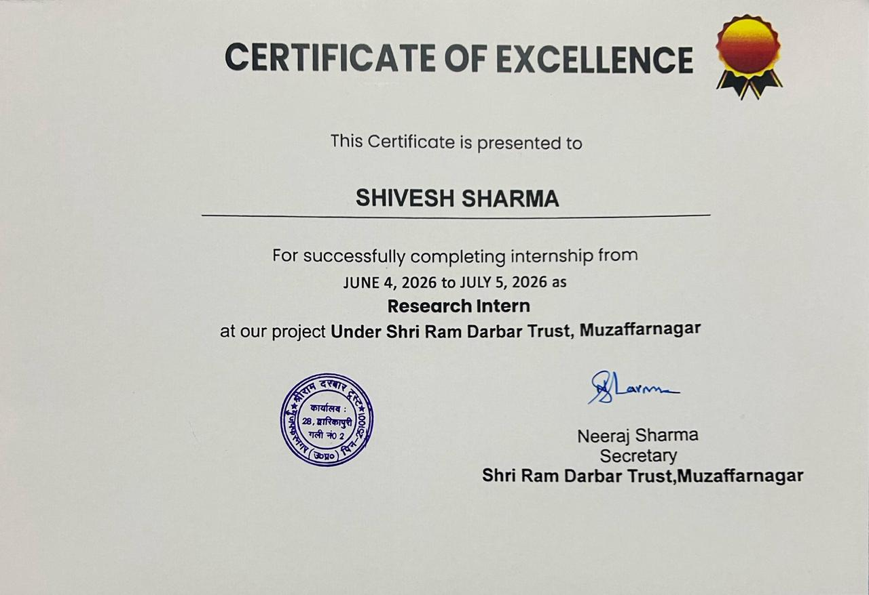

TABLE OF CONTENTS
Chapter No. | Chapter Name | Page Nos.
 | Cover Page | ---
1. | Candidate's Declaration | I
2. | Acknowledgement | Ii
3. | Internship Completion Certificate | Iii
4. | Project Description | 1
 | 4.1 Introduction | 1-2
 | 4.2 Organization Profile | 2-3
 | 4.3 Problem Statement | 3
 | 4.4 Project Objectives | 3-4
 | 4.5 Scope of the Project | 4
 | 4.6 Technologies and Tools Used | 4-5
 | 4.7 System Architecture | 5
 | 4.8 Methodology | 6
 | 4.9 Expected Outcomes | 6-7
 | 4.10 Certificates of completion and other communication mail proof | 7-8
5. | Bibliography/References | 9

Chapter 4: Project Description
4.1 Introduction
Introduction
Social welfare organizations play an important role in addressing the needs of communities and supporting individuals and animals who require care and assistance. In many communities, people may face difficulties in meeting basic requirements such as food, clothing and protection from changing weather conditions. At the same time, animals also require regular care, proper nutrition, a safe environment and continuous attention to their well-being. Organizations working at the grassroots level therefore have an important role in identifying these needs and providing practical support.
Shri Ram Darbar Trust, Muzaffarnagar, is involved in welfare-oriented activities that focus on helping people in need as well as caring for animals. The trust provides essential support such as clothes, blankets and food to people who require assistance. These activities are important because timely access to basic necessities can provide immediate relief and contribute to the well-being and dignity of individuals and families facing difficult circumstances. The trust's work reflects the importance of community participation and organized social support in addressing local needs.
In addition to human welfare activities, the trust also gives attention to animal welfare and care. Animals require regular feeding, access to water, suitable shelter, cleanliness and proper handling. Their well-being depends on consistent daily care rather than occasional attention. The trust's involvement in animal care provided an opportunity to observe how routine activities and responsible management contribute to maintaining a suitable environment for animals.
Another important area associated with the trust is its dairy farm. A dairy farm requires regular management of animals, feeding routines, cleanliness, supervision and day-to-day operational planning. Observing these activities provided useful practical exposure to the relationship between animal welfare and dairy operations. It also helped in understanding how proper organization and routine management can influence the overall functioning of such activities.
I completed my Research Internship at Shri Ram Darbar Trust from 4 June 2026 to 5 July 2026. During this period, I worked primarily as a field-based researcher, where my focus was on observing the activities carried out by the trust and understanding the practical challenges and requirements associated with them. Rather than limiting the internship to theoretical study, I had the opportunity to see the work directly and learn from real situations and day-to-day activities.
My role involved direct observation, interaction, understanding of ongoing activities, identification of practical needs and sharing of suggestions based on what I observed. I tried to understand how support was organized, how essential resources were used, how animals were cared for and how the dairy farm operated as part of the trust's activities. Through this process, I developed a better understanding of how field research can be used to identify existing practices, recognize areas that require attention and suggest simple improvements.
The internship also helped me understand that research is not limited to collecting information from books, websites or reports. Field-based research provides an opportunity to observe real conditions, communicate with people, understand local requirements and connect findings with practical solutions. Direct observation allowed me to recognize the importance of consistency, organization, communication and documentation in welfare activities. It also showed me that even small improvements in planning and record-keeping can support better coordination and make welfare activities more systematic.
Another important aspect of this internship was understanding the connection between social responsibility and practical management. Providing food, clothes or blankets requires planning and awareness of actual needs. Similarly, caring for animals and managing a dairy farm requires regular routines, responsibility and attention to detail. These activities may appear different, but they share a common requirement: effective organization and continuous care.
Overall, this internship was a valuable learning experience that allowed me to connect academic research with real-world social and animal welfare work. It helped me improve my observation, communication, analytical and documentation skills while giving me a practical understanding of grassroots welfare activities. The experience also encouraged me to look at social service not only from the perspective of assistance, but also from the perspective of need assessment, responsible resource use, operational improvement and long-term impact.
This report presents the observations, activities, findings, learning outcomes and recommendations developed during my internship at Shri Ram Darbar Trust. It aims to provide a clear overview of the trust's welfare activities and to document my experience as a Research Intern while highlighting areas where practical and systematic approaches can further strengthen the effectiveness of the work being carried out.
4.2 Organization Profile
Shri Ram Darbar Trust, Muzaffarnagar is a community welfare organization involved in supporting people in need and promoting the care and well-being of animals. The trust provides essential items such as food, clothes and blankets to individuals who require support.
Along with social welfare activities, the trust also focuses on animal care and protection. Regular feeding, cleanliness, shelter and proper attention to animals form an important part of its activities. The trust also operates a dairy farm, where daily animal-care and dairy-related operations are carried out.
The organization provides a useful environment for field-based learning and research because its activities involve real community and animal-welfare needs. During my internship, I observed these activities closely as a Research Intern, studied the existing practices and identified areas where better planning, documentation and organization could improve the overall effectiveness of the work.
Overall, the trust works across human welfare, animal care and dairy activities, giving an opportunity to understand how community service and practical management can work together.
4.3 Problem Statement
Shri Ram Darbar Trust is involved in supporting people in need and caring for animals through food, clothes, blankets, animal welfare and dairy-farm activities. Managing these different activities requires regular planning, coordination, proper use of resources and continuous monitoring. During the internship, the focus was to observe these activities and identify practical areas where the existing system could be made more organized and effective.
Key Problems Identified
- Identification of Community Needs: Understanding the changing needs of people is important so that food, clothes and blankets can be provided to those who require them the most.
- Resource Management: Proper planning and organization of available food, clothes, blankets and other resources can help reduce wastage and ensure timely support.
- Animal Care Management: Animals require regular feeding, clean surroundings, adequate water and proper attention, making consistent daily care an important requirement.
- Dairy Farm Management: Daily dairy-farm activities require proper routines, cleanliness, feeding schedules and supervision to maintain smooth operations.
- Documentation and Record-Keeping: Maintaining basic records of welfare activities, resources and animal-care routines can help in tracking work and planning future activities.
- Coordination and Monitoring: Better coordination between people involved in different activities and regular monitoring can improve efficiency and ensure that important tasks are completed on time.
4.4 Project Objectives
The main objective of this project was to study the activities of Shri Ram Darbar Trust through direct observation and practical field research. The project focused on understanding the trust’s work for people in need, animal welfare and dairy-farm activities, while also identifying practical challenges and possible areas for improvement. The internship aimed to connect research knowledge with real-world community service and develop a better understanding of how welfare activities are managed at the ground level.
Key Objectives
- To understand the trust’s social welfare activities and study how support is provided to people who require assistance.
- To study the distribution of essential items such as food, clothes and blankets and understand their importance for the community.
- To observe animal welfare practices including feeding, cleanliness, shelter and regular care of animals.
- To understand dairy-farm operations and observe the daily routines and management involved in caring for dairy animals.
- To identify practical challenges related to resources, planning, coordination and the management of different welfare activities.
- To document field observations and understand existing practices, requirements and areas where improvements may be possible.
- To provide practical recommendations for improving planning, documentation, coordination and the overall effectiveness of the trust’s activities.

4.5 Scope of the Project
The scope of this project is to study and understand the different welfare and operational activities carried out by Shri Ram Darbar Trust, Muzaffarnagar. The study mainly covers the trust’s support for people in need through food, clothes and blankets, along with its work related to animal welfare and dairy-farm management. During the internship, direct observations were made to understand daily activities, identify practical challenges, and examine areas where better planning, coordination, documentation and resource management could improve the effectiveness of the trust’s work. The project also focuses on gaining practical research experience by connecting field observations with useful and realistic recommendations..
4.6 Technologies and Tools Used
• MS Word: Used for preparing, editing and formatting the internship report in a clear and structured manner.
• MS PowerPoint: Used to prepare the presentation and communicate the major activities, observations, findings and recommendations.
• MS Excel: Used for organizing information, maintaining basic records and arranging field observations systematically.
• Smartphone/Camera: Used for taking notes, capturing relevant field activities and maintaining visual documentation where required.
• Internet & Digital Resources: Used for collecting general background information and supporting research wherever necessary.
• Direct Observation: Used as the primary field-research method to understand community support, animal care and dairy-farm activities.
• Manual Note-Taking: Used to record important observations, discussions, daily activities and practical issues during the internship.
• Interaction & Discussion: Used to understand the working process, responsibilities, requirements and challenges associated with different activities. 4.7
4.7 System Architecture
Since this project is based on field research and observation rather than software development, the system architecture represents the flow of information from field activities to analysis and recommendations.
Field Activities → Data Collection → Documentation → Analysis → Findings → Recommendations
- Field Activities: Observation of community support, animal care and dairy-farm operations.
- Data Collection: Gathering information through direct observation, discussions, photographs and notes.
- Documentation: Organizing collected information using MS Word, MS Excel and digital records.
- Analysis: Reviewing observations to identify important patterns, needs, challenges and areas for improvement.
- Findings: Summarizing the major observations related to welfare activities, animal care and dairy operations.
- Recommendations: Developing practical suggestions for better planning, coordination, documentation and resource management.
This architecture provides a simple and systematic framework for converting real-world field observations into useful research findings and practical recommendations.
4.8 Methodology
The methodology of this project was based mainly on field-based observation, information collection and practical analysis. The study was conducted during my internship at Shri Ram Darbar Trust, where I observed different welfare activities and interacted with the people involved in the organization’s daily work.
Research Methodology
- Direct Observation: Activities related to community support, animal care and dairy-farm operations were observed directly.
- Interaction and Discussion: Information was collected through discussions with people involved in the trust’s activities to understand their responsibilities, routines and practical challenges.
- Data Collection: Relevant information was collected through field notes, observations and available records wherever applicable.
- Documentation: Important observations and activities were recorded systematically for further review and analysis.
- Need Identification: The collected information was studied to identify common needs, operational challenges and areas requiring attention.
- Analysis: Observations were reviewed and compared to understand existing practices and identify possible improvements.
- Recommendations: Based on the findings, practical suggestions were developed for better planning, coordination, documentation, resource management and monitoring.
This methodology helped connect practical field experience with research analysis, providing a clear understanding of the trust’s activities and possible areas for improvement.
4.9 Expected Outcomes
The project is expected to provide a clear understanding of the welfare and operational activities carried out by Shri Ram Darbar Trust. Through field observation and research, the project aims to identify existing practices, understand practical challenges and suggest improvements that may help the trust work in a more organized and effective manner.
Expected Outcomes
- Better Understanding of Welfare Activities: Develop a clear understanding of how food, clothes and blankets are provided to people in need.
- Improved Understanding of Animal Care: Gain practical knowledge about feeding, cleanliness, shelter and regular care of animals.
- Understanding of Dairy-Farm Operations: Develop awareness of the daily routines, management practices and responsibilities involved in the dairy farm.
- Identification of Practical Challenges: Identify common difficulties related to resources, planning, coordination and daily operations.
- Better Documentation: Encourage systematic recording of important activities, observations, resources and requirements.
- Practical Recommendations: Provide realistic suggestions for improving planning, resource management, monitoring and coordination.
- Development of Research Skills: Improve practical skills in observation, data collection, analysis, documentation and communication through real-world field research.
4.10 Certificates of completion and other communication mail proof
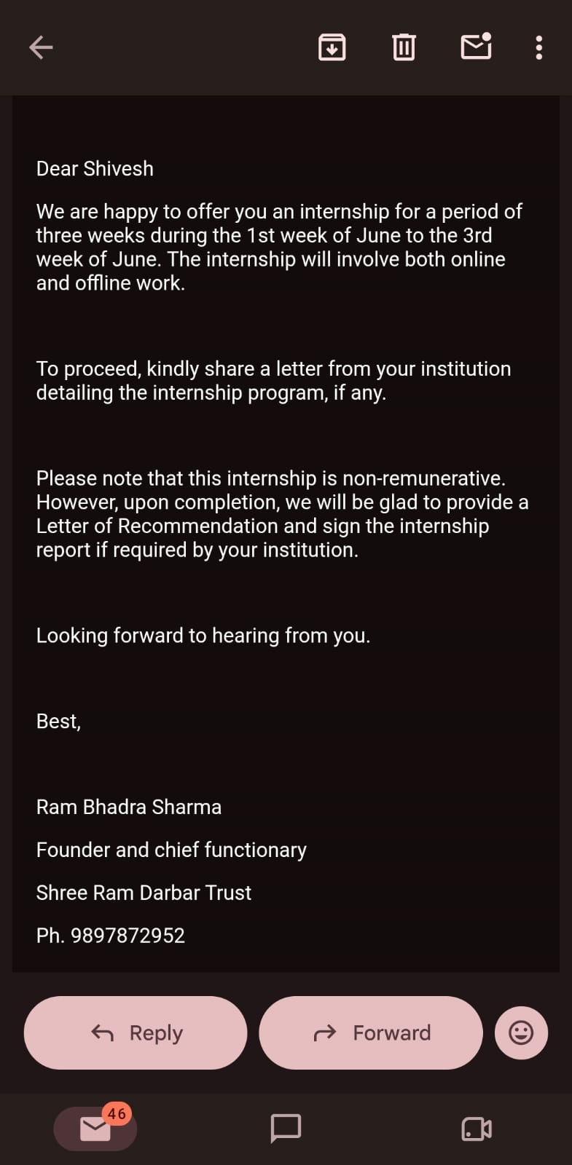
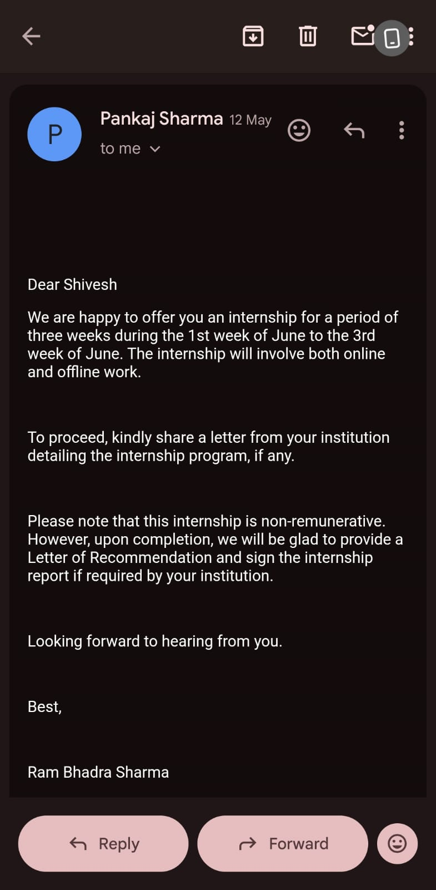
[ Certificates of internship completion and copies of related communication/mail correspondence with the supervisor and Shiri Ram Darbar Trust are to be attached here. ]



Chapter 5: Bibliography/References

The following sources and materials were referred to during the preparation of this internship report:
- Shri Ram Darbar Trust, Muzaffarnagar – Information collected through direct field observation, discussions and activities during the internship.
- Internship Field Notes and Observations – Personal notes and observations recorded during the internship period from 4 June 2026 to 5 July 2026.
- Microsoft Word – Used for preparing and formatting the internship report.
- Microsoft Excel – Used for organizing and maintaining research observations and information.
- Microsoft PowerPoint – Used for preparing the internship presentation.
- General Reference Material on Social Welfare and Community Development – Used to understand basic concepts related to community support and welfare activities.
- General Reference Material on Animal Welfare and Dairy Management – Used to support the understanding of animal-care practices and basic dairy-farm management.
- Photographs and Visual Records from Field Activities – Used as supporting material for documenting relevant observations during the internship.

