TEMPLATE OUTPUT — GENERATED FROM SYNTHETIC DEMO DATA
Replace cs_registry_demo.csv with your own dataset and re-run cs_stats_engine.py to regenerate this report with real figures.
First-Line Vasoactive Strategy and Outcomes in Cardiogenic Shock: A Registry Analysis
Draft generated 2026-07-28 · EMC Digitals — CS Vasoactive Platform

Methods
We analysed 240 patients with cardiogenic shock stratified by initial vasoactive strategy (Norepinephrine monotherapy, Norepinephrine+Dobutamine, Norepinephrine+Levosimendan). Continuous variables are reported as mean ± SD when the Shapiro-Wilk test did not reject normality (p > 0.05), and as median [IQR] otherwise. Between-group comparisons used Welch's t-test or one-way ANOVA for normally distributed continuous variables, Mann-Whitney U or Kruskal-Wallis for non-normal variables, and chi-square or Fisher's exact test for categorical variables as appropriate to expected cell counts. Time-to-event analysis used the Kaplan-Meier method with the log-rank test. A multivariable logistic regression model for 30-day mortality was adjusted for SCAI shock stage, baseline lactate, and age. Statistical significance was set at two-sided p < 0.05.

Results
Baseline and outcome characteristics by first-line vasoactive strategy are shown in Table 1.
Variable | Norepinephrine monotherapy  (n=56) | Norepinephrine+Dobutamine  (n=114) | Norepinephrine+Levosimendan  (n=70)
age | 65.8 ± 14.2 | 66.0 ± 11.1 | 66.6 ± 11.9
lactate baseline | 3.0 [2.2–4.0] | 3.2 [2.4–4.7] | 3.3 [2.2–4.5]
map 1h | 70.9 ± 9.5 | 68.5 ± 9.8 | 66.5 ± 10.0
icu los days | 4.2 [2.3–5.9] | 5.0 [3.2–7.5] | 4.6 [2.6–6.5]

Between-group comparisons
age: one-way ANOVA, p = 0.918
lactate baseline: Kruskal-Wallis, p = 0.252
map 1h: one-way ANOVA, p = 0.041 *
icu los days: Kruskal-Wallis, p = 0.067
sex: Chi-square, p = 0.054
scai stage: Chi-square, p = 0.777
mortality 30d: Chi-square, p = 0.040 *

Time-to-event analysis
Log-rank test across 3 groups: p = 0.012.
Estimated survival at last follow-up — Norepinephrine monotherapy: 18.5% | Norepinephrine+Dobutamine: 22.5% | Norepinephrine+Levosimendan: 27.6%
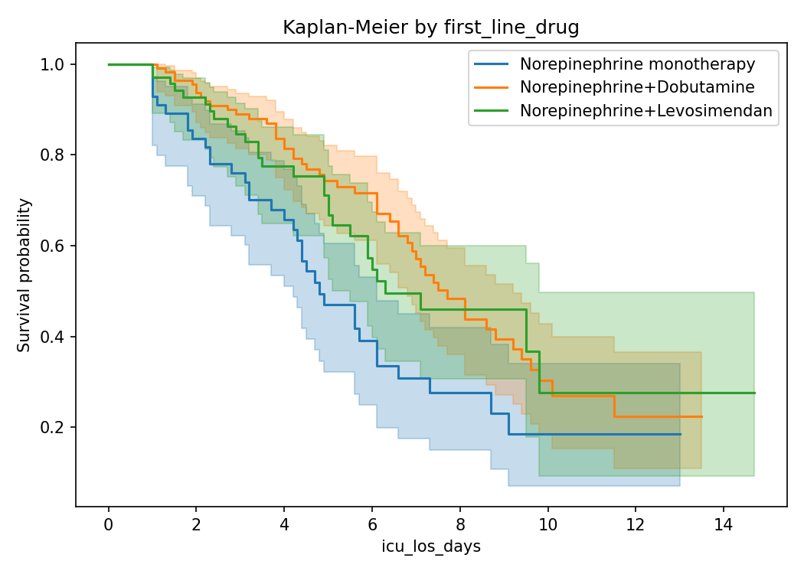

Multivariable logistic regression — 30-day mortality
n = 240, pseudo-R² = 0.065. Adjusted odds ratios below; OR > 1 indicates higher odds of 30-day mortality.
Covariate | OR | 95% CI | p
lactate_baseline | 1.13 | 0.97–1.31 | 0.114
age | 1.01 | 0.98–1.03 | 0.589
scai_stage_D | 2.73 | 1.51–4.92 | 0.001
scai_stage_E | 3.96 | 1.81–8.68 | 0.001

Discussion
[Populate after reviewing the computed results above against the study's clinical context and the existing literature — e.g. Riccardi et al. Eur J Heart Fail 2024;26:411–431 for the pharmacological rationale and prior trial evidence (SOAP-II, OptimaCC, DOREMI, LIDO/SURVIVE) to compare against.]

Limitations
[Registry/observational design — confounding by indication is expected (sicker patients more likely to receive combination therapy); document data completeness, missingness handling, and any propensity-adjustment performed.]

