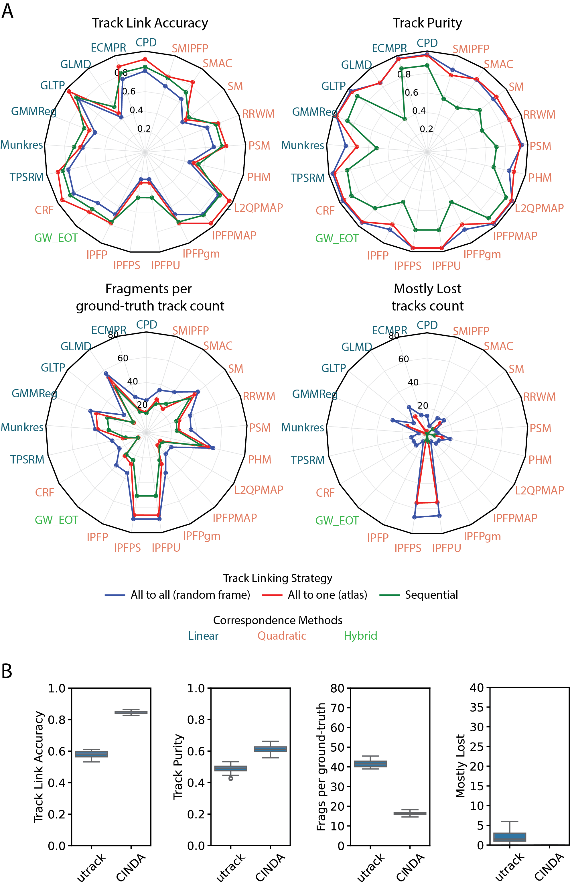
Supplementary Figure 1. A) Comparison of MOT metrics across track linking strategies paired with various correspondence estimation methods on synthetic data. Noise in the video (precision and recall values were kept fixed at 0.9). Sequential track linking strategy performs worst and ‘All to one’ track linking strategy performs the best. B) MOT metrics achieved by Min-cost flow optimization based track linking strategies.
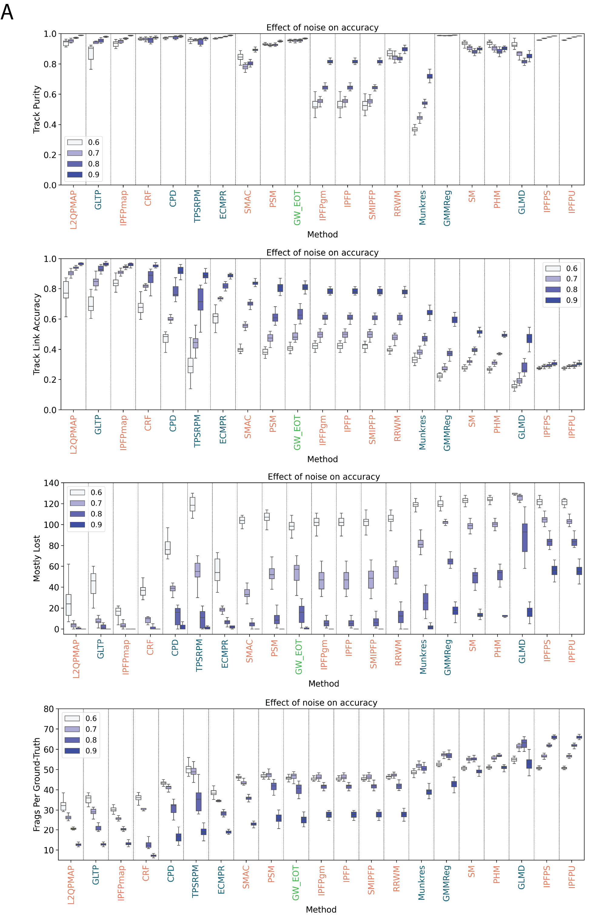
Supplementary Figure 2. A) Effect of noise on MOT metrics across correspondence estimation methods. Boxes for each method correspond to different Precision/Recall values of 0.6, 0.7, 0.8 and 0.9. Noise levels (False positive and False negative cells) are adjusted by varying Precision and Recall values. Methods such as IPFPMAP, CRF are more robust to increase in noise level compared to other methods.
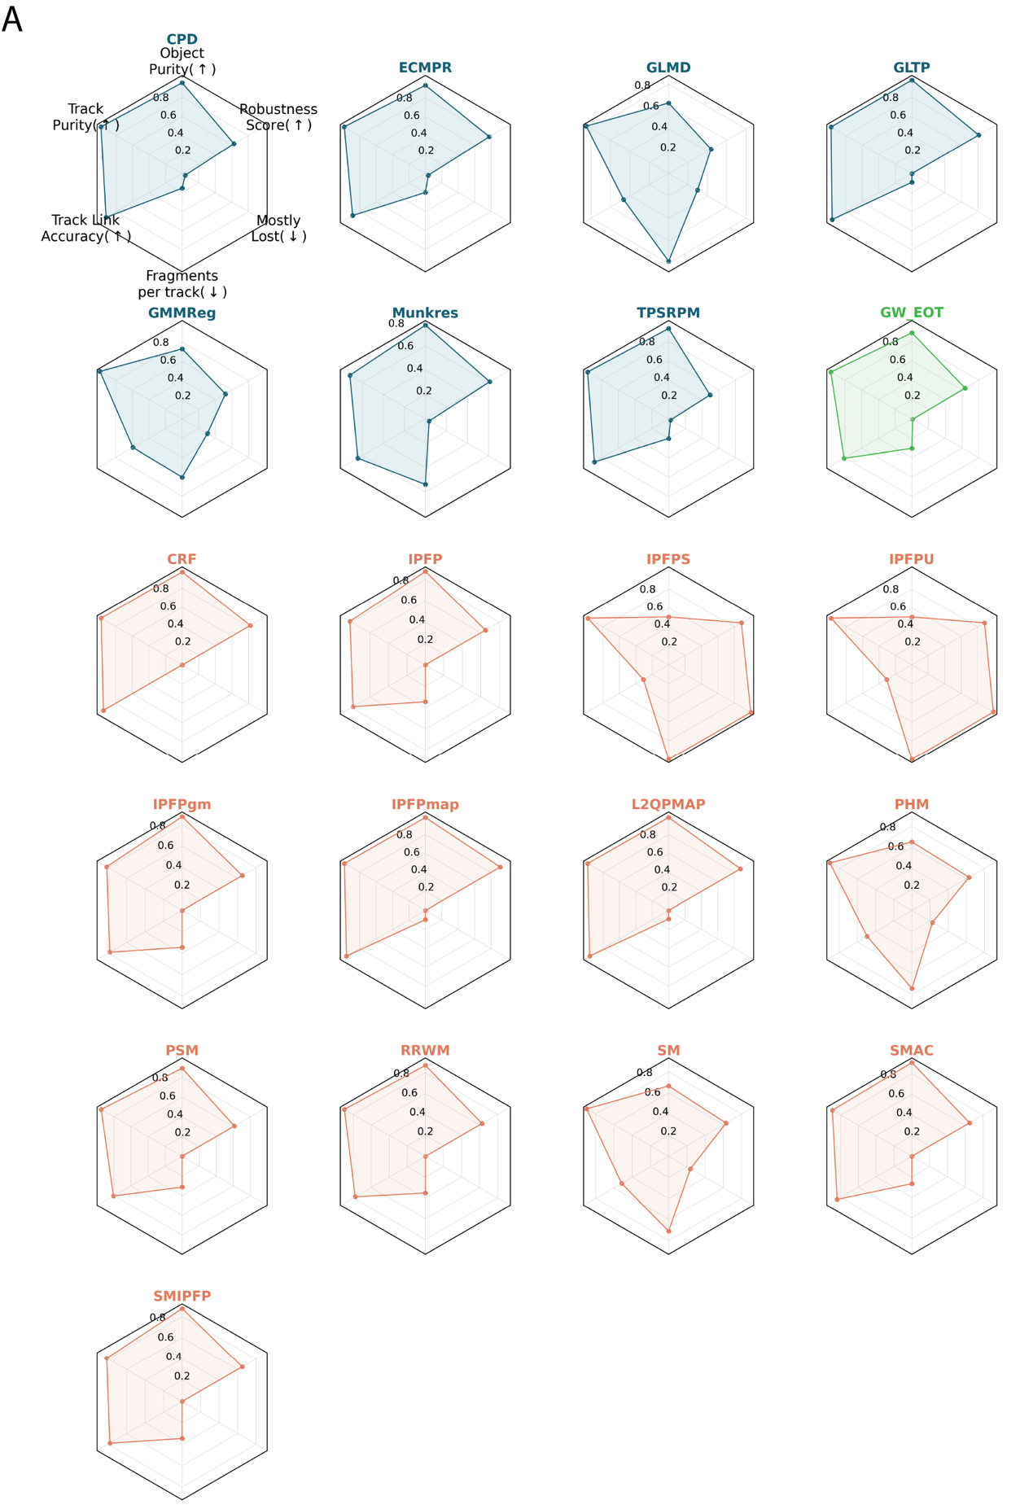
Supplementary Figure 3. A Multidimensional screen of correspondence estimation methods using synthetic data. A) Examples of MOT accuracy achieved by Linear (Blue), Quadratic (Orange) and Hybrid (Green) methods. Up-arrow indicates higher values of the metric are desired and Down-arrow indicates lower values for the metric are desired.
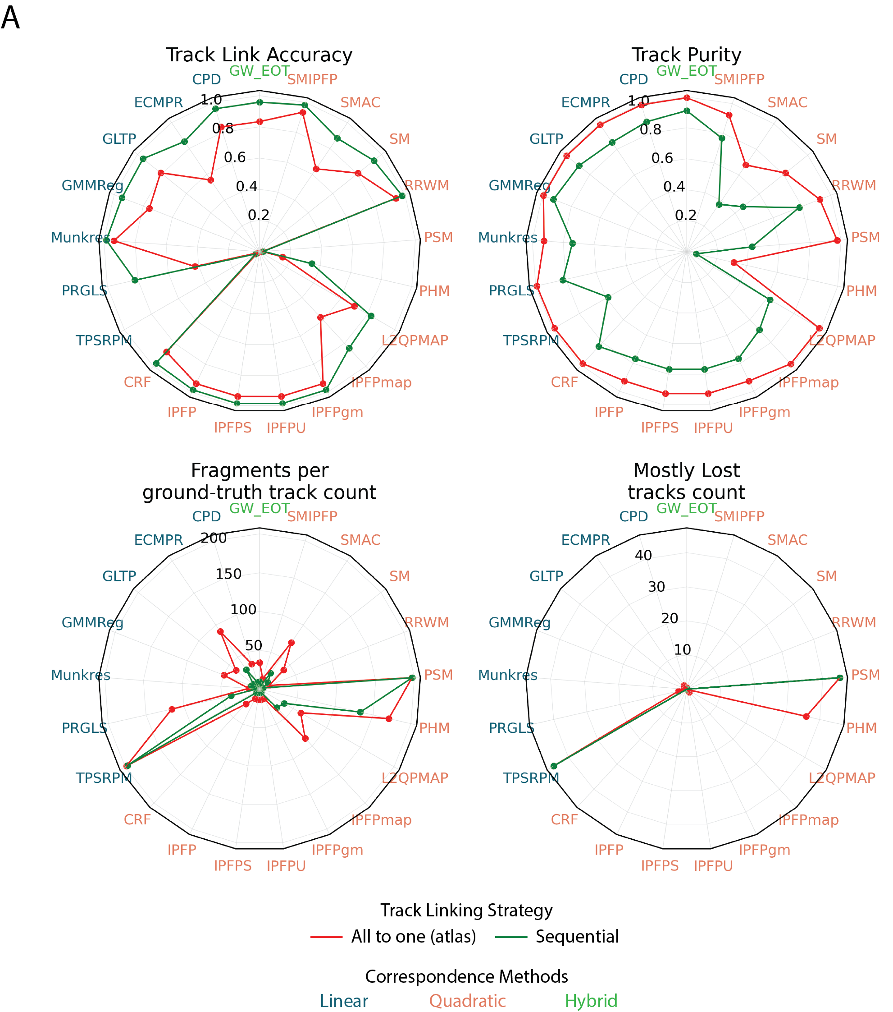
Supplementary Figure 4. A) Comparison of MOT metrics across track linking strategies paired with various correspondence estimation methods on real freely moving whole-brain data. Metrics are calculated based on manually labeled ground-truth tracks across 200 frames. Sequential track linking strategy performs worse compared to ‘All to one’ track linking strategy.
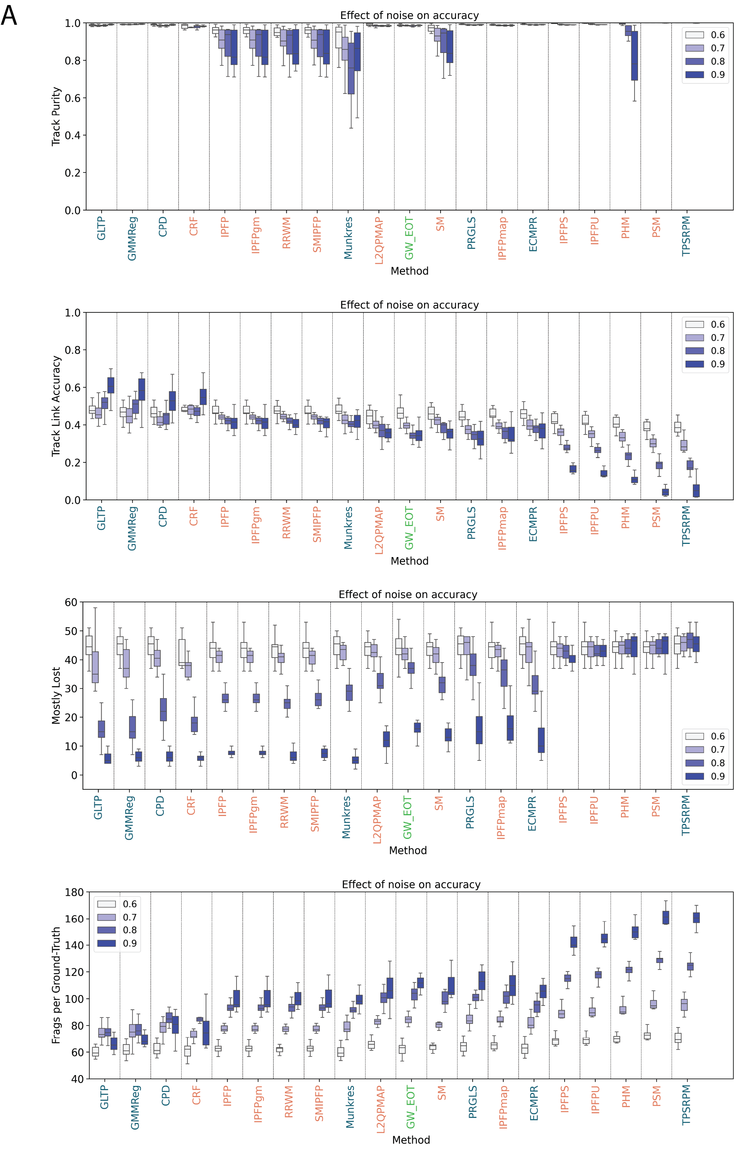
Supplementary Figure 5. A) Effect of noise on MOT metrics across correspondence estimation methods evaluated on real freely-moving whole-brain data. Boxes for each method correspond to different Precision/Recall values of 0.6, 0.7, 0.8 and 0.9. Noise levels (False positive and False negative cells) are adjusted by varying Precision and Recall values. Methods such as GLTP and CRF achieve high accuracy and are more robust to noise.

