OCR TEXT TRANSLATOR

APP NAME : OCR

Version : 1.02

ID: nf.co.hoproject.ocrdemo

**IMPORTANT :**

Visit <https://tech.yandex.com/translate/?ncrnd=1127>and get your YANDEX API KEY

Visit <https://ocr.space/ocrapi>and get your OCRSPACE API KEY

Put these keys in string.xml

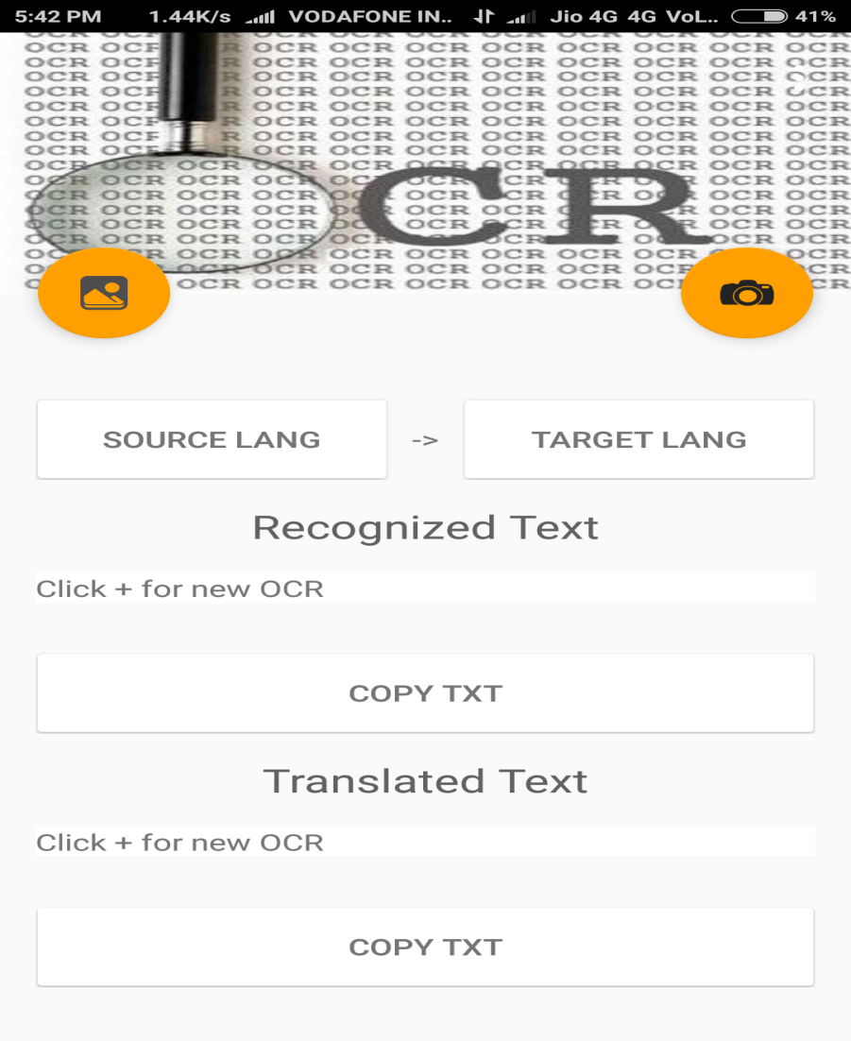

SYSTEM DIAGRAM

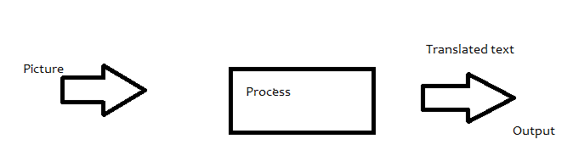

* **INPUT**

1. Select the image from the gallery or select the image to be translated using the mobile camera.

Format : jpg ,png,jpeg

Max size : 1Mb

Max Resolution : 2000 x 2000 px

Min Resolution : 40 x 40px

Source and Target Language codes

* **PROCESSING**

1. The file is sent to firebase storage for processing   
2. Unique URL for the file is obtained   
3. The url is passed to Ocrspace API for translation   
4. Obtain the SOURCE and TARGET language codes form user and pass the codes and the recognized text to yadex api for translation

* **Output**

1. Shows recognized text
2. Shows the final translated text to user.

**REPORT**

**OCR SPACE API**

API Basics

The free OCR API provides you with a simple way of parsing images and even multi-page PDF documents and getting the extracted text results returned in a JSON format. The API can be used from any internet-connected device (desktop, mobile, iPhone, Android, Windows phone, refrigerator...). The OCR API was first built for our own use, but - *the more people use it, the more stable and robust the solution gets over time. So... please use it and please help spread the word!*A tweet or link back is always appreciated.

### The Free OCR API Endpoint

**Free OCR API**[**https://api.ocr.space/parse/image**](https://api.ocr.space/parse/image)The API supports both, https:// (SSL) and plain http:// connections.

### PRO Plans Payment options

You can subscribe to the PRO plans via the [PRO](https://sites.fastspring.com/a9t9/instant/ocr-api-pro) and [PRO PDF](https://sites.fastspring.com/a9t9/instant/ocr-api-pro-pdf) links. You are billed monthly and you can cancel anytime. We do [not](https://ocr.space/faq" \l "security) store your credit card information on our servers. If you can not pay via credit card, let us know. We also offer pre-paid [quarterly](https://sites.fastspring.com/a9t9/instant/ocrspaceapipro3month), [half-yearly](https://sites.fastspring.com/a9t9/instant/ocrspaceapipro6month) and [yearly plans](https://sites.fastspring.com/a9t9/instant/ocrspaceapiproyearly) with other payment options like Paypal, wire transfer, purchase order and many local options such as Alipay for China.   
  
You will receive the URLs of the three global PRO endpoints and your API key in the welcome email directly after you have signed-up for the PRO or PRO PDF account

[Top](https://ocr.space/ocrapi" \l "GettingStarted)

# Post Parameters

| **Key** | **Value** | **Description** |
| --- | --- | --- |
| apikey | API Key (send in the header) | [Get your free API key](http://eepurl.com/bOLOcf) |
| url or file or base64Image | url: URL of remote image file file: Multipart encoded image file with filename base64Image: Image as Base64 encoded string | You can use three differents methods to upload the input image or PDF. |
| language | [Optional] Chinese(Simplified)=chs Chinese(Traditional)=cht Danish = dan Dutch = dut English = eng Finnish = fin French = fre German = ger Greek = gre Hungarian = hun Korean = kor Italian = ita Japanese = jpn Norwegian = nor Polish = pol Portuguese = por Russian = rus Spanish = spa Swedish = swe Turkish = tur | Language used for OCR. If no language is specified, English engis taken as default.  IMPORTANT: The language code has always 3-letters (not 2). So it is "eng" and not "en". |
| isOverlayRequired | [Optional] Boolean value indicating if the overlay is required along with the image/pdf parsed result | Default = False Allows you to specify if the image/pdf text overlay is required. Overlay could be used to show the text over the image |

[Top](https://ocr.space/ocrapi" \l "GettingStarted)

# Response

The API returns results in JSON format. The result typically contains the ExitCode, Error details (if occurred) and a bunch of parsed results for the Image / PDF pages. Please check below the response that the Web API returns and definition of various parameters. The illustration below shows both success as well as error responses.

| **Key** | **Value** | **Description** |
| --- | --- | --- |
| ParsedResults | An Array of all parsed results | The parsed results for image file / each page of PDF. Each has its own exit code, parsed result and error message (if any) |
| OCRExitCode | Primary exit code returned by the application for parsed results | The exit code signifies if the parsing of image / pdf completed successfully, partially or failed with error  1: Parsed Successfully (Image / All pages parsed successfully) 2: Parsed Partially (Only few pages out of all the pages parsed successfully) 3: Image / All the PDF pages failed parsing (This happens maily because the Parsing engine fails to parse an image) 4: Error occurred when attempting to parse (This happens when a fatal error occurs during parsing image / PDF) |
| IsErroredOnProcessing | true/false | If an error occurrs when parsing the Image / PDF pages |
| ErrorMessage | The error message | The error message of the error occurred when parsing the image |
| ErrorDetails | The details of the error message | The detailed error message |
| **IMAGE / PAGE PARSING RESULT** |  |  |
| FileParseExitCode | Exit code for each parsed result | The exit code returned by the parsing engine 0: File not found 1: Success -10: OCR Engine Parse Error -20: Timeout -30: Validation Error -99: Unknown Error |
| ParsedText | Parsed Text | The parsed text for an image |
| TextOverlay | An array of overlay of the text in the image/pdf | If, 'isOverlayRequired' is set to 'True', then this will contain the text overlay for the image/pdf |
| Lines | An array of lines in the overlay text | This contains an array of all the lines. Each line will contain an array of words |
| Words | An array of words in a line | This contains the words with the specific details of a word like its text and position |
| WordText | Text of the word | This contains the text of that specific word |
| Left | Distance of word from left (in Pixels) | Contains the distance (in Pixels) of the word from the left edge of the original size of image |
| Top | Distance of word from top (in Pixels) | Contains the distance (in Pixels) of the word from the top edge of the original size of image |
| Height | Height of the word | Contains the height (in Pixels) of the word in the original size of image |
| Width | Width of the word | Contains the width (in Pixels) of the word in the original size of image |
| MaxHeight | Maximum Height of the line | Contains the height (in Pixels) of the line in the original size of image |
| MinTop | Minimum distance of the line from the top edge of image | Contains the distance (in Pixels) of the line from the top edge in the original size of image |
| HasOverlay | Overlay is present or not | True/False depending upon if the overlay for the parsed result is present or not |
| ErrorMessage | Error Message | Error message returned by the parsing engine |
| ErrorDetails | Error Details | Detailed error message returned from the parsing engine for debugging purposes |

**YANDEX API**

# Overview

## Interfaces

You can use any of the following for accessing the Yandex.Translate API over HTTPS:

* XML interface (returns the response as an XML document).
* [JSON](http://www.json.org/) interface (returns the response as JavaScript objects with the same names and semantics as the XML elements).
* JSONP interface (returns the response as JavaScript objects wrapped in a callback function with the specified name).

All the interfaces have the same functionality and use the same set of input parameters.

## Supported languages

You can use the Yandex.Translate API to translate text into the following languages:

|  |  |  |  |
| --- | --- | --- | --- |
| **Language** | **Code** | **Language** | **Code** |
| Azerbaijan | az | Maltese | mt |
| Albanian | sq | Macedonian | mk |
| Amharic | am | Maori | mi |
| English | en | Marathi | mr |
| Arabic | ar | Mari | mhr |
| Armenian | hy | Mongolian | mn |
| Afrikaans | af | German | de |
| Basque | eu | Nepali | ne |
| Bashkir | ba | Norwegian | no |
| Belarusian | be | Punjabi | pa |
| Bengali | bn | Papiamento | pap |
| Bulgarian | bg | Persian | fa |
| Bosnian | bs | Polish | pl |
| Welsh | cy | Portuguese | pt |
| Hungarian | hu | Romanian | ro |
| Vietnamese | vi | Russian | ru |
| Haitian (Creole) | ht | Cebuano | ceb |
| Galician | gl | Serbian | sr |
| Dutch | nl | Sinhala | si |
| Hill Mari | mrj | Slovakian | sk |
| Greek | el | Slovenian | sl |
| Georgian | ka | Swahili | sw |
| Gujarati | gu | Sundanese | su |
| Danish | da | Tajik | tg |
| Hebrew | he | Thai | th |
| Yiddish | yi | Tagalog | tl |
| Indonesian | id | Tamil | ta |
| Irish | ga | Tatar | tt |
| Italian | it | Telugu | te |
| Icelandic | is | Turkish | tr |
| Spanish | es | Udmurt | udm |
| Kazakh | kk | Uzbek | uz |
| Kannada | kn | Ukrainian | uk |
| Catalan | ca | Urdu | ur |
| Kyrgyz | ky | Finnish | fi |
| Chinese | zh | French | fr |
| Korean | ko | Hindi | hi |
| Xhosa | xh | Croatian | hr |
| Latin | la | Czech | cs |
| Latvian | lv | Swedish | sv |
| Lithuanian | lt | Scottish | gd |
| Luxembourgish | lb | Estonian | et |
| Malagasy | mg | Esperanto | eo |
| Malay | ms | Javanese | jv |
| Malayalam | ml | Japanese | ja |

# Requirements for the use of translation results

According to the [Terms of Use for the Yandex.Translate service](http://legal.yandex.com/translate_api/), the text **“Powered by Yandex.Translate”**must be shown above or below the translation result, with a clickable link to the page <http://translate.yandex.com/>.

**Requirements for placing this text**

This text must be shown:

* In the description of the software product (on the About page).
* In the help for the software product.
* On the official website of the software product.
* On all pages or screens where data from the service is used.

**Requirements for font color**

The font color of this text must match the font color of the main text.

**Requirements for font size**

The font size of this text must not be smaller than the font size of the main text.

[← Ctrl Prev](https://tech.yandex.com/translate/doc/dg/concepts/design-requirements-docpage/)[Next](https://tech.yandex.com/translate/doc/dg/reference/detect-docpage/) Ctrl →

# Get the list of supported languages

Gets a list of translation directions supported by the service.

**In this section:**

* [JSON and JSONP interfaces](https://tech.yandex.com/translate/doc/dg/reference/getLangs-docpage/" \l "JSON)
* [XML interface](https://tech.yandex.com/translate/doc/dg/reference/getLangs-docpage/" \l "XML)
* [Response codes](https://tech.yandex.com/translate/doc/dg/reference/getLangs-docpage/" \l "codes)

## JSON and JSONP interfaces

The response is returned in JSON format. If the callback parameter is set, the JSON object is wrapped in a function with the name specified in this parameter (JSONP).

### Request syntax

https://translate.yandex.net/api/v1.5/tr.json/getLangs ?

key=<API key>

& [ui=<language code>]

& [callback=<name of the callback function>]

|  |  |
| --- | --- |
| key | [API key](https://tech.yandex.com/key/form.xml?service=trnsl). It is issued free of charge. |
| ui | Required parameter.  In the response, supported languages are listed in the langs field with the definitions of the language codes. Language names are output in the language corresponding to the code in this parameter.  All the language codes are shown in the [list of supported languages](https://tech.yandex.com/translate/doc/dg/concepts/api-overview-docpage/" \l "languages). |
| callback | The name of the callback function. Use for getting a JSONP response. |

Note. All special characters must be escaped.

[**Request example**](https://tech.yandex.com/translate/doc/dg/reference/getLangs-docpage/)

[Response example](https://tech.yandex.com/translate/doc/dg/reference/getLangs-docpage/)

[Error example](https://tech.yandex.com/translate/doc/dg/reference/getLangs-docpage/)

POST /api/v1.5/tr.json/getLangs?ui=en&key=API-KEY HTTP/1.1

Host: translate.yandex.net

Accept: \*/\*

Content-Type: application/x-www-form-urlencoded

The response is returned in JSON format.

Note. Due to changes in the service, the dirs field has been deprecated. Supported languages are listed in the langs field.

|  |
| --- |
| **With the "ui=en" parameter** |
| {  "dirs": [  "ru-en",  "ru-pl",  "ru-hu",  ...  ],  "langs": {  "ru": "Russian",  "en": "English",  "pl": "Polish",  ...  }  } |

If the request can't be processed, an error message is returned.

|  |
| --- |
| {"code":401,"message":"API key is invalid"} |

## XML interface

The response is returned in XML format.

### Request syntax

https://translate.yandex.net/api/v1.5/tr/getLangs ?

key=<API key>

& ui=<language code>

|  |  |
| --- | --- |
| key | [API key](https://tech.yandex.com/key/form.xml?service=trnsl). It is issued free of charge. |
| ui | Required parameter.  In the response, supported languages are listed in the langs field with the definitions of the language codes. Language names are output in the language corresponding to the code in this parameter.  All the language codes are shown in the [list of supported languages](https://tech.yandex.com/translate/doc/dg/concepts/api-overview-docpage/" \l "languages). |

Note. All special characters must be escaped.

[**Request example**](https://tech.yandex.com/translate/doc/dg/reference/getLangs-docpage/)

[Response example](https://tech.yandex.com/translate/doc/dg/reference/getLangs-docpage/)

[Error example](https://tech.yandex.com/translate/doc/dg/reference/getLangs-docpage/)

POST /api/v1.5/tr./getLangs?ui=en&key=API-KEY HTTP/1.1

Host: translate.yandex.net

Accept: \*/\*

Content-Type: application/x-www-form-urlencoded

The response is returned in XML format.

Note. Due to changes in the service, the dirs field has been deprecated. Supported languages are listed in the langs field.

|  |
| --- |
| **With the "ui=en" parameter** |
| <Langs>  <dirs>  <string>ru-en</string>  <string>ru-pl</string>  <string>ru-hu</string>  ...  </dirs>  <langs>  <Item key="ru" value="Russian"/>  <Item key="en" value="English"/>  <Item key="pl" value="Polish"/>  </langs>  </Langs> |

If the request can't be processed, an error message is returned.

|  |
| --- |
| <Error code="401" message="API key is invalid"/> |

## Response codes

Explanations of possible response codes.

A response code is returned only if the request fails.

|  |  |
| --- | --- |
| **Value** | **Description** |
| 401 | Invalid API key |
| 402 | Blocked API key |

[← Ctrl Prev](https://tech.yandex.com/translate/doc/dg/reference/getLangs-docpage/)[Next](https://tech.yandex.com/translate/doc/dg/reference/translate-docpage/) Ctrl →

# Detect the language

Detects the language of the specified text.

**In this section:**

* [JSON and JSONP interfaces](https://tech.yandex.com/translate/doc/dg/reference/detect-docpage/" \l "JSON)
* [XML interface](https://tech.yandex.com/translate/doc/dg/reference/detect-docpage/" \l "XML)
* [Response codes](https://tech.yandex.com/translate/doc/dg/reference/detect-docpage/" \l "codes)

The response is returned as the language code. To define the language name by its code, use the [Get the list of supported languages](https://tech.yandex.com/translate/doc/dg/reference/getLangs-docpage/) operation and set the [ui](https://tech.yandex.com/translate/doc/dg/reference/getLangs-docpage/" \l "param_ui) parameter when calling.

## JSON and JSONP interfaces

The response is returned in JSON format. If the callback parameter is set, the JSON object is wrapped in a function with the name specified in this parameter (JSONP).

### Request syntax

https://translate.yandex.net/api/v1.5/tr.json/detect ?

key=<API key>

& text=<text>

& [hint=<list of probable text languages>]

& [callback=<name of the callback function>]

|  |  |
| --- | --- |
| key | [API key](https://tech.yandex.com/key/form.xml?service=trnsl). It is issued free of charge. |
| text | The text to detect the language for. |
| hint | A list of the most likely languages (they will be given preference when detecting the text language). Use the comma as a separator. |
| callback | The name of the callback function. Use for getting a JSONP response. |

Note. All special characters must be escaped.

[**Request example**](https://tech.yandex.com/translate/doc/dg/reference/detect-docpage/)

[Response example](https://tech.yandex.com/translate/doc/dg/reference/detect-docpage/)

POST /api/v1.5/tr.json/detect?hint=en,de&key=API-KEY HTTP/1.1

Host: translate.yandex.net

Accept: \*/\*

Content-Length: 17

Content-Type: application/x-www-form-urlencoded

text=Hello World!

{

"code": 200,

"lang": "en"

}

## XML interface

The response is returned in XML format.

### Request syntax

https://translate.yandex.net/api/v1.5/tr/detect ?

key=<API key>

& text=<text>

& hint=<list of probable text languages>

|  |  |
| --- | --- |
| key | [API key](https://tech.yandex.com/key/form.xml?service=trnsl). It is issued free of charge. |
| text | The text to detect the language for. |
| hint | A list of the most likely languages (they will be given preference when detecting the text language). Use the comma as a separator. |

Note. All special characters must be escaped.

[**Request example**](https://tech.yandex.com/translate/doc/dg/reference/detect-docpage/)

[Response example](https://tech.yandex.com/translate/doc/dg/reference/detect-docpage/)

POST /api/v1.5/tr/detect?hint=en,de&key=API-KEY HTTP/1.1

Host: translate.yandex.net

Accept: \*/\*

Content-Length: 17

Content-Type: application/x-www-form-urlencoded

text=Hello World!

HTTP/1.1 200 OK

Server: nginx

Content-Type: application/xml; charset=utf-8

Content-Length: 68

Connection: keep-alive

Keep-Alive: timeout=120

X-Content-Type-Options: nosniff

Date: Thu, 31 Mar 2016 10:50:20 GMT

<?xml version="1.0" encoding="utf-8"?>

<DetectedLang code="200" lang="en"/>

## Response codes

Explanations of possible response codes.

|  |  |
| --- | --- |
| **Value** | **Description** |
| 200 | Operation completed successfully |
| 401 | Invalid API key |
| 402 | Blocked API key |
| 404 | Exceeded the daily limit on the amount of translated text |

[← Ctrl Prev](https://tech.yandex.com/translate/doc/dg/reference/detect-docpage/)[Next](https://tech.yandex.com/translate/doc/dg/concepts/faq-api-translate-docpage/) Ctrl →

# Translate text

Translates text to the specified language.

**In this section:**

* [JSON and JSONP interfaces](https://tech.yandex.com/translate/doc/dg/reference/translate-docpage/" \l "JSON)
* [XML interface](https://tech.yandex.com/translate/doc/dg/reference/translate-docpage/" \l "XML)
* [Response codes](https://tech.yandex.com/translate/doc/dg/reference/translate-docpage/" \l "codes)

## JSON and JSONP interfaces

The response is returned in JSON format. If the callback parameter is set, the JSON object is wrapped in a function with the name specified in this parameter (JSONP).

### Request syntax

https://translate.yandex.net/api/v1.5/tr.json/translate ?

key=<API key>

& text=<text to translate>

& lang=<translation direction>

& [format=<text format>]

& [options=<translation options>]

& [callback=<name of the callback function>]

|  |  |
| --- | --- |
| key | [API key](https://tech.yandex.com/key/form.xml?service=trnsl). It is issued free of charge. |
| text | The text to translate.  Tip.  You can use multiple text parameters in a request.  Restrictions:   * For POST requests, the maximum size of the text being passed is 10,000 characters.   In GET requests, the restriction applies not to the text itself, but to the size of the entire request string, which can contain other parameters besides the text.  The maximum size of the string is from 2 to 10 KB (depending on the browser version). |
| lang | The translation direction.  You can set it in either of the following ways:   * As a pair of language codes separated by a hyphen (“from”-“to”). For example, en-ru indicates translating from English to Russian. * As the target language code (for example, ru). In this case, the service tries to detect the source language automatically. |
| format | Text format.  Possible values:   * plain - Text without markup (default value). * html - Text in HTML format. |
| options | The only option available at this time is whether the response should include the automatically detected language of the text being translated. This corresponds to the value 1 for this parameter.  If the language of the text being translated is defined explicitly, meaning the lang parameter is set as a pair of codes, the first code defines the source language. This means that the options parameter does not allow switching to automatic language detection. However, it does allow you to understand whether the source language was defined correctly in the lang parameter. |
| callback | The name of the callback function. Use for getting a JSONP response. |

Note. All special characters must be escaped.

[**Request example**](https://tech.yandex.com/translate/doc/dg/reference/translate-docpage/)

POST /api/v1.5/tr.json/translate?lang=en-ru&key=API-KEY HTTP/1.1

Host: translate.yandex.net

Accept: \*/\*

Content-Length: 17

Content-Type: application/x-www-form-urlencoded

text=Hello World!

## XML interface

The response is returned in XML format.

### Request syntax

https://translate.yandex.net/api/v1.5/tr/translate ?

key=<API key>

& text=<text to translate>

& lang=<translation direction>

& [format=<text format>]

& [options=<translation options>]

|  |  |
| --- | --- |
| key | [API key](https://tech.yandex.com/key/form.xml?service=trnsl). It is issued free of charge. |
| text | The text to translate.  Tip.  You can use multiple text parameters in a request.  Restrictions:   * For POST requests, the maximum size of the text being passed is 10,000 characters.   In GET requests, the restriction applies not to the text itself, but to the size of the entire request string, which can contain other parameters besides the text.  The maximum size of the string is from 2 to 10 KB (depending on the browser version). |
| lang | The translation direction.  You can set it in either of the following ways:   * As a pair of language codes separated by a hyphen (“from”-“to”). For example, en-ru indicates translating from English to Russian. * As the target language code (for example, ru). In this case, the service tries to detect the source language automatically. |
| format | Text format.  Possible values:   * plain - Text without markup (default value). * html - Text in HTML format. |
| options | The only option available at this time is whether the response should include the automatically detected language of the text being translated. This corresponds to the value 1 for this parameter.  If the language of the text being translated is defined explicitly, meaning the lang parameter is set as a pair of codes, the first code defines the source language. This means that the options parameter does not allow switching to automatic language detection. However, it does allow you to understand whether the source language was defined correctly in the lang parameter. |

Note. All special characters must be escaped.

[**Request example**](https://tech.yandex.com/translate/doc/dg/reference/translate-docpage/)

POST /api/v1.5/tr/translate?lang=en-ru&key=API-KEY HTTP/1.1

Host: translate.yandex.net

Accept: \*/\*

Content-Length: 17

Content-Type: application/x-www-form-urlencoded

text=Hello World!

## Response codes

Explanations of possible response codes.

|  |  |
| --- | --- |
| **Value** | **Description** |
| 200 | Operation completed successfully |
| 401 | Invalid API key |
| 402 | Blocked API key |
| 404 | Exceeded the daily limit on the amount of translated text |
| 413 | Exceeded the maximum text size |
| 422 | The text cannot be translated |
| 501 | The specified translation direction is not supported |

[← Ctrl Prev](https://tech.yandex.com/translate/doc/dg/concepts/faq-api-translate-docpage/)Next Ctrl →

# How does it work?

Yandex.Translate is a statistical machine translation system. The system translates separate words, complete texts, and web pages. It is available as a web service and mobile application, and is also used in other Yandex products, such as translating web pages in Yandex.Browser.

Yandex.Translate has an automated dictionary that sets it apart from the limited number of similar existing services. The technology, developed by a Yandex team of linguists and programmers, combines current statistical machine translation approaches with traditional linguistic tools.

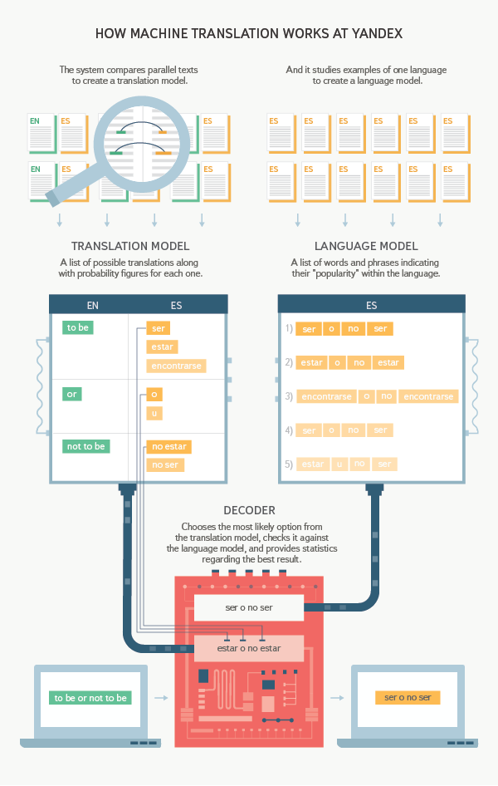

Yandex machine translation is based on the statistical approach. To learn a language, the system compares hundreds of thousands of parallel texts that translate each other “sentence by sentence”. It has two main components: the translation model and the language model.

The translation model constructs a graph containing all the possible ways to translate a sentence. The language model selects the best translation in terms of the optimal word combinations in natural language.

The translation model learns from extensive bilingual parallel corpora. The language model is built from large single-language corpora, and contains all the language's most frequent n-word combinations. N may be from 1 to 7 (usually 5).

Yandex uses BLEU metrics to automatically evaluate the quality of machine translation; it determines the percent of n-grams (n<=4) that match between the machine translation and the standard translation of a sentence. Translations are usually manually rated for two factors, Adequacy and Fluency, using a 5-point scale.

# Firebase

**Firebase** is a mobile and web application platform with tools and infrastructure designed to help developers build high-quality apps. Firebase is made up of complementary features that developers can mix-and-match to fit their needs. The team is based in [San Francisco](https://en.wikipedia.org/wiki/San_Francisco) and [Mountain View, California](https://en.wikipedia.org/wiki/Mountain_View,_California). The company was founded in 2011 by Andrew Lee and James Tamplin.[[1]](https://en.wikipedia.org/wiki/Firebase" \l "cite_note-crunch2011-1) Firebase's initial product was a realtime database, which provides an [API](https://en.wikipedia.org/wiki/API) that allows developers to store and sync data across multiple clients. Over time, it has expanded its product line to become a full suite for app development. The company was acquired by [Google](https://en.wikipedia.org/wiki/Google) in October 2014 and a significant number of new features were featured in May 2016 at [Google I/O](https://en.wikipedia.org/wiki/Google_I/O).[[6]](https://en.wikipedia.org/wiki/Firebase" \l "cite_note-6)

**Firebase** is a mobile and web application platform with tools and infrastructure designed to help developers build high-quality apps. Firebase is made up of complementary features that developers can mix-and-match to fit their needs. The team is based in [San Francisco](https://en.wikipedia.org/wiki/San_Francisco) and [Mountain View, California](https://en.wikipedia.org/wiki/Mountain_View,_California). The company was founded in 2011 by Andrew Lee and James Tamplin.[[1]](https://en.wikipedia.org/wiki/Firebase" \l "cite_note-crunch2011-1) Firebase's initial product was a realtime database, which provides an [API](https://en.wikipedia.org/wiki/API) that allows developers to store and sync data across multiple clients. Over time, it has expanded its product line to become a full suite for app development. The company was acquired by [Google](https://en.wikipedia.org/wiki/Google) in October 2014 and a significant number of new features were featured in May 2016 at [Google I/O](https://en.wikipedia.org/wiki/Google_I/O).[[6]](https://en.wikipedia.org/wiki/Firebase" \l "cite_note-6)