<https://www.youtube.com/watch?v=uCleiJw40Kw>

<https://www.google.com/search?source=hp&ei=1sxiXLjCIMuc9QO216zQCw&q=tomcat+build+deployment+using+jenkins+and+ssh+plugin+on+centos+7&btnK=Google+Search&oq=tomcat+build+deployment+using+jenkins+and+ssh+plugin+on+centos+7&gs_l=psy-ab.3...3204.60324..60497...10.0..4.1044.12876.0j46j8j3j0j1j1j1......0....1..gws-wiz.....0..0i131j0j0i10j0i22i30j33i22i29i30j33i160j33i21.HZfyvZUlfHQ#btnK=Google%20Search&kpvalbx=1>

<https://medium.com/@Alibaba_Cloud/ci-cd-with-jenkins-part-3-use-jenkins-for-continuous-delivery-2519ce773a6>

<https://medium.com/finoit/continues-integration-using-jenkins-for-java-spring-4439ecd23bec>

(Tomcat issue in jenkins)

Conf/server.xml file

<Host name="localhost" appBase="webapps"

unpackWARs="true" autoDeploy="true">

<Context path="" docBase="erp"/>

<https://www.youtube.com/watch?v=cbUqgS82d48> (angular)

<https://www.youtube.com/watch?v=cbUqgS82d48> (Angular1)

<https://stackoverflow.com/questions/52170298/jenkins-angular-how-to-execute-ng-build-after-git-push/52179023> (angular)

<https://www.youtube.com/watch?v=QvFungzXI5s> ( role strategy

<https://github.com/gayatri-sa/samplejava.git> (java project)

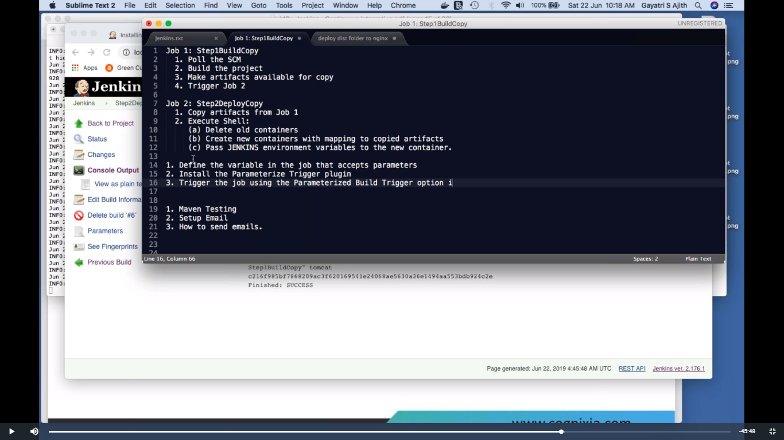

+++++++++++++++++++++++++++++++++++++++++++++++++++++++++++++++++++++++++++++++++++++

Start

<https://www.youtube.com/watch?v=nE4b9mW2ym0> (Job deployment using Jenkins & Ansible)

<https://github.com/ValaxyTech/hello-world.git> (Valaxy)

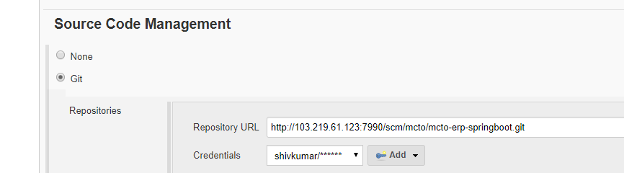

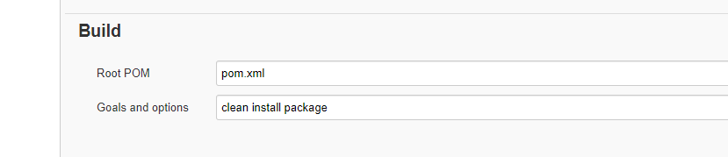

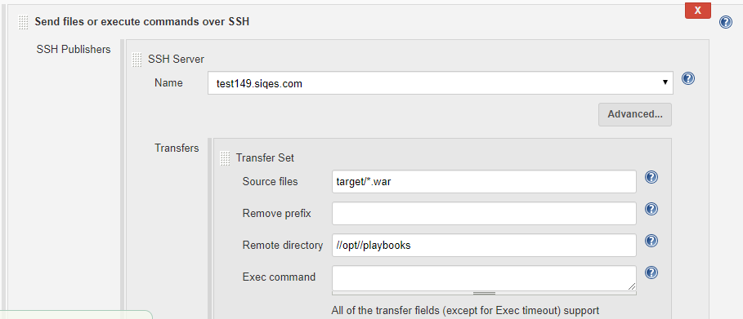

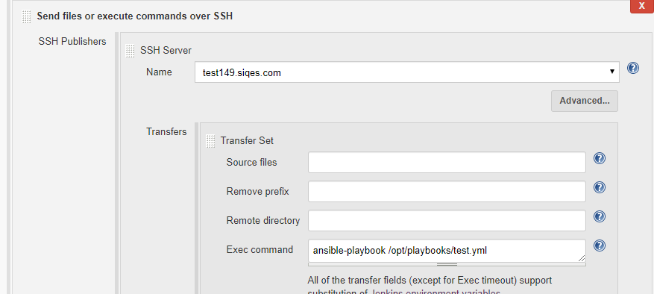

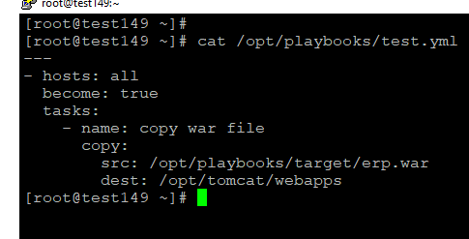

End

++++++++++++++++++++++++++++++++++++++++++++++++++++++++++++++++++++++++++++++++

<https://www.youtube.com/watch?v=CXdfVJxK1OQ> (email notification)

(push image in docker hun and run container

<https://www.youtube.com/watch?v=gdbA3vR2eDs> (javahome pipeline/cicd)

<https://github.com/javahometech/my-app>

++++++++++++++++++++++++++++++++++++++++++++++

**How to push image in docker hub**

Docker login

Sshd authentication yes

Ownership of dockeadmin(username)

Chown –R dockeradmin:dockeradmin /opt/docker (directory where dockerfile and war file to be copied)

Username should be docker group)

Docker –a –G docker dockeradmin

Create job- add repo (pom.xml clean package)

Copy or exeute publish over ssh (create **three** copy or execute publichs over ssh )

1. (source /webapp/target/*.war)
2. (source Dockerfile)
3. Below command

cd /opt/docker

docker build -t shivg09/app:65 .

docker login -u shivg09 -p Shi0800

docker push shivg09/app:65

+++++++++++++++++++++++++++++++++en

<https://www.youtube.com/watch?v=GQZYpIRxi-g> (Jenkins + s3 artifact)

++++++++++++++++++

<https://www.youtube.com/watch?v=uCleiJw40Kw> (java Home)

node{

stage('Scm CheckOut'){

git 'https://github.com/javahometech/my-app'

}

stage('Mvn Package'){

def mvnHome = tool name: 'mvn3.6.1', type: 'maven'

def mvnCMD="${mvnHome}/bin/mvn"

sh label: '', script: "${mvnCMD} clean package"

}

stage('deploy war'){

sshagent(['tomcat1']) {

sh label1: '', script: "scp -o StrictHostKeyChecking=no target/*.war root@192.168.1.149:/opt/tomcat/webapps"

}

}

}

++++++++++++++++++++++++

<http://cloudnixpro.com/2019/04/19/jenkins-project-java-maven/> ()

<https://github.com/aniket-8158/devops_java.git>

+++++++++++++++++++++++

node {

stage('Scm Checkout'){

git 'https://github.com/javahometech/my-app'

}

stage('Mvn Package'){

def mvnHome = tool name: 'MAVEN_HOME', type: 'maven'

def mvnCMD = "${mvnHome}/bin/mvn"

sh "${mvnCMD} clean package"

}

stage('buikd docker image'){

sh "docker build -t shivg09/testapp:101 ."

}

stage('docker image push'){

withCredentials([string(credentialsId: 'dockerpwd', variable: 'DockerHUB')]) {

sh "docker login -u shivg09 -p ${DockerHUB}"

}

sh "docker push shivg09/testapp:101"

}

stage('deploy docker container'){

def DockerRun = 'docker run -it -p 8080:8080 shivg09/testapp:101'

sshagent(['agentr']) {

sh "ssh root@192.168.1.149 ${DockerRun}"

}

}

}

+++++++++++++++++++++++++++

<https://github.com/aniket-8158/devops_java.git>