<https://www.youtube.com/watch?v=XokLzvcB4pY>

<https://mail.google.com/mail/u/1/#inbox/QgrcJHrhwzhHLGfShWpqDNGszzxbVTmpQgG?projector=1>

<https://www.quora.com/How-do-I-learn-Python-for-scripting>

<http://docs.linuxtone.org/ebooks/Python/OReilly.Python.for.Unix.and.Linux.System.Administration.Sep.2008.pdf>

<https://www.ibm.com/developerworks/aix/library/au-python/index.html> (scripting )

not working script list

1. /home/py/process.py
2. Sync
3. Delete.py

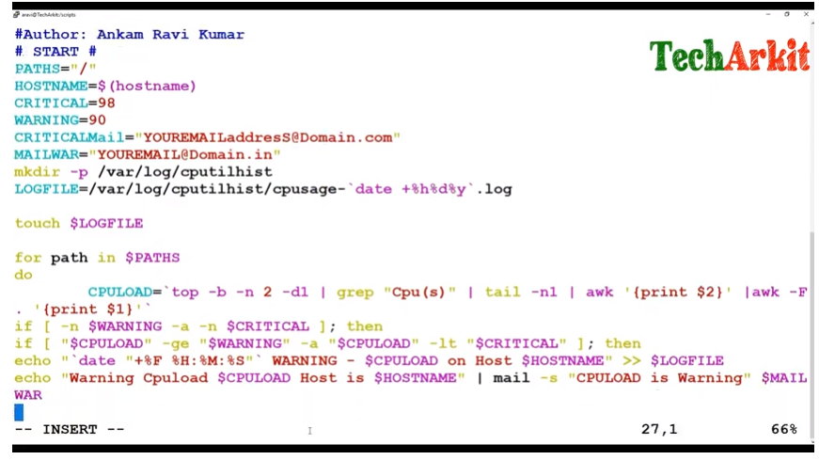

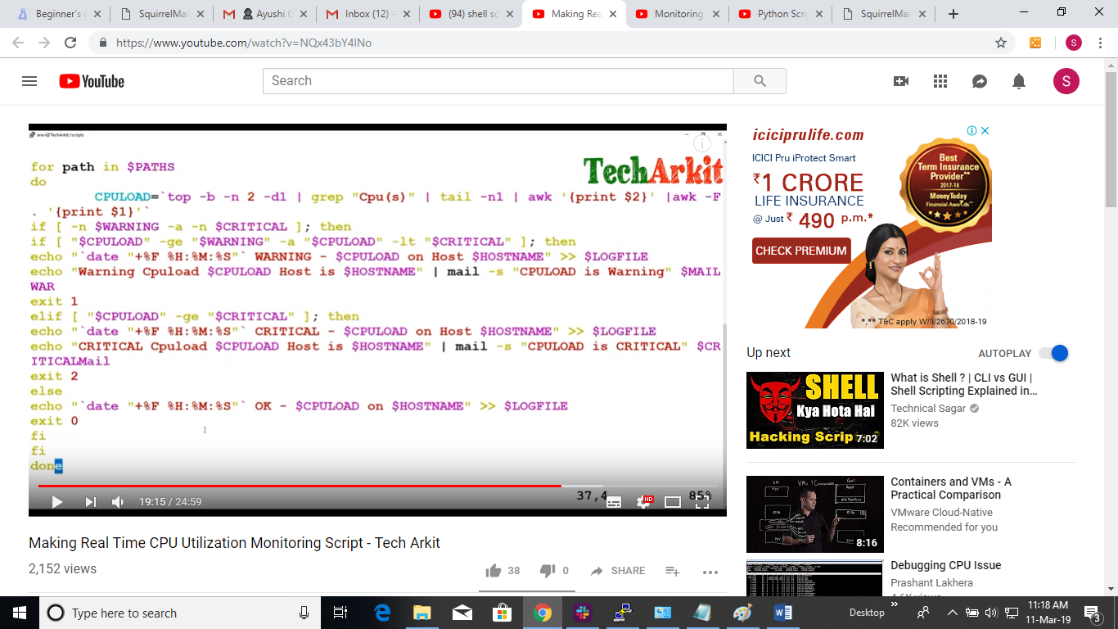

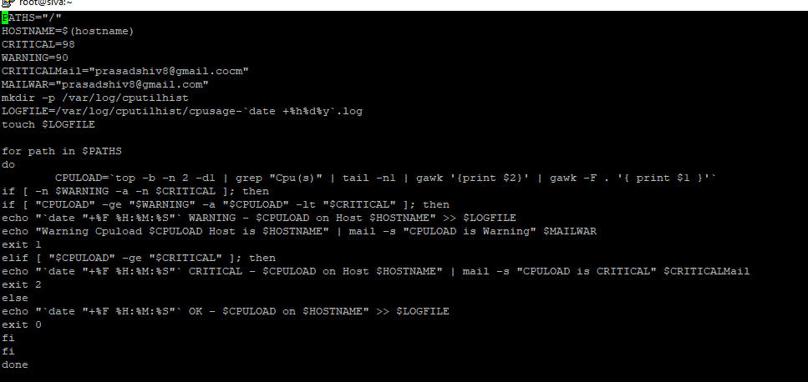

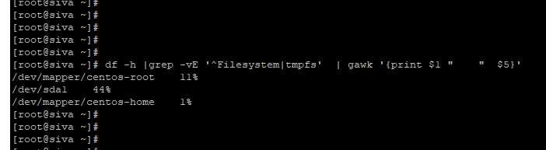

Date 11 march (Python)

<https://www.youtube.com/watch?v=tJxcKyFMTGo>

<https://www.youtube.com/watch?v=Uh2ebFW8OYM>

<https://www.youtube.com/watch?v=DEwgZNC-KyE>

<https://www.youtube.com/watch?v=q5uM4VKywbA>

<https://www.youtube.com/watch?v=YYXdXT2l-Gg&list=PL-osiE80TeTt2d9bfVyTiXJA-UTHn6WwU>

<https://www.youtube.com/watch?v=bkpLhQd6YQM>

Virtual Env in Python

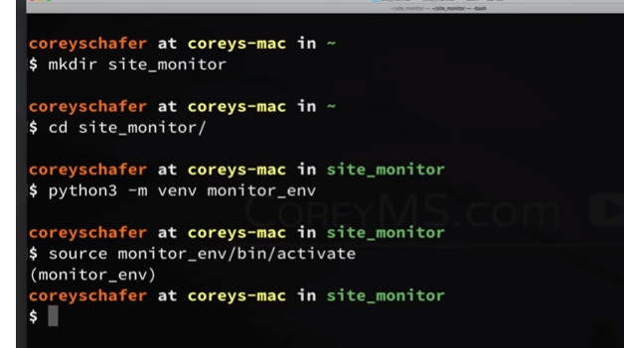

<https://www.youtube.com/watch?v=yqm6MBt-yfY&t=2479s> (SCRIPT to monitor website)

<https://github.com/CoreyMSchafer/code_snippets/blob/master/Python/Site-Monitor/monitor.py>

Environment variable- <https://www.youtube.com/watch?v=5iWhQWVXosU>

<https://coreyms.com/category/development/python/page/2>