**Academia Installations Ubuntu**

**There are 3 step installation on Three separate server**

1. **Install mysql server 5.6**
2. **Install tomcat server with java**
3. **Install Apache web server**

**1 Step For Databases server**

**sudo apt-get install mysql-server-5.6** 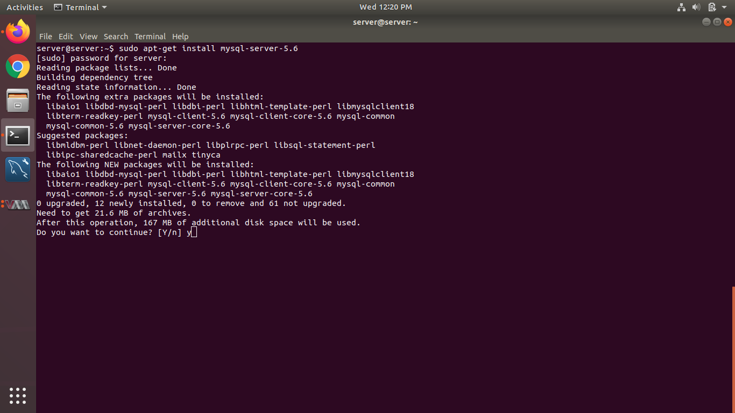

**Set Mysql root user password** 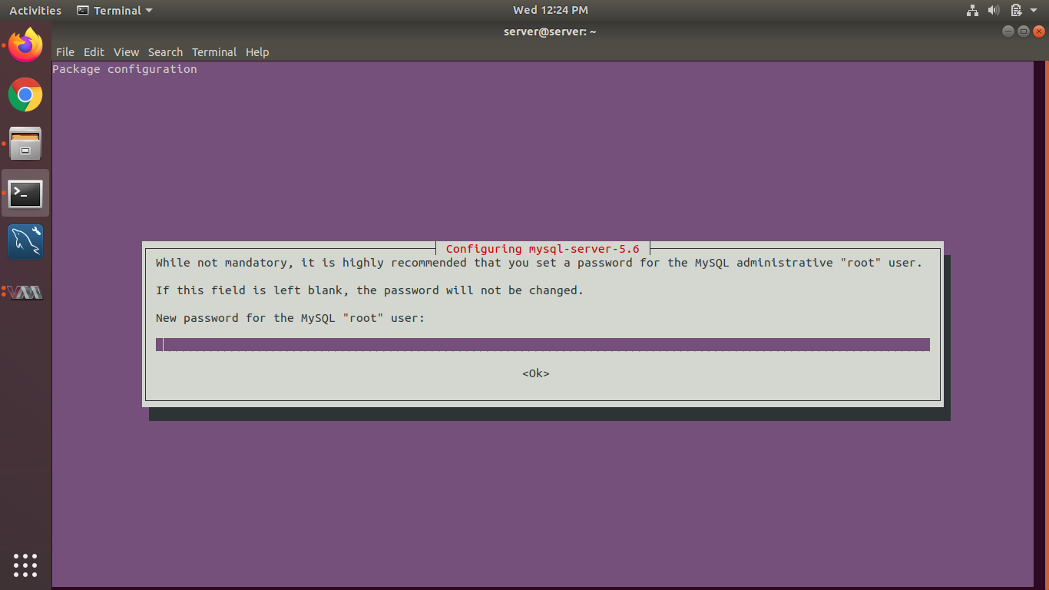

**Check mysql service status .**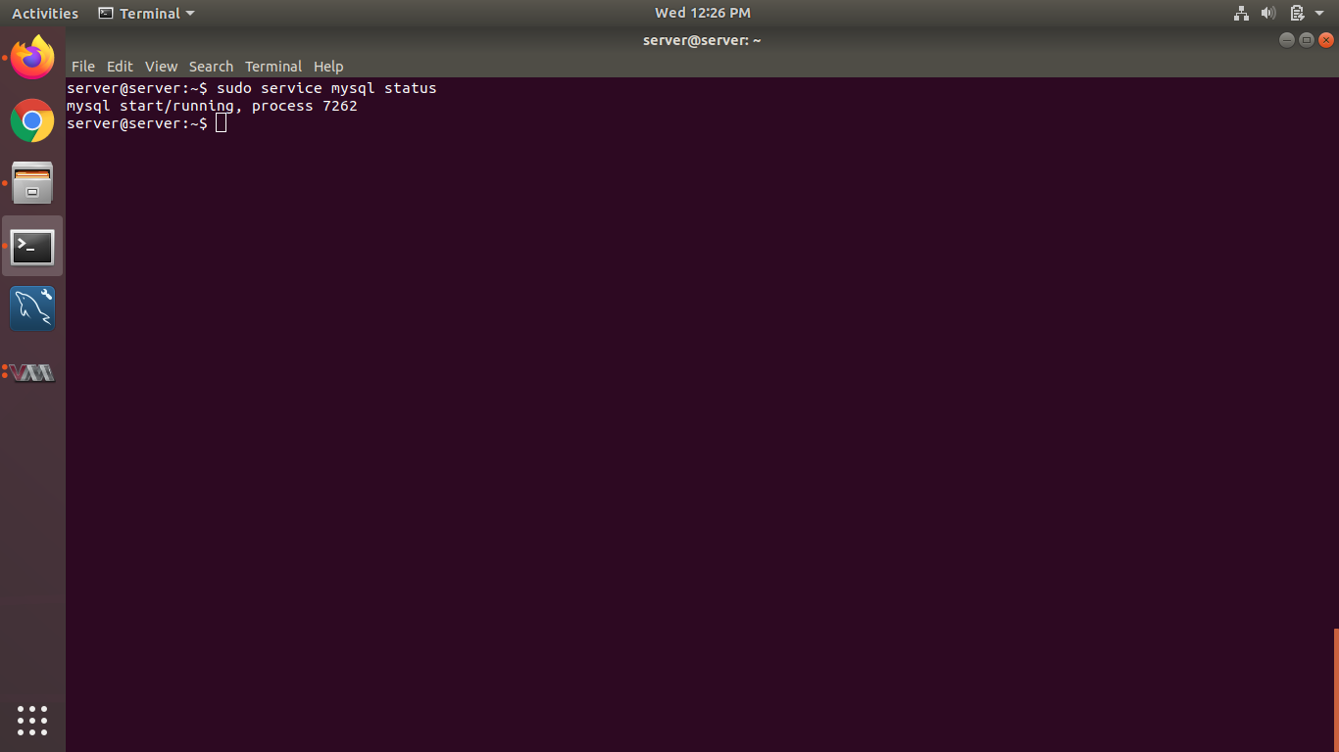

**Run mysql_secure_installation**

**Enter current password for root (enter for none): Provide root password**

**Change the root password? [Y/n] n**

**Remove anonymous users? [Y/n] y**

**Disallow root login remotely? [Y/n] y**

**Remove test database and access to it? [Y/n] y**

**Reload privilege tables now? [Y/n] y**

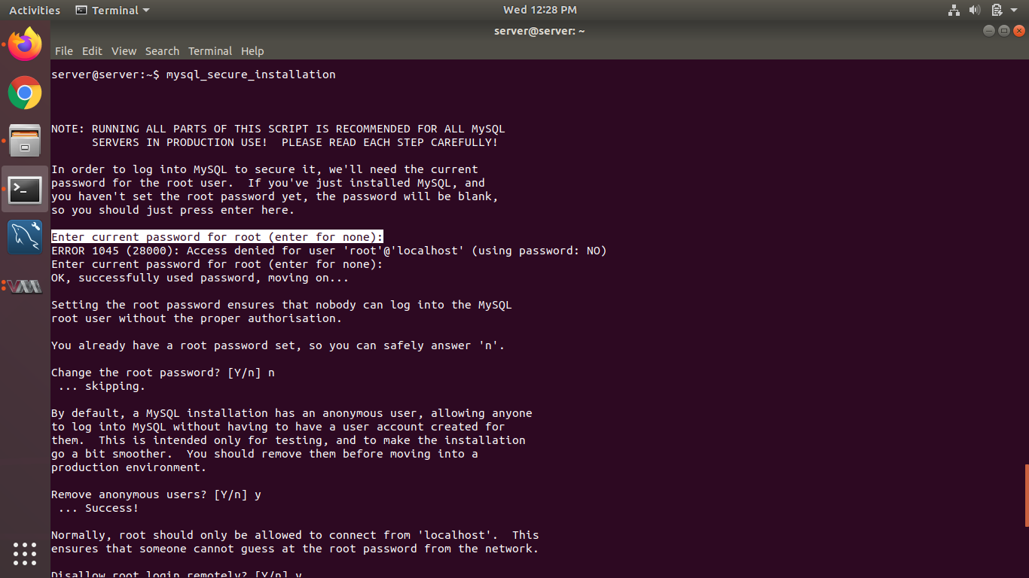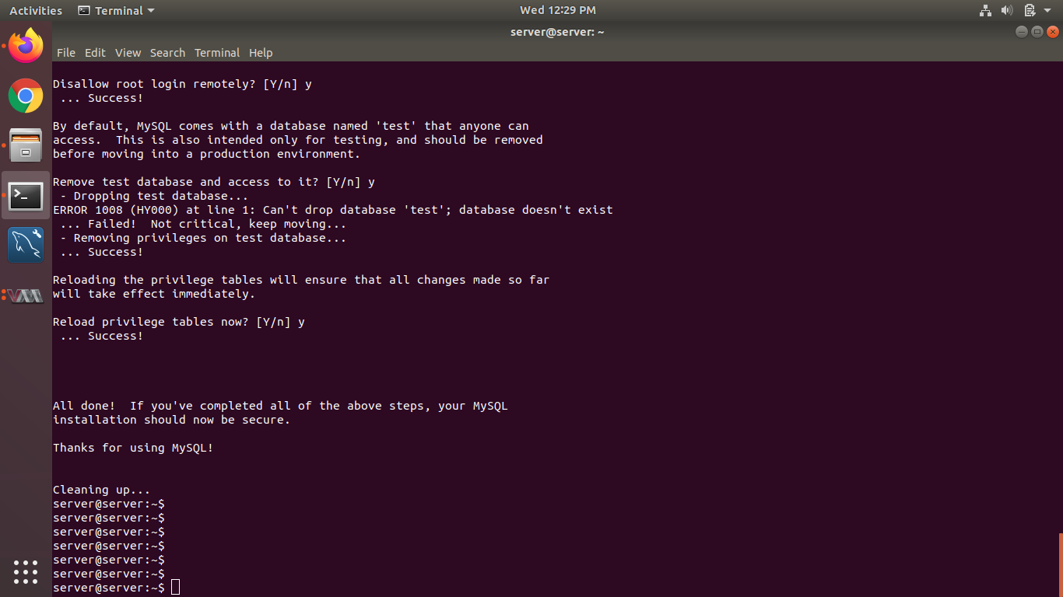

**Then restart mysql service and login in mysql**

**sudo service mysql restart**

**mysql -u root -p type root password**

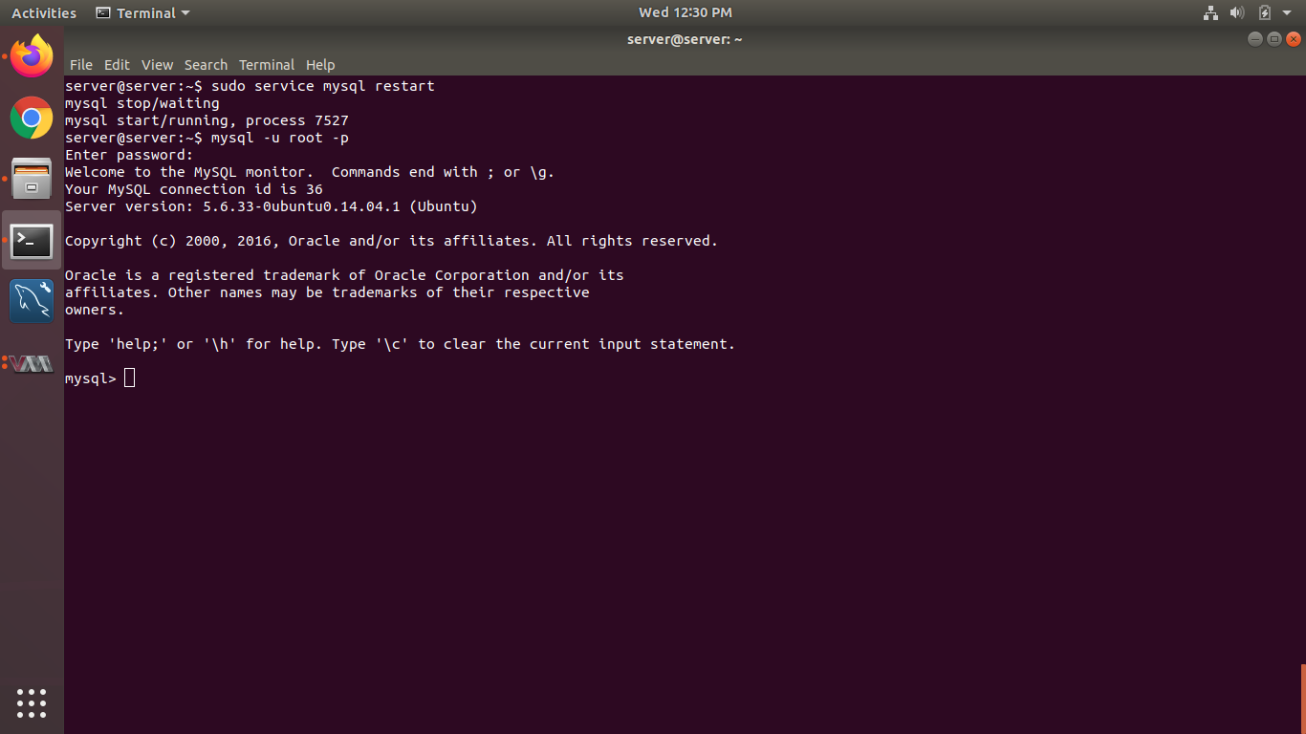

**Then create new user ss_root with grant option .**

**SET GLOBAL validate_password_policy=LOW;**

**create user 'ss_root'@'%' identified by 's3r0s0ft';**

**grant all privileges on *.* to 'ss_root'@'%' with grant option;**

**flush privileges;**

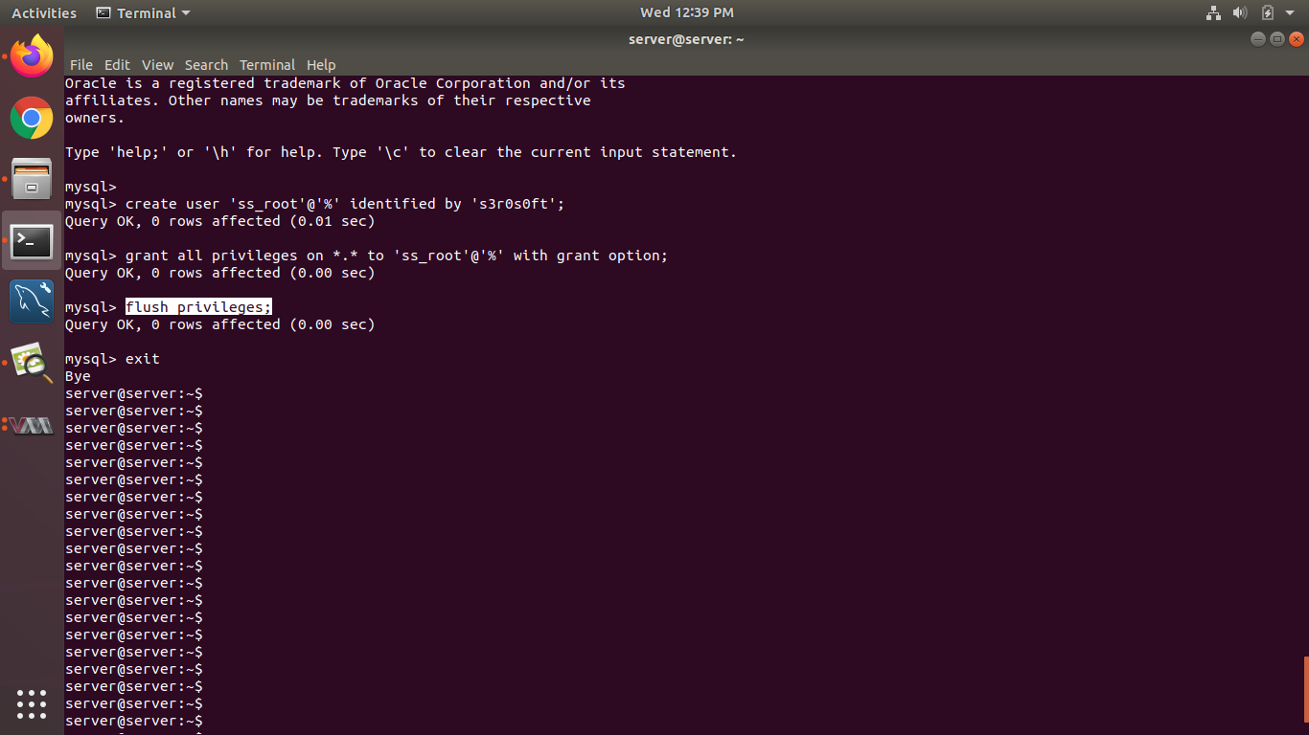

**Set max_connections and innodb_buffer_pool_size in my.cnf file as per Server physical ram**

**sudo vim /etc/mysql/my.cnf**

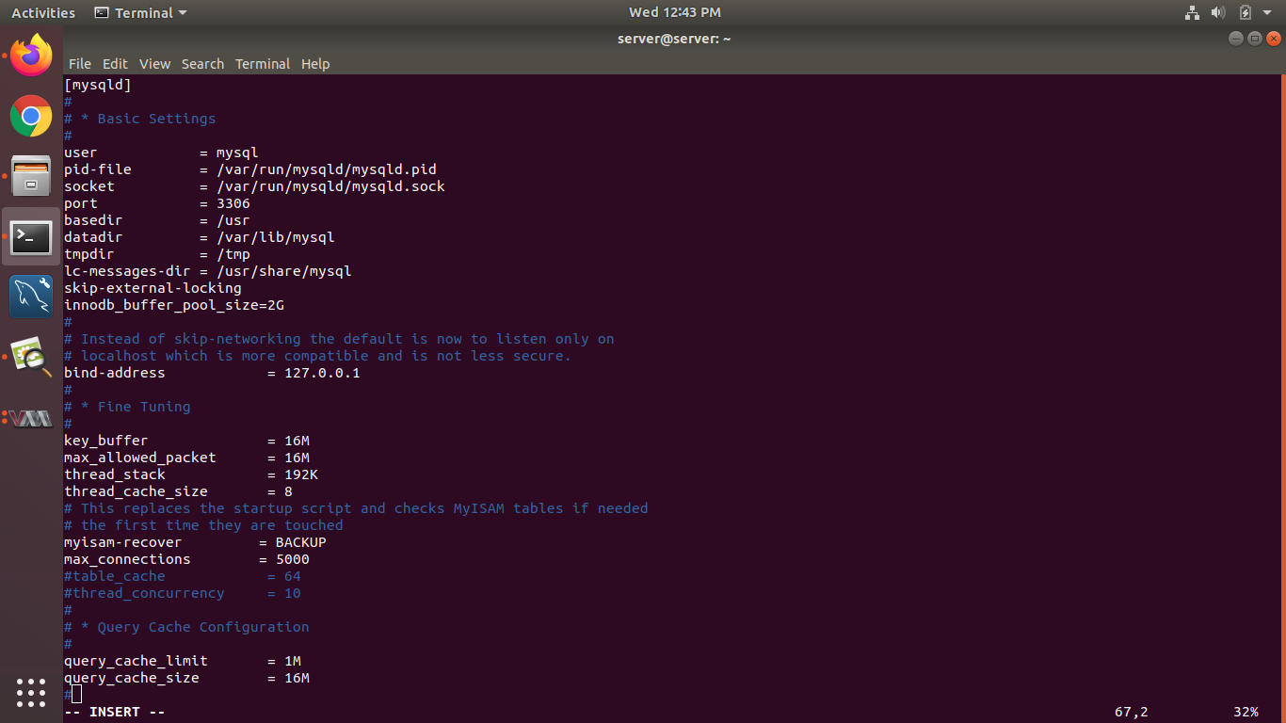

**And comment #bind-address**

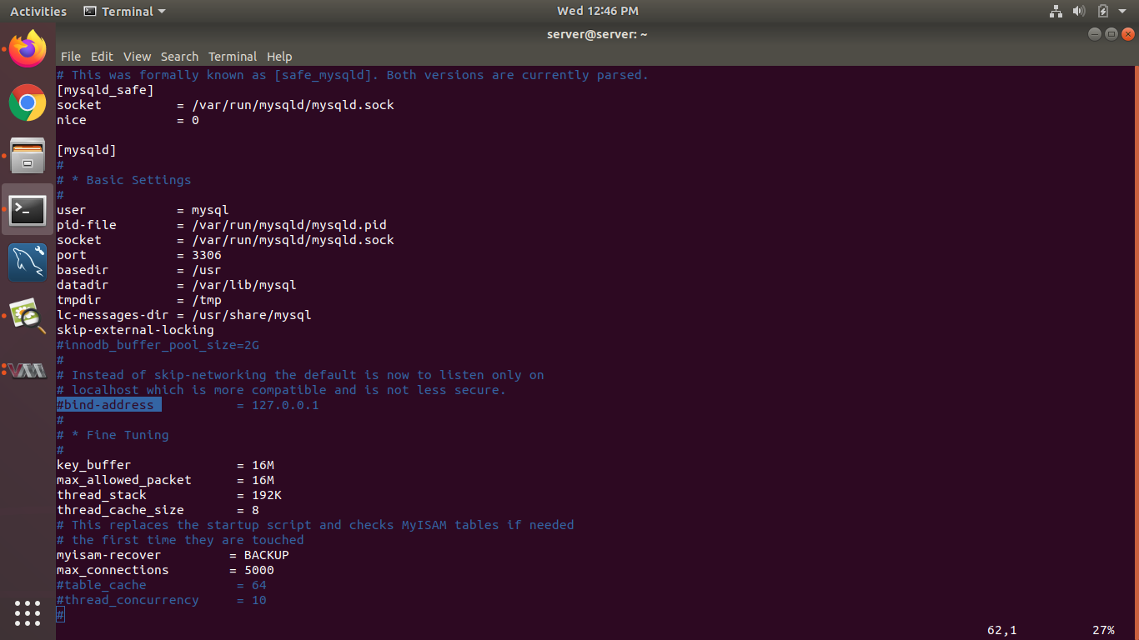

**Then restart mysql service**

**sudo service mysql restart**

**Check mysql port listen or not**

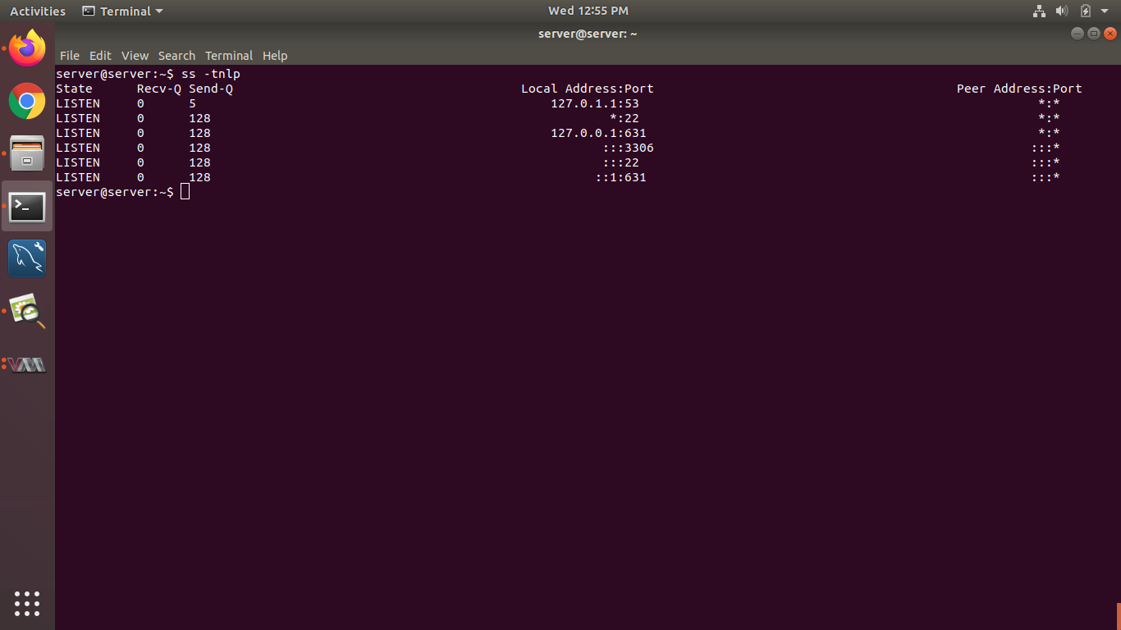

**Disable ufw**

**sudo ufw disable**

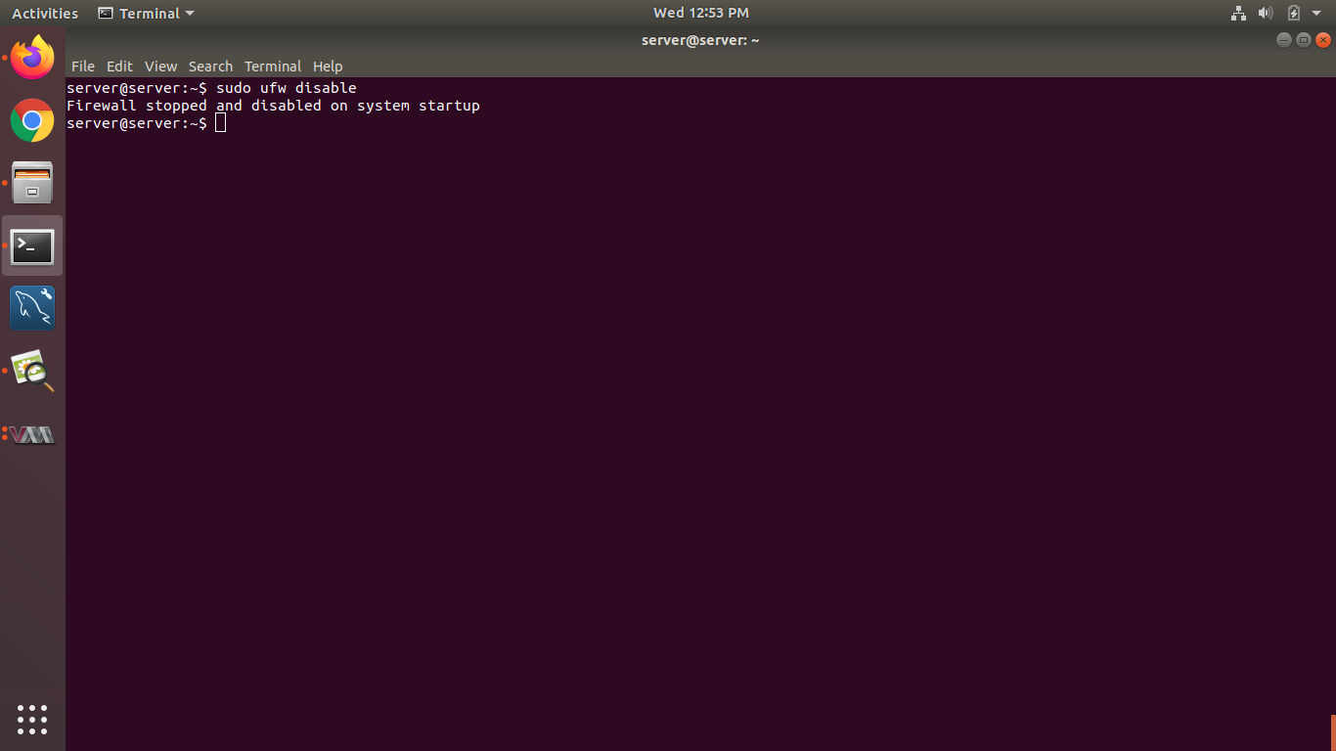

**Restore db File Provide by serosoft**

**mysql -u ss_root -p < abc.sql**

**Step 2 for Tomcat server**

**Install java 8**

**sudo add-apt-repository ppa:openjdk-r/ppa**

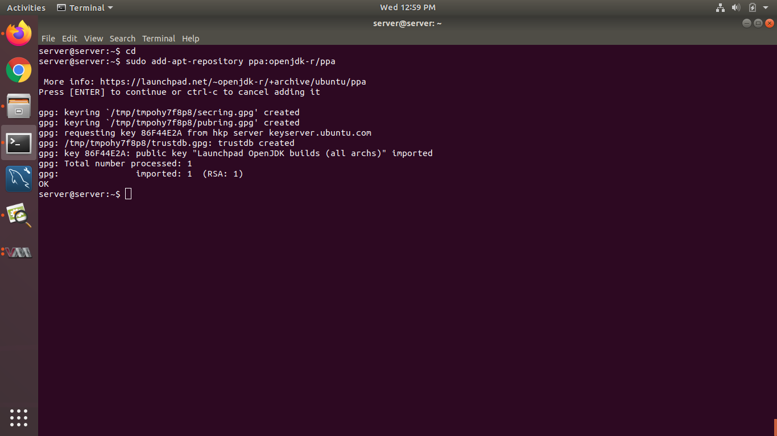

**Update repo**

**s0udo apt-get update**

**sudo apt-get install openjdk-8-jdk**

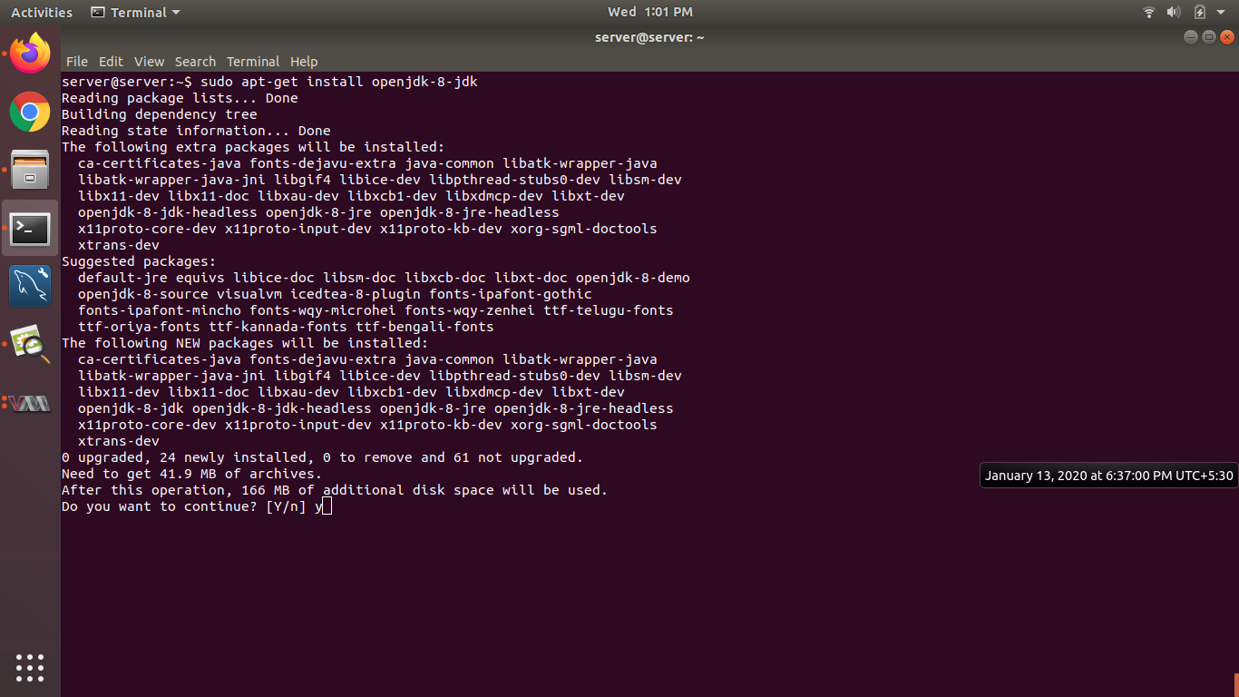

**Check java version**

**java -version**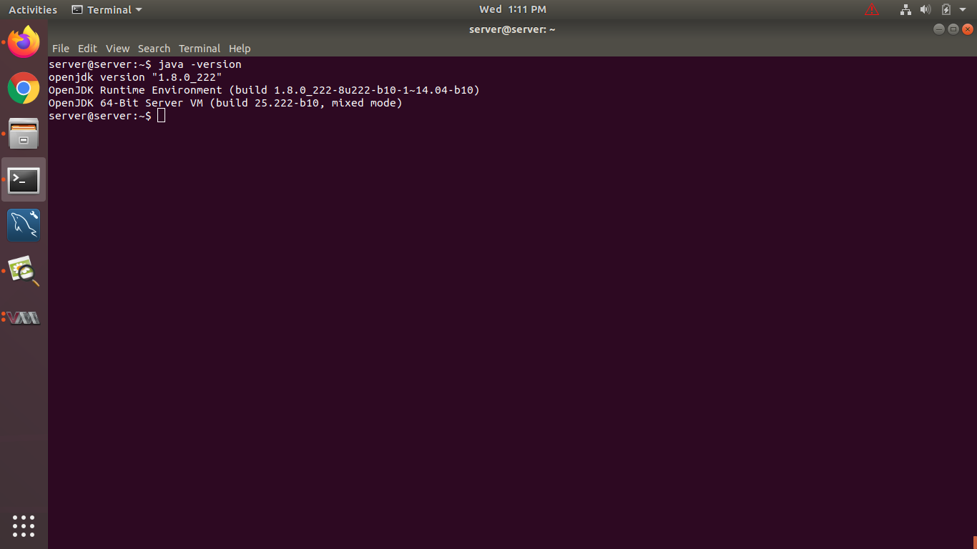

**Create serosoft folder in /opt**

**sudo mkdir /opt/serosoft**

**cd /opt/serosoft/**

**sudo wget** [**https://archive.apache.org/dist/tomcat/tomcat-9/v9.0.21/bin/apache-tomcat-9.0.21.zip**](https://archive.apache.org/dist/tomcat/tomcat-9/v9.0.21/bin/apache-tomcat-9.0.21.zip)

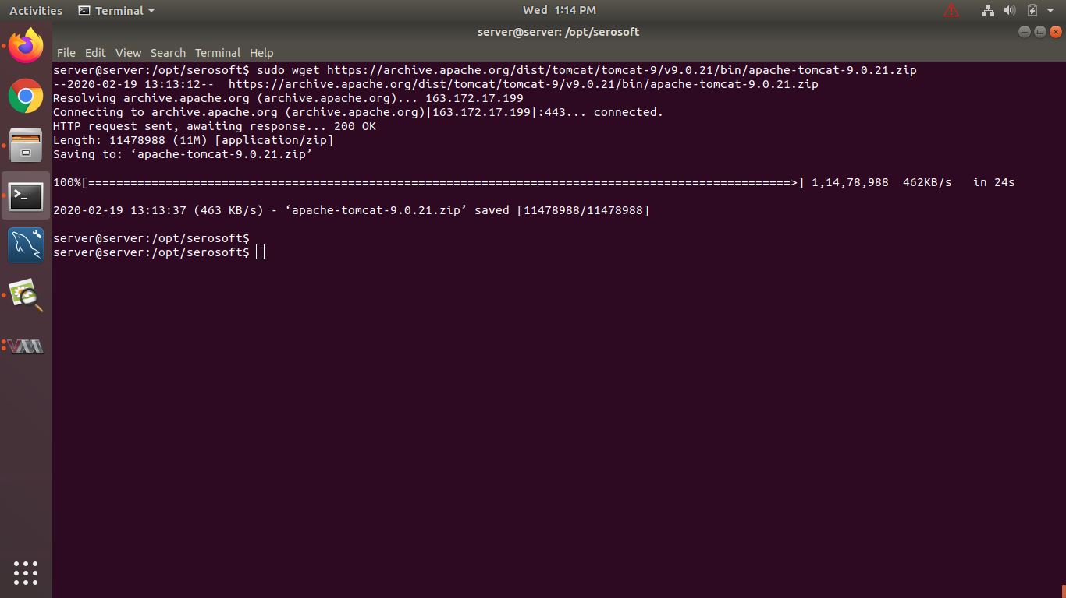

**sudo apt-get install unzip zip**

**sudo unzip apache-tomcat-9.0.21.zip**

**cd apache-tomcat-9.0.21/bin/**

**sudo vim setenv.sh and paste below lines in setenv.sh and save**

**export JAVA_OPTS="$JAVA_OPTS -Xmx6000m -Xms800m -XX:MaxPermSize=800m -Xverify:none -Djava.awt.headless=true -Dfile.encoding=UTF-8 -XX:+ExplicitGCInvokesConcurrent -XX:+UseConcMarkSweepGC -XX:+UseParNewGC -XX:ParallelGCThreads=4 -XX:+CMSClassUnloadingEnabled -XX:CMSInitiatingOccupancyFraction=75 -XX:+UseCMSInitiatingOccupancyOnly -XX:+UseCompressedOops"**

**export JAVA_HOME='/usr/lib/jvm/java-8-openjdk-amd64/jre'**

**Note -change Xmx6000m -Xms800m -XX:MaxPermSize=800m as per server ram**

**Change permission 777**

**cd /opt/serosoft/apache-tomcat-9.0.21/bin**

**sudo chmod 777 \***

**Change ownership**

**sudo chown -R server:server /opt/ (Change as per your user)**

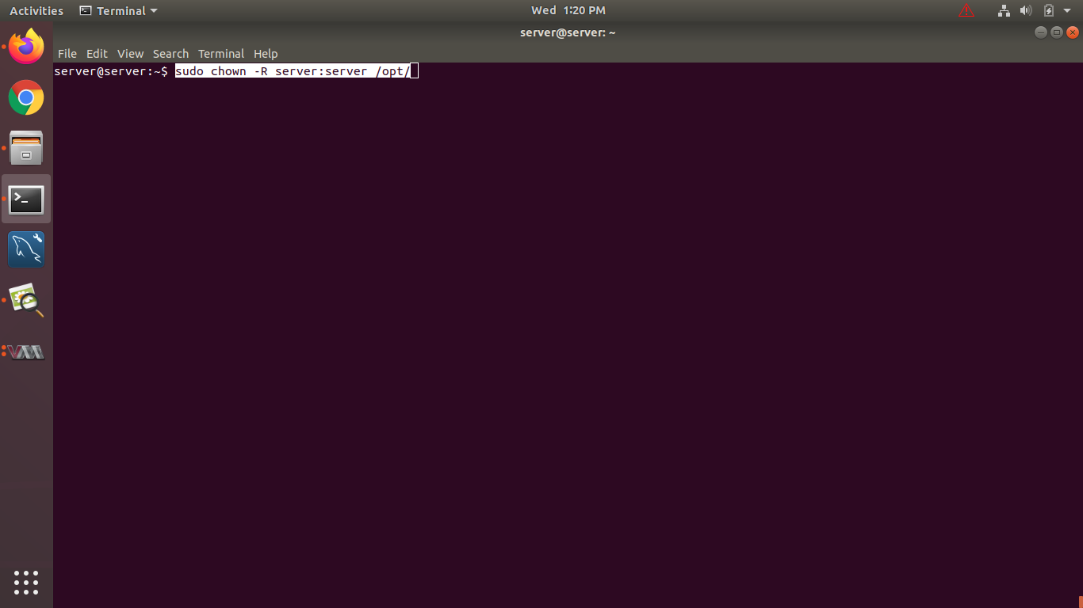

**Then start tomcat and check port no**

**cd /opt/serosoft/apache-tomcat-9.0.21/bin**

**sh startup.sh**

**ss -tnlp its 8080**

**ps -ef|grep tomcat**

**Put war files in /opt/serosoft/apache-tomcat-9.0.21/webapps (provide by serosoft)**

**And start tomcat**

**Cd /opt/serosoft/apache-tomcat-9.0.21/bin**

**sh startup.sh**

**For log**

**Cd /opt/serosoft/apache-tomcat-9.0.21/logs**

**tail -f catalina.out**

**cd /opt/serosoft/apache-tomcat-9.0.21/webapps**

**sudo cp -r africaudemo /var/www/html/ ( am copy africaudemo folder for demo)**

**Step 3 Install apache2**

**sudo apt-get install apache2**

**sudo apt-get install libapache2-mod-security2**

**sudo apt-get install libapache2-mod-jk**

**sudo apt-get install php libapache2-mod-php**

**sudo add-apt-repository ppa:ondrej/php**

**sudo apt-get update**

**sudo apt-get install php5-gd php5-intl php5-mcrypt php5 php5-cli php5-common php5-curl php5-fpm php5-json php5-mcrypt php5-memcache php5-mysql**

**Or**

**sudo apt-get install php7.2 php7.2-gd php7.2-intl php7.2-cli php7.2-common php7.2-curl php7.2-fpm php7.2-json php7.2-mbstring php7.2-mysql libapache2-mod-php7.2**

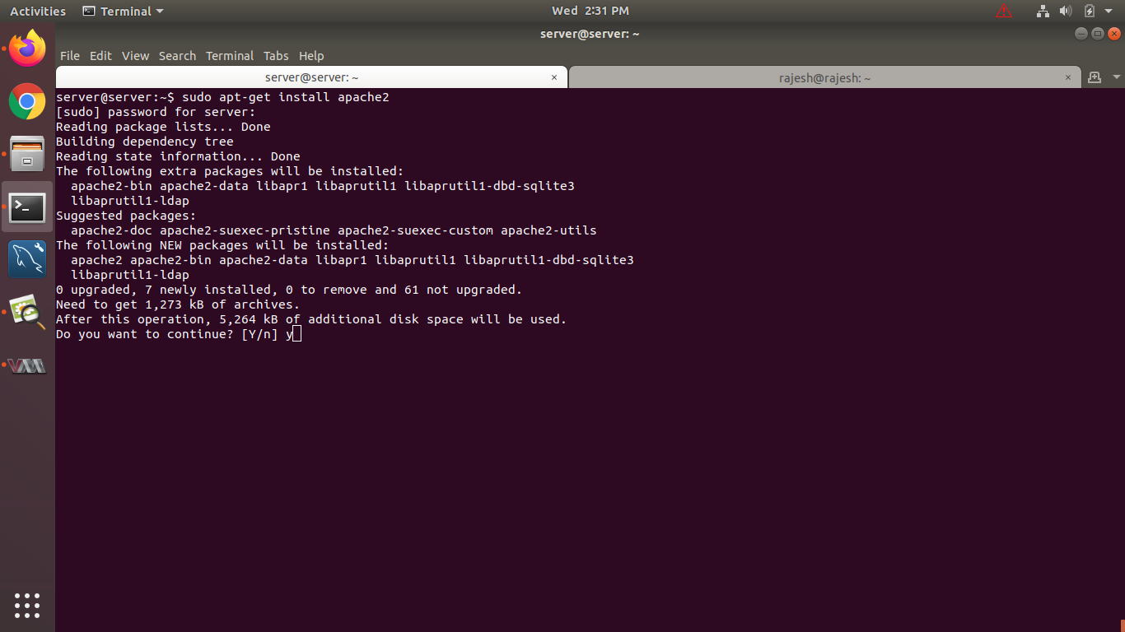

**Check php module**

**php -m**

**Bcmath bz2 calendar Core ctype curl date dba dom reg exif**

**Fileinfo filter ftp gd gettext hash iconv intl json libxml mbstring memcache mhash mysql mysqli openssl pcntl pcre PDO pdo_mysql Phar posix readlicdne Reflection session shmop**

**SimpleXML soap sockets SPL standard sysvmsg sysvsem sysvshm tokenizer wddx xml**

**Xmlreader xmlwriter Zend OPcache zip zlib**

Create worker properties file

**sudo vim /etc/apache2/workers.properties**

Add following line into workers.properties by press “ **i** ”

**# Define 1 real worker using ajp13**

**worker.list=worker1**

**# Set properties for worker (ajp13)**

**worker.worker1.type=ajp13**

**worker.worker1.host=localhost**

**worker.worker1.port=8009**

**sudo vim /etc/apache2/mods-available/jk.conf (Update jk.conf file)**

**JkWorkersFile /etc/apache2/workers.properties** (add this line)

**# JkWorkersFile /etc/libapache2-mod-jk/workers.properties** (comment this line)

**Note - for tomcat port**

**cd /opt/serosoft/apache-tomcat-9.0.21/conf/**

**vim server.xml**

<Connector port="8009" protocol="AJP/1.3" redirectPort="8080" /> (Uncomment this line and change server port 8443 to 8080)

Create conf file

**sudo vim /etc/apache2/sites-available/blank.academiaerp.com.conf**

**And past below config**

**-------------------------------------------------------------------------------------------------------------------------------**

**<VirtualHost *:80>**

**# The ServerName directive sets the request scheme, hostnameJkWorkersFile /etc/apache2/workers.properties and port that**

**# the server uses to identify itself. This is used when creating**

**# redirection URLs. In the context of virtual hosts, the ServerName**

**# specifies what hostname must appear in the request's Host: header to**

**# match this virtual host. For the default virtual host (this file) this**

**# value is not decisive as it is used as a last resort host regardless.**

**# However, you must set it for any further virtual host explicitly.**

**#ServerName www.example.com**

**ServerName africaudemo.academiaerp.com**

**ServerAlias www.africaudemo.academiaerp.com**

**DocumentRoot /var/www/html/africaudemo/**

**Redirect / https://africaudemo.academiaerp.com/**

**#SSLEngine on**

**#SSLCertificateFile /etc/apache2/ssl/server.crt**

**#SSLCertificateKeyFile /etc/apache2/ssl/server.key**

**#SSLCertificateChainFile /etc/apache2/ssl/server.csr**

**</VirtualHost>**

**<VirtualHost *:443>**

**ServerName africaudemo.academiaerp.com**

**ServerAlias www.africaudemo.academiaerp.com**

**RewriteEngine on**

**# RewriteLog logs/apache-mod_rewrite**

**RewriteRule ^/rest/(.*)$ /africaudemo/rest/$1 [L,PT]**

**RewriteRule ^/oauth/(.*)$ /africaudemo/oauth/$1 [L,PT]**

**RewriteRule ^/logout /africaudemo/logout [L,PT]**

**RewriteRule ^/*.jsp/(.*)$ /africaudemo/*.jsp/$1 [L,PT]**

**RewriteRule ^/resources/images/uploads/PERSON/(.*)$ /africaudemo/resources/images/uploads/PERSON/$1 [L,PT]**

**ServerAdmin webmaster@localhost**

**DocumentRoot /var/www/html/africaudemo/**

**# AliasMatch "/oauth/(.*)$" "/uoa/oauth/$1"**

**# Available loglevels: trace8, ..., trace1, debug, info, notice, warn,**

**# error, crit, alert, emerg.**

**# It is also possible to configure the loglevel for particular**

**# modules, e.g.**

**#LogLevel info ssl:warn**

**ErrorLog ${APACHE_LOG_DIR}/integration_amazon.error.log**

**CustomLog ${APACHE_LOG_DIR}/integration_amazon.access.log combined**

**#For Caching**

**CacheQuickHandler off**

**CacheLock on**

**CacheLockPath /tmp/mod_cache-lock**

**CacheLockMaxAge 5**

**CacheIgnoreHeaders Set-Cookie**

**<Location />**

**CacheEnable disk**

**CacheHeader on**

**CacheDefaultExpire 600**

**CacheMaxExpire 86400**

**CacheLastModifiedFactor 0.5**

**</Location>**

**# For most configuration files from conf-available/, which are**

**# enabled or disabled at a global level, it is possible to**

**# include a line for only one particular virtual host. For example the**

**# following line enables the CGI configuration for this host only**

**# after it has been globally disabled with "a2disconf".**

**#Include conf-available/serve-cgi-bin.conf**

**# JkMount /tomcat-demo* worker1**

**# Send JSPs for context /examples to worker named worker1**

**JkMount /africaudemo/rest/* worker1**

**JkMount /africaudemo/oauth/* worker1**

**JkMount /africaudemo/logout worker1**

**JkMount /africaudemo/*.jsp worker1**

**JkMount /africaudemo/resources/images/uploads/PERSON/* worker1**

**# Other directives here**

**<Directory />**

**Options FollowSymLinks**

**AllowOverride None**

**</Directory>**

**<Directory /var/www/html/africaudemo>**

**Options Indexes FollowSymLinks MultiViews**

**AllowOverride All**

**Order allow,deny**

**allow from all**

**</Directory>**

**SSLEngine on**

**SSLCertificateFile /etc/apache2/ssl/server.crt**

**SSLCertificateKeyFile /etc/apache2/ssl/server.key**

**SSLCertificateChainFile /etc/apache2/ssl/server.csr**

**AccessFileName .htaccess**

**</VirtualHost>**

**--------------------------------------------------------------------------------------------------------------------------**

**africaudemo is name of folder in /var/www/html**

**-----------------------------------------------------------------------------------------------------------------------------**

**Copy ssl certificate files in /etc/apache2/ssl folder**

**Enable deflate**

**sudo vim /etc/apache2/mods-enabled/deflate.conf (copy past below text)**

**------------------------------------------------------------------------------------------------**

**<IfModule mod_deflate.c>**

**<IfModule mod_filter.c>**

**# these are known to be safe with MSIE 6**

**AddOutputFilterByType DEFLATE text/html text/plain text/xml**

**# everything else may cause problems with MSIE 6**

**AddOutputFilterByType DEFLATE text/css**

**AddOutputFilterByType DEFLATE application/x-javascript application/javascript application/ecmascript**

**AddOutputFilterByType DEFLATE application/rss+xml**

**AddOutputFilterByType DEFLATE application/xml**

**AddOutputFilterByType DEFLATE image/png**

**AddOutputFilterByType DEFLATE application/json**

**AddOutputFilterByType DEFLATE font/woff**

**AddOutputFilterByType DEFLATE text/javascript**

**AddOutputFilterByType DEFLATE image/jpg**

**</IfModule>**

**</IfModule>**

**-----------------------------------------------------------------------------------------------**

**cd /etc/apache2/sites-available/**

**sudo a2enmod mod-security  
sudo a2enmod ssl  
sudo a2enmod cache  
sudo a2enmod rewrite  
sudo a2enmod jk  
sudo a2enmod headers  
sudo a2enmod deflate**

**sudo service apache2 restart**

**sudo a2ensite blank.academiaerp.com.conf**

**Change Permission on html folder   
cd /var/www/html/  
sudo chmod -R 755 africau  
sudo chown -R www-data:www-data africau**

**For Test PHP modue working or not**[**https://testing-cgc.academiaerp.com/writeFile.php**](https://testing-cgc.academiaerp.com/writeFile.php) **its show {"success":false} mens working properly..**