CalendarMate
Test Execution Log
Workflow: CalendarMate – Full (Single Workflow) | Prepared: 20 September 2026

1. Overview
This document records the prompts sent to the CalendarMate workflow in n8n, the PowerShell command used for each, the response observed in the n8n execution log, and the screenshot taken as evidence. Test numbers follow the original log; the log contains no test 11.

2. Test environment
Workflow | CalendarMate – Full (Single Workflow)
Platform | n8n Cloud (forn8n1984.app.n8n.cloud)
Test endpoint | POST https://forn8n1984.app.n8n.cloud/webhook-test/calendarmate/chat
Request | Content-Type application/json; body {"message": "<prompt>"}
Triggers exercised | Webhook – User Request1; Cron – Daily Briefing Trigger1
Tracing | Langfuse (Build OTel Payload → Log Trace to Langfuse1)
Test dates | 19–20 September 2026 (as shown in the screenshots)

3. Running a test
- In n8n, click Execute workflow (from Webhook – User Request1). The test URL listens for a single request after this click.
- Send the PowerShell command for the test.
- Read the result in the Logs panel, usually the Respond to Webhook1 output.

4. Test summary
ID | Prompt | Observed response | Figure
Cron | Cron trigger (no prompt) | Briefing for 20 Sep 2026 with two events; overlap flagged. | Fig. 1
T1 | What does my day look like today? | Schedule for 19 Sep 2026 (four items); overlap flagged. | Fig. 2
T2 | Give me a summary of my meetings for tomorrow? | Events listed for 19 Sep 2026; overlap flagged. | Fig. 3
T3 | Schedule a 30-minute meeting with shivkartik28@outlook.com tomorrow at 2pm. | Free at 2:00 PM IST on 20 Sep; confirmation prompt produced; run cancelled at approval. | Fig. 4
T4 | Set up a sync with the design team sometime this week. | Clarifying question: who is the meeting with (email). | Fig. 5
T5 | Find a time for a 1-hour meeting with john@ext.com and lisa@ext.com next Monday. | Three 60-minute slots proposed for Mon 21 Sep; external calendars not visible. | Fig. 6
T6 | Summarize my unread emails. | Response is a 19 Sep 2026 schedule; no email summary visible. | Fig. 7
T7 | What emails need my attention today? | Response is a 19 Sep 2026 schedule; no email content visible. | Fig. 8
T8 | Book a meeting but I forgot with whom. | Clarifying question: who should be included. | Fig. 9
T9 | Do I have any conflicts this week? | Schedule for 19 Sep 2026; overlap flagged. | Fig. 10
T10 | Schedule a meeting at the same time as my existing standup. | Clarifying question: date or attendees. | Fig. 11
T12 | What's happening next Thursday? | Clarifying question: who should be checked; no events listed. | Fig. 12

5. Detailed results
Each test below lists the prompt, the command that was sent, the response observed and the supporting screenshot.

Cron: Scheduled run: daily briefing (Cron trigger)
Trigger: Workflow executed from the Cron – Daily Briefing Trigger1 node (no webhook call).
Observed response: Briefing for 20 Sep 2026 listing two events (Project call-Imp 14:30–15:30, Program Call 15:00–16:00) with an overlap flagged.
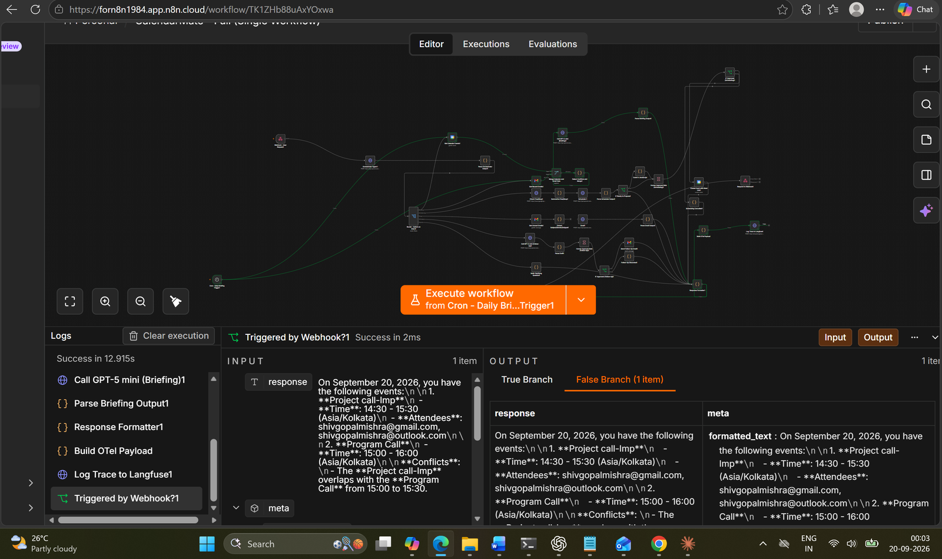
Figure 1: Cron run. Execution log: Triggered by Webhook?1 output (false branch)

T1: What does my day look like today?
Prompt: What does my day look like today?
Command
Invoke-RestMethod -Uri "https://forn8n1984.app.n8n.cloud/webhook-test/calendarmate/chat" -Method POST -ContentType "application/json" -Body '{"message": "What does my day look like today?"}'
Observed response: Schedule for 19 Sep 2026 with four items; overlap flagged between Project Discussion and Program Discussion.
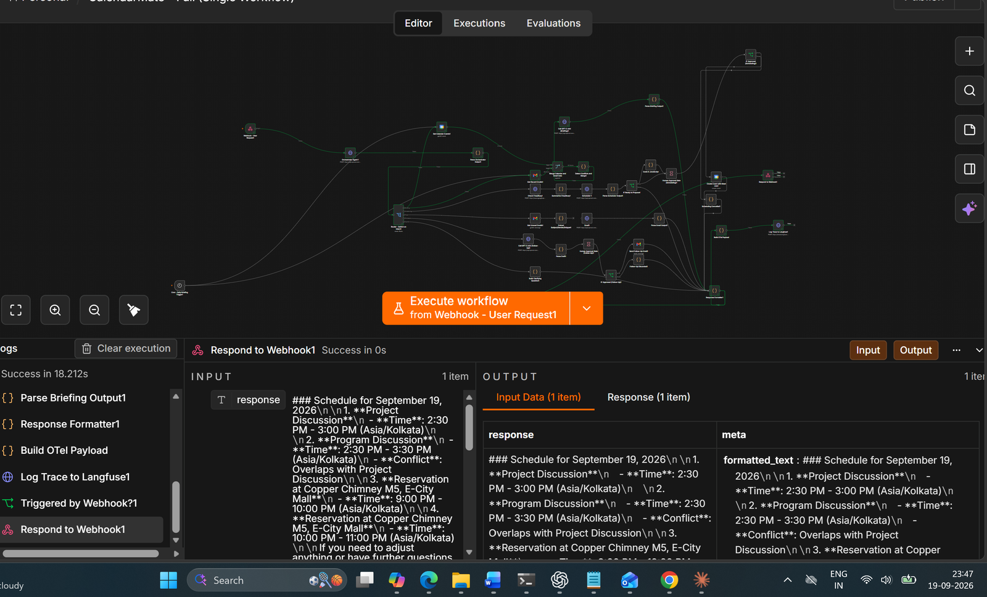
Figure 2: T1. Execution log: Respond to Webhook1 output

T2: Give me a summary of my meetings for tomorrow?
Prompt: Give me a summary of my meetings for tomorrow?
Command
Invoke-RestMethod -Uri "https://forn8n1984.app.n8n.cloud/webhook-test/calendarmate/chat" -Method POST -ContentType "application/json" -Body '{"message": "Give me a summary of my meetings for tomorrow?"}'
Observed response: Events listed for 19 Sep 2026 (four items); overlap flagged between Project Discussion and Program Discussion.
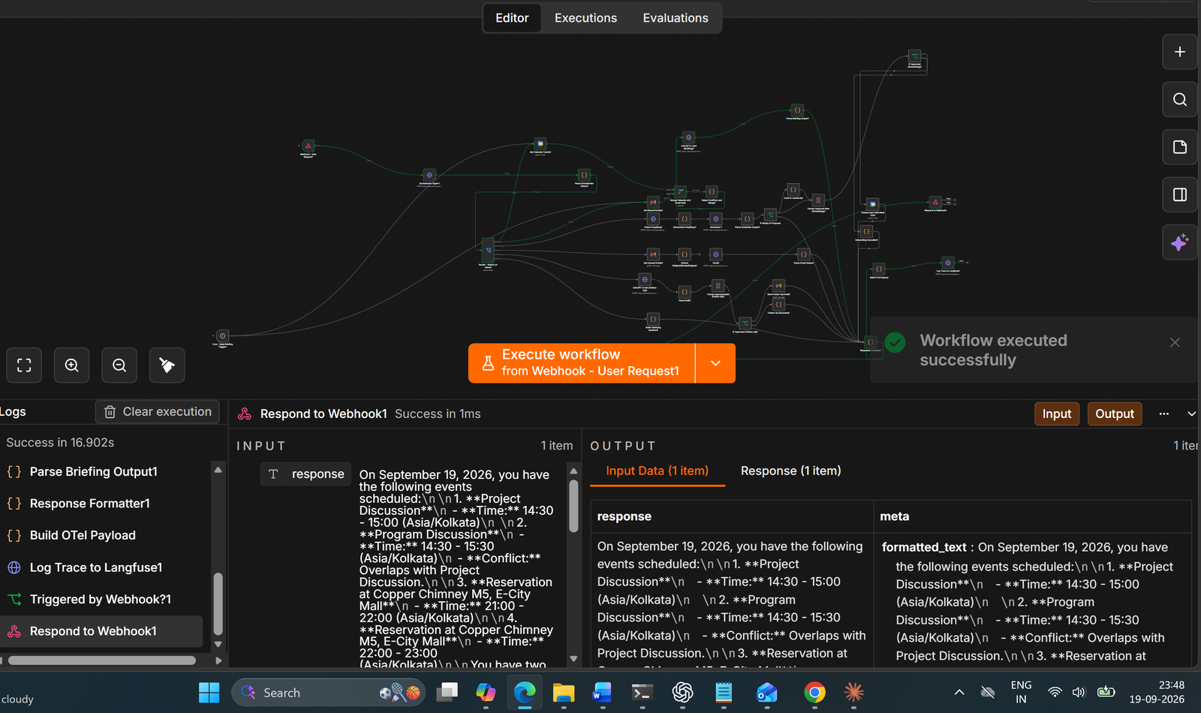
Figure 3: T2. Execution log: Respond to Webhook1 output

T3: Schedule a 30-minute meeting with shivkartik28@outlook.com tomorrow at 2pm.
Prompt: Schedule a 30-minute meeting with shivkartik28@outlook.com tomorrow at 2pm.
Command
Invoke-RestMethod -Uri "https://forn8n1984.app.n8n.cloud/webhook-test/calendarmate/chat" -Method POST -ContentType "application/json" -Body '{"message": "Schedule a 30-minute meeting with shivkartik28@outlook.com tomorrow at 2pm."}'
Observed response: Availability check passed and a confirmation prompt was produced: free on Sun 20 Sep 2026, 2:00 PM IST, 30 minutes, with shivkartik28@outlook.com. The execution was cancelled while waiting for approval, so event creation is not shown.
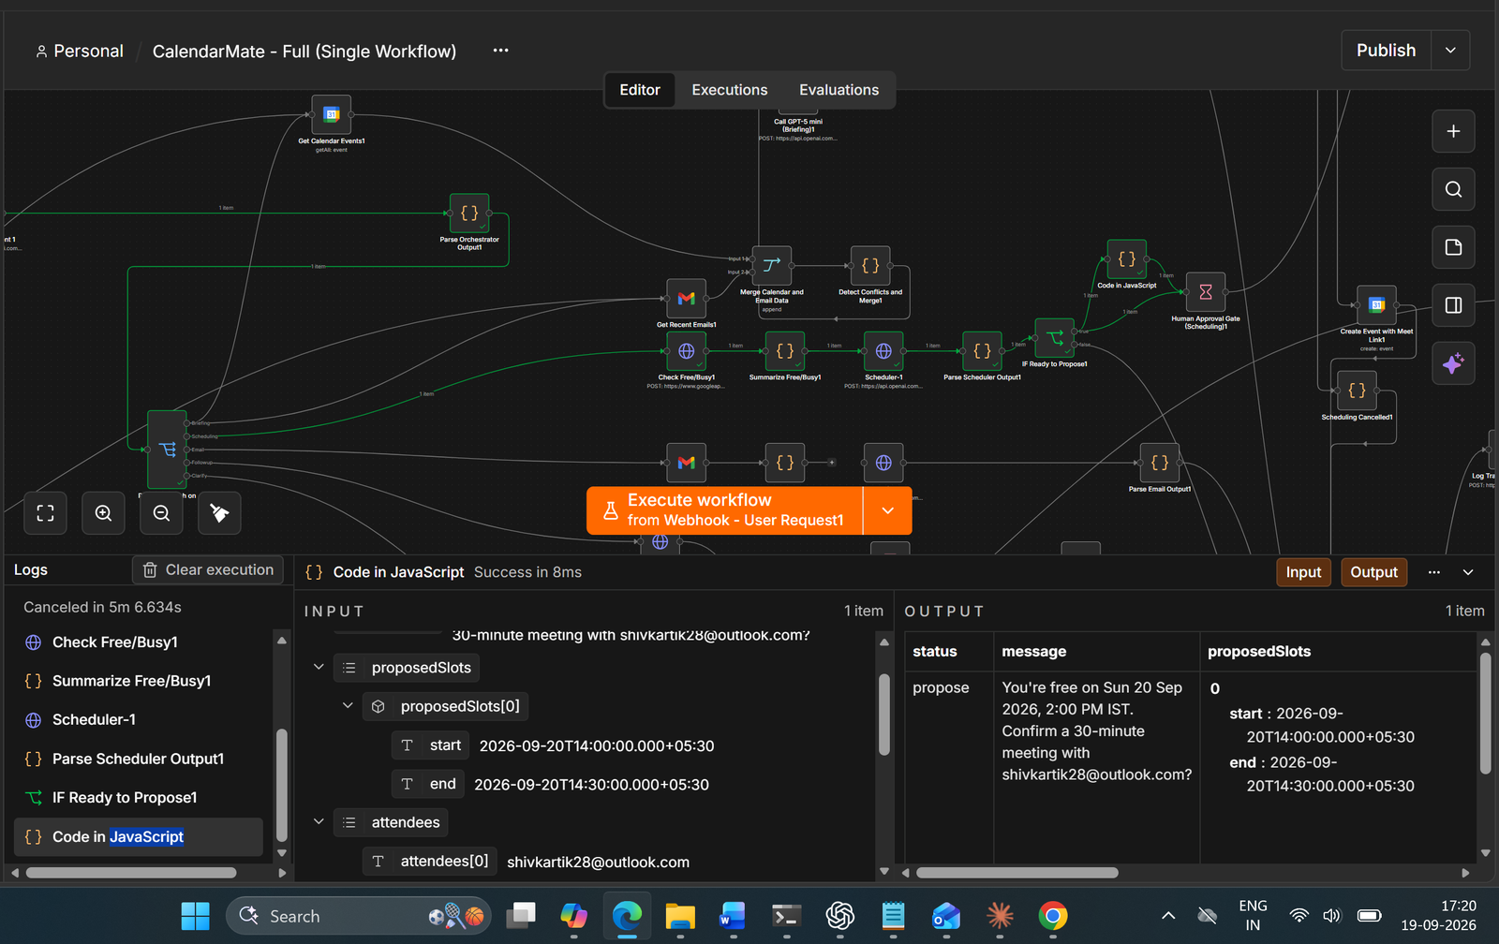
Figure 4: T3. Execution log: Code in JavaScript output (status: propose)

T4: Set up a sync with the design team sometime this week.
Prompt: Set up a sync with the design team sometime this week.
Command
Invoke-RestMethod -Uri "https://forn8n1984.app.n8n.cloud/webhook-test/calendarmate/chat" -Method POST -ContentType "application/json" -Body '{"message": "Set up a sync with the design team sometime this week."}'
Observed response: Clarifying question: “Please tell me who the meeting is with (email).”
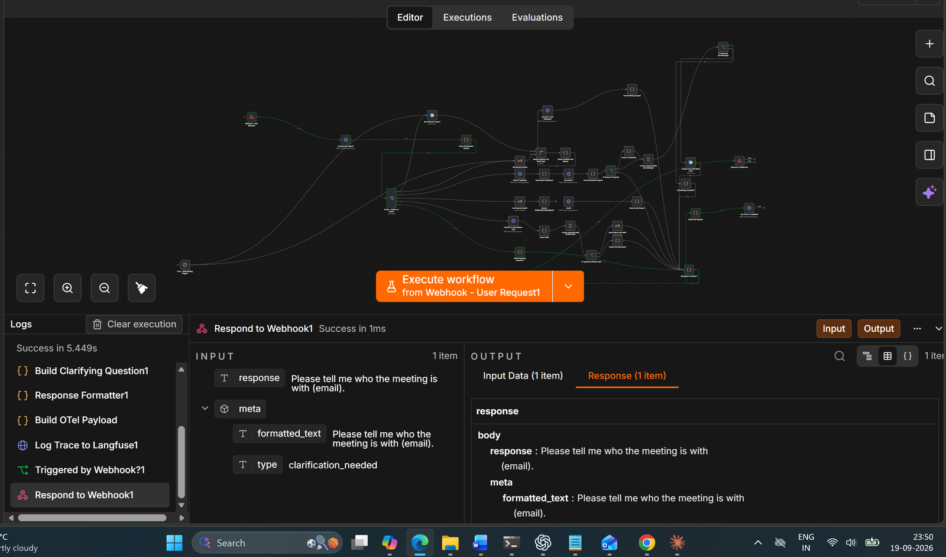
Figure 5: T4. Execution log: Respond to Webhook1 output (clarification_needed)

T5: Find a time for a 1-hour meeting with john@ext.com and lisa@ext.com next Monday.
Prompt: Find a time for a 1-hour meeting with john@ext.com and lisa@ext.com next Monday.
Command
Invoke-RestMethod -Uri "https://forn8n1984.app.n8n.cloud/webhook-test/calendarmate/chat" -Method POST -ContentType "application/json" -Body '{"message": "Find a time for a 1-hour meeting with john@ext.com and lisa@ext.com next Monday."}'
Observed response: Three 60-minute slots proposed for Mon 21 Sep (9:00–10:00, 10:00–11:00, 11:00–12:00 AM), with a note that the calendars of john@ext.com and lisa@ext.com could not be seen. The execution shows as cancelled.
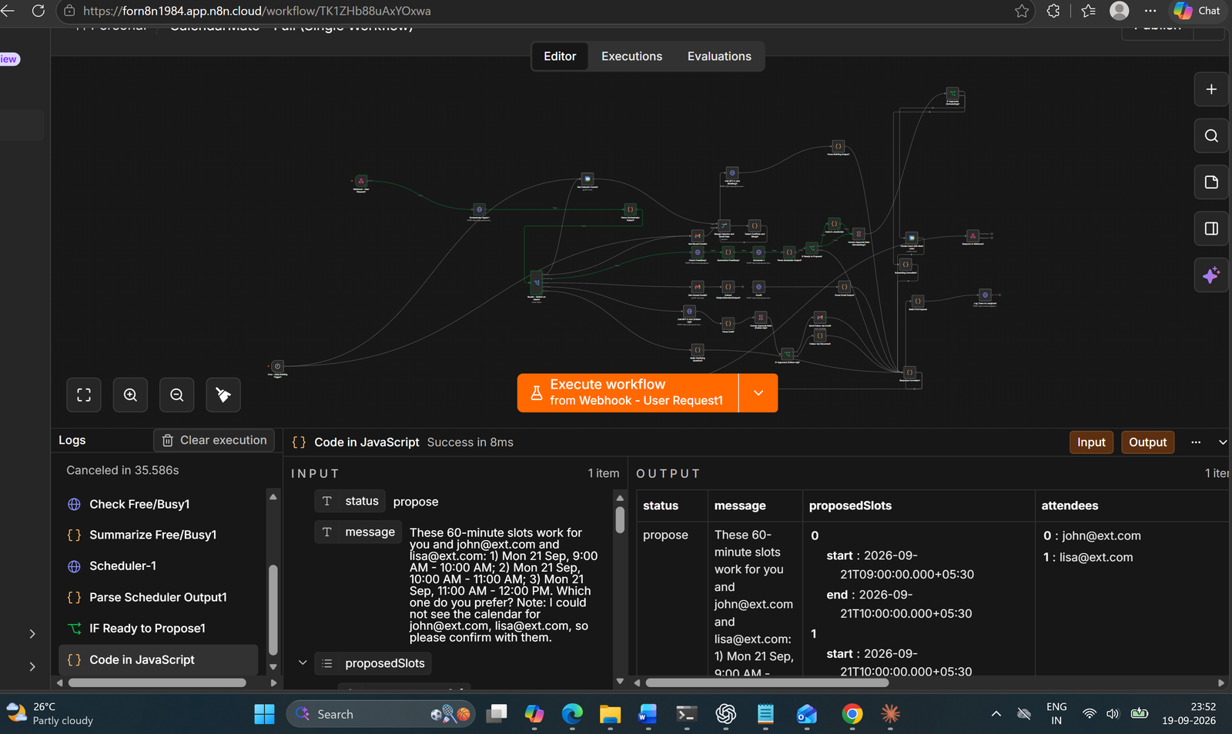
Figure 6: T5. Execution log: Code in JavaScript output (status: propose)

T6: Summarize my unread emails.
Prompt: Summarize my unread emails.
Command
Invoke-RestMethod -Uri "https://forn8n1984.app.n8n.cloud/webhook-test/calendarmate/chat" -Method POST -ContentType "application/json" -Body '{"message": "Summarize my unread emails."}'
Observed response: Response is a schedule for 19 Sep 2026 (calendar items with a conflict note). No email summary is visible in the screenshot.
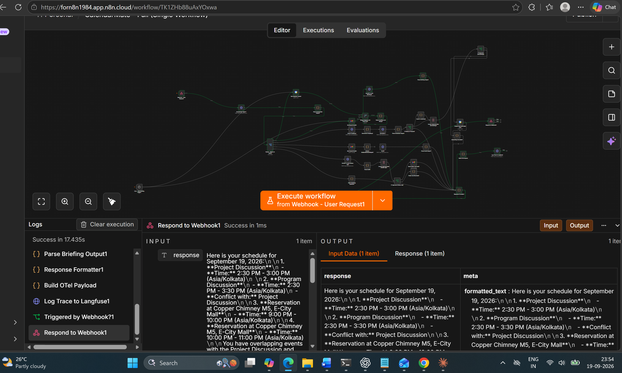
Figure 7: T6. Execution log: Respond to Webhook1 output

T7: What emails need my attention today?
Prompt: What emails need my attention today?
Command
Invoke-RestMethod -Uri "https://forn8n1984.app.n8n.cloud/webhook-test/calendarmate/chat" -Method POST -ContentType "application/json" -Body '{"message": "What emails need my attention today?"}'
Observed response: Response is a schedule for 19 Sep 2026 with attendees and a conflict note. No email content is visible in the screenshot.
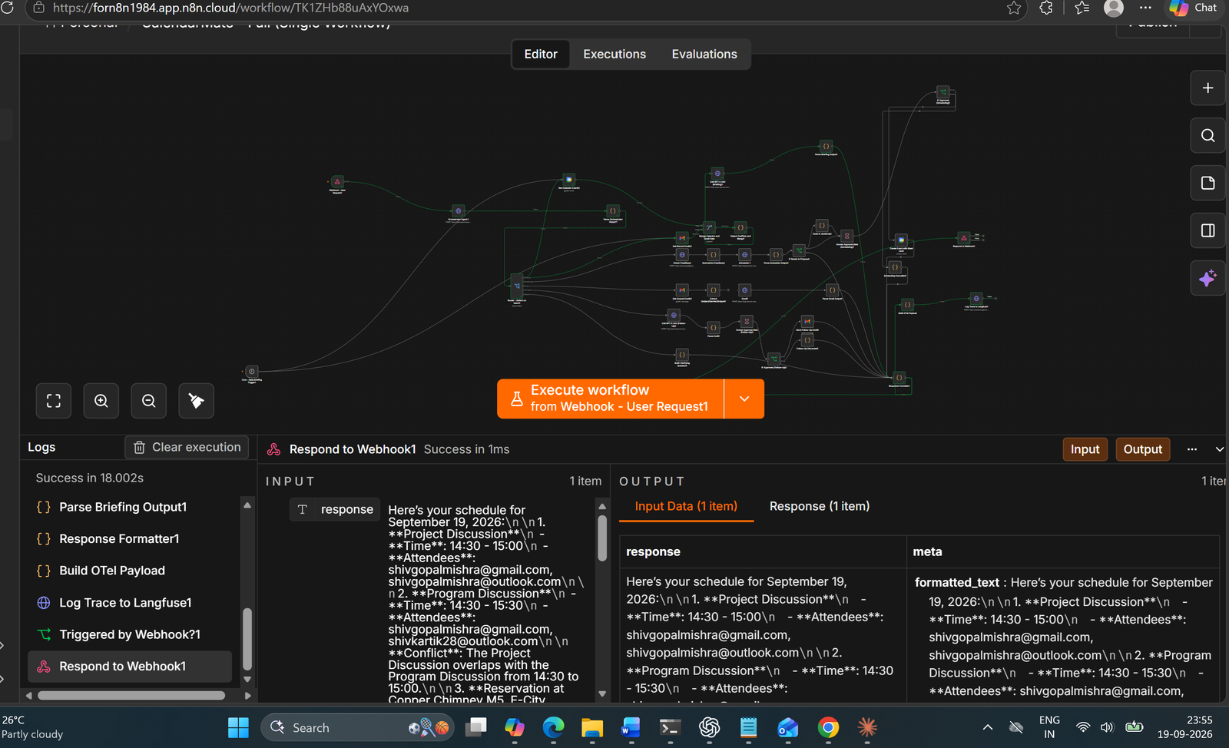
Figure 8: T7. Execution log: Respond to Webhook1 output

T8: Book a meeting but I forgot with whom.
Prompt: Book a meeting but I forgot with whom.
Command
Invoke-RestMethod -Uri "https://forn8n1984.app.n8n.cloud/webhook-test/calendarmate/chat" -Method POST -ContentType "application/json" -Body '{"message": "Book a meeting but I forgot with whom."}'
Observed response: Clarifying question: “Who should be included in the meeting?”
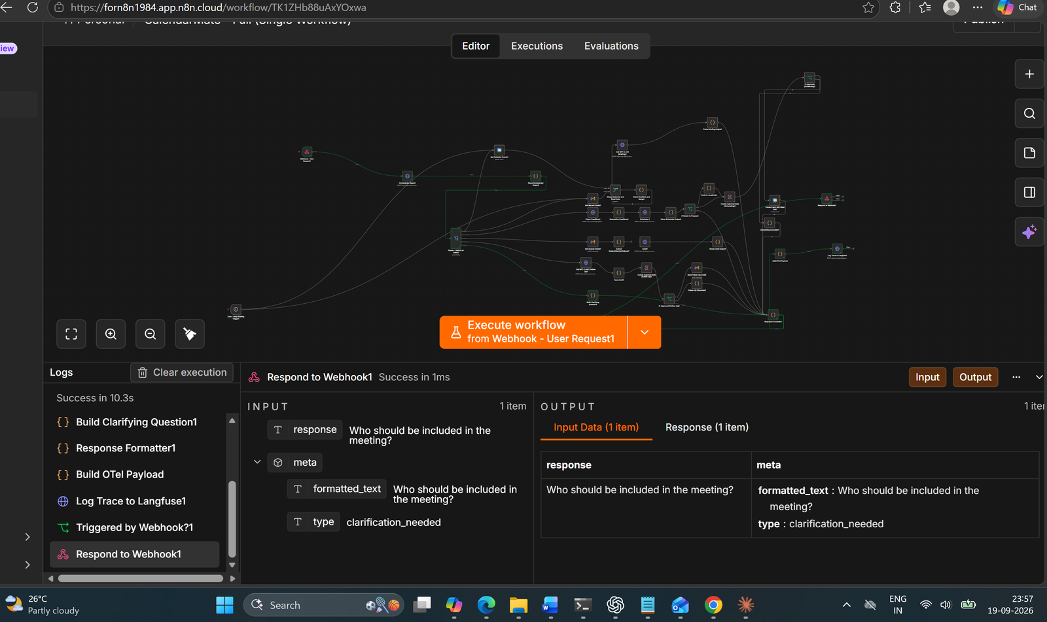
Figure 9: T8. Execution log: Respond to Webhook1 output (clarification_needed)

T9: Do I have any conflicts this week?
Prompt: Do I have any conflicts this week?
Command
Invoke-RestMethod -Uri "https://forn8n1984.app.n8n.cloud/webhook-test/calendarmate/chat" -Method POST -ContentType "application/json" -Body '{"message": "Do I have any conflicts this week?"}'
Observed response: Schedule for 19 Sep 2026 with the overlap between Project Discussion and Program Discussion flagged.
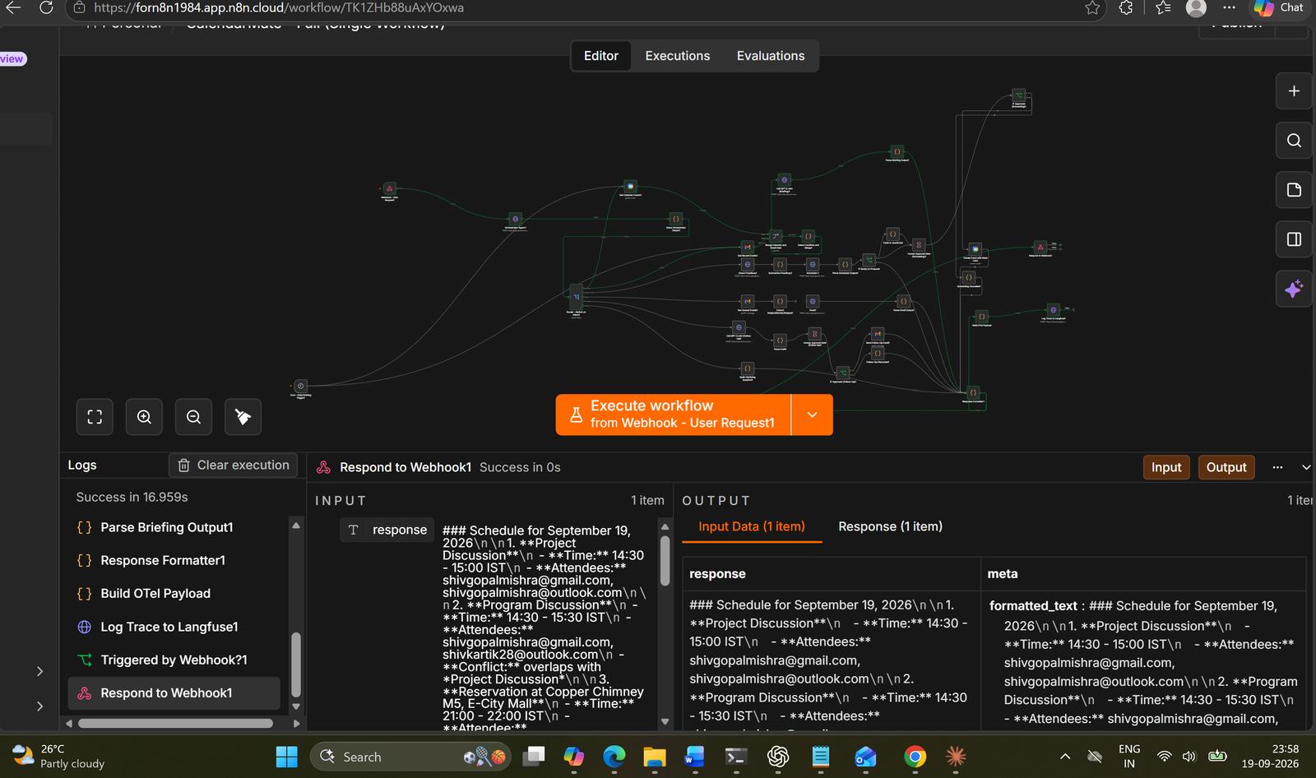
Figure 10: T9. Execution log: Respond to Webhook1 output

T10: Schedule a meeting at the same time as my existing standup.
Prompt: Schedule a meeting at the same time as my existing standup.
Command
Invoke-RestMethod -Uri "https://forn8n1984.app.n8n.cloud/webhook-test/calendarmate/chat" -Method POST -ContentType "application/json" -Body '{"message": "Schedule a meeting at the same time as my existing standup."}'
Observed response: Clarifying question: “Please provide the date or attendees for the meeting.”
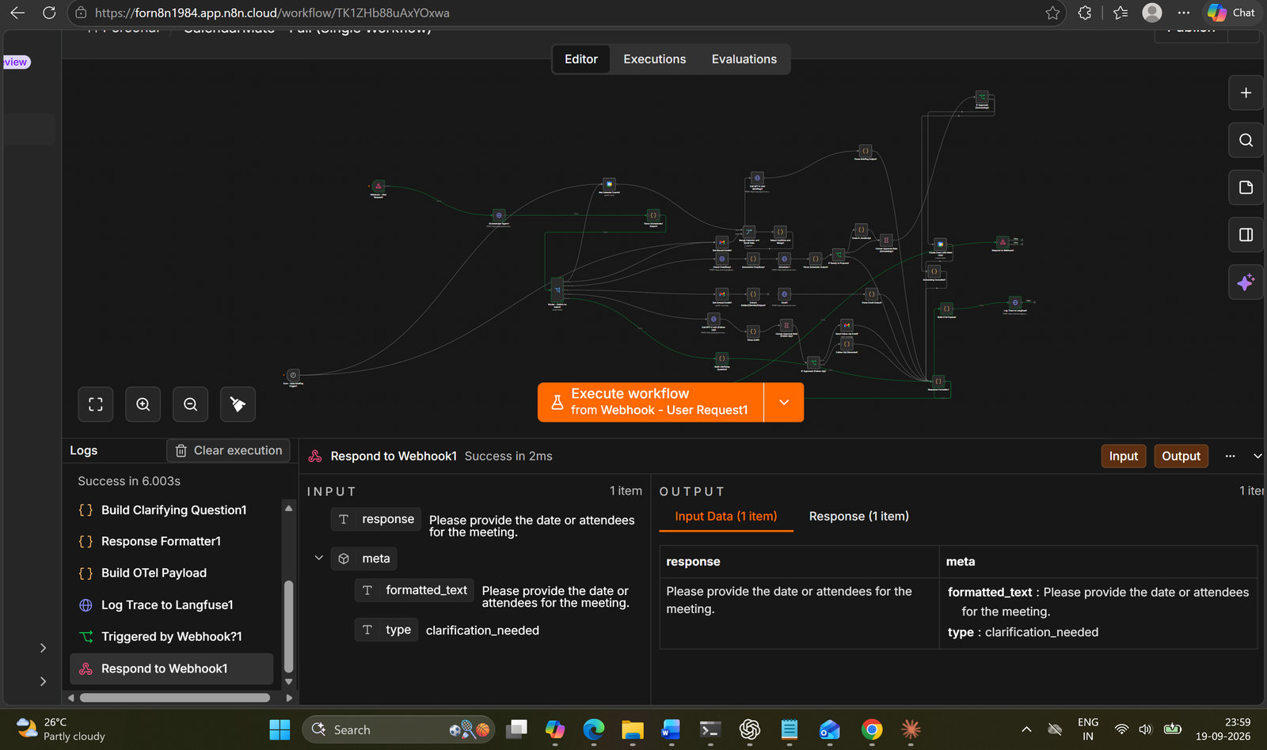
Figure 11: T10. Execution log: Respond to Webhook1 output (clarification_needed)

T12: What's happening next Thursday?
Prompt: What's happening next Thursday?
Command
$body = @{ message = "What's happening next Thursday?" } | ConvertTo-Json
Invoke-RestMethod -Uri "https://forn8n1984.app.n8n.cloud/webhook-test/calendarmate/chat" -Method POST -ContentType "application/json" -Body $body
Note: The prompt contains an apostrophe, which would end a single-quoted PowerShell string early, so the body is built with ConvertTo-Json.
Observed response: Clarifying question: “Who should I check for the events happening next Thursday?” (type: clarification_needed). No events for the requested date are listed.
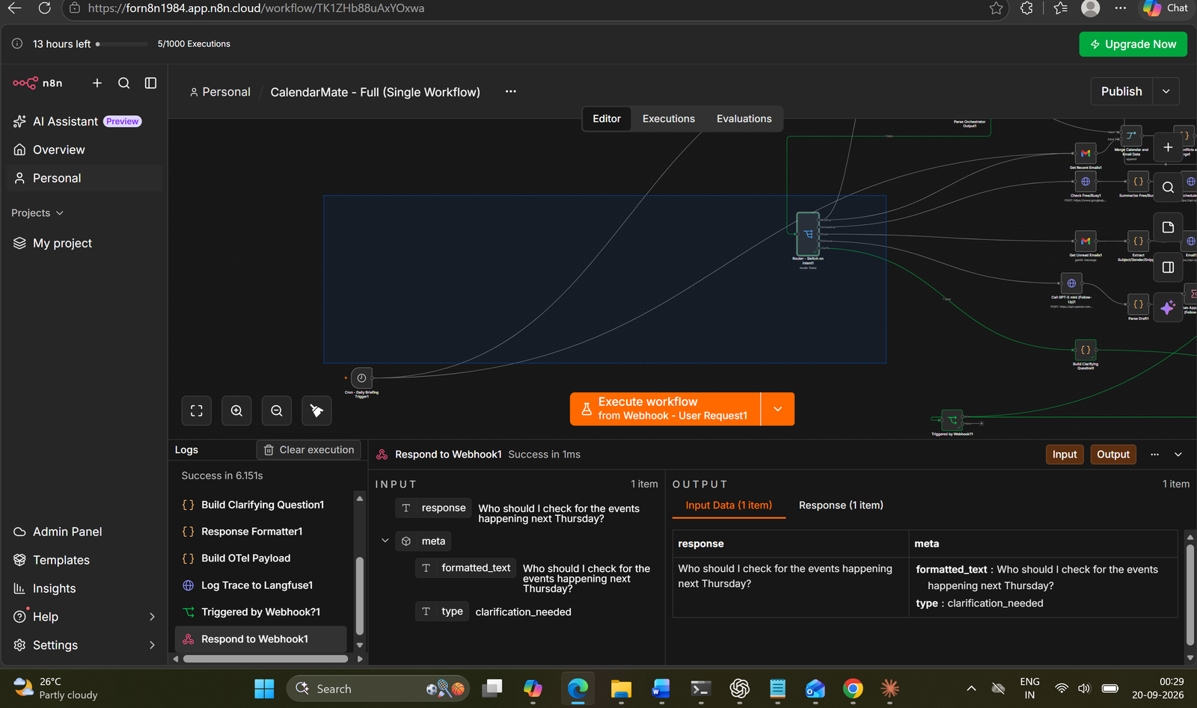
Figure 12: T12. Execution log: Respond to Webhook1 output (clarification_needed)

