Assignment 1

The analysis was done for six files in case of non persistent and persistent connections.
Time taken during persistent connection:
- file 1 = 4578 µs
- file 2 = 310 µs
- file 3 = 347 µs
- file 4 = 353 µs
- file 5 = 558 µs
- file 6 = 660 µs
Total time taken by 6 files is 6806 µs
Time taken during non persistent connection:
- file 1 = 4366 µs
- file 2 = 2810 µs
- file 3 = 3731 µs
- file 4 = 2696 µs
- file 5 = 4606 µs
- file 6 = 2704 µs
Total time taken by 6 files is 20913 µs
Thus it is evident that the time taken by persistent connection to transfer six files is comparatively less than the time taken by non persistent connection to transfer the same files. This is because in the non persistent connection TCP connection is established for every request and after the transfer of one file the connection is closed. Thus, we have total of twelve Round Trips in case of non persistent. Whereas, in case of persistent connection the TCP connection is established only during the first request and in the subsequent round trips files are transferred over same connection until the connection is closed by the client. Hence, we have seven Round Trips in total.
As we can see above the Round Trip Time in case of first file transfer is approximately equal. This is because in both cases TCP connection is being initiated in both cases.
The time taken to transfer same file using UDP was 657µs. This is approximately equivalent to the time taken by subsequent files in the TCP persistent connection and is comparatively less than TCP non persistent connection. This is because UDP is a connectionless protocol i.e. there is no connection made from the client to server and thus no extra Round Trip is required.

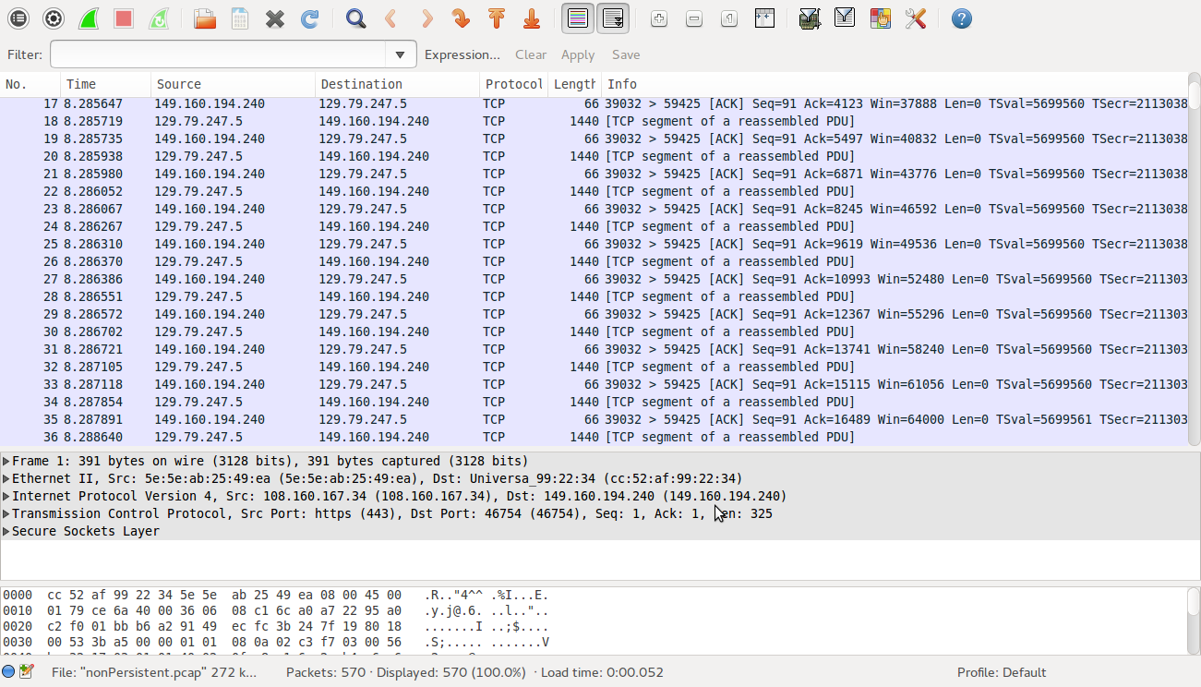

In the above analysis of UDP client and server, no UDP packet loss was encountered in case of small files. Whereas for large file of (approximately 1.MB), the client was able to receive the file without packet loss when I introduced sleep() for 2000µs – 200000µs. Without introducing sleep() the udpclient was getting overwhelmed by the server and would start dropping the packets after receiving 90-100KB.

MultiThreaded server is able to accept request from multiple clients at the same time. I tried to retrieve one file via my client from the server and another file via browser. Both files were correctly received .
While retrieving 2 files each of approximately 1.6MB via different clients (client coded by me) at the same time from the multiThreaded (server). The request from the first client took 2647934µs , whereas the request from second client took 3228232µs. Thus I could conclude that the retrieval of same time file takes more time as more number of clients connect to the server.
After multiple sample of retrieval time in case of 2 and three clients connected at the same time a linear growth in retrieval time was observed.

