Name: Shivani Shaileshkumar Varu
Student ID: 8941914

Screenshot 1

a. Homepage



Screenshot 2

b. 3 to-do, 1 in progress, and 1 done card.

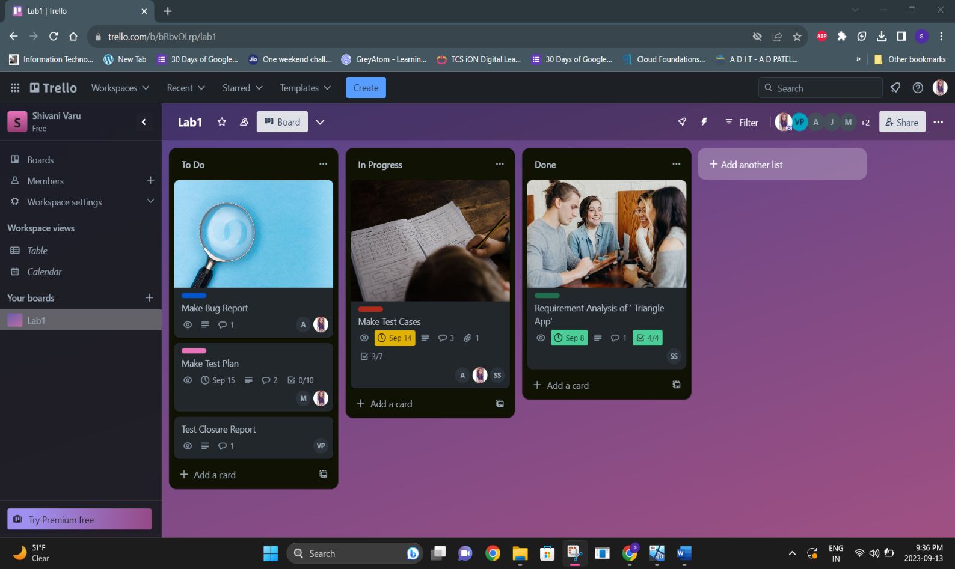

Screenshot 3

C. In Progress Card


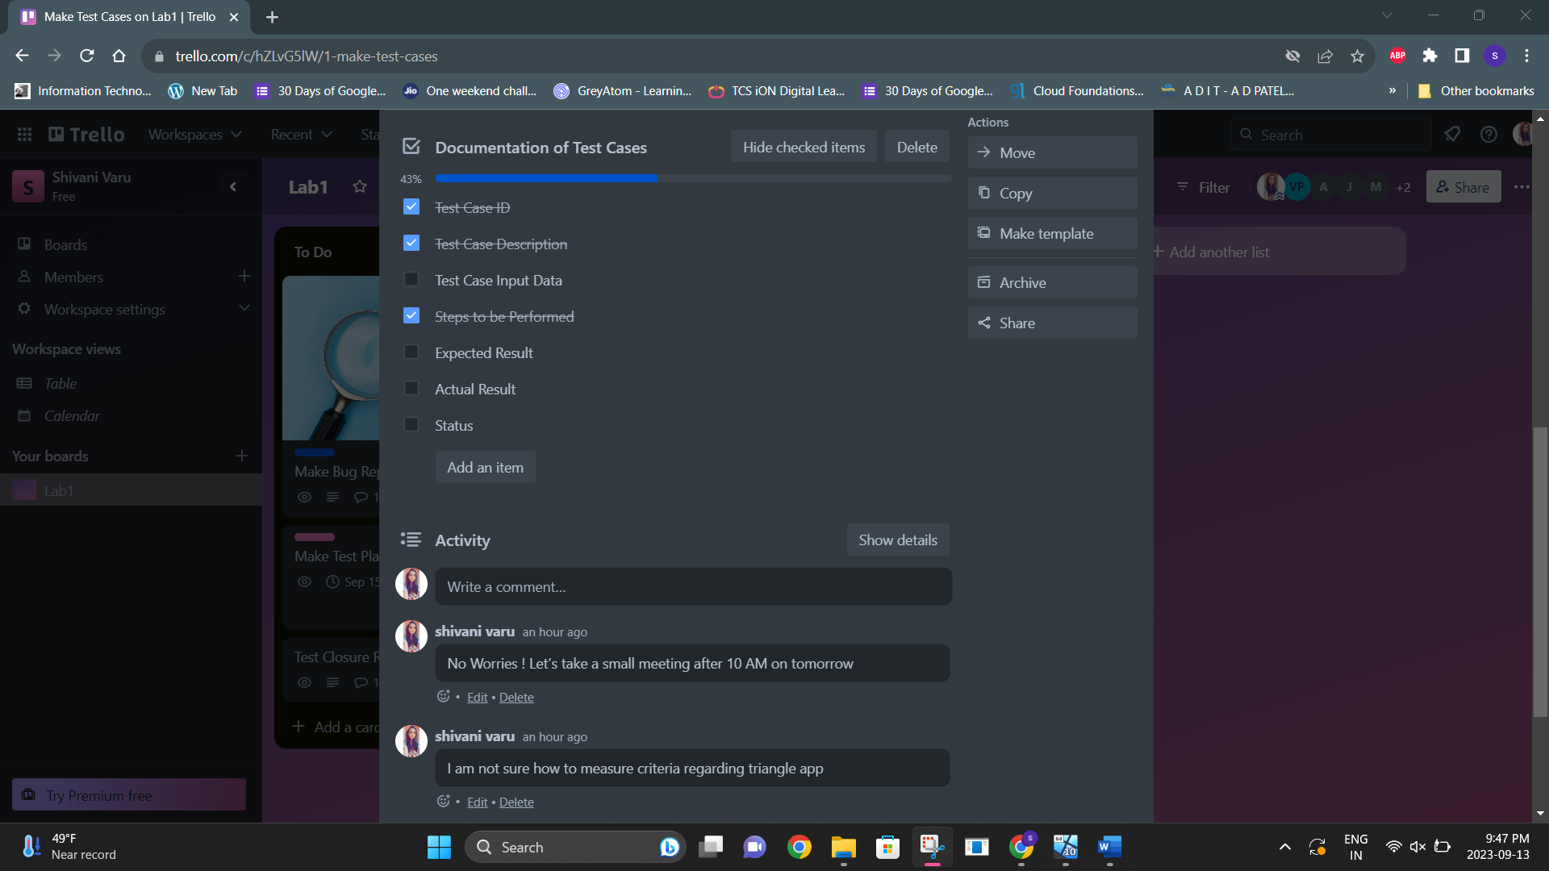
Screenshot 4
d. Done Card


